ASSIGNMENT 7

Q.1)Write a query that counts all orders for October 3.

ANS:

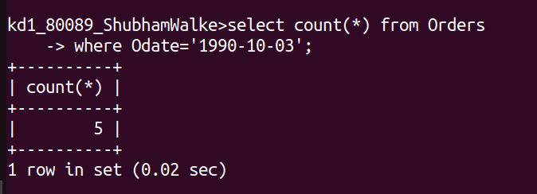

Q.2)Write a query that counts the number of different
non-NULL city values in the Customerat table.

ANS:

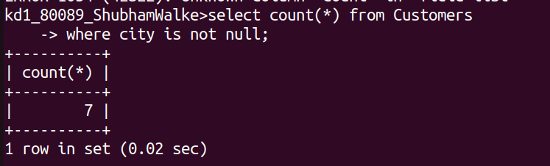

Q.3)Write a query that selects each customer's
smallest order.
ANS:
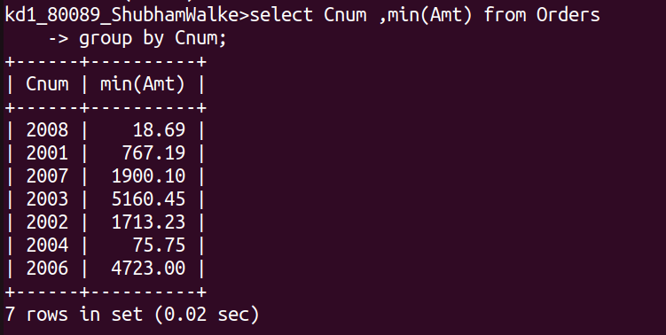

Q.4)Write a query that selects the first customer, in alphabetical order, whose name begins with G.

ANS:
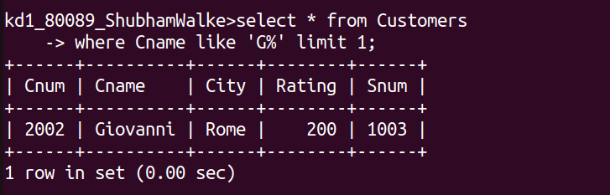

Q.5)Write a query that selects the highest rating in
each city.

ANS:
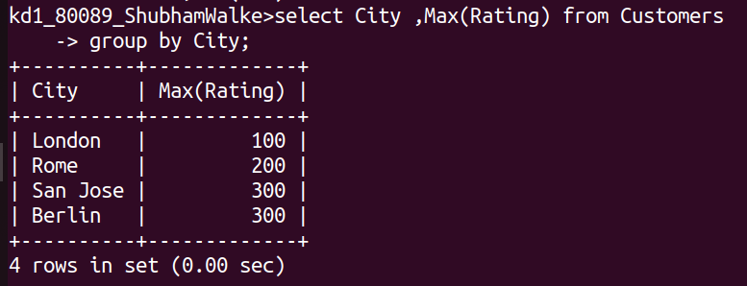
Q.6) Write a query that counts the number of salespeople registering orders for each day. (Ifa salesperson has more than one order on a givenday, he or she should be counted only once.)
ANS:
