ASSIGNMENT 5

Q.1)Write a query that will give you all orders for
more than Rs. 1,000

ANS:
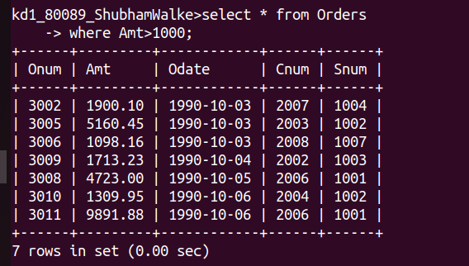
Q.2)Write a query that will give you the names and
cities of all salespeople in london with a comm
above 0.10.
ANS:
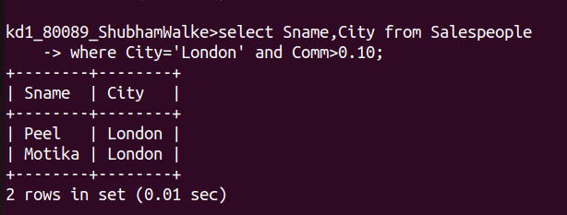
Q.3)Write a query on the Customers table whose output will exclude all customers with a rating <= 100, unless hey are located in Rome.
ANS:
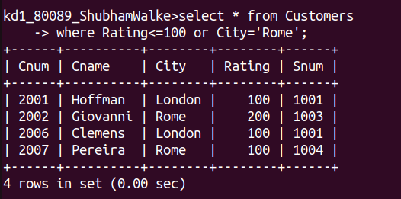
Q.4) What will be the output from the following
query.
Select * from Orders
where (amt < 1000 OR NOT (odate = 1990-10-03’
AND cnum > 2003))
ANS:
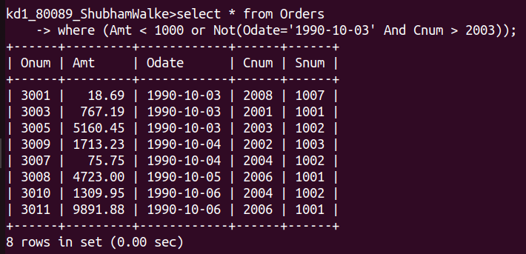
Q.5)What will be the output of the following query?
Select * from Orders where NOT ((odate =
'1990-10-03' OR snum >1006) AND amt >=
1500);
ANS:
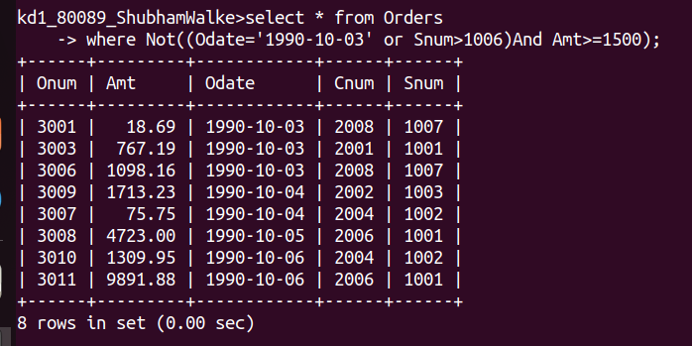
Q.6)What is a simpler way to write this query?
select snum, sname, city, comm From Salespeople
Comm>.12 OR comm <.14
ANS:
