Assignment -15

Q.1)Assume there is a table called Multicust, with all of the same
column definitions as Salespeople. Write a command that
inserts all salespeople with more than one customer into this
table.

ANS:

Q.2)Write a command that deletes all customers with no current
orders.
ANS:

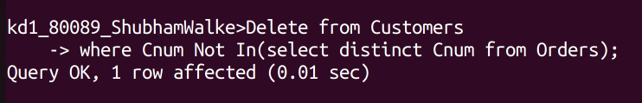

Q.3)Write a command that increases by twenty percent the
commissions of all salespeople with total orders above Rs.
3,000.

ANS:
