**First copy the "tvii_gfxdrv_v2.3.0_apps " folder and paste it into C:\ directory, then follow the below steps -**

1. Open VS code and open this folder “tvii_gfxdrv_v2.3.0_apps “

(Directory - C: \tvii_gfxdrv_v2.3.0_apps).

1. 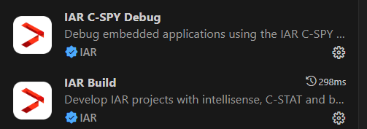Install Two extensions in VS code, "IAR Build", and "IAR C-SPY Debug" in VS Code.
2. Click on “Terminal” in top menu of the VS code and then click on “Run Build Task”.
3. Then select “build_4M-cpu”.
4. After the completing the build system, close the VS code and follow the below instructions.
5. Open IAR from the below directory:-

C:\ tvii_gfxdrv_v2.3.0_apps\04_sample\basic_graphics\helmet_detection_fw\tools\iar\tviic2d4m \capture2display (IAR IDE Workspace)

1. After opening the IAR, make some setups –
2. Select the debug as “cm0plus – Debug” shown in the below figure -

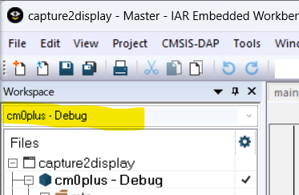

1. 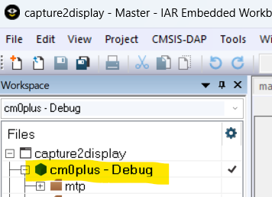Then right click on “cm0plus – Debug” and click on “Options”.
2. Then click on “Output Converter” and select “Output format:” as “Motorola S-records” (For Debugging).
3. Then unselect the “Override default”, then select it again and then click on “OK”.

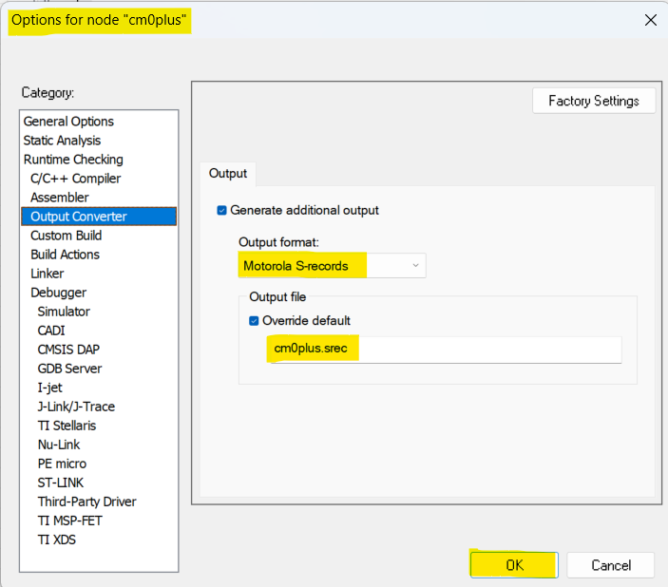

1. Then right click on “cm7 – Debug” and click on “Options”

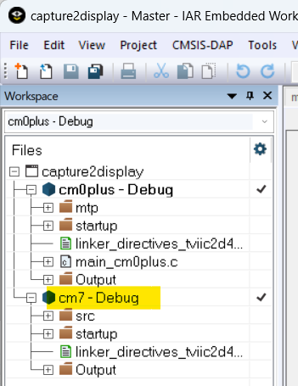

1. Then click on “Output Converter” and select “Output format:” as “Raw binary” (For Debugging).
2. Then unselect the “Override default”, then select it again and then click on “OK”.

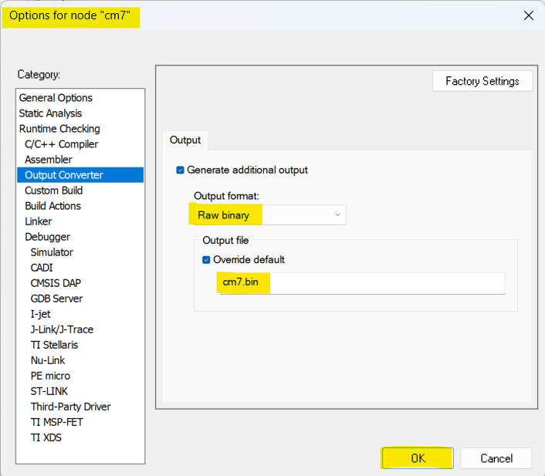

1. Now the setup is completed and ready for build and debug.
2. There are another procedure for “build” the code and generate the “.hex” files

**# Building procedure -**

1. First build “cm7 -Debug” (“Rebuild All” option)
2. Then build “cm0plus – Debug” (“Rebuild All” option)

Note: Please select the Rebuild all option and not the Make option for both the core for building the project.

**# Hex file generation procedure –**

1. **“cm0plus.hex” Generation :**
2. Right click on “cm0plus – Debug” and click on “Options”.
3. Click on “Output Converter” and select “Output format:” as “Intel Extended hex”
4. Then unselect the “Override default”, then select it again and then click on “OK”.
5. Then right click on “cm7 – Debug” and click on “Options”.
6. Click on “Output Converter” and select “Output format:” as “Raw binary”
7. Then unselect the “Override default”, then select it again and then click on “OK”.
8. Then first build “cm7 -Debug” (“Rebuild All” option)
9. Then build “cm0plus – Debug” (“Rebuild All” option)
10. Then take the “cm0plus.hex” from Output folder
11. **“cm7.hex” Generation :**
12. Right click on “cm7 – Debug” and click on “Options”.
13. Click on “Output Converter” and select “Output format:” as “Intel Extended hex”
14. Then unselect the “Override default”, then select it again and then click on “OK”.
15. Then build the “cm7 -Debug” again (“Rebuild All” option)
16. Then take the “cm7.hex” from Output folder

Now you got two .hex files (i.e., - “cm0plus.hex” and “cm7.hex”). So now you can flash them by Auto Flash Utility.