PROGRAMMING FUNDAMENTALS ASSIGNMENT – 2

1. Elucidate the following concepts: 'Statically Typed Language', 'Dynamically Typed Language', 'Strongly Typed Language', and 'Loosely Typed Language'? Also, into which of these categories would Java fall?”

- Statically Typed Language – Computer Language which Type checking during the compiling stage.
Ex : java,C,C++,Rust,Go,Scala

- Dynamically Typed Language – Computer Language which Type checking during run time.
Ex : Perl, Ruby, Python, PHP, JavaScript, Erlang

- Strongly Typed Language – The language that consider the data types.
Ex : java,C++,swift

- Loose Typed Language – The language that not consider the data types.
Ex : PHP,Perl

- Java falls to Dynamically Typed Language and Strongly Types Language.

2. "Could you clarify the meanings of 'Case Sensitive', 'Case Insensitive', and 'Case Sensitive-Insensitive' as they relate to programming languages with some examples? Furthermore, how would you classify Java in relation to these terms?”

- Case-sensitive Language - A case-sensitive language is a programming language in which the distinction between uppercase and lowercase letters is significant.
Ex : java,C,C++,C#,Phython,Ruby,javaScript

- Case-Insensitive Language - A case-insensitive language is a programming language in which the distinction between uppercase and lowercase letters is not significant .
Ex : VB.NET

- Case sensitive - Insensitive Language - Some programming languages provide options to treat identifiers as either case sensitive or case insensitive based on a specific setting or compiler flag. In such languages, you can choose whether the distinction between uppercase and lowercase letters matters (case sensitive) or doesn't matter (case insensitive) when writing code.

- Java is a Case-sensitive Language

3. Explain the concept of Identity Conversion in Java? Please provide two examples to substantiate your explanation.

In Java, identity conversion is the simplest form of type conversion. It occurs when a value of a certain type is assigned to a variable of the same type (or a compatible type).

An identity conversion is a safe and straightforward operation because it involves converting a value to the exact same type or to a type that is considered compatible without any loss of precision or risk of data loss.

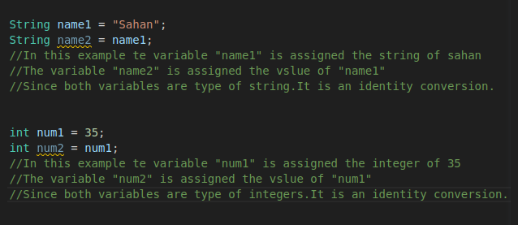

4. Explain the concept of Primitive Widening Conversion in Java with examples and diagrams.

The type conversion in Java where a value of a smaller data type is assigned to a variable of a larger data type is called primitive widening conversion.

Primitive widening conversions in Java involve automatically converting a smaller data type to a larger data type without any loss of information or need for explicit casting.

This type conversion is happening towards the direction of arrows in the below diagram.

byte
short
int
long
char
float
double

5. Explain the the difference between run-time constant and Compile-time constant in java with examples.

Compile-time constant:

A compile-time constant is the constants that are already known at compile-time, and their values are determined before the program runs.

final int MATH_MARKS = 85;

In the given example, MATH_MARKS represents a compile-time constant. The value 80 is already known to the compiler during the compilation phase. Consequently, the Java compiler will replace all instances of MATH_MARKS with the value 80 in the compiled code. This "baking" of the constant value into the code eliminates any runtime overhead for accessing it, as the value is directly substituted during compilation.

Run-time constant:

A run-time constant is a value that is known only at runtime, These constants are determined or calculated during program execution, and they cannot be evaluated by the compiler during the compilation phase.

final int RANDOM_NUMBER = new Random().nextInt(5);

In this particular instance, RANDOM_NUMBER serves as a run-time constant. Its value is determined at runtime when the program executes the new Random().nextInt(5) statement. Due to the fact that the value is only known during runtime, the Java compiler cannot replace it with a specific value during compilation. As a result, RANDOM_NUMBER remains dynamic throughout program execution and cannot be statically evaluated during the compilation phase.

6. Explain the difference between Implicit (Automatic) Narrowing Primitive Conversions and Explicit Narrowing Conversions (Casting) and what conditions must be met for an implicit narrowing primitive conversion to occur?

Implicit (Automatic) Narrowing Primitive Conversions

Implicit narrowing primitive conversions, take place when a value of a larger data type is assigned to a variable of a smaller data type. During this conversion, the Java compiler automatically truncates or discards some information to fit the larger value into the smaller data type.

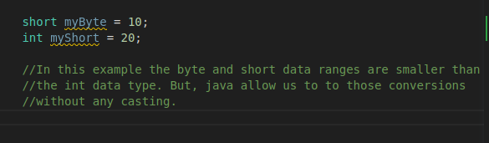

Conditions for Implicit Narrowing Primitive Conversion:

For an implicit narrowing primitive conversion to occur:
- The value being converted should be a constant.
- The constant value should be within the valid range of the target data type.
- The constant value should be known at compile-time, not determined at run-time.
Explicit Narrowing Conversions (Casting)

Explicit narrowing conversions, also known as casting, occur when you manually convert a value from a larger data type to a smaller data type. You do this by using a cast operator ((type)) to inform the compiler that you are aware of the potential loss of data, and you still want to perform the conversion.

7. How can a long data type, which is 64 bits in Java, be assigned into a float data type that's only 32 bits? Could you explain this seeming discrepancy?”

The key point to understand here is that float uses a different representation format called IEEE 754 floating-point format. In this format, the 32 bits are divided into three parts:
- The sign bit: 1 bit to represent the sign of the value (positive or negative).
- The exponent: A group of bits that represents the magnitude of the value.
- The fraction (mantissa): A group of bits that represents the fractional part of the value.
By using the exponent and mantissa, float can represent a wide range of values, including very large and very small numbers, but with reduced precision compared to long.

