**PRACTICAL-3**

**AIM:** Write a program to check whether the given string is palindrome or not.

­

**Source Code:**

# function which return reverse of a string

def isPalindrome(s):

return s == s[::-1]

# Driver code

s = input("Enter a string :\n#>")

ans = isPalindrome(s)

if ans:

print("Yes")

else:

print("No")

**Output:**

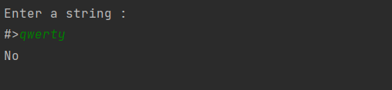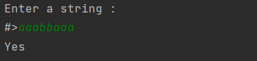

**AIM:** Write a program that accepts a string from user and performs the following operations:

* Print the string in reverse order
* Print all the odd indexed charactes of the string
* Print the count of all the vowels in the string
* Print the count of the frequency of an input character in the string

**Source Code:**

# print the string in reverse order

def toString(str):

return str[::-1]

#print odd indexes characters of the string

def oddS(str):

for i in str:

if str.index(i) % 2 != 0 :

print(i, end=" - ")

#count the vowels of a string

def vowelCount(str):

string = str.lower()

count = 0

for i in str:

if (i == 'a') or (i == 'e') or (i == 'u') or (i == 'i') or (i == 'o'):

count+=1

return count

# Print the count of the frequency of an input character in the string

def letcount(str,ch):

count=0

for i in str:

if ch==i:

count+=1

return count

#menu

def next():

bool = input("\nDo you want to continue [y/n]?")

if bool == 'y':

menu()

def menu():

str = input("Enter a string:\n#>")

choice = int(input("=====================================MENU=================================\n"

"[1] - Print the string in reverse order\n"

"[2] - Print all the odd indexed charactes of the string\n"

"[3] - Print the count of all the vowels in the string\n"

"[4] - Print the count of the frequency of an input character in the string\nMake a choice : "))

if choice==1:

print(toString(str))

next()

elif choice == 2:

oddS(str)

next()

elif choice == 3:

print(vowelCount(str))

next()

elif choice==4:

char = input("Enter the character that you want frequency :\n#>")

print("The frequency of '{0}' in '{1}' is {2}".format(char, str, letcount(str, char)))

next()

else:

print("Error! ")

next()

menu()

**Output:**

