Initial data segment

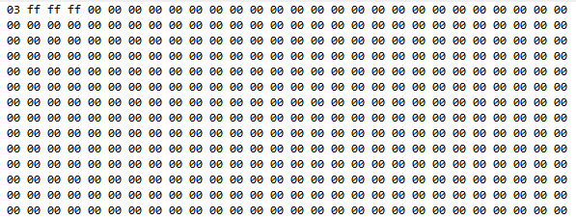

Initial register contents

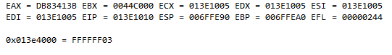

mov eax, number

C:\Users\Michael\AppData\Local\Temp\ScreenClip.png

add eax, 74

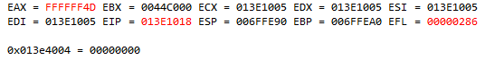

mov sum, eax

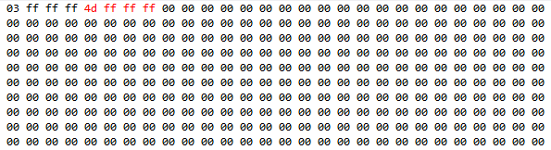

C:\Users\Michael\AppData\Local\Temp\ScreenClip.png