**1-amaliy ish**

**Ollanazarov Jamshidbek**

**Laravel dasturchilari ish qidirishi va o’zlari haqida malumotlar joylashi uchun web sahifa.**

**Case1.Registiratsiya bo’limi.**

2.Register tugmasini bosish

3.Ro’yxatdan o’tish

4.Asosiy sahifada ism familiya chiqishi

5.Sahifaga ish joylash tugmasining chiqishi

**Case.2.Avtorizatsiya bo’limi.**

1.Avtorizatsiya qilish

2. Administrator sifatida, ishlarni sahifaga qo’sha olishi

3.Foydalanuvchi sifatida avtorizatsiyadan o’tish

4.Avtorizatsiya oynasida login kiritish

5.Kirish tugmasini bosish

6.Asosiy sahifada ism familiya chiqishi

**Case.3.Avtorizatsiya qilish( muvafaqiyatsiz).**

1.Avtorizatsiya oynasida login kiritish xató chiqishi

2.Foydalanuvchi sifatida avtorizatsiyadan o’tishda xatolik

3.Kirish tugmasini bosishda xatolik

4.Xato xaqida malumot chiqadi

**Case.4. Ish joylash.**

1.Ish yaratish tugmasini bosish

2.Ish malumotlarini to’ldirish

3.Yaratish tugmasini bosish

4.Asosiy sahifada ish malumotlari chop etiladi

**Case.5.Ish joylash( muvafaqiyatsiz).**

1.Ish yaratish tugmasini bosish

2.Ish malumotlarini to’ldirish

3.Yaratish tugmasini bosish

4.Xato haqida malumot olish

**Case.6.Ish haqida barcha malumotlarni olish.**

1.Asosiy sahifaga kirish

2.Jadval ko’rinishida chop etilgan ishlardan istalgan ishning sarlavhasi ustiga bosish

3.Ish haqida batafsil malumotlarning chop etilishi

**Case.7.Foydalanuvchi sifatida joylangan ishlar o’zgartirish.**

1. Manage listings tugmasi bosiladi

2.Jadval ko’rinishida chop etilgan ishlardan istalgan ishning edit tugmasini bosish

3.Ish malumotlarning chop etilishi

4.Ish malumotlarini o’zgartirish

5.Saqlash tugmasini bosish

6.O’zgartirilganligi haqida malumot chiqishi

**Case.8.Foydalanuvchi sifatida joylangan ishni o’chirish.**

1. Manage listings tugmasi bosiladi

2.Jadval ko’rinishida chop etilgan ishlardan istalgan ishning delete tugmasini bosish

3.Ish malumotlarning o’chirish

4.O’chirilganligi haqida malumot chiqishi

**Funksional talablar:**

**Administrator**

**Talab 1.** Administrator sifatida, ishlarni tizimga qo’sha olishi kerak.

**Talab 2.** Administrator sifatida, ishlarni ro‘yhatini ko‘ra olishi kerak.

**Talab 3.** Administrator sifatida, ishlarni ma’lumotlarini o‘zgartira olishi kerak.

**Talab 4.** Administrator sifatida, ishlarni ma’lumotlarini o‘chira olishi kerak.

**Talab 5.** Administrator sifatida, foydalanuvchilarni kirita olishi kerak.

**Talab 6.** Administrator sifatida, foydalanuvchilarni ko‘ra olishi kerak.

**Talab 7.** Administrator sifatida, foydalanuvchilarni o‘zgartira olishi kerak.

**Talab 8.** Administrator sifatida, foydalanuvchilarni o‘chira olishi kerak.

**UI**

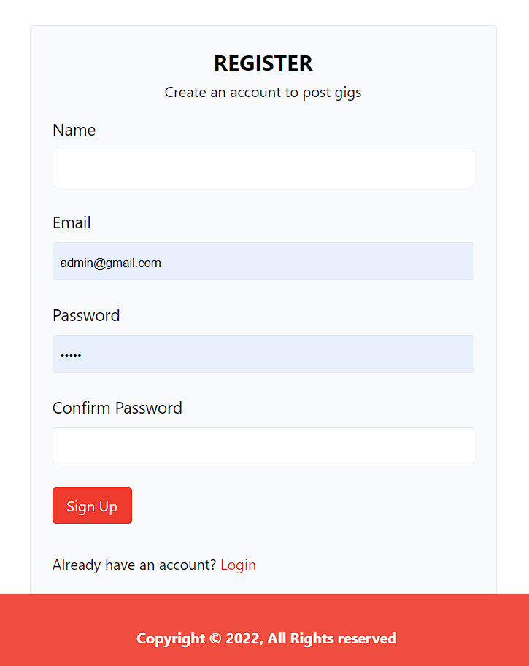

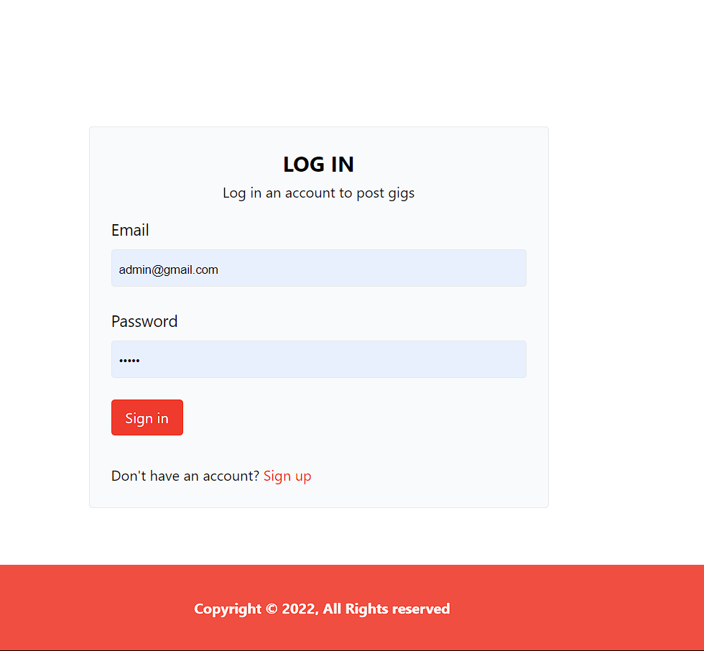

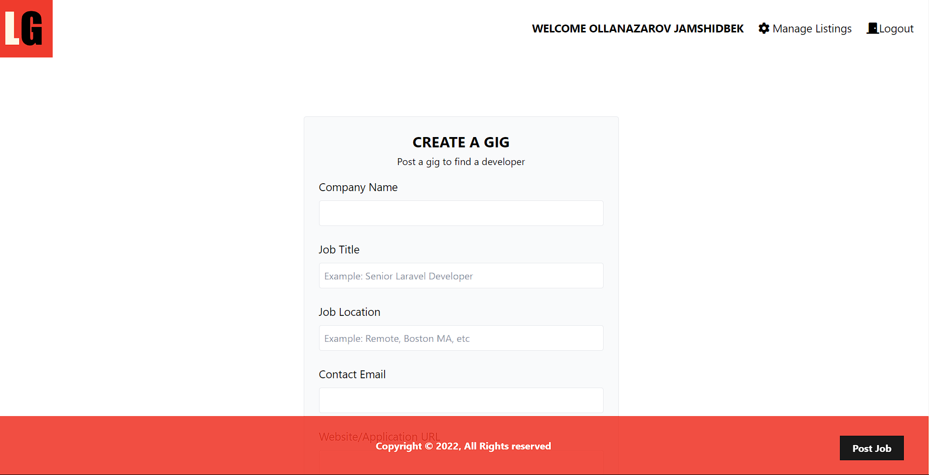

**Ux**

<x-layout>  
 <x-card class="p-10 max-w-lg mx-auto mt-24">  
 <header class="text-center">  
 <h2 class="text-2xl font-bold uppercase mb-1">  
 Register  
 </h2>  
 <p class="mb-4">Create an account to post gigs</p>  
 </header>  
  
 <form method="post" action="/users">  
 @csrf   
 <div class="mb-6">  
 <label for="name" class="inline-block text-lg mb-2">  
 Name  
 </label>  
 <input  
 type="text"  
 class="border border-gray-200 rounded p-2 w-full"  
 name="name"  
 value="{{old('name')}}"  
 />  
 @error('name')  
 <p class="text-red-5-00 text-xs mt-1">  
 {{$message}}  
 </p>  
 @enderror  
 </div>  
  
 <div class="mb-6">  
 <label for="email" class="inline-block text-lg mb-2"  
 >Email</label  
 >  
 <input  
 type="email"  
 class="border border-gray-200 rounded p-2 w-full"  
 name="email"  
 value="{{old('email')}}"  
 />  
 @error('email')  
 <p class="text-red-5-00 text-xs mt-1">  
 {{$message}}  
 </p>  
 @enderror  
 </div>  
  
 <div class="mb-6">  
 <label  
 for="password"  
 class="inline-block text-lg mb-2"  
 >  
 Password  
 </label>  
 <input  
 type="password"  
 class="border border-gray-200 rounded p-2 w-full"  
 name="password"  
 value="{{old('password')}}"  
 />  
 @error('password')  
 <p class="text-red-5-00 text-xs mt-1">  
 {{$message}}  
 </p>  
 @enderror  
 </div>  
  
 <div class="mb-6">  
 <label  
 for="password2"  
 class="inline-block text-lg mb-2"  
 >  
 Confirm Password  
 </label>   
 <input  
 type="password"  
 class="border border-gray-200 rounded p-2 w-full"  
 name="password_confirmation"  
 value="{{old('password_confirmation')}}"  
 />  
 @error('password_confirmation')  
 <p class="text-red-5-00 text-xs mt-1">  
 {{$message}}  
 </p>  
 @enderror  
  
 </div>  
  
 <div class="mb-6">  
 <button  
 type="submit"  
 class="bg-laravel text-white rounded py-2 px-4 hover:bg-black"  
 >  
 Sign Up  
 </button>  
 </div>  
  
 <div class="mt-8">  
 <p>  
 Already have an account?  
 <a href="/login" class="text-laravel"  
 >Login</a  
 >  
 </p>  
 </div>  
 </form>  
 </x-card>  
</x-layout>

<x-layout>  
 <x-card class="p-10 max-w-lg mx-auto mt-24">  
 <header class="text-center">  
 <h2 class="text-2xl font-bold uppercase mb-1">  
 LOG IN  
 </h2>  
 <p class="mb-4">Log in an account to post gigs</p>  
 </header>  
  
 <form method="post" action="/authenticate">  
 @csrf   
 <div class="mb-6">  
 <label for="email" class="inline-block text-lg mb-2"  
 >Email</label  
 >  
 <input  
 type="email"  
 class="border border-gray-200 rounded p-2 w-full"  
 name="email"  
 value="{{old('email')}}"  
 />  
 @error('email')  
 <p class="text-red-5-00 text-xs mt-1">  
 {{$message}}  
 </p>  
 @enderror  
 </div>  
  
 <div class="mb-6">  
 <label  
 for="password"  
 class="inline-block text-lg mb-2"  
 >  
 Password  
 </label>  
 <input  
 type="password"  
 class="border border-gray-200 rounded p-2 w-full"  
 name="password"  
 value="{{old('password')}}"  
 />  
 @error('password')  
 <p class="text-red-5-00 text-xs mt-1">  
 {{$message}}  
 </p>  
 @enderror  
 </div>  
  
 <div class="mb-6">  
 <button  
 type="submit"  
 class="bg-laravel text-white rounded py-2 px-4 hover:bg-black"  
 >  
 Sign in  
 </button>  
 </div>  
  
 <div class="mt-8">  
 <p>  
 Don't have an account?  
 <a href="/register" class="text-laravel"  
 >Sign up</a  
 >  
 </p>  
 </div>  
 </form>  
 </x-card>  
</x-layout>

<x-layout>  
 <x-card  
 class="p-10 max-w-lg mx-auto mt-24"  
 >  
 <header class="text-center">  
 <h2 class="text-2xl font-bold uppercase mb-1">  
 Create a Gig  
 </h2>  
 <p class="mb-4">Post a gig to find a developer</p>  
 </header>  
  
 <form method="POST" action="/listings" enctype="multipart/form-data">  
 @csrf  
 <div class="mb-6">  
 <label  
 for="company"  
 class="inline-block text-lg mb-2"  
 >Company Name</label  
 >  
 <input  
 type="text"  
 class="border border-gray-200 rounded p-2 w-full"  
 name="company"  
 value="{{old('company')}}"  
 />  
 @error('company')  
 <p class="text-red-500 text-xs mt-1">{{$message}}</p>  
 @enderror  
 </div>  
  
 <div class="mb-6">  
 <label for="title" class="inline-block text-lg mb-2"  
 >Job Title</label  
 >  
 <input  
 type="text"  
 class="border border-gray-200 rounded p-2 w-full"  
 name="title"  
 placeholder="Example: Senior Laravel Developer"  
 value="{{old('title')}}"  
 />  
 @error('title')  
 <p class="text-red-500 text-xs mt-1">{{$message}}</p>  
 @enderror  
 </div>  
  
 <div class="mb-6">  
 <label  
 for="location"  
 class="inline-block text-lg mb-2"  
 >Job Location</label  
 >  
 <input  
 type="text"  
 class="border border-gray-200 rounded p-2 w-full"  
 name="location"  
 placeholder="Example: Remote, Boston MA, etc"  
 value="{{old('location')}}"  
 />  
 @error('location')  
 <p class="text-red-500 text-xs mt-1">{{$message}}</p>  
 @enderror  
 </div>  
  
 <div class="mb-6">  
 <label for="email" class="inline-block text-lg mb-2"  
 >Contact Email</label  
 >  
 <input  
 type="text"  
 class="border border-gray-200 rounded p-2 w-full"  
 name="email"  
 value="{{old('email')}}"  
 />  
 @error('email')  
 <p class="text-red-500 text-xs mt-1">{{$message}}</p>  
 @enderror  
 </div>  
  
 <div class="mb-6">  
 <label  
 for="website"  
 class="inline-block text-lg mb-2"  
 >  
 Website/Application URL  
 </label>  
 <input  
 type="text"  
 class="border border-gray-200 rounded p-2 w-full"  
 name="website"  
 value="{{old('website')}}"  
 />  
 @error('website')  
 <p class="text-red-500 text-xs mt-1">{{$message}}</p>  
 @enderror  
 </div>  
  
 <div class="mb-6">  
 <label for="tags" class="inline-block text-lg mb-2">  
 Tags (Comma Separated)  
 </label>  
 <input  
 type="text"  
 class="border border-gray-200 rounded p-2 w-full"  
 name="tags"  
 placeholder="Example: Laravel, Backend, Postgres, etc"  
 value="{{old('tags')}}"  
 />  
 @error('tags')  
 <p class="text-red-500 text-xs mt-1">{{$message}}</p>  
 @enderror  
 </div>  
  
 <div class="mb-6">  
 <label for="logo" class="inline-block text-lg mb-2">  
 Company Logo  
 </label>  
 <input  
 type="file"  
 class="border border-gray-200 rounded p-2 w-full"  
 name="logo"  
 />  
 @error('logo')  
 <p class="text-red-500 text-xs mt-1">{{$message}}</p>  
 @enderror  
 </div>  
  
 <div class="mb-6">  
 <label  
 for="description"  
 class="inline-block text-lg mb-2"  
 >  
 Job Description  
 </label>  
 <textarea  
 class="border border-gray-200 rounded p-2 w-full"  
 name="description"  
 rows="10"  
 placeholder="Include tasks, requirements, salary, etc"  
 >{{old('description')}}</textarea>  
 @error('description')  
 <p class="text-red-500 text-xs mt-1">{{$message}}</p>  
 @enderror  
 </div>  
  
 <div class="mb-6">  
 <button  
 class="bg-laravel text-white rounded py-2 px-4 hover:bg-black"  
 >  
 Create Gig  
 </button>  
  
 <a href="/" class="text-black ml-4"> Back </a>  
 </div>  
 </form>  
 </x-card>  
</x-layout>