941-23 guruh talabasi Alimboyev
Jayxunning Mobil ilovalarni
ishlab chiqish fanidan
bajargan 8-amaliyot ishi

Mobil ilovalarda geolokatsiya xizmatlari va interaktiv xaritalar bilan ishlashni dasturlash

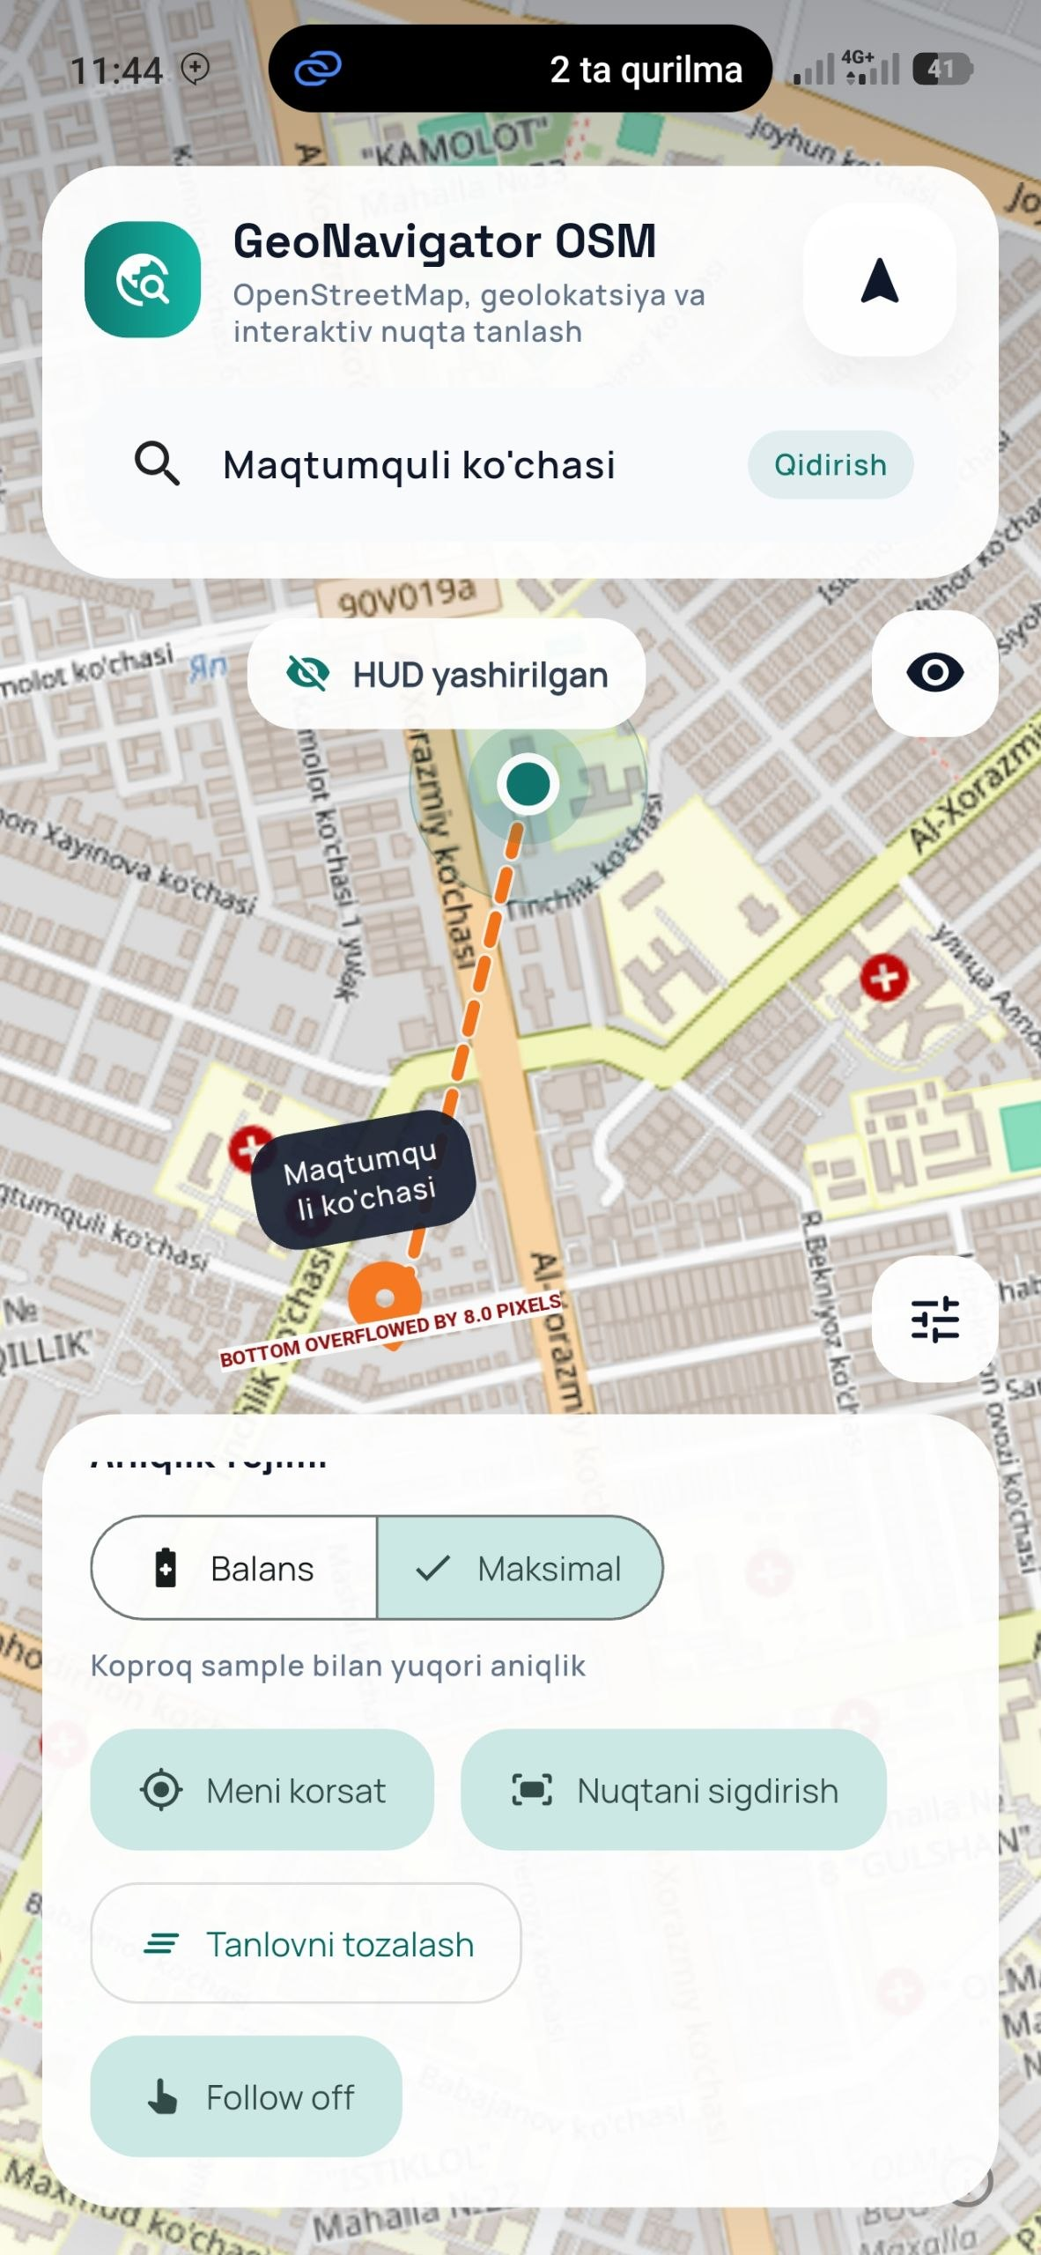
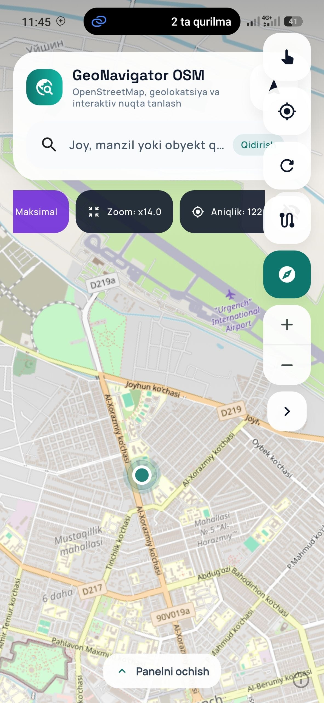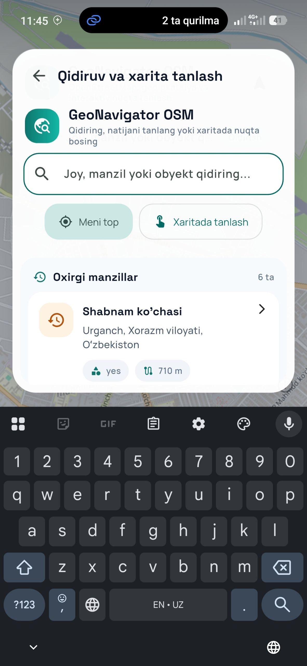
import 'dart:async';

import 'package:dio/dio.dart';
import 'package:flutter_riverpod/flutter_riverpod.dart';
import 'package:geolocator/geolocator.dart';
import 'package:latlong2/latlong.dart';

import '../../../core/constants/app_constants.dart';
import '../data/location_service.dart';
import '../data/open_street_map_repository.dart';
import '../data/search_history_repository.dart';
import '../domain/map_place.dart';
import '../domain/map_preferences.dart';
import 'map_session_state.dart';

final autoInitializeMapSessionProvider = Provider<bool>((_) => true);

final dioProvider = Provider<Dio>((ref) {
final dio = Dio(buildMapDioOptions());
ref.onDispose(() => dio.close(force: true));
return dio;
});

final deviceLocationServiceProvider = Provider<DeviceLocationService>(
(_) => const DeviceLocationService(),
);

final openStreetMapRepositoryProvider = Provider<OpenStreetMapRepository>(
(ref) => OpenStreetMapRepository(ref.watch(dioProvider)),
);

final searchHistoryRepositoryProvider = Provider<SearchHistoryRepository>(
(_) => const SearchHistoryRepository(),
);

final mapSessionControllerProvider =
NotifierProvider<MapSessionController, MapSessionState>(
MapSessionController.new,
);

class MapSessionController extends Notifier<MapSessionState> {
final Distance _distance = Distance();
StreamSubscription<ServiceStatus>? _serviceStatusSubscription;
StreamSubscription<Position>? _positionSubscription;
bool _initialized = false;
int _searchTicket = 0;
int _viewportId = 0;

DeviceLocationService get _locationService =>
ref.read(deviceLocationServiceProvider);

OpenStreetMapRepository get _repository =>
ref.read(openStreetMapRepositoryProvider);

SearchHistoryRepository get _historyRepository =>
ref.read(searchHistoryRepositoryProvider);

@override
MapSessionState build() {
ref.onDispose(() {
unawaited(_serviceStatusSubscription?.cancel());
unawaited(_positionSubscription?.cancel());
});

if (ref.read(autoInitializeMapSessionProvider)) {
Future.microtask(initialize);
}

return const MapSessionState();
}

Future<void> initialize() async {
if (_initialized) {
return;
}
_initialized = true;

state = state.copyWith(isBootstrapping: true, errorMessage: null);

await _bindServiceStatus();

final recentPlaces = await _historyRepository.loadRecentPlaces();
state = state.copyWith(recentPlaces: recentPlaces);

final hasAccess = await _refreshAccessState(requestPermission: true);
if (!hasAccess) {
state = state.copyWith(isBootstrapping: false);
return;
}

final lastKnownPosition = await _locationService.getLastKnownPosition();
if (lastKnownPosition != null) {
_applyCurrentPosition(
lastKnownPosition,
followOnMap: true,
updateTrail: false,
);
}

await refreshCurrentLocation(
silent: lastKnownPosition != null,
followOnMap: lastKnownPosition == null,
);

state = state.copyWith(isBootstrapping: false);
}

Future<void> refreshCurrentLocation({
bool silent = false,
bool followOnMap = true,
}) async {
if (!silent) {
state = state.copyWith(isResolvingLocation: true, errorMessage: null);
}

final hasAccess = await _refreshAccessState(requestPermission: true);
if (!hasAccess) {
state = state.copyWith(
isResolvingLocation: false,
isBootstrapping: false,
);
return;
}

try {
final currentPosition = await _locationService.getCurrentPosition(
precisionMode: state.precisionMode,
);
_applyCurrentPosition(
currentPosition,
followOnMap: followOnMap,
updateTrail: false,
);
} on TimeoutException {
_setError('GPS javobi kechikdi. Qayta urinib koring.');
} on LocationServiceDisabledException {
_setError('Lokatsiya xizmati ochiq emas. Qurilma sozlamalaridan yoqing.');
} catch (_) {
_setError('Joriy joylashuvni olib bolmadi.');
} finally {
state = state.copyWith(
isResolvingLocation: false,
isBootstrapping: false,
);
}
}

Future<void> requestPermissionFlow() async {
await refreshCurrentLocation(silent: false, followOnMap: true);
}

Future<void> toggleTracking() async {
if (state.isTracking) {
await _stopTracking();
return;
}

final hasAccess = await _refreshAccessState(requestPermission: true);
if (!hasAccess) {
return;
}

await _startTracking();

if (state.currentPosition == null) {
await refreshCurrentLocation(silent: true, followOnMap: true);
}
}

Future<void> setPrecisionMode(LocationPrecisionMode mode) async {
if (state.precisionMode == mode) {
return;
}

state = state.copyWith(precisionMode: mode, errorMessage: null);

if (state.isTracking) {
await _startTracking(reseedTrail: false);
return;
}

await refreshCurrentLocation(silent: true, followOnMap: false);
}

void toggleFollowUser() {
final nextValue = !state.isFollowingUser;
state = state.copyWith(isFollowingUser: nextValue);

if (nextValue && state.currentPlace != null) {
_focusCenter(state.currentPlace!.latLng, state.currentZoom);
}
}

void clearTrackingTrail() {
state = state.copyWith(trackingTrail: const []);
}

Future<void> searchPlaces(String query) async {
final normalizedQuery = query.trim();
final ticket = ++_searchTicket;

state = state.copyWith(
searchQuery: normalizedQuery,
isSearching: normalizedQuery.length >= 3,
errorMessage: null,
searchResults: normalizedQuery.length >= 3
? state.searchResults
: const [],
);

if (normalizedQuery.length < 3) {
state = state.copyWith(isSearching: false, searchResults: const []);
return;
}

try {
final places = await _repository.searchPlaces(normalizedQuery);
if (ticket != _searchTicket) {
return;
}
state = state.copyWith(isSearching: false, searchResults: places);
} on MapDataException catch (error) {
if (ticket != _searchTicket) {
return;
}
state = state.copyWith(
isSearching: false,
searchResults: const [],
errorMessage: error.message,
);
}
}

