941-23 guruh talabasi Alimboyev
Jayxunning Mobil ilovalarni
ishlab chiqish fanidan
bajargan 9-amaliyot ishi

Flutter frameworkidan foydalangan holda ko‘p funksiyali mobil ilova ishlab chiqish (ma’lumotlar bazasi, xarita va foydalanuvchi interfeysi integratsiyasi)

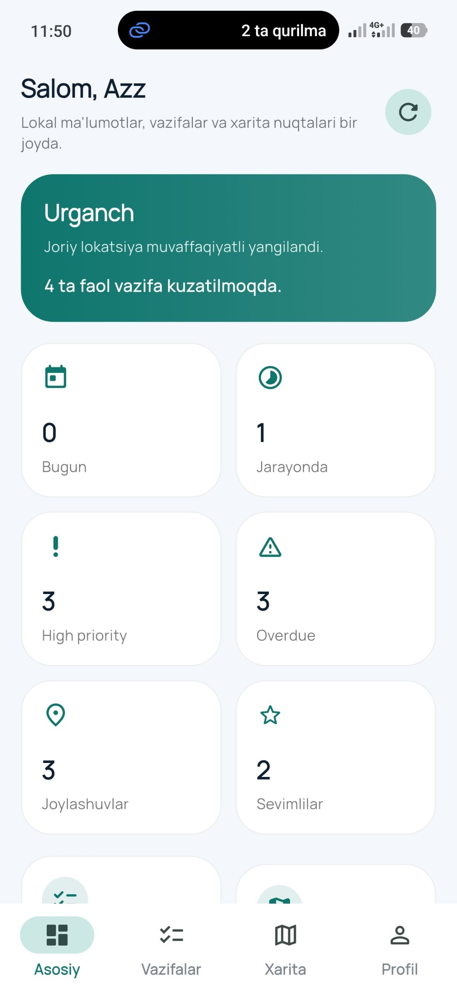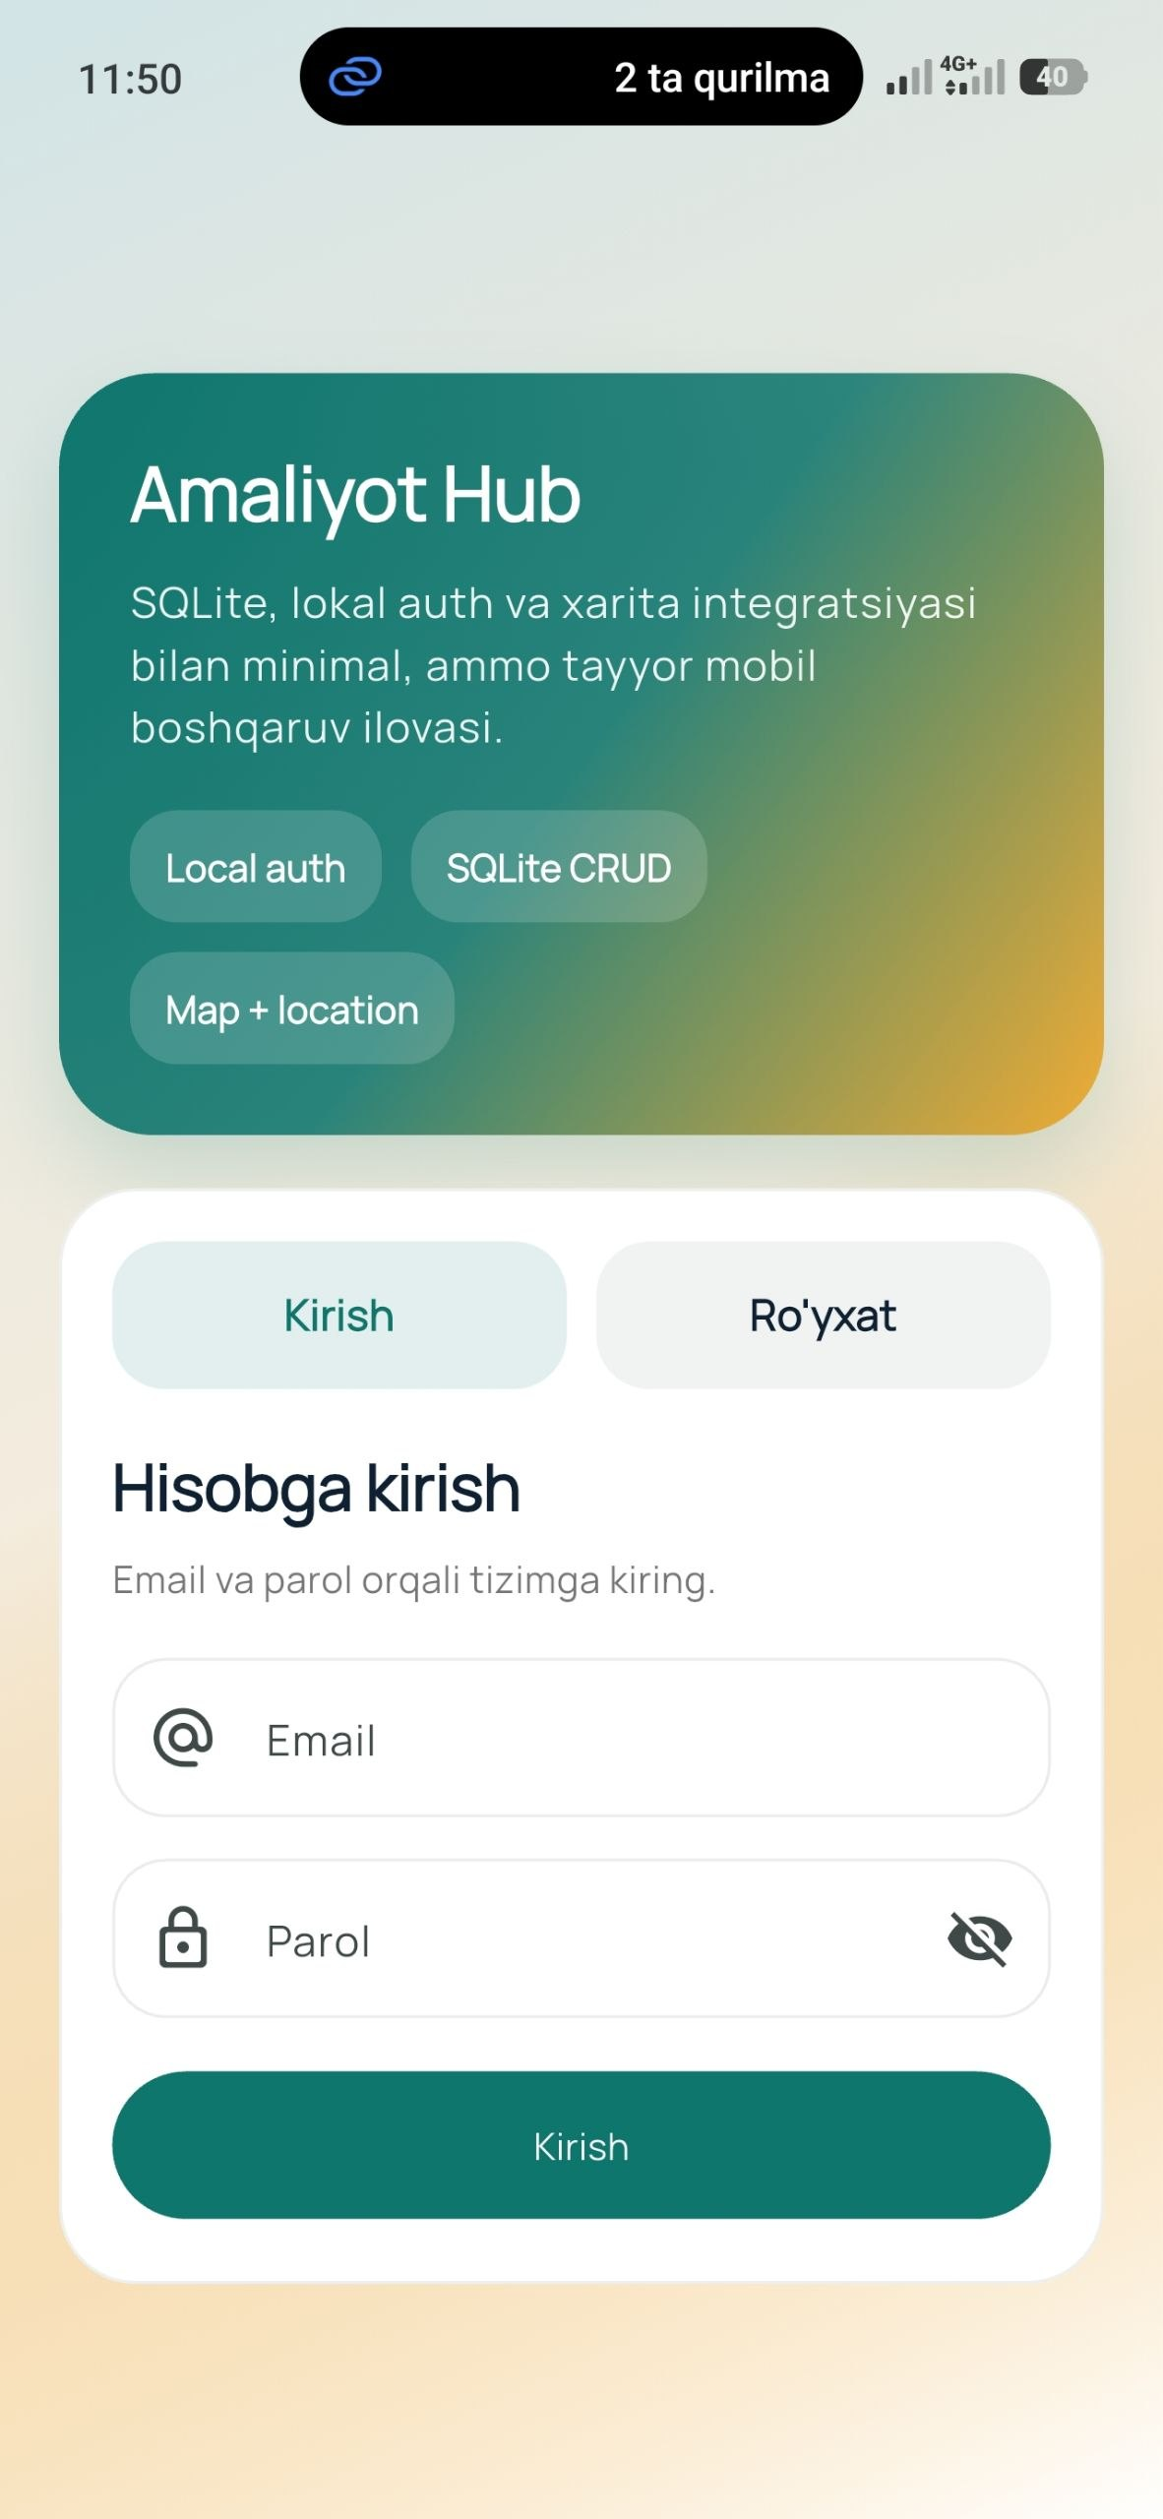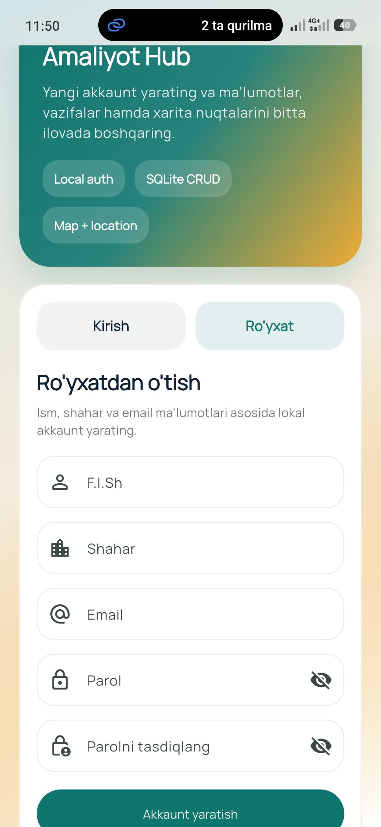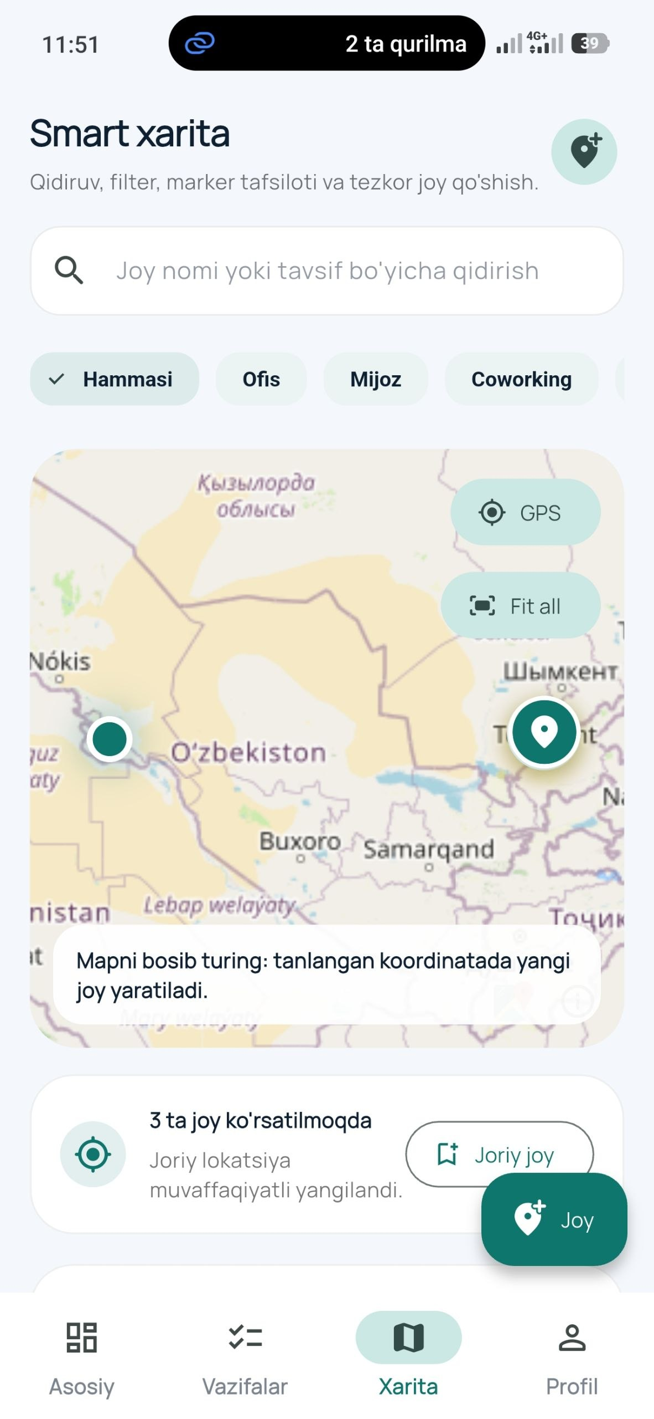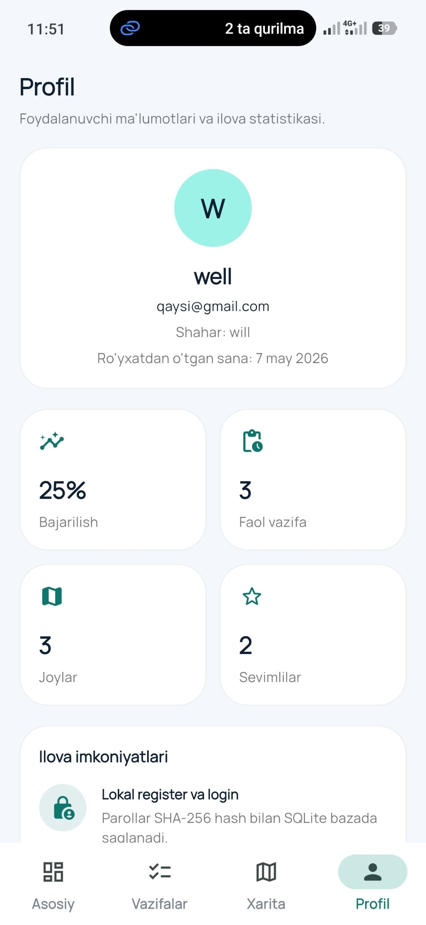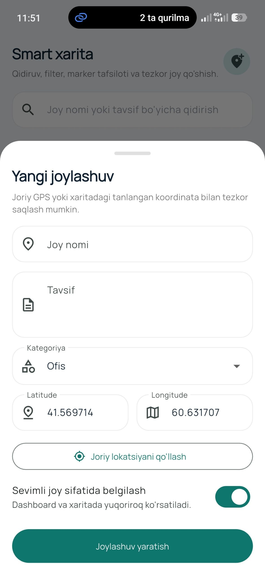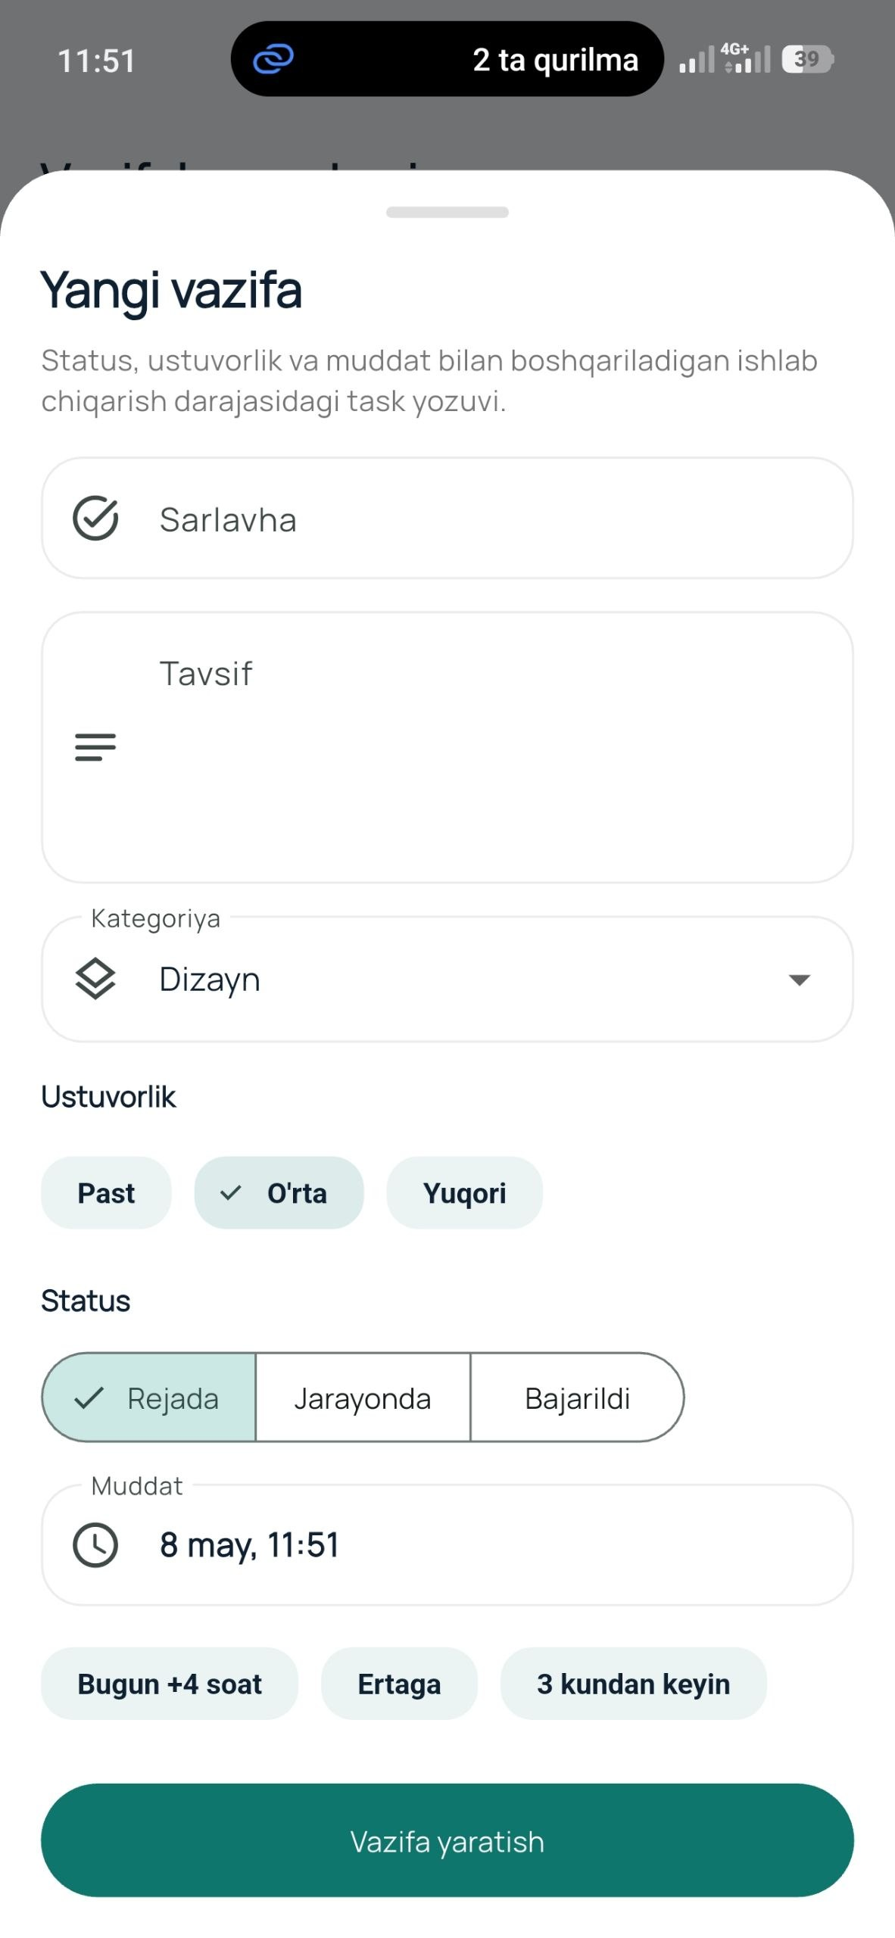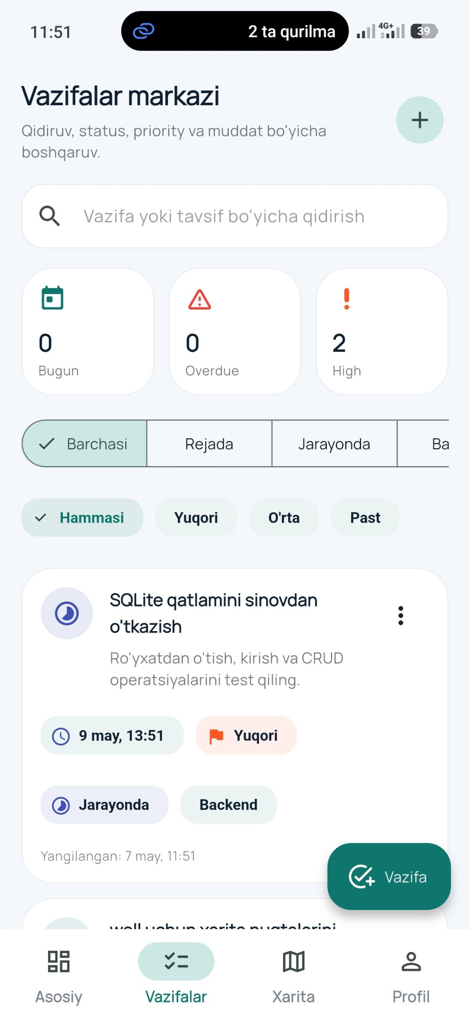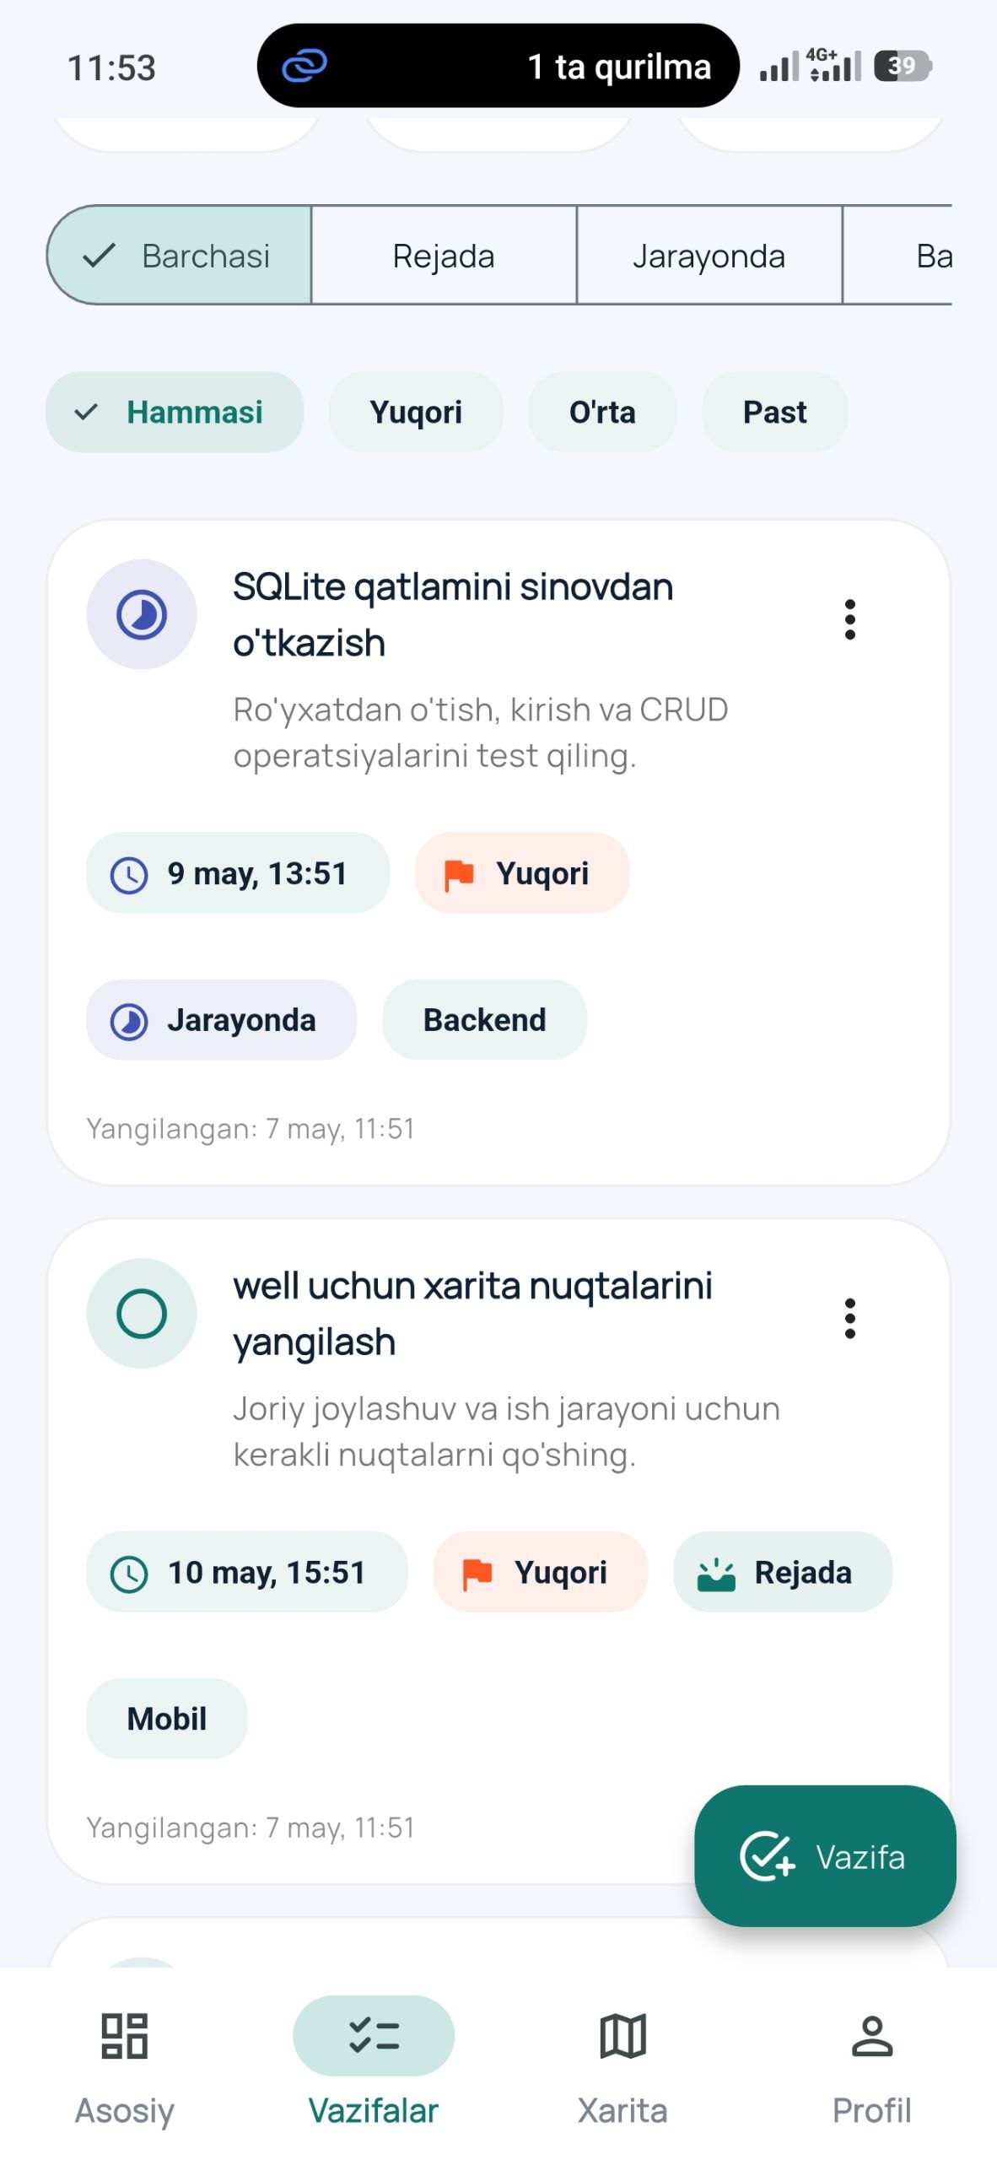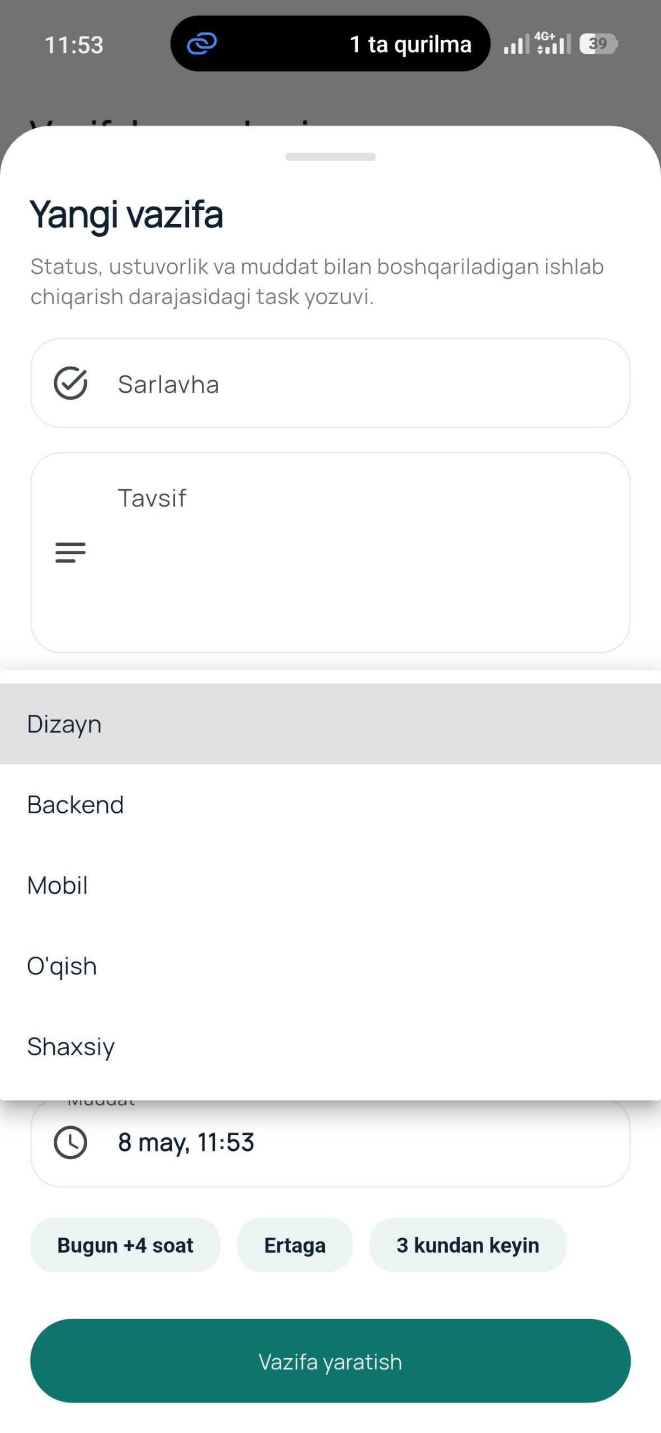

import 'package:latlong2/latlong.dart';

class AppConstants {
const AppConstants._();

static const String appName = 'Amaliyot Hub';
static const LatLng defaultCenter = LatLng(41.311081, 69.240562);

static const List<String> taskCategories = [
'Dizayn',
'Backend',
'Mobil',
'O\'qish',
'Shaxsiy',
];

static const List<String> placeCategories = [
'Ofis',
'Mijoz',
'Coworking',
'Ta\'lim',
'Shaxsiy',
];
}

import 'package:flutter/foundation.dart';

import '../data/models/app_user.dart';
import '../data/repositories/auth_repository.dart';

class AuthController extends ChangeNotifier {
AuthController({required this.authRepository});

final AuthRepository authRepository;

AppUser? _currentUser;
bool _isBusy = false;
bool _isInitializing = true;
String? _errorMessage;

AppUser? get currentUser => _currentUser;
bool get isBusy => _isBusy;
bool get isInitializing => _isInitializing;
bool get isAuthenticated => _currentUser != null;
String? get errorMessage => _errorMessage;

Future<void> initialize() async {
_currentUser = await authRepository.restoreSession();
_isInitializing = false;
notifyListeners();
}

Future<bool> login({required String email, required String password}) async {
_setBusy(true);
_errorMessage = null;

try {
_currentUser = await authRepository.login(
email: email,
password: password,
);
return true;
} on AuthFailure catch (error) {
_errorMessage = error.message;
return false;
} catch (_) {
_errorMessage = 'Kirish jarayonida xatolik yuz berdi.';
return false;
} finally {
_setBusy(false);
}
}

Future<bool> register({
required String fullName,
required String email,
required String city,
required String password,
}) async {
_setBusy(true);
_errorMessage = null;

try {
_currentUser = await authRepository.register(
fullName: fullName,
email: email,
city: city,
password: password,
);
return true;
} on AuthFailure catch (error) {
_errorMessage = error.message;
return false;
} catch (_) {
_errorMessage = 'Ro\'yxatdan o\'tishda xatolik yuz berdi.';
return false;
} finally {
_setBusy(false);
}
}

Future<void> logout() async {
_setBusy(true);
_errorMessage = null;

try {
await authRepository.logout();
_currentUser = null;
} finally {
_setBusy(false);
}
}

void clearError() {
_errorMessage = null;
notifyListeners();
}

void _setBusy(bool value) {
_isBusy = value;
notifyListeners();
}
}

