- 解压EZVideoTalkDemo.zip
- 打开EZVideoTalkDemo/test/iOS/EZBAVDemo/EZBAVDemo.xcodeproj工程
- 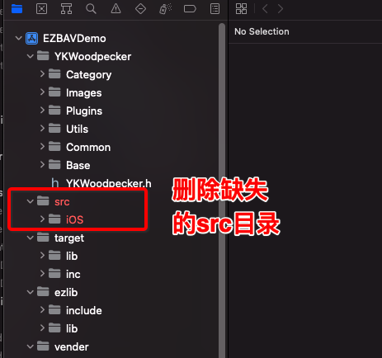
- 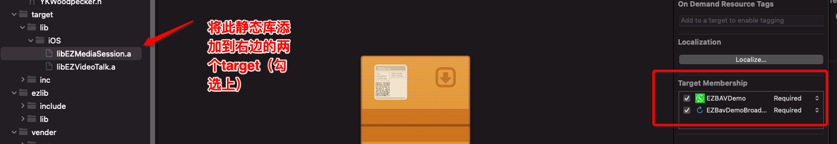
- 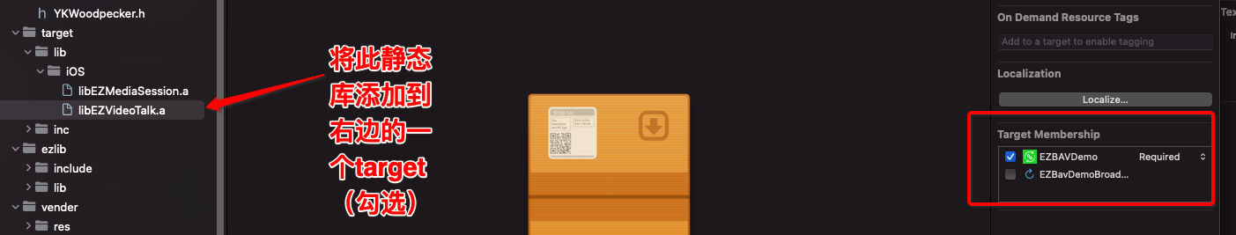
- 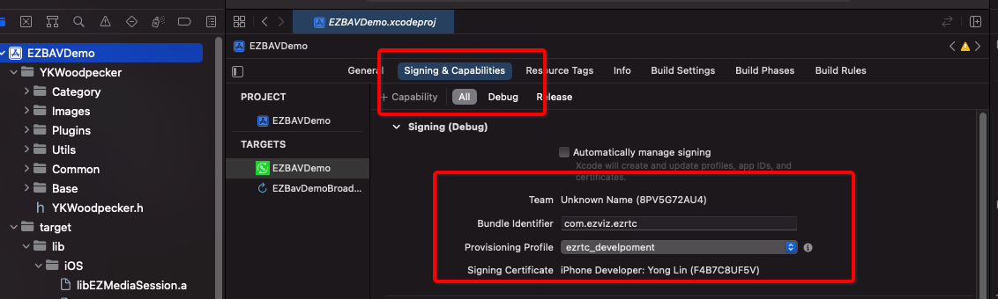
- 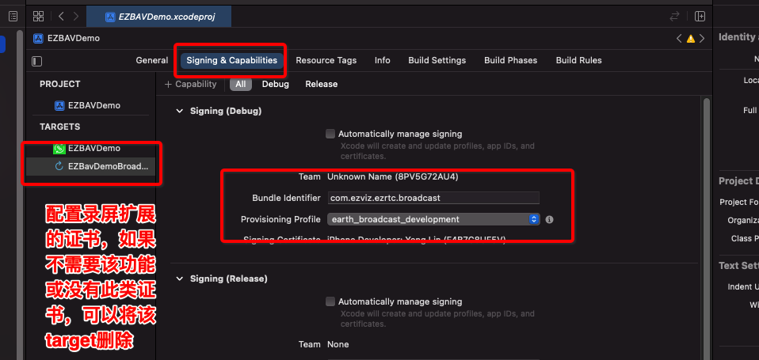
- 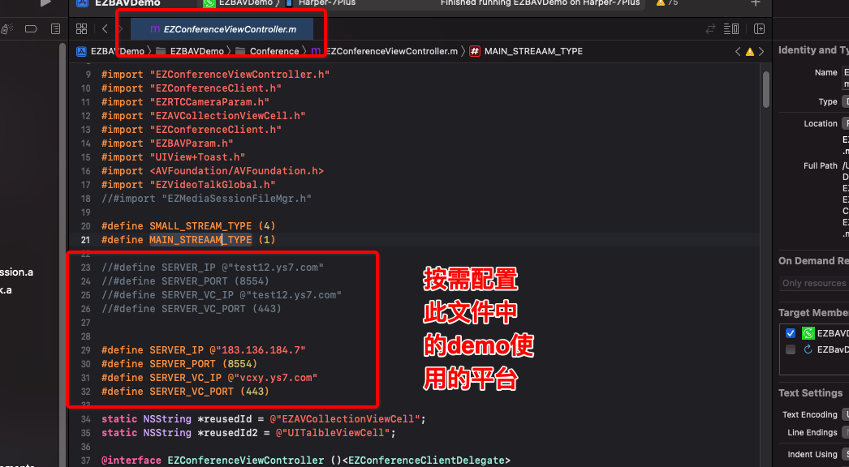
- 运行程序

