Name: Mai Ngoc Diem My
Course: Web authoring

CTS1831C Homework 3
Cascading Style Sheets (1)
2. Nextweinvestigatesizeunitsinthecontextofdivisions.
- Open a text editor and enter/copy the following HTML markup:
- Save the HTML markup to a file name page03B.html in your practice directory.
- Open the file In a web browser
- You should see four coloured rectangles plusatable within formation about theorientation, width and height of the browser window. Inside each rectangle you see what size units were used to set the dimensions of the rectangle. The bottom two rectangles (blue and orange) should be wider than the top two rectangles (yellow and red).
- The red rectangle is 1 CSS inch wide and 1 CSS inch high. Does that correspond to 1 ‘real’ inch in width and height? If not, why not? If you could figure out what the pixel density of your monitor is, you might be able to figure out why the dimensions of the rectangle are what they are.
- An inch (in) in CSS is not always equal to an real inch in width and height on the screen. According to the CSS specification, one inch make up 96 pixels. This measurement is absolute and is unaffected by the size or resolution of the user's screen.
- Nevertheless, a number of variables, such as screen size, resolution, and pixel density (also known as DPI or PPI), can affect how big a `1in} by {1in} square appears on a screen. A (1in) by (1in) square, for instance, may be less than a physical inch on a standard desktop display, but larger on a high-resolution mobile device.

- For dimensions of the bottom two rectangles, relative units have been used. Resize the browser window and see how the width and height of these two boxes changes.
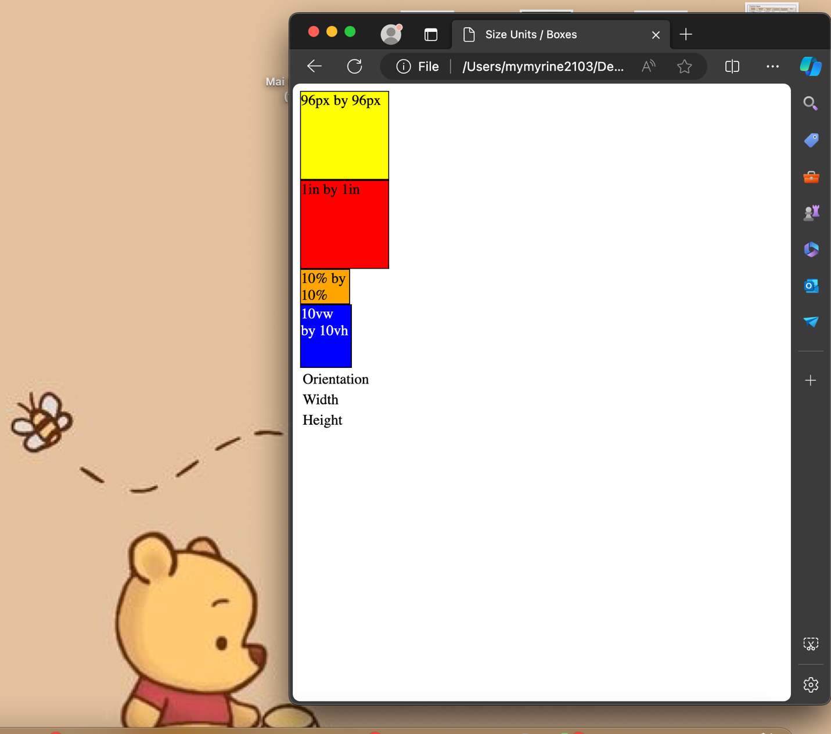
- The width of the blue rectangle is ‘10vw’, that is, 10% of the viewport width while the width of the orange rectangle is ‘10%’, that is, 10% of the width of the surrounding block. If you look carefully you see that the blue rectangle is slightly wider than the orange rectangle. Use the inspect functionality of your web browser to verify that this is true. Why is that? What is the ‘surrounding block’ of the orange rectangle and why is it slighly narrower than the viewport?

- In the case of the orange rectangle, the surrounding block is the <body> element, because the <div> for the orange rectangle is directly inside the <body>. The orange rectangle is defined with a width and height of 10%. This means it will be 10% of the width and height of its surrounding block, which is the <body>.
- The reason why the orange rectangle might appear slightly narrower than the viewport is due to the default margin and padding values that browsers apply to the <body> element. These default styles can cause the <body> to be slightly smaller than the viewport, and since the size of the orange rectangle is based on the size of the <body>, it will also be slightly smaller.

- The height of the blue rectangle is‘10vh’, that is, 10% of the viewport height while the height of the orange rectangle is ‘10%, that is, 10% of the height of the surrounding block. Why does that not seem to work? Refer to [6] for an explanation.
- The difference between 10vh (used for the blue rectangle) and 10% (used for the orange rectangle) lies in what they are relative to.
- 10vh means 10% of the viewport height. The viewport is the visible area of the webpage on screen. So, regardless of the size of the surrounding block, 10vh will always be 10% of the height of the viewport.
- 10%, on the other hand, is relative to the size of the surrounding block (in this case, the <body> element). If the height of the <body> is not explicitly set, it will be as tall as the content it contains. Therefore, if the content does not fill the entire height of the viewport, 10% of the <body> height will be less than 10vh.
- In this case, if the orange rectangle doesn’t seem to be 10% of the viewport height, it’s likely because the <body> element is not filling the entire height of the viewport.

- If possible, open the web page in a web browser on a smartphone. Change the orientation of the smartphone from landscape to portrait. Do the yellow and the red rectangle stay the same in visual size? Look at the window width and height reported at the bottom of the page. We would expect that when you change the orientation from landscape to portrait then width and height just swap. Is this so? Does that help to explain what is going on? Try to modify page03B.html so that changing the orientation of the smartphone does not change the size of the yellow and the red rectangle. Refer to the notes for Lecture 5 for a solution.

- To prevent the size of the yellow and red rectangles from changing when the orientation of the smartphone changes, I use CSS pixels (px) to specify their sizes. Because px is an absolute unit in CSS, and it does not change with the orientation of the device.

