Name: Mai Ngoc Diem My
Course: Web authoring

2. Let us now consider the overall layout of a web page.
- Open a text editor and enter/copy the following HTML markup:
- SavetheHTMLmarkuptoafilenamepage04B.htmlinyourdirectory.
- Open the file page04B.html in a web browser, open the URL
- You should see three rectangles, blue, green, and blue. Use the inspect functionality of the web browser to figure out which parts of the HTML markup these rectangles correspond to.
Green and blue rectangles are different sections of the webpage defined by the CSS Grid layout:
- Green is the navigation (nav) area of the webpage.
- Blue are the header and footer areas of the webpage.

- Resize the browser window horizontally and see how the rectangles behave.
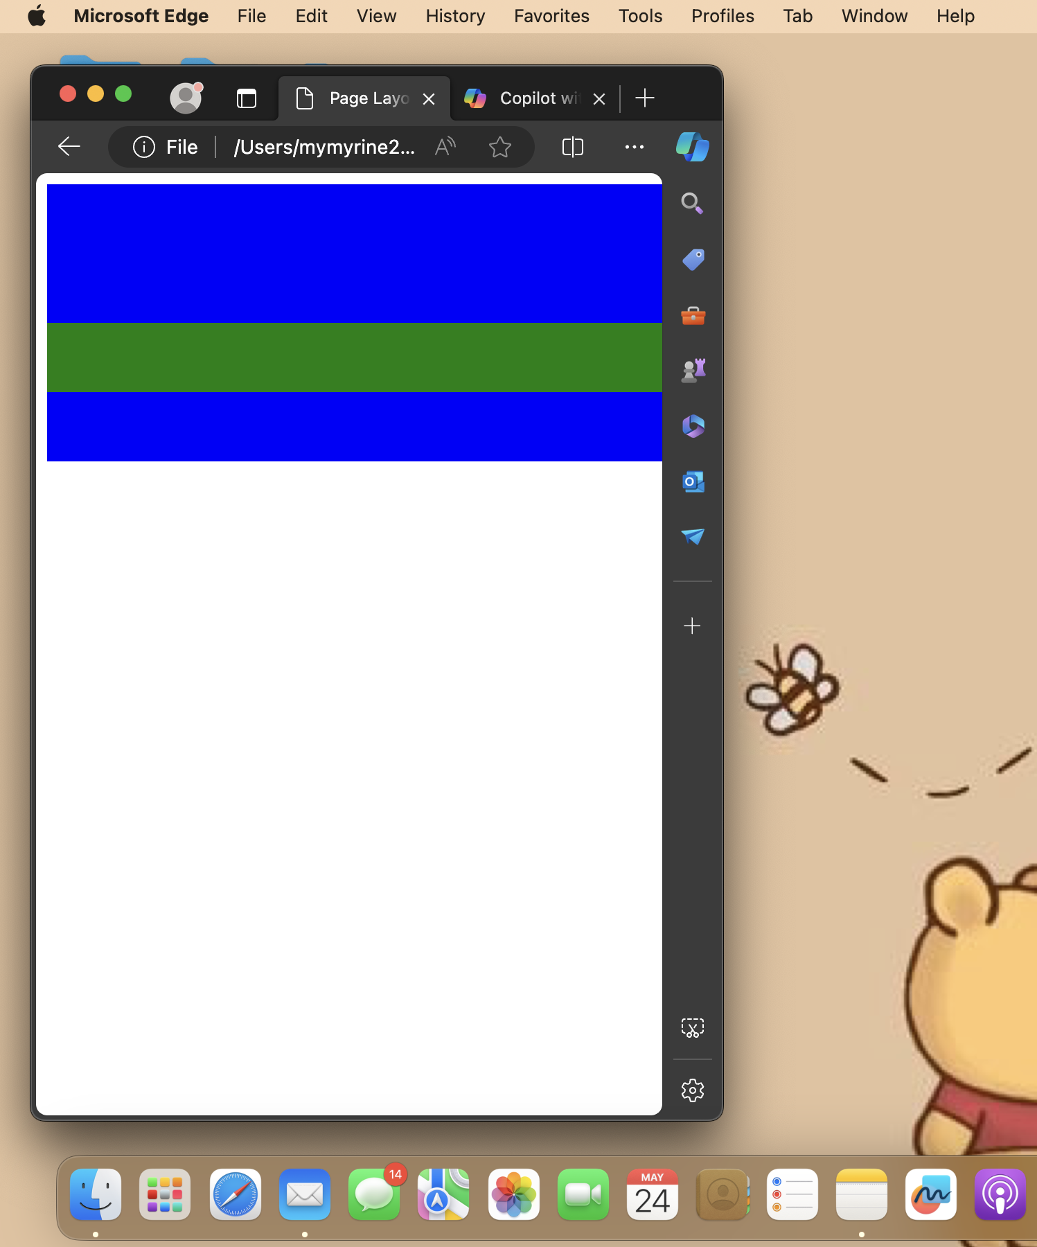
- According to the HTML markup, there should also be a yellow rectangle for content and an orange rectangle for ads. Why are they not visible?
- The yellow rectangle for content and the orange rectangle for ads are not visible because there is no content inside these elements in your HTML code. The <section> and <aside> tags, which are meant to contain the main content and ads respectively, are empty.
- Add some arbitrary text to the section element and the aside element of the HTML markup. What effect does that have?

- It visible when I add some content:
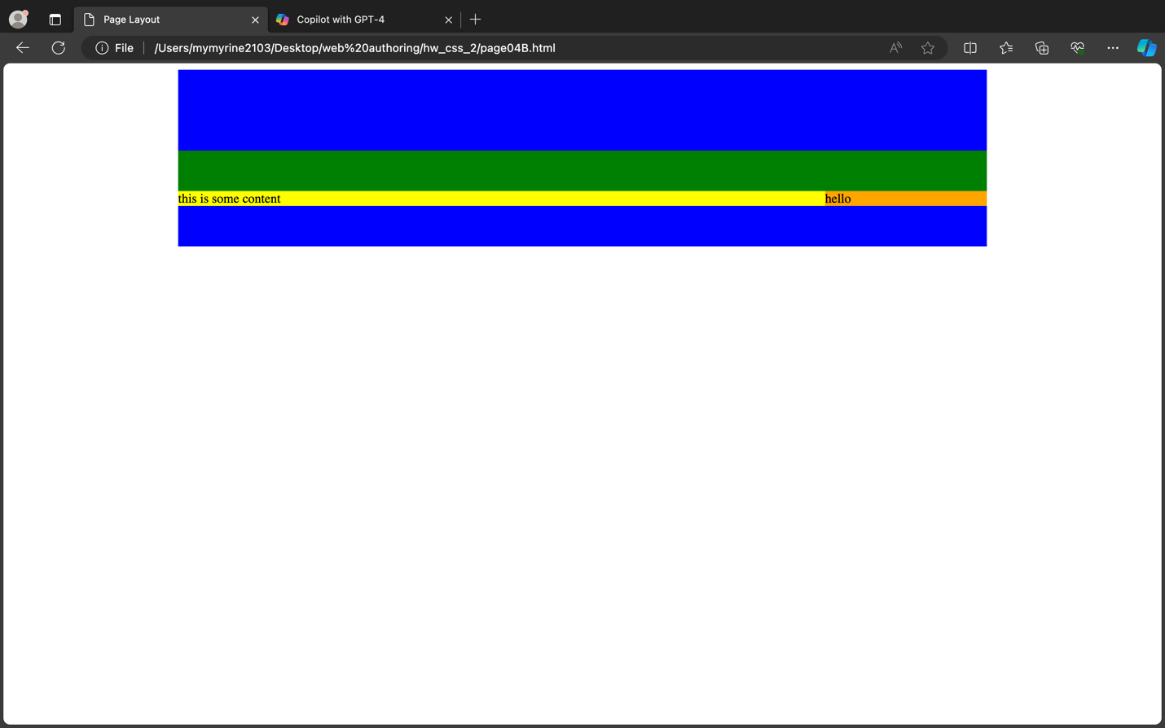

3. Thepagelayoutinthepreviousexerciseusedacontentareaoffixedsize,quiteacommonlayout on the web. However, such a layout is problematic for users of mobile devices. A more responsive layout would better cater for such users.
- In a web brower, open the URL
- Notethatinthefooterofthepagethereisinformationaboutthescreenorientation,screen width and window width.
- Resize the width of web browser window so that it fits the width of of your screen. Then resize the width of the web browser window so that is half the width of your screen or less. See what the effect on the layout of the HTML document is. If there appears to be no effect, reload the HTML document after resizing the window. Take note of the information in the footer.
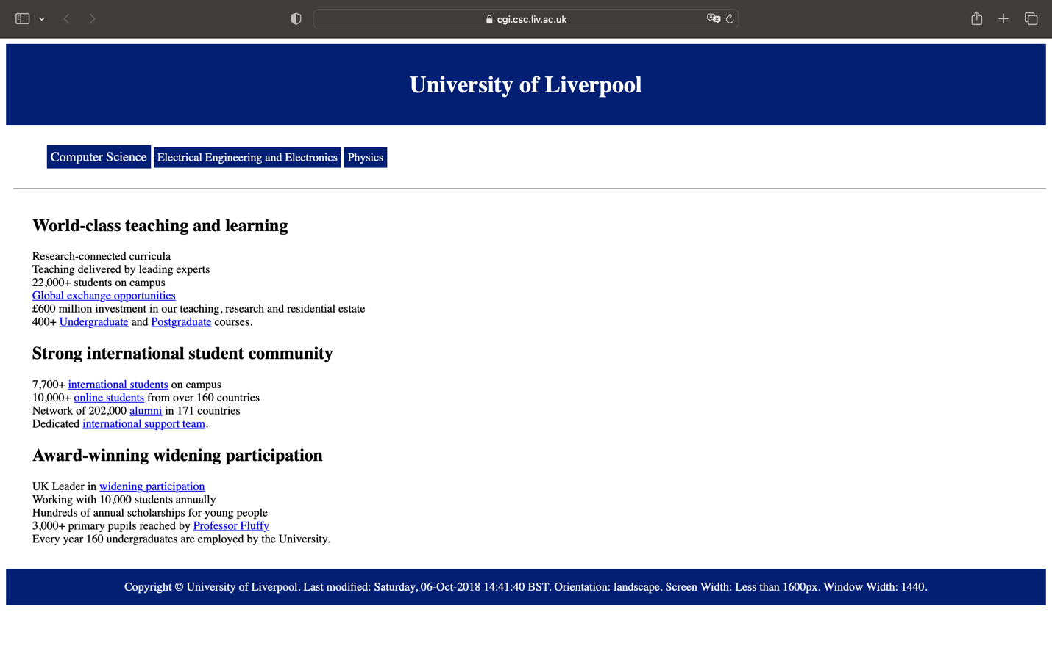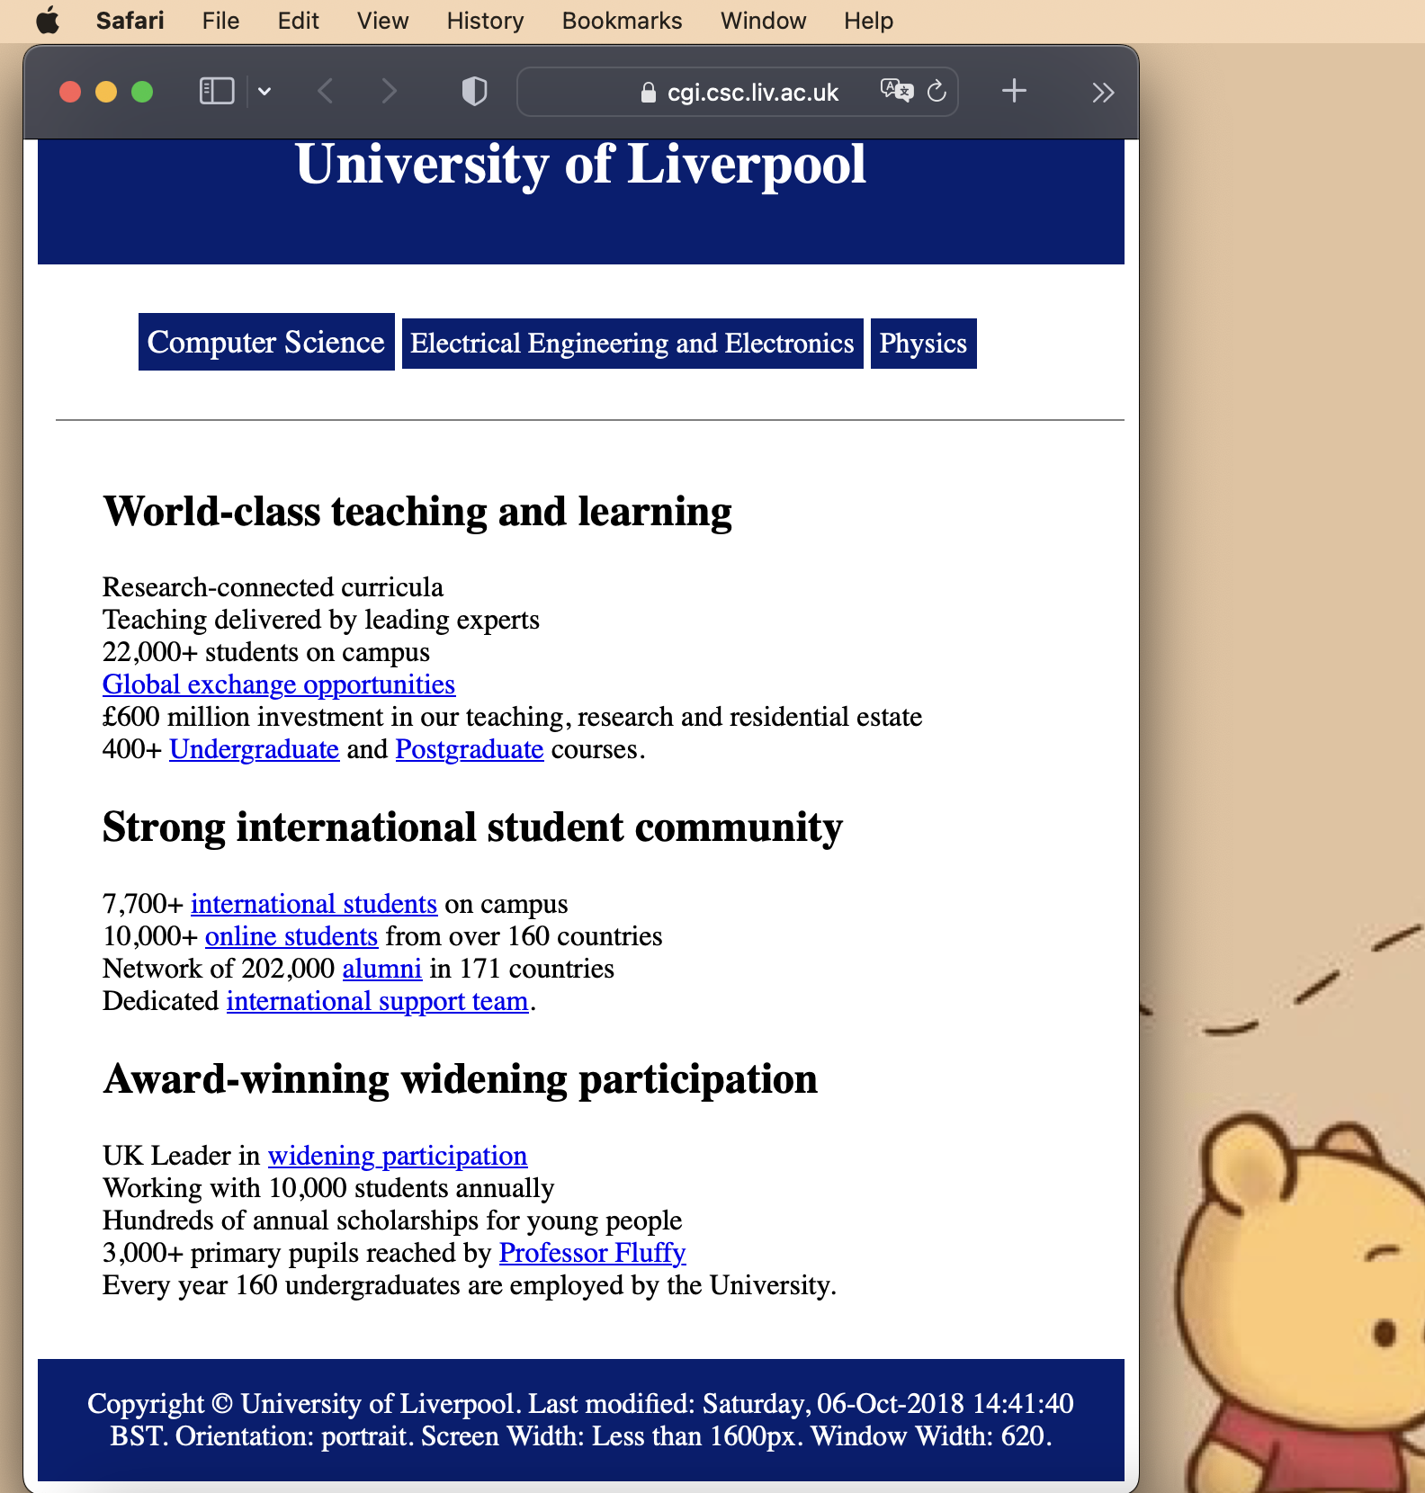
- If possible, open the web page in a web browser on a smartphone. Change the orientation of the smartphone from portrait to landscape. See if there is any effect on the layout of the HTML document. Take note of the information in the footer.
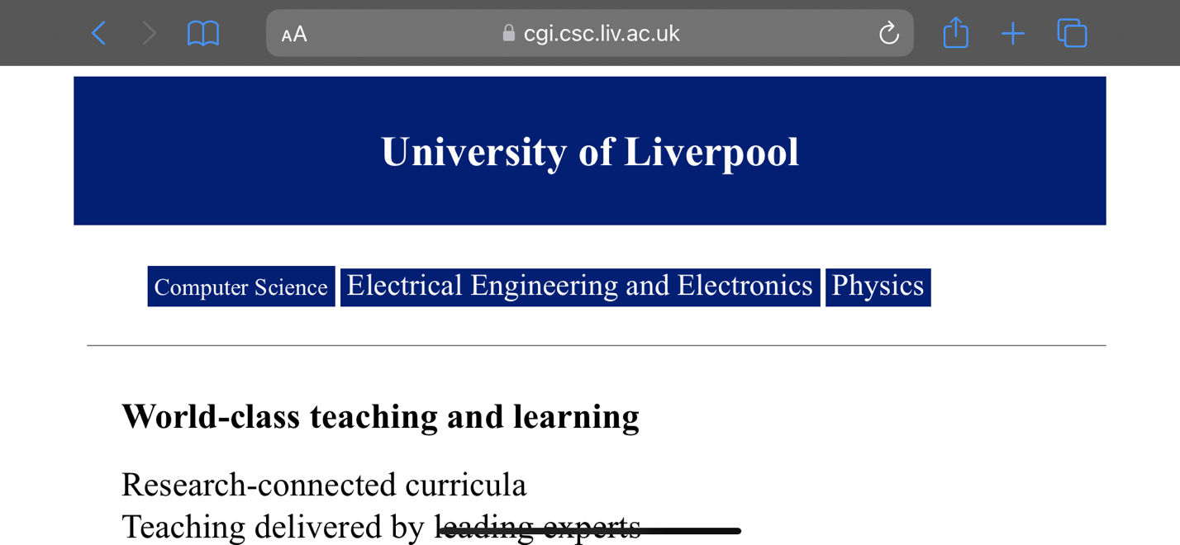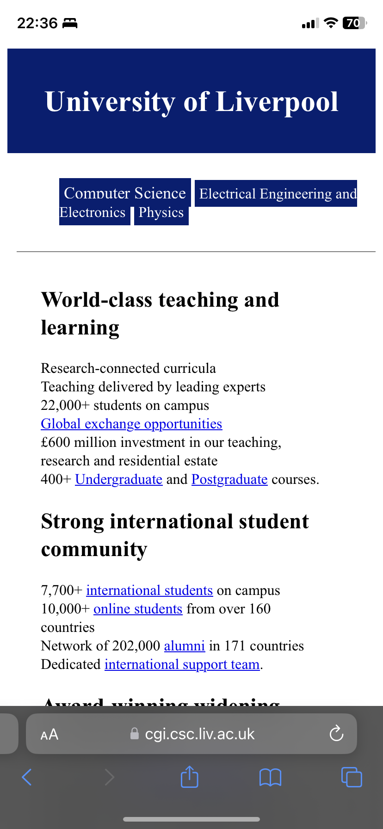
- Look at the HTML markup of the document and use the inspect functionality of your web browser to figure out how the changes to the layout are achieved.
- It used media=”screen… to change the layout when the size of screen is changed.
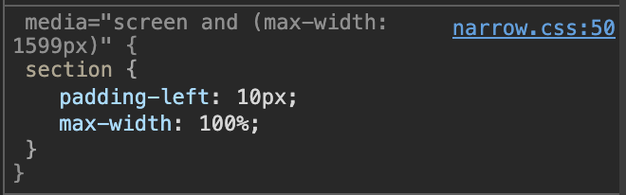
- Copy the files uol.html, wide.css, narrow.css to your own public_html directory. Make sure that you set the file permissions of the copied files correctly.
- The visual design of the navigation bar is suboptimal: Once the window width is such that narrow.css applies, the three entries of the navigation bar are shown side by side, even if there is not enough space to properly fit them. Modify the visual design so that the entries of the navigation bar are arranged vertically if the window width gets too narrow.
Test your solution also on a smartphone.

