Divine Word College of Legazpi
School of Engineering and Computer Sciences
Department of Computer Sciences and Information Technology
AY 2025-2026, 2nd Semester

Evaluation of Artificial Intelligence tools on IT and CS
Students in Divine Word College of Legazpi

In partial fulfillment
Of the requirements in
IT PC 221: Quantitative Methods

ADANTE, Sean Jairus Cardel
DEXISNE, Ronnie Bermejo
LISAY, Alex Bio
PLANDANO, Lionele De Mesa

May 19, 2026
1.0 INTRODUCTION
Artificial Intelligence (AI) continues to transform different sectors of society, including education. As technology advances, AI tools are becoming more accessible to students and educators, especially in technology-related programs such as Information Technology (IT) and Computer Science (CS). These tools are increasingly used to assist in academic tasks, programming activities, and learning processes. Because of the growing influence of AI in education, it is important to examine how these technologies affect students’ learning experiences and academic performance.
Background and Rationale of the Study
In 2026, Artificial Intelligence (AI) has become widely used in education, particularly among IT and CS students. AI-powered tools such as large language models, code generators, and virtual assistants are commonly used to help students write code, debug programs, generate ideas, answer academic questions, and complete school-related tasks more efficiently. These technologies have become increasingly accessible and are now considered part of many students’ daily academic activities.
At Divine Word College of Legazpi, IT and CS students are among the groups most exposed to AI technologies due to the nature of their courses and their frequent use of computers and digital tools. Many students use AI applications to support programming activities, understand difficult concepts, and improve productivity in completing projects and assignments. Because of this growing dependence on AI, it becomes important to examine how these tools influence students’ learning experiences and academic development.
Although AI tools provide convenience and efficiency, concerns have also emerged regarding their possible negative effects on students. Some students may become overly dependent on AI-generated responses instead of developing their own understanding, analytical thinking, and problem-solving abilities. Excessive reliance on AI may reduce opportunities for independent learning, creativity, and critical thinking. In addition, issues related to academic integrity, originality of work, and ethical use of AI continue to be discussed in educational institutions.
This study is conducted to evaluate the use of AI tools among IT and CS students at DWCL and to determine whether these technologies genuinely support students’ learning and academic performance. Specifically, the researchers aim to investigate the effects of AI tools on students’ critical thinking, problem-solving skills, productivity, and overall academic experience.
The findings of this study may provide valuable insights for teachers, students, and academic institutions regarding the responsible and effective integration of AI in education. The results may help educators develop appropriate guidelines and strategies concerning the use of AI tools inside and outside the classroom. Ultimately, this research aims to contribute to a better understanding of how AI technologies affect the learning process of IT and CS students and whether these tools should be encouraged, regulated, or balanced to ensure the continuous development of students’ independent thinking and technical skills.
OBJECTIVES
General Objectives:
To find out how artificial intelligence affects IT student’s learning
Specific Objectives:
- To determine how IT students use artificial intelligence in their studies.
- To identify the effects of artificial intelligence on students’ learning.
- To examine how artificial intelligence influences students’ critical thinking and problem-solving skills.
- To evaluate the impact of artificial intelligence on students’ academic performance.
  - RESEARCH PROBLEMS/QUESTION
1. How does the use of AI tools influence the learning experience of IT students in college?
2. How frequently do IT students use AI tools for academic purpose?
3. What are the perceived benefits of using AI in learning among IT students?
4. Does the use of AI improve academic performance or understanding of IT subjects?
  - RELATED STUDIES
Artificial Intelligence (AI) has become an important part of modern computer science education due to its growing applications across different industries. As demand for AI-related skills increases, students are expected to develop strong competencies in understanding and applying AI concepts. However, learning AI can be challenging due to its complexity, which may affect students’ motivation and learning experience.
Motivation is an important factor in student success, especially in difficult subjects. According to learning theories, students become more engaged when they experience meaningful, hands-on, and interactive learning activities. Effective teaching strategies such as collaborative learning, problem-based learning, and guided instruction can also improve understanding and engagement.
Studies show that students generally have a positive perception of AI and recognize its importance for future careers. However, some still lack confidence in their skills and understanding of AI concepts. This highlights the need for supportive and inclusive learning environments that enhance students’ critical thinking, computational skills, and problem-solving abilities, which are essential in AI education.
A study conducted by Nurjanah et al. (2024) examined the implementation of Artificial Intelligence (AI) in the teaching and learning process. The research highlights that AI has become an important innovation in education due to its ability to simulate human intelligence functions such as thinking, learning from experience, and problem-solving. The study explains that AI can significantly improve the learning experience by personalizing educational materials based on students’ needs and abilities.
Furthermore, the findings show that the integration of AI in education enhances teaching efficiency and supports more adaptive and student-centered learning environments. Teachers benefit from improved instructional tools, while students experience more tailored and effective learning support. The study concludes that AI has strong potential to transform modern education by increasing both learning quality and accessibility.
Yim and Su (2024) conducted a scoping review on the use of Artificial Intelligence (AI) learning tools in K–12 education. The study found that AI tools such as Google Teachable Machine, Scratch, and Machine Learning for Kids are increasingly used in classrooms to support learning. These tools are often applied through project-based and interactive learning approaches.
The findings show that AI-based learning improves students’ understanding, engagement, and development of problem-solving and collaboration skills. The study also highlights that these tools can be effective across different educational levels when properly designed for learners.
A study by De Leon et al. (2025) titled “The Future of Education: Factors Affecting Students’ Perception of the Usefulness of AI Tools in Education” examined the factors influencing students’ perception of the usefulness of artificial intelligence (AI) tools in academic settings. The study revealed that students’ perception of AI tools is significantly affected by their level of AI literacy, where students with higher understanding and familiarity with AI tend to perceive these tools as more useful for academic tasks such as learning support, problem-solving, and information processing. The findings also emphasized that perceived usefulness plays a crucial role in students’ acceptance and continued use of AI-based tools in education. This study is relevant to the present research as it provides insights into how IT and CS students may evaluate AI tools based on their knowledge, experience, and perceived benefits in academic performance and learning efficiency.
A study conducted by Fabia et al. (2025) entitled “How AI Tools are Accepted and Utilized in Academia: A Mixed Methods Study” examined the factors influencing the acceptance and utilization of artificial intelligence (AI) tools among students and academic staff in a higher education institution in the Philippines. The study utilized the Unified Theory of Acceptance and Use of Technology (UTAUT) model and revealed that performance expectancy and facilitating conditions are the primary drivers of AI tool acceptance in academic settings. Findings also showed that both students and staff demonstrate high familiarity with AI tools and commonly use them for academic tasks such as learning support, research assistance, and content generation. However, the study highlighted concerns regarding data privacy, ethical use, and institutional readiness, emphasizing the need for transparent AI governance and proper guidelines in educational environments. This study is relevant to the present research as it provides a localized perspective on AI tool adoption in Philippine higher education and supports the evaluation of AI tools among IT and CS students in terms of usefulness, acceptance, and usage behavior.
  - VARIABLES
- AI TOOLS (Independent Variable)
Conceptual Definition: AI Tools refer to software applications and platforms that utilize artificial intelligence, machine learning, and natural language processing to perform tasks traditionally requiring human intelligence. In an educational context, this includes generative AI and automated programming assistants.
Operational Definition: In this study, AI Tools are defined as the specific software used by DWCL students for academic purposes, specifically ChatGPT, GitHub Copilot, and Claude. These will be measured based on the frequency of use and the types of tasks performed (e.g., debugging, code generation, or concept explanation).
- STUDENT’S LEARNING OUTCOMES / EVALUATION ( Dependent Variable)
Conceptual Definition: Students’ learning outcomes refer to the knowledge, skills, academic performance, and perceived effectiveness gained by IT and CS students as a result of their learning experiences.
Operational Definition: In this study, students’ learning outcomes will be assessed through self-reported academic improvement, understanding of programming concepts, problem-solving ability, productivity in completing tasks, and their perception of the usefulness of artificial intelligence tools. These indicators will be measured using a structured survey questionnaire employing Likert scale items ranging from Strongly Disagree to Strongly Agree. The instrument will include statements such as “AI tools help me understand programming better” and “Using AI improves my productivity,”
allowing respondents to indicate the extent to which they agree based on their experiences.
2.0 METHODOLOGY
2.1. Research design
This study will use a descriptive survey research design to evaluate the impact Artificial intelligence in Information Technology (IT) and Computer Science (CS) students in Divine World College of Legazpi. This design is appropriate for the study as it allows the researchers to gather, analyze, and interpret data regarding the students’ experience, perceptions, and usage of artificial intelligence in their academic activities.
2.2 Participants
The target participants of this study are Information Technology (IT) and Computer Science (CS) students from all year levels at Divine Word College of Legazpi. These participants were chosen because they are directly engaged in technology-related courses and are more likely to encounter and use artificial intelligence tools as part of their academic activities. The study uses a convenience sampling method, where respondents are selected based on their availability and willingness to participate. This method is appropriate for the study as it allows the researchers to easily gather data from accessible students within the institution.
A total of 102 respondents participated in this study. This number of respondents was considered sufficient to provide reliable and valid data for the research, allowing the researchers to gather meaningful insights and support the objectives of the study.
2.3. Research instrument
The research instrument used in this study is a survey questionnaire designed to collect data on students’ use of Artificial Intelligence (AI) tools and its impact on their learning and academic performance. The survey has the following parts:
1. Demographic Information: This part asks for basic information such as sex and year level
2. AI Usage: This part asks how often students use AI tools and what types of AI tools they use for studying.
3. Open-Ended Question: This part lets students share their own experiences and opinions about using AI in their studies
2.4 Analysis
The collected data will be analyzed using appropriate statistical tools such as frequency, percentage, and mean. Frequency and percentage will be primarily used to summarize the respondents’ use of artificial intelligence, including how often it is used and the types of tools utilized. The mean will be used to interpret responses from the Likert scale statements to determine the level of agreement of the participants. Responses from the open-ended question will also be analyzed using thematic analysis to identify common insights and patterns. Basic demographic data, such as sex and year level, will be presented to provide general background information about the respondents.
2.5 Data collection procedure
The data for this study were gathered through a structured process that began with formal communication with the school administration to request permission to conduct the research. A letter of approval was submitted, outlining the purpose of the study and the data collection procedures. Upon receiving approval, coordination with instructors and students was arranged to ensure proper distribution of the survey.
The primary data collection tool was a survey questionnaire administered through Google Forms. The questionnaire consisted of statements designed to measure the respondents’ perceptions and experiences regarding artificial intelligence. A Likert scale format was used, ranging from 1 (Strongly Disagree) to 5 (Strongly Agree), to quantify their responses.
During the data collection process, several challenges were encountered. These included delays in obtaining approval from the institution, limited response rates from participants, which affected access to the online survey. Despite these difficulties, follow-ups and reminders were conducted to ensure sufficient data were collected for the study.
3.0 RESULTS
Table 1. Demographic Profile of the Respondents
Sex | Frequency(f) | Percentage (%)
Male | 67 | 67.7 %
Female | 27 | 27.3%
Prefer not to say | 5 | 5.1 %
Total | 99 | 100%

Figure 1. Visual Representation of Respondent by Sex
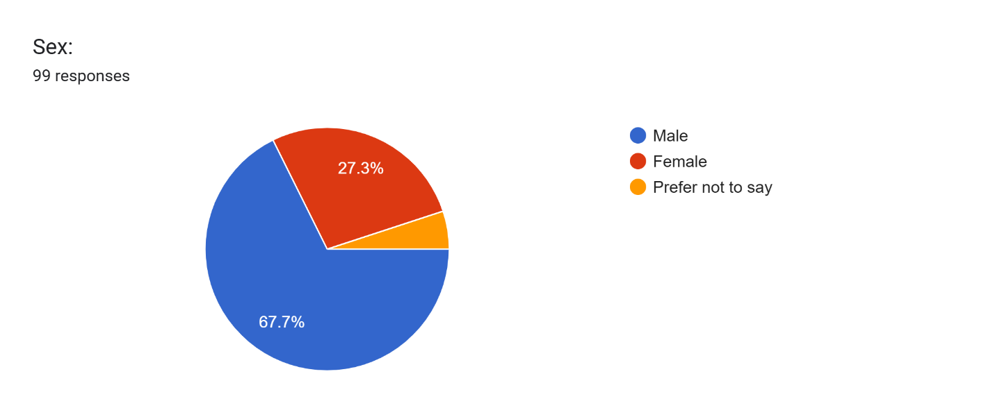
Discussion
The data shows that male respondents comprised the majority of the participants, with 67.7% identified as male, 27.3% as female, and 5.1% preferred not to disclose their sex. Out of the 102 total respondents, only 99 answered the question regarding sex. This distribution simply describes the demographic composition of the respondents involved in the study.
In the context of this research, the findings regarding the usage and perceptions of Artificial Intelligence (AI) are based on the overall responses of the participants regardless of sex. Therefore, the results represent the collective perspectives of Information Technology (IT) and Computer Science (CS) students of Divine Word College of Legazpi.
Table 2. Ai Usage Base on Frequency of Use
Frequency of use | Frequency (f) | Percentage (%)
Daily | 45 | 44.1%
Weekly | 28 | 27.5%
Rarely | 25 | 24.5%
Monthly | 2 | 2%
Never | 2 | 2%
Total | 102 | 100%

Figure 2. Visual Representation of AI Usage Among Respondents
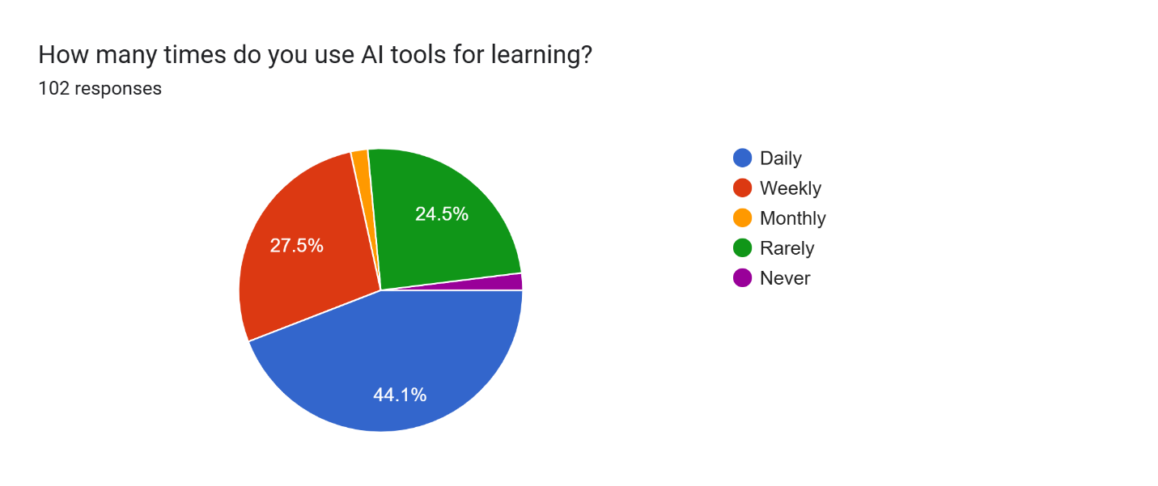

Discussion:
The data indicates a high frequency of AI tool usage among the respondents from the IT (Information Technology) and CS (Computer Science) programs of Divine Word College of Legazpi. Among the 102 respondents, 44.1% reported using AI tools daily, while 27.5% used them weekly. This means that a majority of the respondents regularly use AI tools in their academic activities, suggesting that AI has become a common and accessible resource for students.
Meanwhile, 24.5% of the respondents reported rarely using AI tools, while only 2% used them monthly and another 2% reported never using them. The low percentage of non-users indicates that most students have already experienced or utilized AI tools in some way. Overall, the findings show that AI usage is widely practiced among IT and CS students and has become part of their learning experience.
Table 3. AI Tools Used by IT and CS Students
AI Tool | Frequency (f) | Percentage (%)
ChatGPT / AI Chatbot | 86 | 84.3%
Gemini AI | 44 | 43.1%
AI Coding Assistant (GitHub Copilot, etc.) | 17 | 16.7%
AI-based Learning Platform | 15 | 14.7%
Grok AI | 9 | 8.8%
Others (Claude, DeepSeek, Windsurf, etc.) | 7 | 7.8%

Figure 3. Distribution of the AI Tools Used by Respondents
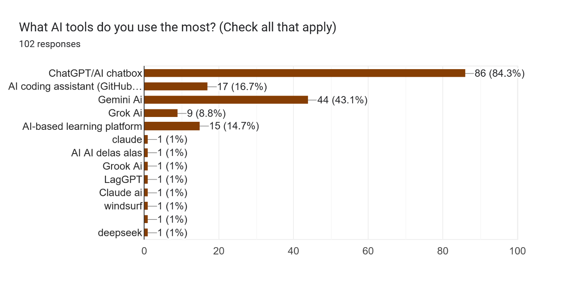
Discussion:
The results show that students mainly prefer general AI chatbots over more specialized AI tools. ChatGPT had the highest usage among respondents at 84.3%, followed by Gemini at 43.1%. This suggests that students tend to use AI tools that are flexible and capable of supporting different academic tasks such as explaining lessons, answering questions, generating ideas, and assisting with schoolwork.
AI coding assistants such as GitHub Copilot were used by only 16.7% of the respondents, while AI-based learning platforms were used by 14.7%. Grok also showed lower usage at 8.8%. These findings may indicate that students rely more on AI for general academic support and understanding rather than for specialized coding or technical development tasks.
The “Others” category, which included tools such as Claude, DeepSeek, and Windsurf, accounted for 7.8% of the responses. This shows that some students are also aware of and exploring alternative AI tools beyond the more commonly used platforms.
Table 3. Level of Agreement on the Impact of AI on Students’ Learning
Statement | Mean | Verbal Interpretation
1. AI helps me understand complex technology concepts more easily | 3.80 | Agree
2. AI saves time when completing assignments | 3.82 | Agree
3. AI improves coding/programming skills | 3.5 | Agree
4. AI helps learners learn independently without a tutor | 3.67 | Agree
5. AI responses are sometimes difficult to interpret | 3.52 | Agree
6. The information provided by AI tools is consistently accurate | 3.27 | Neutral
7. AI usage enhances personal critical thinking and problem-solving | 3.25 | Neutral
8. AI tools can be distracting during study sessions | 3.20 | Neutral
Source: Adapted from ResearchGate (2021), Mean range and interpretation of the Likert scale type.
Figure 3. Mean Scores of Students’ Agreement on the Impact of AI in Learning
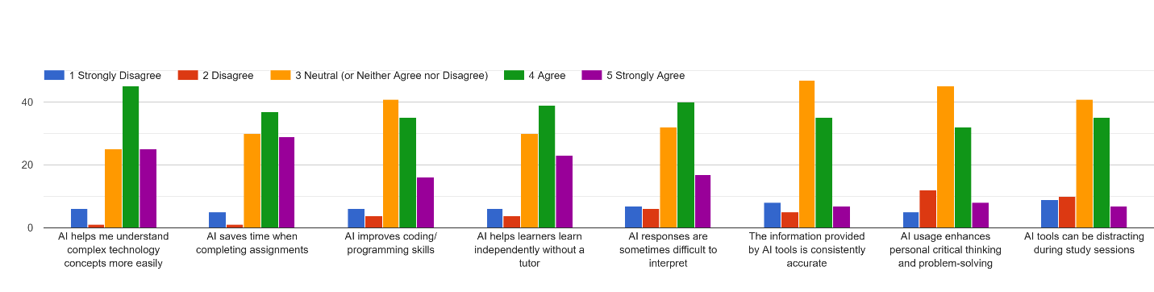
Discussion
The results indicate that students generally have a positive perception of Artificial Intelligence (AI) as a learning tool. Among the indicators, the highest mean was obtained from AI saving time when completing assignments (3.82), followed closely by helping students understand complex technology concepts (3.80). This suggests that AI is mainly valued for its ability to improve efficiency and simplify difficult academic content, making it a useful support tool in students’ learning process within Divine Word College of Legazpi.
Other items such as improving coding skills (3.50) and supporting independent learning (3.67) also received positive ratings, showing that students recognize AI’s academic benefits. However, neutral responses were recorded for its accuracy (3.27), impact on critical thinking (3.25), and distractibility (3.20), suggesting some uncertainty about its limitations. Overall, students view AI as a helpful learning tool but remain cautious about its reliability and deeper educational effects.
Table 4. Academic Impact & Ethics
Statement | Mean | Verbal Interpretation
- Overall, AI has significantly improved academic performance | 3.5 | Agree
- Ai raises ethical concerns, including plagiarism and bias | 3.31 | Neutral
- Integrating AI into IT education is essential for preparing students for future careers | 3.50 | Agree
Source: Adapted from ResearchGate (2021), Mean range and interpretation of the Likert scale type.

Figure 4 Mean Scores of Academic Impact & Ethics
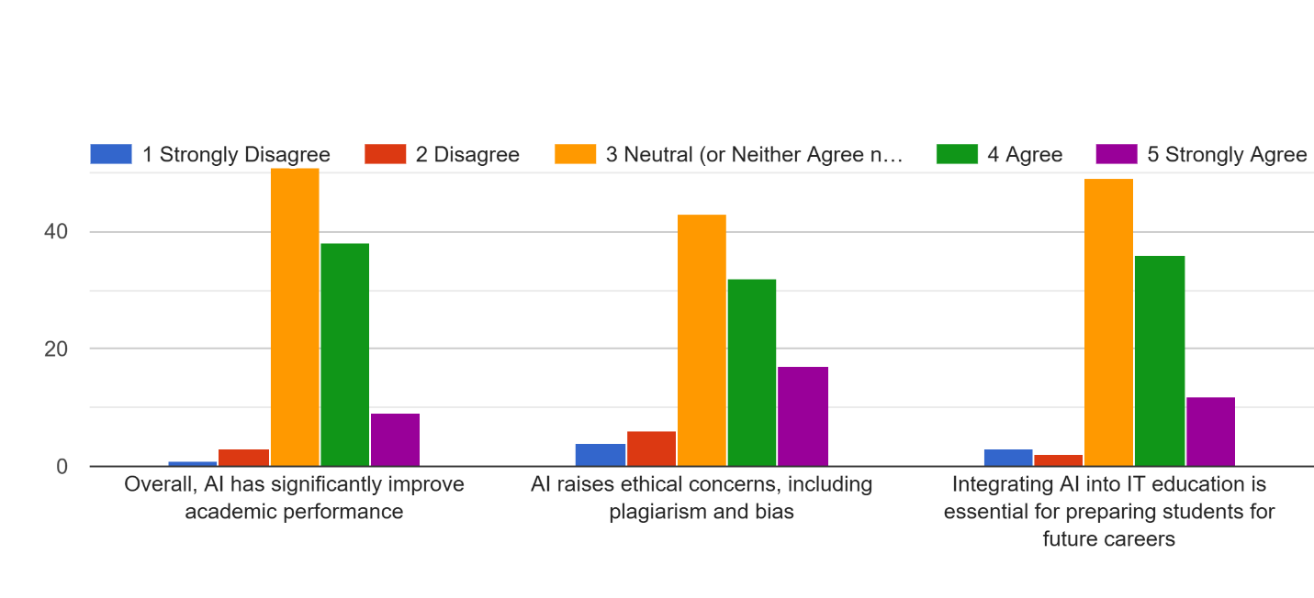
Discussion:
The results show that students generally have a positive perception of AI in terms of academic impact and its role in education. The statements on AI significantly improving academic performance (3.5) and integrating AI into IT education being essential for future careers (3.50) were both rated as “Agree,” indicating that students recognize AI as a useful tool for learning and career preparation within Divine Word College of Legazpi.
The statement on ethical concerns such as plagiarism and bias (3.31) was rated as “Neutral,” suggesting that students are still uncertain about the ethical implications of AI use. Overall, the findings suggest that students see AI as beneficial for education while also acknowledging the need for responsible use.

Thematic Analysis of Open-ended Question:
How has AI helped you the most in your IT studies?
Theme | Description | Sample Responses
Understanding Difficult Concepts and Lessons | Respondents stated that AI helps them better understand complex topics, programming concepts, and lessons that are difficult to understand in class. | “It helped me understand complex concept and helped me self-study”  “Helps me understand complex studies and topics i don't understand”  “Understanding lessons that weren’t able to understand in class”
Coding and Programming Assistance | AI helps students with coding tasks such as debugging, understanding code, and solving programming problems. | “It helps me correct my errors in programming also in other projects”  “Coding/programming”  “It helps me understand code to write”  “It help me Understanding codes that I don’t understand”
Faster Completion of Academic task | AI helps students’ complete assignments, activities, and academic requirements more quickly and efficiently. | “It helped me pass all of my activities and exam”,  “by finishing the activities on time”,  “It helps me with my daily task”
Research, Information, and Study Support | Students use AI to search for information, references, reviewers, and other study materials for academic purposes. | “How to find references.”,  “To have an Information about my study”, “it has helped me by making it easier to access information you normally would browse through the internet”

What are your experiences in using AI tools for academic purposes?
Theme | Description | Sample Responses
Positive Academic Support and Learning Aid | Students generally find AI helpful in their academic work, learning, and studying experience. | “Good”  “Great”  “Excellent”  “Very Good”
Academic Efficiency (Time-saving and Productivity) | AI helps students finish tasks faster and manage academic workload efficiently. | “Saves time”,  “AI is actually study saver, when sometimes rush activities.”,  “It makes my school works easy to finish.”,  “it help me do my academic work faster and easier”
Learning and Understanding Support | AI helps students understand lessons, summarize topics, and improve comprehension. | “To summarize the whole lesson”,  “To gain some info”,  “To learn better”
Coding and Technical Assistance | AI assists students in programming tasks such as coding, debugging, and fixing errors. | “It helps me correct my errors in programming also in other projects”,  “Coding/programming”  “It helps me with everything”,  “I use it everytime I have projects for syntax and debug help”
Negative effects and concern | Some students expressed concerns about overreliance, accuracy issues, and reduced personal skill development. | “Mostly, it is helpful yet my conscience eats me when i always rely on AI.”,  “Using AI changes my life both good and bad”,  “i rely too much on ai”
Neutral / Minimal Responses | Some responses are very short, unclear, or general statements | “A little bit”  “Yes”  “Yes”  “NA”  “N/A”  “N/A”

What are your general thoughts about AI tools in learning?
Positive Views on AI in Learning | Students generally view AI as helpful, useful, and beneficial for learning and academic support. | “It has a huge impact on students, maybe it’s recommended for using it in IT but we mustn’t take advantage of using it”  “It is a good tool but not reliable at times”  “Great but only in moderation”  “AI tools is very helpful specially for students who have a hardtime in understanding the lessons”
Efficiency and Learning Improvement | AI helps students study faster, easier, and improves learning accessibility. | “It helps us study at home”  “make studying more faster and accessible for students, as long as they use it the right way.”  “AI tools are useful in learning because they make studying easier, faster, and more interactive”
Responsible Use and Moderation | Students emphasize that AI should be used properly and not abused or overused. | “Great but only in moderation”  “My general view is that AI should be used as a collaborative partner, not a replacement”  “It's good to use it just not abuse it to the extent you end up making plagiarized contents and do not learn from AI”
Dependence and Overreliance Concerns | Some students worry that excessive AI use may lead to dependence and reduced learning effort. | “its useful, but people are more dependent on ai”  “Do not be dependent on ai”  “Don't be dependent on ai”
Accuracy and Limitations | AI is useful but not always accurate and may have limitations depending on usage. | “It is a good tool but not reliable at times”  “It's more conflict sometimes because of the prompts that you input”  “Honestl, AI tools sometimes its not accurate giving information I need unless good prompt.”
Negative Effects and Concerns | Students mention risks such as laziness, reduced critical thinking, and misuse. | “It makes it easier to improve but suggests lazyness for people who don't know how to utilize it properly”  “Using AI makes me rely more in AI…”  “It somehow lessens the students critical thinking in the long run”
Neutral / Minimal / Unclear Responses | Short or unclear responses without explanation. | “masaya”  “N/A”  “NA”  “none”  “nothing”

4.0 CONCLUSION
This study examined the usage, perceptions, and impact of Artificial Intelligence (AI) tools among Information Technology (IT) and Computer Science (CS) students at Divine Word College of Legazpi. The findings show that a large majority of students frequently use AI tools, with ChatGPT and Gemini being the most commonly used platforms. This indicates that students prefer general AI chatbots that can support various academic tasks such as answering questions, explaining lessons, and assisting in schoolwork.
In terms of perception, students generally agreed that AI has a positive impact on their learning. They believe that AI helps them understand complex concepts, saves time in completing tasks, and supports their coding and independent learning skills. However, they also have a mixed views regarding its accuracy, effect on critical thinking, and potential distractions, this suggest that AI is helpful but with limitations.
The results show that AI is widely used for understanding lessons, coding assistance, completing academic requirements, and research support. However, students also raised concerns about overreliance, reduced independent thinking, and occasional inaccuracies. Overall, the study concludes that AI is a valuable academic tool for IT and CS students, but it should be used responsibly and in moderation to maximize its benefits while minimizing its drawbacks, and also the study shows that using ai has a different effect depending on the user.
References
Ghazali, N. M. B., et al. (2021). Mean range and interpretation of the Likert scale type. ResearchGate. https://www.researchgate.net/figure/Mean-range-and-interpretation-of-the-Likert-scale-type_tbl1_353458760
Delos Santos, M. S. M., Abugan, D. L., Arcenal, A. A., Barredo, M. C. S., Lara, F. S., & Peteros, E. D. (2025). The influence of critical thinking and computational skills on the problem-solving skills of Grade 7 students. British Journal of Teacher Education and Pedagogy, 4(7), 15–31. https://al-kindipublishers.org/index.php/bjtep/article/view/11388
Nurjanah, A., Salsabila, I. N., Azzahra, A., Rahayu, R., & Marlina, N. (2024). Artificial Intelligence (AI) usage in today’s teaching and learning process: A review. Syntax Idea. https://doi.org/10.46799/syntax-idea.v6i3.3126
Yim, I. H. Y., & Su, J. (2024). Artificial intelligence (AI) learning tools in K-12 education: A scoping review. Journal of Computers in Education. https://doi.org/10.1007/s40692-023-00304-9
De Leon, N., Palaya, J., & Prado, M. (2025). The future of education: Factors affecting students’ perception of the usefulness of AI tools in education. International Journal of Research and Innovation in Social Science, 9(2), 4602–4619. https://doi.org/10.47772/IJRISS.2025.9020362
Fabia, J. N. V., Napoles, V. V., Goh, J. E. E., & Borbon, M. R., Jr. (2025). How AI tools are accepted and utilized in academia: A mixed methods study. Journal of Social and Scientific Education, 2(1), 24–41. https://doi.org/10.58230/josse.v2i1.295
Appendix
APPROVE LETTER FROM THE OFFICE HEAD/PRESIDENT
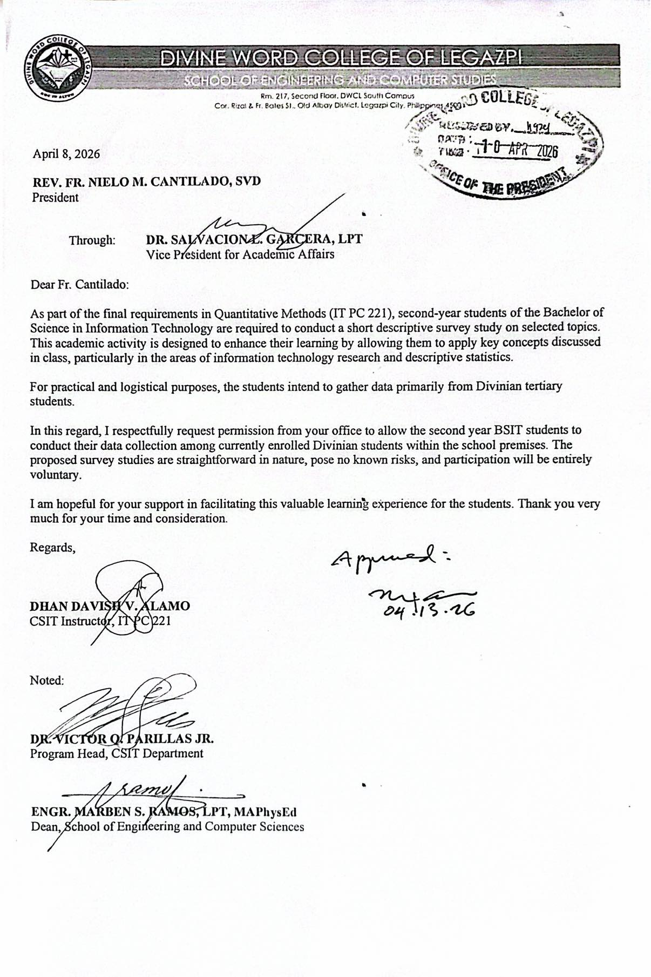

PROOF OF CONDUCTING THE STUDY
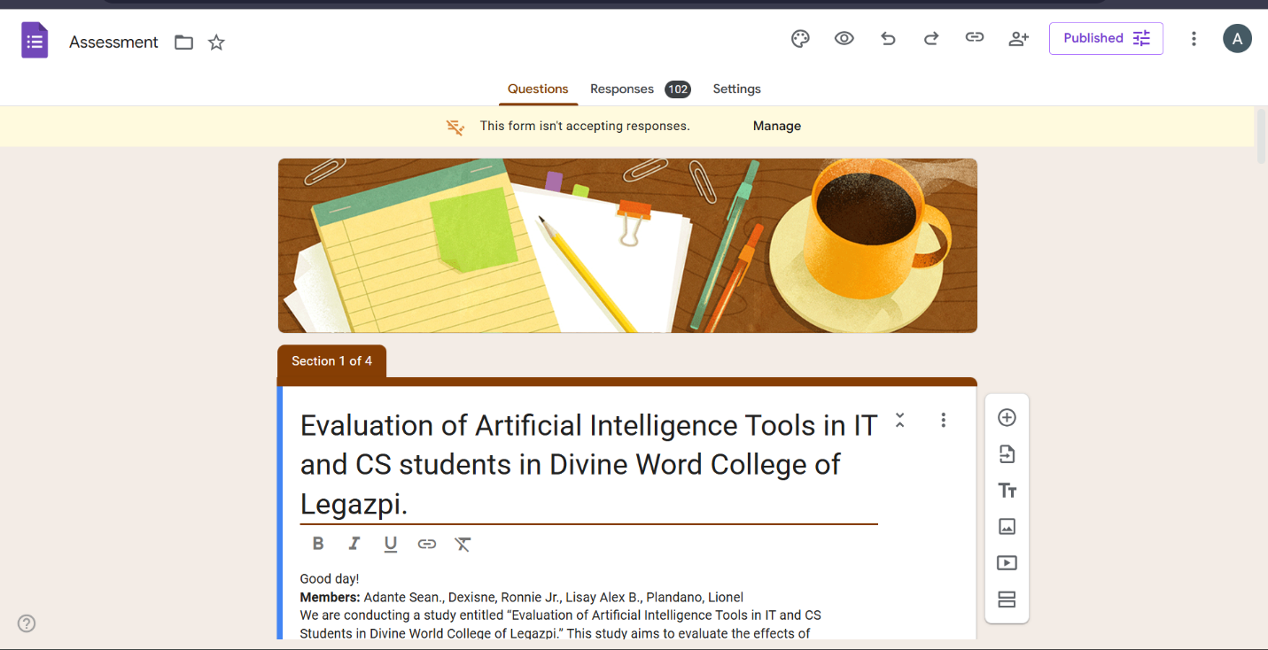
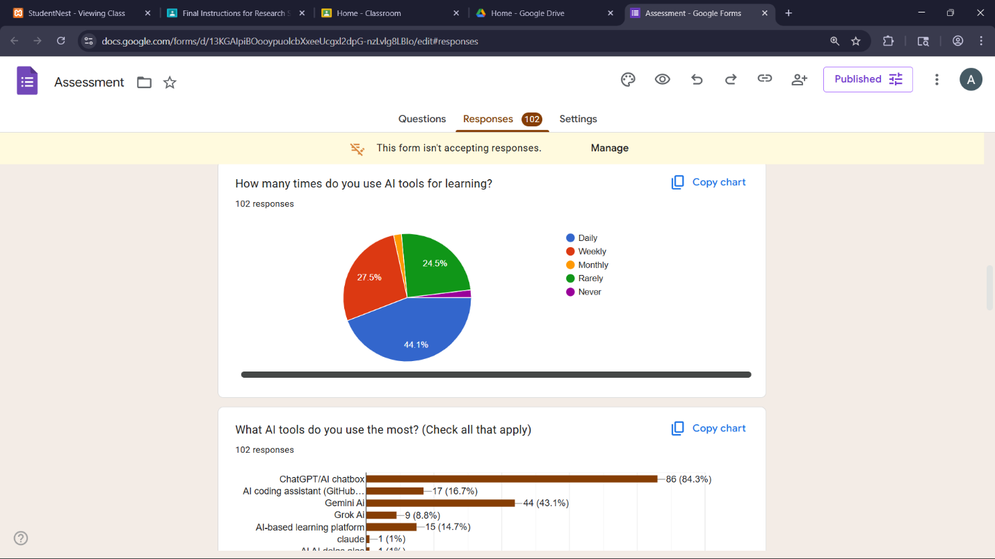

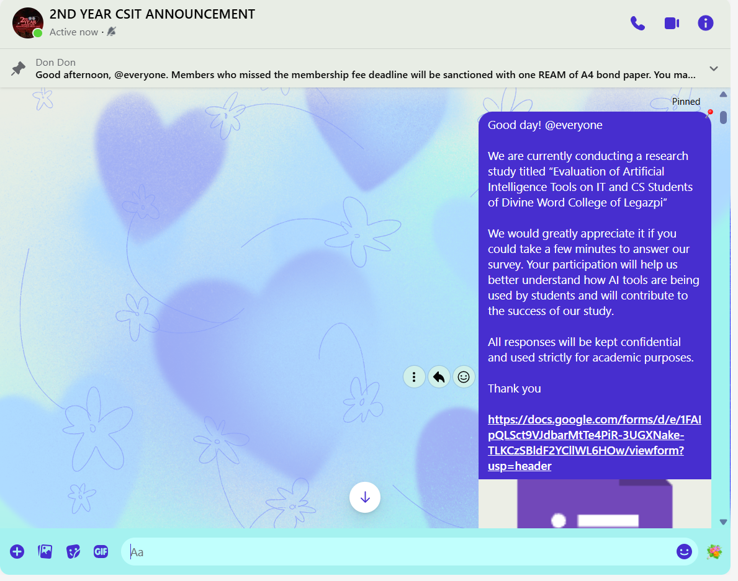
RESEARCH SURVEY QUESTIONNAIRE
General Instructions: Please answer the questionnaire honestly and carefully. Your responses will be kept confidential and will be used solely for academic research purposes. Kindly choose the option that best represents your opinion or experience. For each item, select only one answer unless otherwise stated.
Demographic Information:
Name (optional): ______________________
Sex:
◯ Male ◯ female ◯Prefer not to say
Year Level:
◯1st Year
◯2nd Year
◯3rd Year
◯4th Year
AI USAGE
- How many times do you use AI tools for learning?
◯Daily
◯Weekly
◯Monthly
◯Rarely
◯Never
- What AI tools do you use the most? (Check all that apply)
◯ChatGPT / AI chatbot
◯ AI coding assistant (GitHub Copilot, etc.)
◯ Gemini Ai
◯ Grook Ai
◯AI-based learning platforms
Other: ____________

Directions: Please indicate your level of agreement with each statement by selecting a rating from 1 to 5. Place a check (✓) mark in the column that corresponds to your chosen rating.
1 — Strongly Disagree
2 — Disagree
3 — Neutral (or Neither Agree nor Disagree)
4 — Agree
5 — Strongly Agree
Statement | 1  Strongly Disagree | 2  Disagree | 3  Neutral | 4  Agree | 5  Strongly Agree
- AI helps me understand complex technology concepts more easily.
- AI saves time when completing assignments.
- AI improves coding/programming skills.
- AI helps learners learn independently without a tutor.
- AI responses are sometimes difficult to interpret.
- The information provided by AI tools is consistently accurate.
- Ai usage enhances personal critical thinking and problem-solving.
- AI tools can be distracting during study sessions

ACADEMIC IMPACT & ETHICS
Statement | 1  Strongly Disagree | 2  Disagree | 3  Neutral | 4  Agree | 5  Strongly Agree
- Overall, AI has significantly improved academic performance.
- AI raises ethical concerns, including plagiarism and bias.
- Integrating AI into IT education is essential for preparing students for future careers

OPEN-ENDED QUESTIONS
- How has AI helped you the most in your IT studies?
___________________________________________
- What are your experiences in using AI tools for academic purposes?
___________________________________________________
- What are your general thoughts about AI tools in learning?
___________________________________________________

ETHICAL CONSIDERATIONS AND ADHERENCE TO ETHICAL GUIDELINES
The researchers sought and obtained permission from the appropriate authorities to conduct the study entitled “Evaluation of Artificial Intelligence Tools in IT and CS Students in Divine Word College of Legazpi.” This ensured that the research was conducted with proper authorization and in accordance with institutional requirements.
The study strictly adhered to ethical research principles throughout the data collection process. Participation in the survey was entirely voluntary, and respondents were informed about the purpose, scope, and objectives of the study before answering the questionnaire. Informed consent was obtained through the Google Form prior to participation. Respondents were also given the freedom to refuse participation, skip any question, or withdraw from the study at any time without any form of penalty or consequence.
To ensure confidentiality and protect the privacy of the respondents, no personally identifiable information such as names, email addresses, or contact details was collected. All responses were treated with strict confidentiality and were used solely for academic and research purposes. In compliance with the Data Privacy Act of 2012 (Republic Act No. 10173), all collected data were securely stored, handled responsibly, and properly disposed of after the completion of the study.

IINFORMED CONSENT
Good day!
Members: Adante Sean., Dexisne, Ronnie Jr., Lisay Alex B., Plandano, Lionel
We are conducting a study entitled “Evaluation of Artificial Intelligence Tools in IT and CS Students in Divine World College of Legazpi.” This study aims to evaluate the effects of artificial intelligence tools on IT and Computer Science students at Divine Word College of Legazpi. It explores how the use of AI influences students’ academic performance, learning habits, and skill development, particularly in programming and related technical subjects. The research also seeks to determine whether AI tools provide beneficial support for learning or contribute to negative effects such as overreliance, reduced critical thinking, or academic dependency. In addition, the study considers ethical implications related to the use of AI, including issues of academic integrity and compliance with the Data Privacy Act of 2012 in handling student-related information. By assessing both positive and negative outcomes, the study intends to determine whether AI tools are overall advantageous or disadvantageous for IT and CS students in their academic environment.

In line with this, you are respectfully invited to participate as a respondent in this research by
answering a survey questionnaire. Your participation in this study is entirely voluntary. By
agreeing to participate, you confirm that you are willing to answer the questions honestly and to
the best of your knowledge. You may refuse to answer any question or withdraw from the survey
at any time without any penalty.

All information you provide will be treated with strict confidentiality and will be used solely for
academic and research purposes. In accordance with the Data Privacy Act of 2012 (Republic Act
No. 10173), any personal data collected will be processed securely and will not be disclosed to
any unauthorized persons. Your responses will remain anonymous, and all data will be stored
safely and disposed of properly after the completion of the study.

Consent Statement
By proceeding with this survey, you confirm that:
- You have and understood the information provided above.
- You are voluntarily agreeing to participate (You may refuse to answer any question or withdraw from the survey at any time without any penalty).
o I agree to participate in this research survey.
o I do not agree to participate.

___________________________________
Participants’ signature over printed name

