- Project Title: Recipe Finder Website
- Description of the System:
The Recipe Finder System is a web-based application designed to assist users in discovering recipes based on the ingredients they have in their home. The system allows users to input one or more ingredients, and it will generate a list of available recipes that can be prepared using those ingredients. This study aims to reduce food waste, help users save time in meal and food planning, and provide easy access to cooking options without visiting multiple sites to find a recipe.
Scope of the study:
1. Users can input multiple ingredients.
2. The System will suggest recipes that match the inputted ingredients that will come from the API.
3. Recipes will include details such as ingredients list, cooking steps.
4. The System will focus on common everyday ingredients and meals suitable for home cooking
- Statement of the problem:
How can users easily find recipes based on the ingredients they have at home?
- Objectives
To provides a platform where users can input available ingredients in there home, and generate a list of recipes that can be made from the inputted ingredients. This platform aims to lessen the time to find a recipe especially the one’s that is new to cooking skills. They don’t need to visit multiple sites to find a recipe
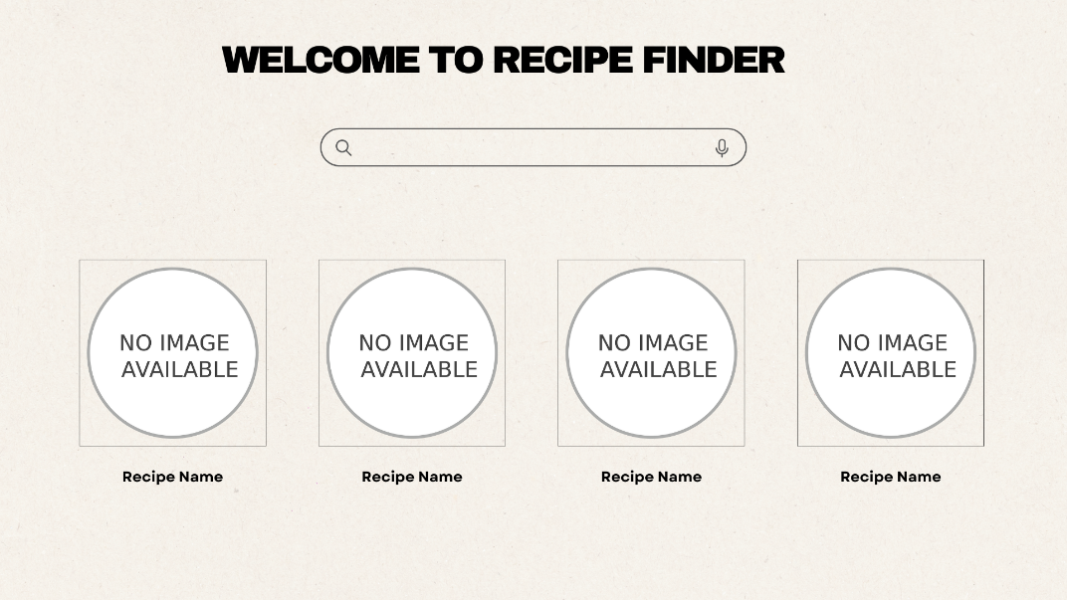
- Mock-up Design
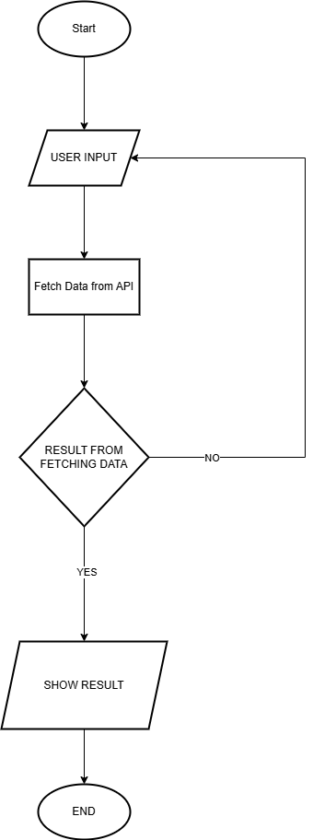
- System Desing ( FlowChart )

