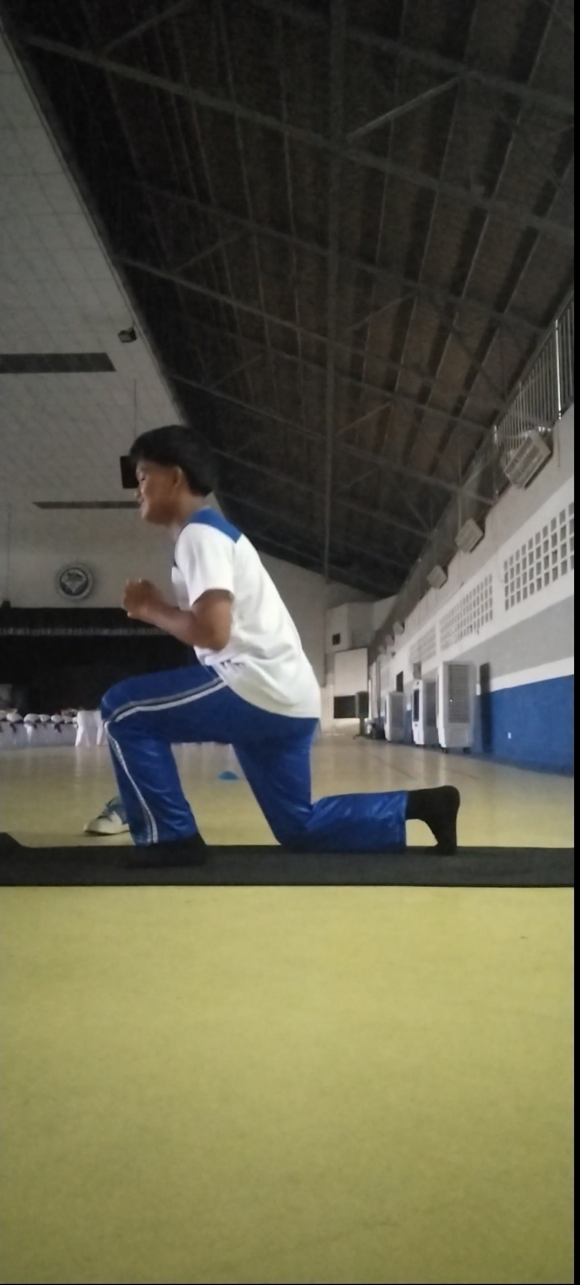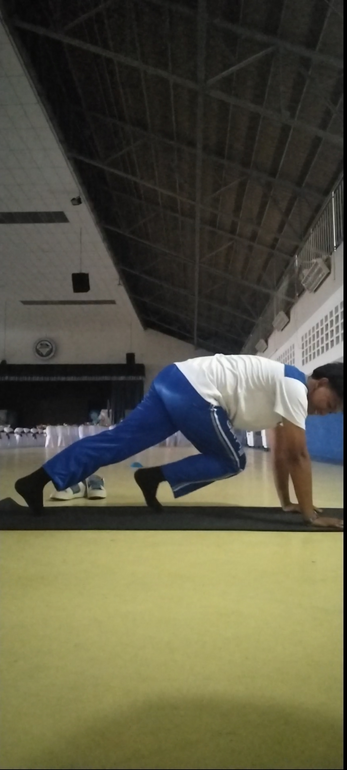

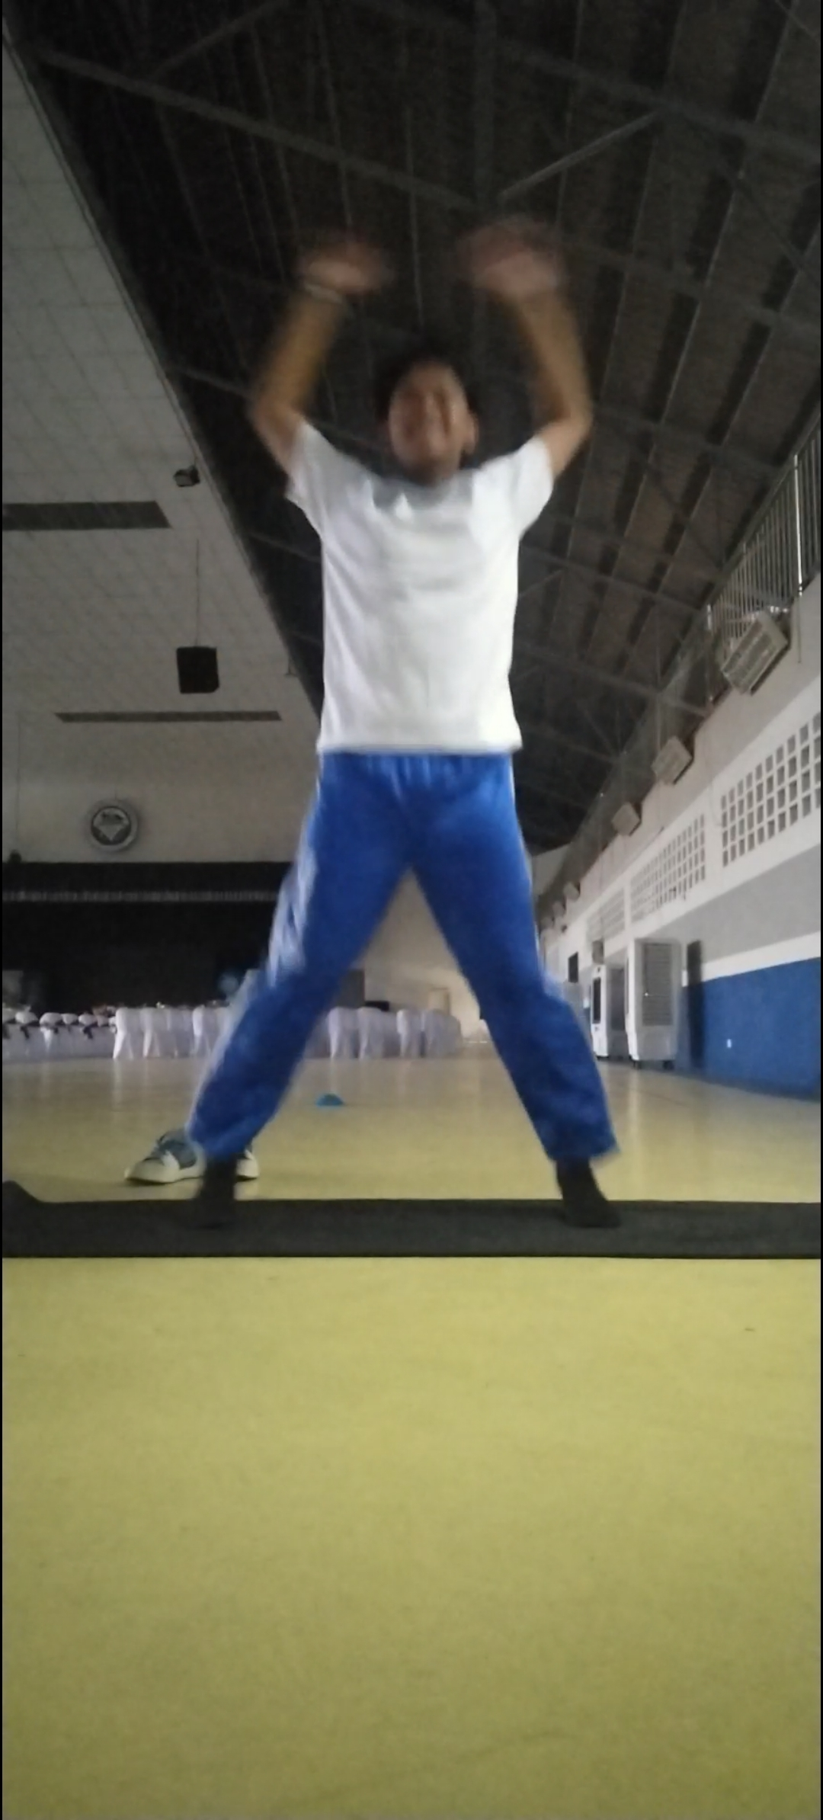

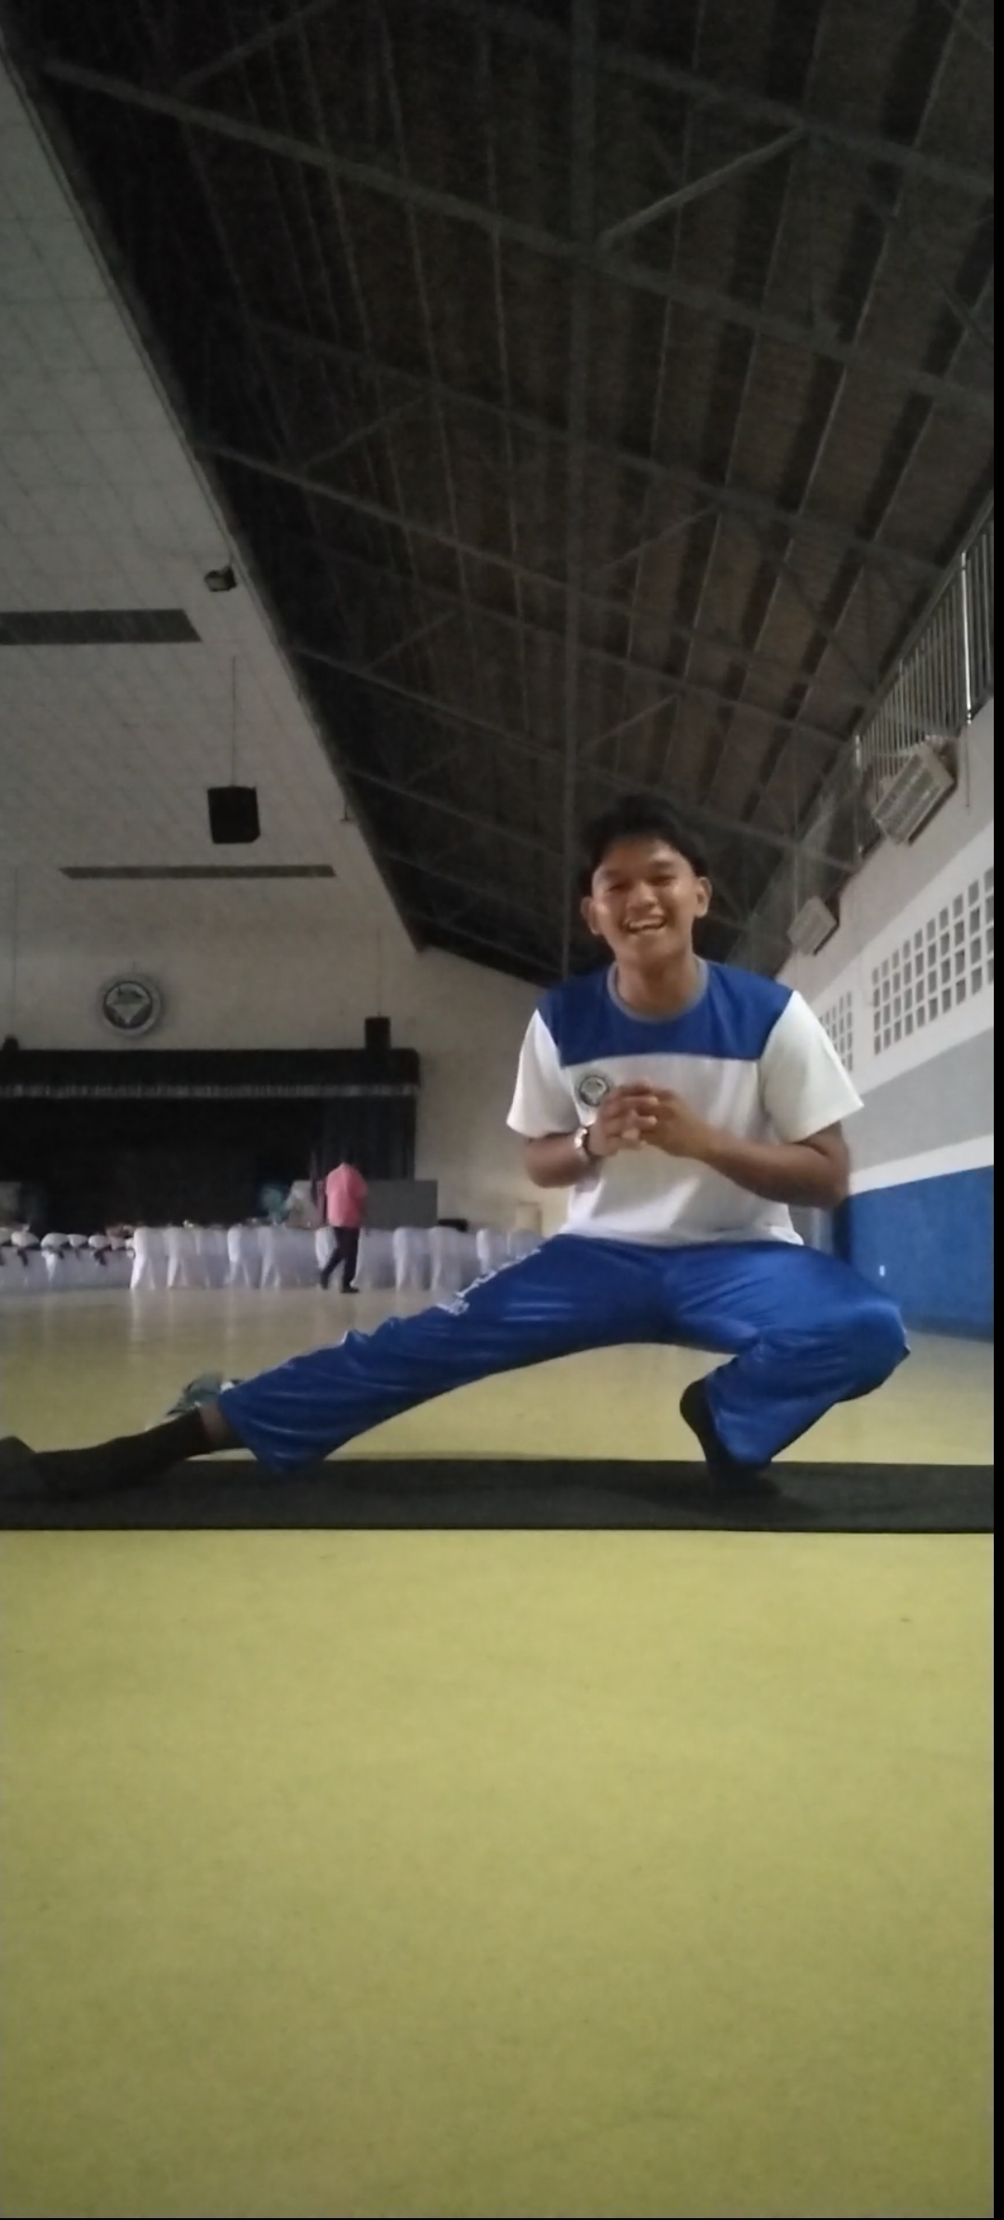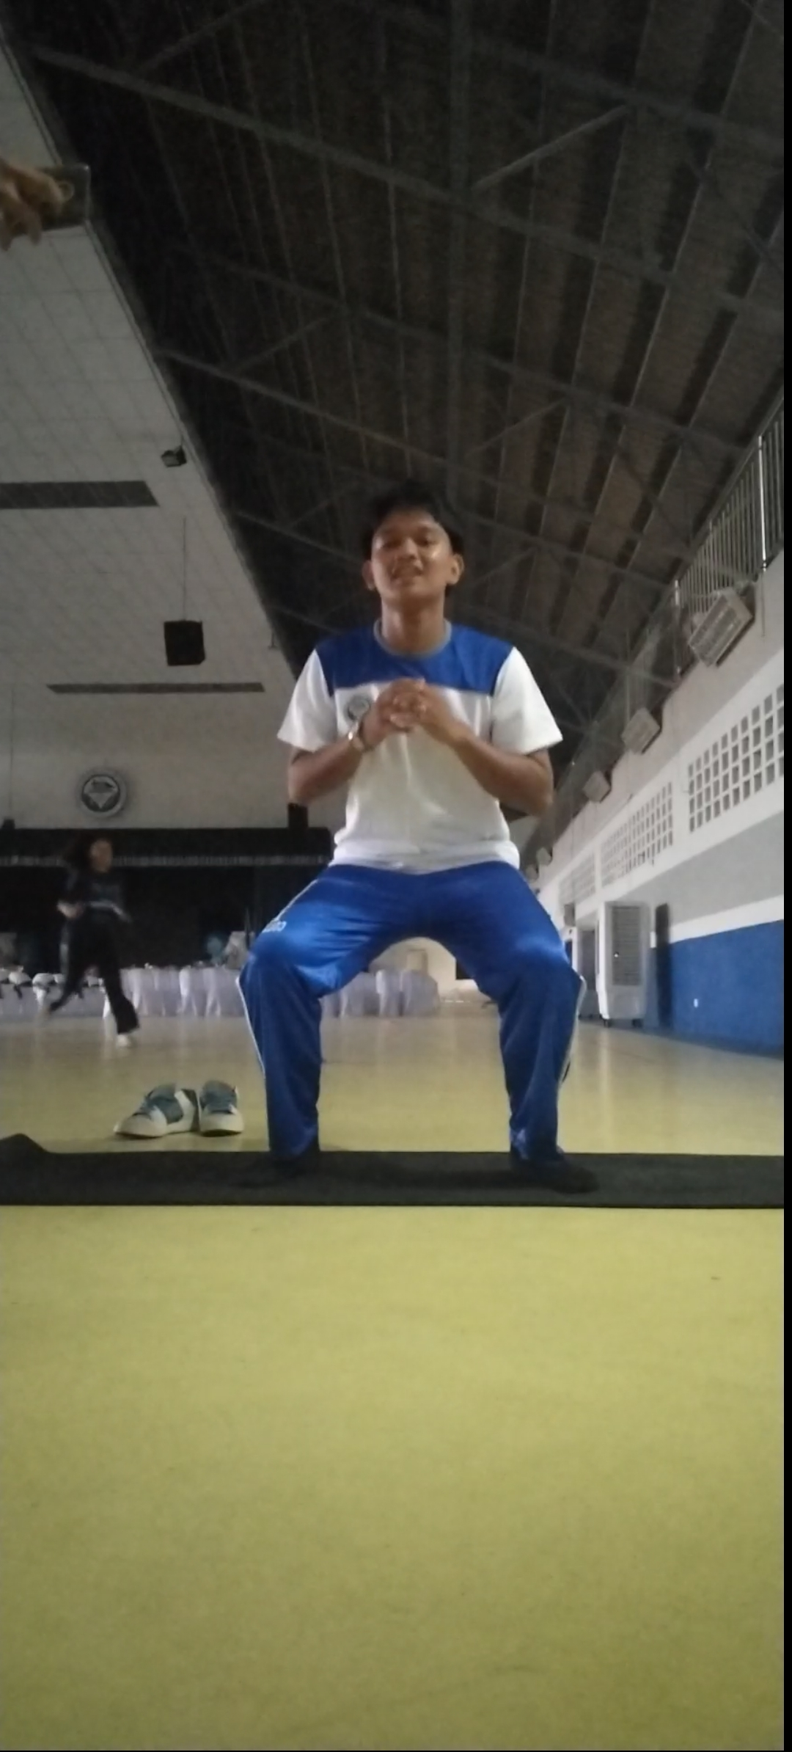

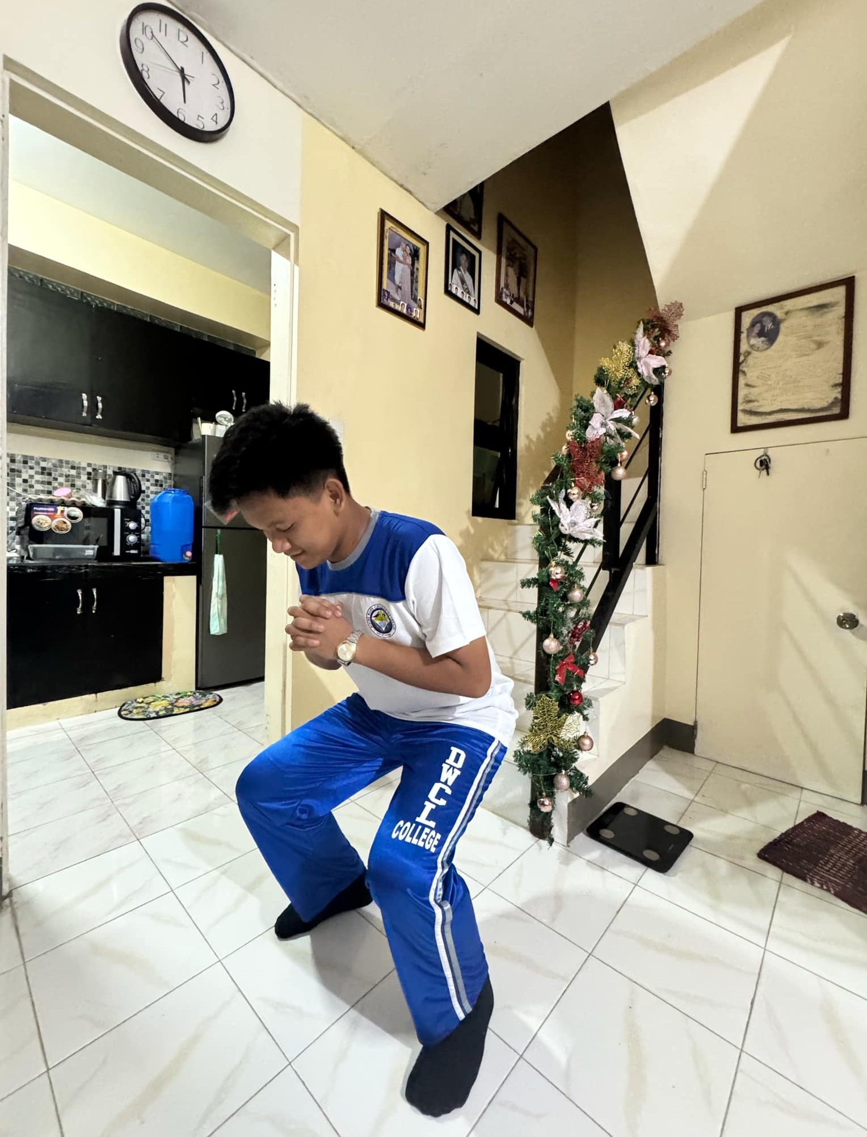

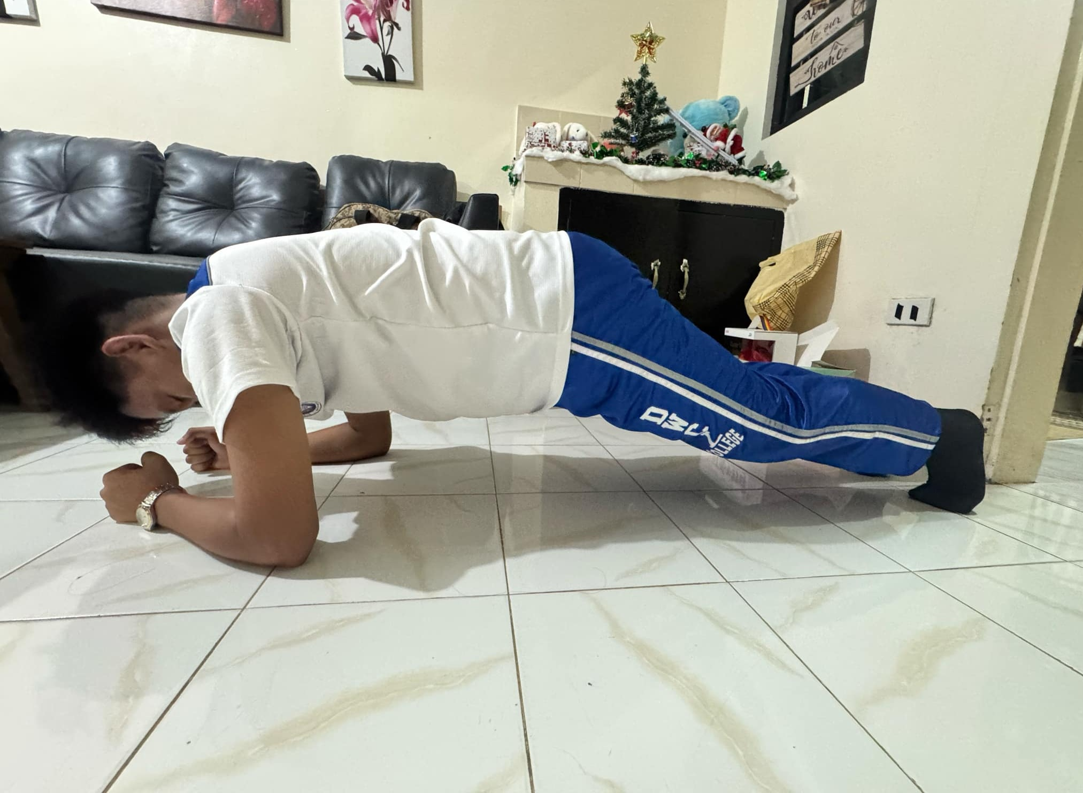

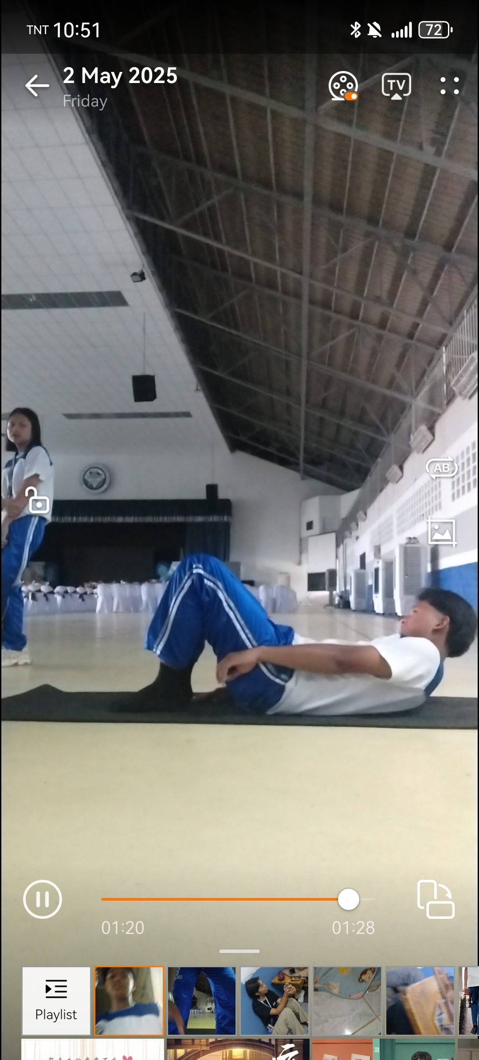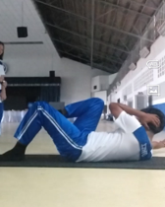

Name: Ronnliegh A. Arrio
Course&Yr: BSIT 1
Block: V Fri: 9-10:30

Friday
Today’s exercise session, which included jumping jacks, lunges, side lunges, mountain climbers, and jump squats, was both challenging and rewarding. Each movement targeted different muscle groups, helping me build strength, endurance, and coordination. I felt my heart rate rise quickly, especially during the jump squats and mountain climbers, which really pushed my cardiovascular limits. Although it was tiring, I’m proud of completing the workout and I know it’s a step forward in improving my overall fitness and discipline. I look forward to continuing and getting stronger with each session.

Sunday

In today’s workout, I performed squats, planks, Russian twists, cross crunches, and heel touches. These exercises focused heavily on core strength and lower body endurance. The squats helped build my leg muscles, while the planks and core exercises really challenged my abdominal strength and stability. One of the biggest struggles I faced was maintaining proper form during the plank and Russian twists, especially as I started to feel fatigued. My core began to burn halfway through, and it was tempting to stop, but I pushed through. Despite the difficulty, I feel stronger and more motivated to keep improving each time.

