Divine Word College of Legazpi
School of Engineering and Computer Sciences
Department of Computer Sciences and Information Technology
AY 2025-2026, 2nd Semester

Evaluation of Artificial Intelligence tools on IT and CS
Students in Divine Word College of Legazpi

In partial fulfillment
Of the requirements in
IT PC 221: Quantitative Methods

Lisay Alex B.

April 2026

1.0 INTRODUCTION
In 2026, Artificial Intelligence (AI) is widely used in education, especially by Information Technology (IT) and Computer Science (CS) students. Tools such as large language models and code generators help students write code, fix errors, and complete tasks faster. At Divine Word College of Legazpi (DWCL), many students use AI as part of their daily academic work.
While AI can make learning easier and faster, it may also affect how students think and solve problems. Some students may rely too much on AI instead of understanding the concepts on their own. Because of this, it is important to study how AI affects students’ learning, especially in areas like critical thinking, problem-solving skills, and academic performance.
We are conducting this study because artificial intelligence (AI) has become increasingly integrated into education, especially for IT and CS students, who frequently use of Technology in their studies. We want to investigate whether AI tools genuinely Support students’ learning, particularly in their critical thinking, problem-solving Skills, and academic performance. Understanding the effects of AI on students’ Learning experiences is important, as this will guide the teacher in determining Whether AI should be encouraged as a learning aid or will be restricted during Academic sessions to ensure students develop independent thinking skills.
  - OBJECTIVES
General Objectives:
To find out how artificial intelligence affects IT student’s learning
Specific Objectives:
- To determine how IT students use artificial intelligence in their studies.
- To identify the effects of artificial intelligence on students’ learning.
- To examine how artificial intelligence influences students’ critical thinking and problem-solving skills.
- To evaluate the impact of artificial intelligence on students’ academic performance.
  - RESEARCH PROBLEMS/QUESTION
1. How does the use of AI tools influence the learning experience of IT students in College?
2. How frequently do IT students use AI tools for academic purpose?
3. What are the perceived benefits of using AI in learning among IT students?
4. Does the use of AI improve academic performance or understanding of IT subjects?
  - RELATED STUDIES
Artificial Intelligence (AI) has become an important part of modern computer science education due to its growing applications across different industries. As demand for AI-related skills increases, students are expected to develop strong competencies in understanding and applying AI concepts. However, learning AI can be challenging due to its complexity, which may affect students’ motivation and learning experience.
Motivation is an important factor in student success, especially in difficult subjects. According to learning theories, students become more engaged when they experience meaningful, hands-on, and interactive learning activities. Effective teaching strategies such as collaborative learning, problem-based learning, and guided instruction can also improve understanding and engagement.
Studies show that students generally have a positive perception of AI and recognize its importance for future careers. However, some still lack confidence in their skills and understanding of AI concepts. This highlights the need for supportive and inclusive learning environments that enhance students’ critical thinking, computational skills, and problem-solving abilities, which are essential in AI education.
A study conducted by Nurjanah et al. (2024) examined the implementation of Artificial Intelligence (AI) in the teaching and learning process. The research highlights that AI has become an important innovation in education due to its ability to simulate human intelligence functions such as thinking, learning from experience, and problem-solving. The study explains that AI can significantly improve the learning experience by personalizing educational materials based on students’ needs and abilities.
Furthermore, the findings show that the integration of AI in education enhances teaching efficiency and supports more adaptive and student-centered learning environments. Teachers benefit from improved instructional tools, while students experience more tailored and effective learning support. The study concludes that AI has strong potential to transform modern education by increasing both learning quality and accessibility.
Yim and Su (2024) conducted a scoping review on the use of Artificial Intelligence (AI) learning tools in K–12 education. The study found that AI tools such as Google Teachable Machine, Scratch, and Machine Learning for Kids are increasingly used in classrooms to support learning. These tools are often applied through project-based and interactive learning approaches.
The findings show that AI-based learning improves students’ understanding, engagement, and development of problem-solving and collaboration skills. The study also highlights that these tools can be effective across different educational levels when properly designed for learners.
A study by De Leon et al. (2025) titled “The Future of Education: Factors Affecting Students’ Perception of the Usefulness of AI Tools in Education” examined the factors influencing students’ perception of the usefulness of artificial intelligence (AI) tools in academic settings. The study revealed that students’ perception of AI tools is significantly affected by their level of AI literacy, where students with higher understanding and familiarity with AI tend to perceive these tools as more useful for academic tasks such as learning support, problem-solving, and information processing. The findings also emphasized that perceived usefulness plays a crucial role in students’ acceptance and continued use of AI-based tools in education. This study is relevant to the present research as it provides insights into how IT and CS students may evaluate AI tools based on their knowledge, experience, and perceived benefits in academic performance and learning efficiency.
A study conducted by Fabia et al. (2025) entitled “How AI Tools are Accepted and Utilized in Academia: A Mixed Methods Study” examined the factors influencing the acceptance and utilization of artificial intelligence (AI) tools among students and academic staff in a higher education institution in the Philippines. The study utilized the Unified Theory of Acceptance and Use of Technology (UTAUT) model and revealed that performance expectancy and facilitating conditions are the primary drivers of AI tool acceptance in academic settings. Findings also showed that both students and staff demonstrate high familiarity with AI tools and commonly use them for academic tasks such as learning support, research assistance, and content generation. However, the study highlighted concerns regarding data privacy, ethical use, and institutional readiness, emphasizing the need for transparent AI governance and proper guidelines in educational environments. This study is relevant to the present research as it provides a localized perspective on AI tool adoption in Philippine higher education and supports the evaluation of AI tools among IT and CS students in terms of usefulness, acceptance, and usage behavior.
  - VARIABLES
- AI TOOLS (Independent Variable)
Conceptual Definition: AI Tools refer to software applications and platforms that utilize artificial intelligence, machine learning, and natural language processing to perform tasks traditionally requiring human intelligence. In an educational context, this includes generative AI and automated programming assistants.
Operational Definition: In this study, AI Tools are defined as the specific software used by DWCL students for academic purposes, specifically ChatGPT, GitHub Copilot, and Claude. These will be measured based on the frequency of use and the types of tasks performed (e.g., debugging, code generation, or concept explanation).
- STUDENT’S LEARNING OUTCOMES / EVALUATION ( Dependent Variable)
Conceptual Definition: Students’ learning outcomes refer to the knowledge, skills, academic performance, and perceived effectiveness gained by IT and CS students as a result of their learning experiences.
Operational Definition: In this study, students’ learning outcomes will be assessed through self-reported academic improvement, understanding of programming concepts, problem-solving ability, productivity in completing tasks, and their perception of the usefulness of artificial intelligence tools. These indicators will be measured using a structured survey questionnaire employing Likert scale items ranging from Strongly Disagree to Strongly Agree. The instrument will include statements such as “AI tools help me understand programming better” and “Using AI improves my productivity,”
allowing respondents to indicate the extent to which they agree based on their experiences.
2.0 METHODOLOGY
2.1. Research design
This study will use a descriptive survey research design to evaluate the impact Artificial intelligence in Information Technology (IT) and Computer Science (CS) students in Divine World College of Legazpi. This design is appropriate for the study as it allows the researchers to gather, analyze, and interpret data regarding the students’ experience, perceptions, and usage of artificial intelligence in their academic activities.
2.2 Participants
The target participants of this study are Information Technology (IT) and Computer Science (CS) students from all year levels at Divine Word College of Legazpi. These participants were chosen because they are directly engaged in technology-related courses and are more likely to encounter and use artificial intelligence tools as part of their academic activities. The study uses a convenience sampling method, where respondents are selected based on their availability and willingness to participate. This method is appropriate for the study as it allows the researchers to easily gather data from accessible students within the institution.
The study gathered 95 respondents through convenience sampling. While some research guidelines suggest a minimum of 100 respondents for survey studies, Roscoe’s rule of thumb, as cited in Scribd (n.d.), states that sample sizes ranging from 30 to 500 are appropriate for most behavioral and social science research. Based on this guideline, the 95 respondents in this study were considered valid and sufficient for data collection, particularly given the use of convenience sampling due to accessibility and time constraints.
2.3. Research instrument
The research instrument used in this study is a survey questionnaire designed to collect data on students’ use of Artificial Intelligence (AI) tools and its impact on their learning and academic performance. The survey has the following parts:
1. Demographic Information: This part asks for basic information such as sex and year level
2. AI Usage: This part asks how often students use AI tools and what types of AI tools they use for studying.
3. Open-Ended Question: This part lets students share their own experiences and opinions about using AI in their studies
2.4 Analysis
The collected data will be analyzed using appropriate statistical tools such as frequency, percentage, and mean. Frequency and percentage will be primarily used to summarize the respondents’ use of artificial intelligence, including how often it is used and the types of tools utilized. The mean will be used to interpret responses from the Likert scale statements to determine the level of agreement of the participants. Responses from the open-ended question will also be analyzed using thematic analysis to identify common insights and patterns. Basic demographic data, such as sex and year level, will be presented to provide general background information about the respondents.
2.5 Data collection procedure
The data for this study were gathered through a structured process that began with formal communication with the school administration to request permission to conduct the research. A letter of approval was submitted, outlining the purpose of the study and the data collection procedures. Upon receiving approval, coordination with instructors and students was arranged to ensure proper distribution of the survey.
The primary data collection tool was a survey questionnaire administered through Google Forms. The questionnaire consisted of statements designed to measure the respondents’ perceptions and experiences regarding artificial intelligence. A Likert scale format was used, ranging from 1 (Strongly Disagree) to 5 (Strongly Agree), to quantify their responses.
During the data collection process, several challenges were encountered. These included delays in obtaining approval from the institution, limited response rates from participants, which affected access to the online survey. Despite these difficulties, follow-ups and reminders were conducted to ensure sufficient data were collected for the study.

3.0 RESULTS
Table 1. Demographic Profile of the Respondents
Sex | Frequency(f) | Percentage (%)
Male | 64 | 69.6%
Female | 24 | 26.1%
Prefer not to say | 4 | 4.3%
Total | 95 | 100%

Figure 1. Visual Representation of Respondent by Sex
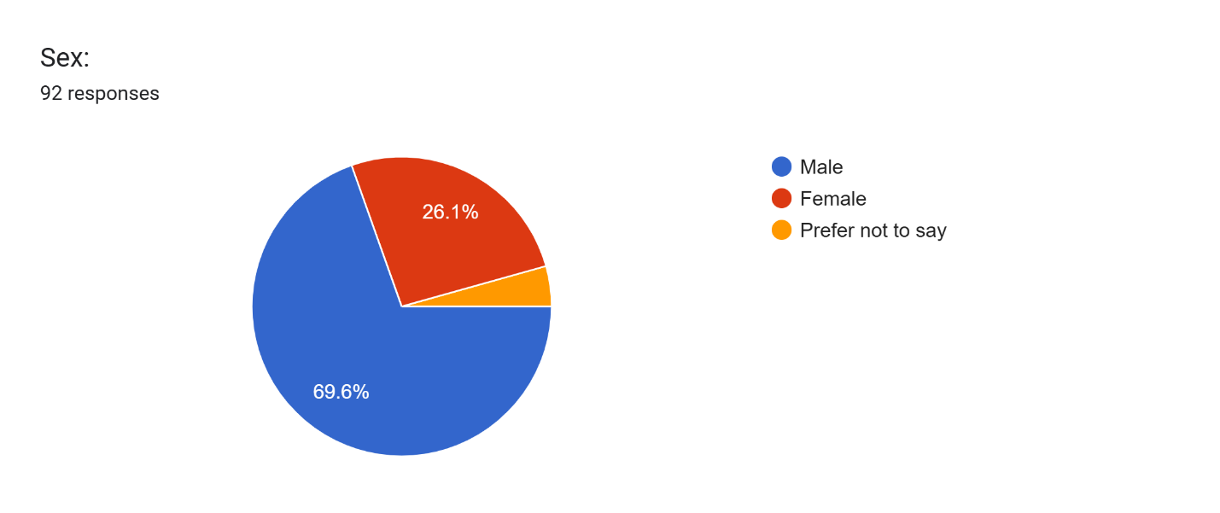
Discussion
The data reveals a difference in the number of male and female respondents, with male students comprising a larger portion of the sample compared to female students. This simply describes the composition of the respondents in the study. In the context of this research, the results on Artificial Intelligence (AI) usage and perceptions are based on the overall responses of the participants, regardless of gender. Therefore, the findings represent the collective perspective of IT and CS students within Divine Word College of Legazpi.
Table 2. Ai Usage Base on Frequency of Use
Frequency of use | Frequency (f) | Percentage (%)
Daily | 44 | 46.3%
Weekly | 27 | 28.4%
Rarely | 22 | 23.2%
Monthly | 1 | 1.1%
Never | 1 | 1.1%
Total | 95 | 100%

Figure 2. Visual Representation of AI Usage Among Respondents
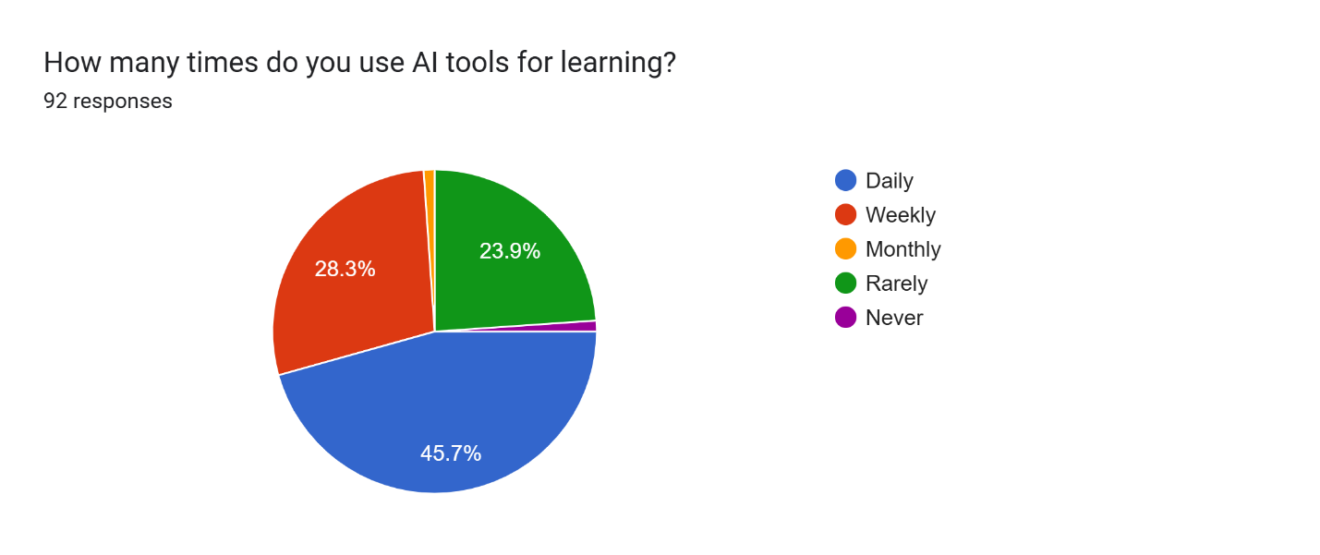

Discussion:
The findings indicate a very high adoption rate of AI tools within the Divine Word College of Legazpi’s IT (information technology) and CS (computer science) students, with 74.7% of the total respondents (the combined Daily and Weekly users) which indicates that AI has become a common tool in their studies.
On the other hand, only 1.1% of students reported never using AI, showing that almost all respondents have at least tried or used AI in their academic activities.
Table 3. AI Tools Used by IT and CS Students
AI Tool | Frequency (f) | Percentage (%)
ChatGPT / AI Chatbot | 80 | 84.2%
Gemini AI | 39 | 41.1%
AI Coding Assistant (GitHub Copilot, etc.) | 16 | 16.8%
AI-based Learning Platform | 14 | 14.7%
Grok AI | 8 | 8.4%
Others (Claude, DeepSeek, Windsurf, etc.) | 7 | 7.4%

Figure 3. Distribution of the AI Tools Used by Respondents
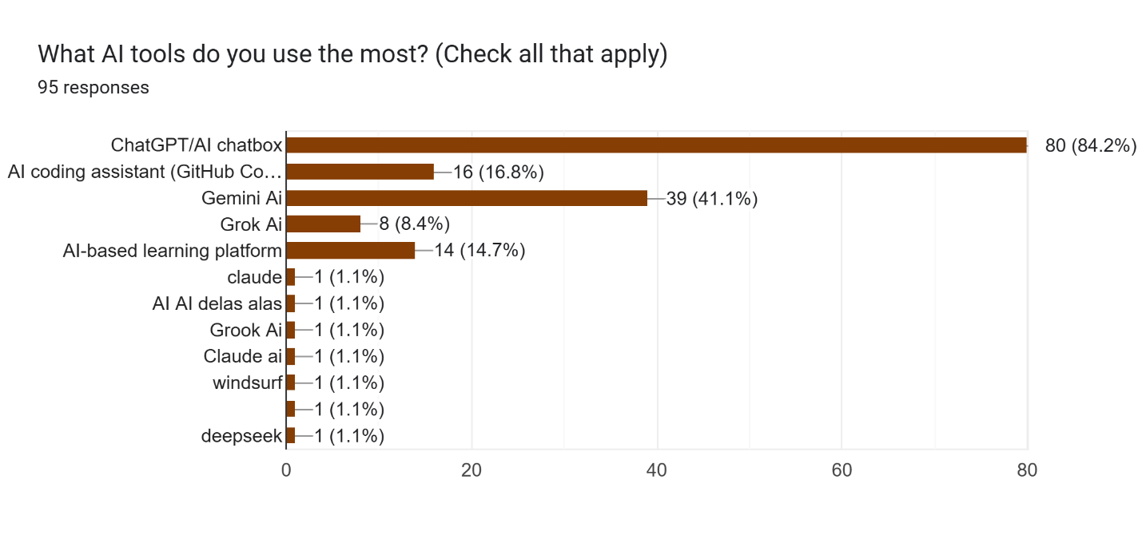
Discussion:
The results show that students mainly prefer general AI chatbots such as ChatGPT and Gemini over more specialized AI tools. ChatGPT / AI chatbot has the highest usage at 84.2%, followed by Gemini AI at 41.1%. This suggests that students tend to use AI tools that are flexible and can support a variety of tasks such as explaining lessons, answering academic questions, and assisting with schoolwork.
On the other hand, AI coding assistants (16.8%) and AI-based learning platforms (14.7%) are used by fewer respondents. This may indicate that students rely more on AI for general understanding and academic support rather than for direct coding or technical development tasks.
The “other” responses, such as Claude and DeepSeek, also show that some students are aware of different AI tools beyond the most commonly used ones.

Table 3. Level of Agreement on the Impact of AI on Students’ Learning
Statement | Mean | Verbal Interpretation
1. AI helps me understand complex technology concepts more easily | 3.87 | Agree
2. AI saves time when completing assignments | 3.89 | Agree
3. AI improves coding/programming skills | 3.55 | Agree
4. AI helps learners learn independently without a tutor | 3.74 | Agree
5. AI responses are sometimes difficult to interpret | 3.58 | Agree
6. The information provided by AI tools is consistently accurate | 3.31 | Neutral
7. AI usage enhances personal critical thinking and problem-solving | 3.24 | Neutral
8. AI tools can be distracting during study sessions | 3.22 | Neutral

Figure 3. Mean Scores of Students’ Agreement on the Impact of AI in Learning
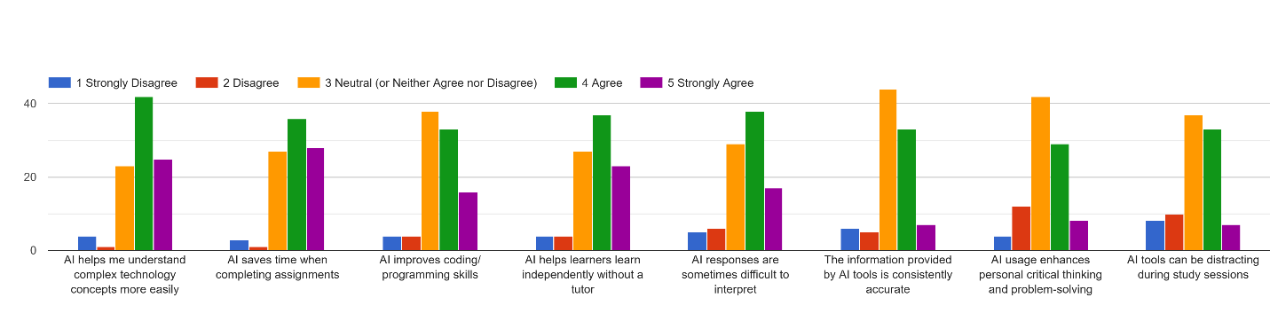
Discussion
The results show that students generally have a positive perception of AI’s impact on their learning. Most of the statements were rated as “Agree,” with the highest means found in AI saving time when completing assignments (3.89) and helping students understand complex technology concepts (3.87). This suggests that AI is primarily valued as a tool for improving efficiency and simplifying difficult topics.
Other indicators, such as AI improving coding skills (3.55) and supporting independent learning (3.74), also received positive responses, showing that students recognize its academic benefits. However, some statements were rated as “Neutral,” particularly regarding the accuracy of AI information (3.31), its impact on critical thinking (3.24), and its potential to be distracting (3.22). This indicates that while students see AI as helpful, they remain uncertain about its reliability and its deeper effects on learning skills. The findings suggest that AI is widely accepted as a learning aid, but students still have mixed views on its accuracy and long-term educational impact.
Table 4. Academic Impact & Ethics
Statement | Mean | Verbal Interpretation
- Overall, AI has significantly improved academic performance | 3.54 | Agree
- Ai raises ethical concerns, including plagiarism and bias | 3.52 | Agree
- Integrating AI into IT education is essential for preparing students for future careers | 3.54 | Agree

Figure 4 Mean Scores of Academic Impact & Ethics
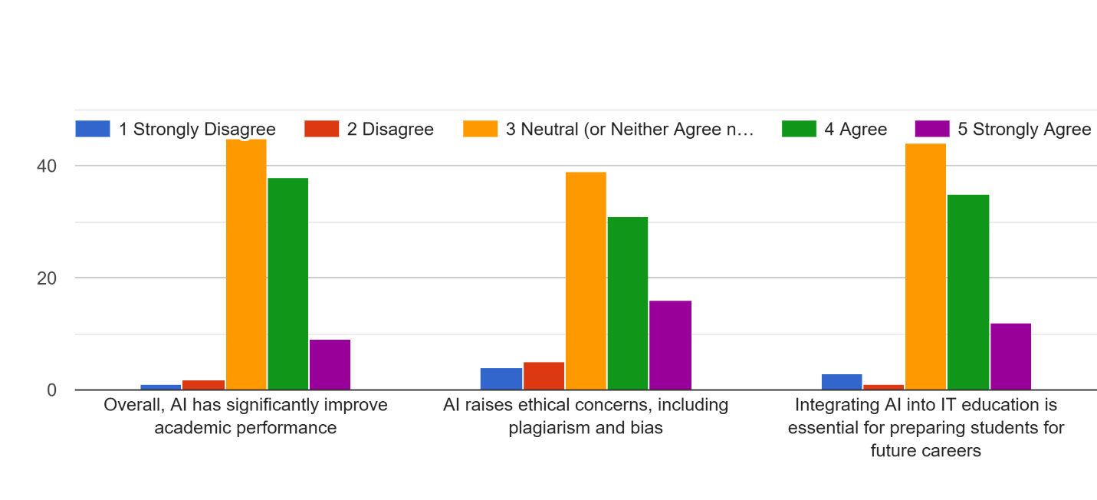
Discussion:
The results generally show that students have a positive perception of AI in terms of both academic impact and its role in education. All statements received a verbal interpretation of “Agree,” indicating that respondents believe AI contributes positively to their academic performance and future career preparation. At the same time, students also recognize that the use of AI may raise ethical concerns such as plagiarism and bias.
The findings suggest that students see AI as a valuable educational tool that supports learning and skill development, while also understanding the importance of responsible and ethical use of AI technologies in academic settings.

Thematic Analysis of Open-ended Question:
How has AI helped you the most in your IT studies?
Theme | Description | Sample Responses
Understanding Difficult Concepts and Lessons | Respondents stated that AI helps them better understand complex topics, programming concepts, and lessons that are difficult to understand in class. | “It helped me understand complex concept and helped me self-study”  “Helps me understand complex studies and topics i don't understand”  “Understanding lessons that weren’t able to understand in class”
Coding and Programming Assistance | AI helps students with coding tasks such as debugging, understanding code, and solving programming problems. | “It helps me correct my errors in programming also in other projects”  “Coding/programming”  “It helps me understand code to write”  “It help me Understanding codes that I don’t understand”
Faster Completion of Academic task | AI helps students’ complete assignments, activities, and academic requirements more quickly and efficiently. | “It helped me pass all of my activities and exam”,  “by finishing the activities on time”,  “It helps me with my daily task”
Research, Information, and Study Support | Students use AI to search for information, references, reviewers, and other study materials for academic purposes. | “How to find references.”,  “To have an Information about my study”, “it has helped me by making it easier to access information you normally would browse through the internet”

What are your experiences in using AI tools for academic purposes?
Theme | Description | Sample Responses
Positive Academic Support and Learning Aid | Students generally find AI helpful in their academic work, learning, and studying experience. | “Good”  “Great”  “Excellent”  “Very Good”
Academic Efficiency (Time-saving and Productivity) | AI helps students finish tasks faster and manage academic workload efficiently. | “Saves time”,  “AI is actually study saver, when sometimes rush activities.”,  “It makes my school works easy to finish.”,  “it help me do my academic work faster and easier”
Learning and Understanding Support | AI helps students understand lessons, summarize topics, and improve comprehension. | “To summarize the whole lesson”,  “To gain some info”,  “To learn better”
Coding and Technical Assistance | AI assists students in programming tasks such as coding, debugging, and fixing errors. | “It helps me correct my errors in programming also in other projects”,  “Coding/programming”  “It helps me with everything”,  “I use it everytime I have projects for syntax and debug help”
Negative effects and concern | Some students expressed concerns about overreliance, accuracy issues, and reduced personal skill development. | “Mostly, it is helpful yet my conscience eats me when i always rely on AI.”,  “Using AI changes my life both good and bad”,  “i rely too much on ai”
Neutral / Minimal Responses | Some responses are very short, unclear, or general statements | “A little bit”  “Yes”  “Yes”  “NA”  “N/A”  “N/A”

What are your general thoughts about AI tools in learning?
Positive Views on AI in Learning | Students generally view AI as helpful, useful, and beneficial for learning and academic support. | “It has a huge impact on students, maybe it’s recommended for using it in IT but we mustn’t take advantage of using it”  “It is a good tool but not reliable at times”  “Great but only in moderation”  “AI tools is very helpful specially for students who have a hardtime in understanding the lessons”
Efficiency and Learning Improvement | AI helps students study faster, easier, and improves learning accessibility. | “It helps us study at home”  “make studying more faster and accessible for students, as long as they use it the right way.”  “AI tools are useful in learning because they make studying easier, faster, and more interactive”
Responsible Use and Moderation | Students emphasize that AI should be used properly and not abused or overused. | “Great but only in moderation”  “My general view is that AI should be used as a collaborative partner, not a replacement”  “It's good to use it just not abuse it to the extent you end up making plagiarized contents and do not learn from AI”
Dependence and Overreliance Concerns | Some students worry that excessive AI use may lead to dependence and reduced learning effort. | “its useful, but people are more dependent on ai”  “Do not be dependent on ai”  “Don't be dependent on ai”
Accuracy and Limitations | AI is useful but not always accurate and may have limitations depending on usage. | “It is a good tool but not reliable at times”  “It's more conflict sometimes because of the prompts that you input”  “Honestl, AI tools sometimes its not accurate giving information I need unless good prompt.”
Negative Effects and Concerns | Students mention risks such as laziness, reduced critical thinking, and misuse. | “It makes it easier to improve but suggests lazyness for people who don't know how to utilize it properly”  “Using AI makes me rely more in AI…”  “It somehow lessens the students critical thinking in the long run”
Neutral / Minimal / Unclear Responses | Short or unclear responses without explanation. | “masaya”  “N/A”  “NA”  “none”  “nothing”

4.0 CONCLUSION
This study examined the usage, perceptions, and impact of Artificial Intelligence (AI) tools among Information Technology (IT) and Computer Science (CS) students at Divine Word College of Legazpi. The findings show that a large majority of students frequently use AI tools, with ChatGPT and Gemini being the most commonly used platforms. This indicates that students prefer general AI chatbots that can support various academic tasks such as answering questions, explaining lessons, and assisting in schoolwork.
In terms of perception, students generally agreed that AI has a positive impact on their learning. They believe that AI helps them understand complex concepts, saves time in completing tasks, and supports their coding and independent learning skills. However, they also have a mixed views regarding its accuracy, effect on critical thinking, and potential distractions, this suggest that AI is helpful but with limitations.
The results show that AI is widely used for understanding lessons, coding assistance, completing academic requirements, and research support. However, students also raised concerns about overreliance, reduced independent thinking, and occasional inaccuracies. Overall, the study concludes that AI is a valuable academic tool for IT and CS students, but it should be used responsibly and in moderation to maximize its benefits while minimizing its drawbacks, and also the study shows that using ai has a different effect depending on the user.
References
Roscoe’s sample rule of thumb. (n.d.). Scribd. https://www.scribd.com/document/712391912/Sample-rule-of-thumb-231031-074536
Delos Santos, M. S. M., Abugan, D. L., Arcenal, A. A., Barredo, M. C. S., Lara, F. S., & Peteros, E. D. (2025). The influence of critical thinking and computational skills on the problem-solving skills of Grade 7 students. British Journal of Teacher Education and Pedagogy, 4(7), 15–31. https://al-kindipublishers.org/index.php/bjtep/article/view/11388
Nurjanah, A., Salsabila, I. N., Azzahra, A., Rahayu, R., & Marlina, N. (2024). Artificial Intelligence (AI) usage in today’s teaching and learning process: A review. Syntax Idea. https://doi.org/10.46799/syntax-idea.v6i3.3126
Yim, I. H. Y., & Su, J. (2024). Artificial intelligence (AI) learning tools in K-12 education: A scoping review. Journal of Computers in Education. https://doi.org/10.1007/s40692-023-00304-9
De Leon, N., Palaya, J., & Prado, M. (2025). The future of education: Factors affecting students’ perception of the usefulness of AI tools in education. International Journal of Research and Innovation in Social Science, 9(2), 4602–4619. https://doi.org/10.47772/IJRISS.2025.9020362
Fabia, J. N. V., Napoles, V. V., Goh, J. E. E., & Borbon, M. R., Jr. (2025). How AI tools are accepted and utilized in academia: A mixed methods study. Journal of Social and Scientific Education, 2(1), 24–41. https://doi.org/10.58230/josse.v2i1.295

