# **A Comprehensive Look at the MyBit Decentralised Development Fund**

The MyBit Decentralised Development Fund (DDF) is a groundbreaking tool that makes next-generation organisations possible through decentralised development and governance. It enables any person, in any location, to be financially rewarded for contributing to open source projects such as those in the MyBit application suite. The MyBit DDF creates an agile environment which avoids the friction of hiring and provides automated features which increase productivity.

The MyBit DDF was firstly released as a framework for facilitating the rapid growth of the MyBit project. However, it is now clear that it has the potential to provide the same value to any open-source project. The trend of decentralised development has just begun and, thanks to the MyBit DDF, anyone can be a part of it.

**The old way of working: *mono-tasked* and full of paperwork**

For decades, since the industrial revolution, companies have used the same model of organisation: *hierarchy*. This model is based on a pyramidal structure, where the top positions guide the strategy of the company and the bottom positions carry out the development of the product or service. While being very effective during the past century, this model is now reaching its efficiency limits.

Companies built on the *hierarchical* model tend to be slow at integrating talented people, due to high volumes of paperwork, and required physical presence. Furthermore, the *decision-makers* of a traditional company - the board of directors - often have a high level understanding of the company, but lack an understanding of the more intricate organisational innerworkings.

But, if the traditional *hierarchical* model seems to be broken, how will future companies be structured?

In the future, only companies built on a decentralised, global, and transparent organisational model will achieve outstanding levels of efficiency and the ability to rapidly adapt to changes in the ecosystem.

In this upcoming model, talented developers will not have to commit to one organisation. Instead, they can contribute to a wide variety of projects at their own leisure. Also, thanks to [automated governance protocols](https://aragon.org/), the decisions will be made by the contributors, and not by a disconnected board of directors.

And here is where the MyBit DDF comes into the game, by making the MyBit Project the first example of an organisation of the future.

**Why is the MyBit DDF valuable?**

At this point, we can agree that this type of decentralised organisation is key for a future of growth.

But why the MyBit DDF?

The MyBit DDF is designed for ease of use, efficiency and friction avoidance. Its value derives from these main sources:

MyBit DDF is global from minute 0

Every person around the globe is a potential contributor to the MyBit Network.

No paperwork

Every contributor can solve a task without contracts, hours reporting or prior onboarding. Only a [GitHub](https://github.com/) account is required.

Legacy tools are included

The tools which are already proven to be useful for task management - for instance [Asana](https://asana.com/) - are included. Interacting with blockchain will be easy and visual.

Automatic rewarding

All funds are stored by a smart contract. Once a task is solved - and is merged with the original repository - the monetary amount is automatically sent to the contributor.

Fast adaptation to new tasks

Unlike other bounty platforms, all the tasks stem from the same codebase. In this context, developers do not need to familiarise themselves with new code for every task.

Full transparency

The MyBit DDF has the potential to be incorporated into every open source project in the ecosystem.

**How does the MyBit DDF work?**

The best way to understand a concept is by going through a real use case. So, for the sake of simplicity - and transparency - we are going to explain how this blog post was created, thanks to the MyBit DDF, as a contribution to the MyBit Network.

It was carried out in seven easy steps:

1. The contributor - who is me, but from now on you can call me *Bob* - explores the different possibilities of collaboration and their rewards through [the MyBit DDF interface](https://ddf.mybit.io/).

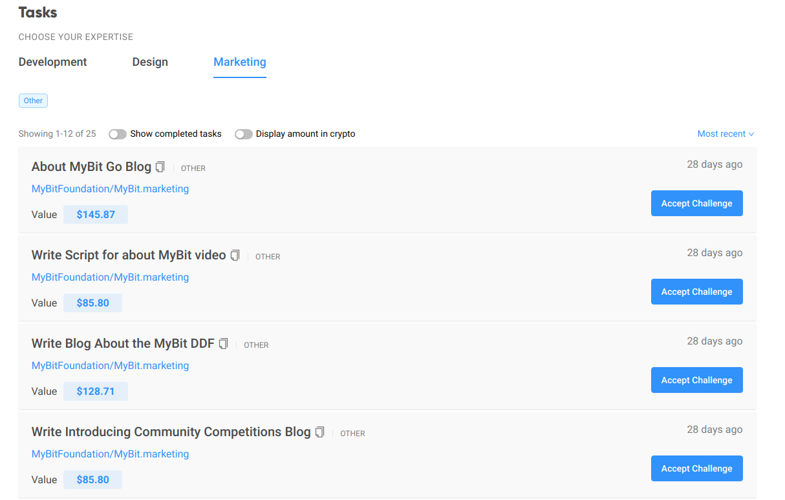

1. Bob decides to accept one of the listed *challenges* - i.e. contribution proposals - which is called *“Write Blog About the MyBit DDF”*.

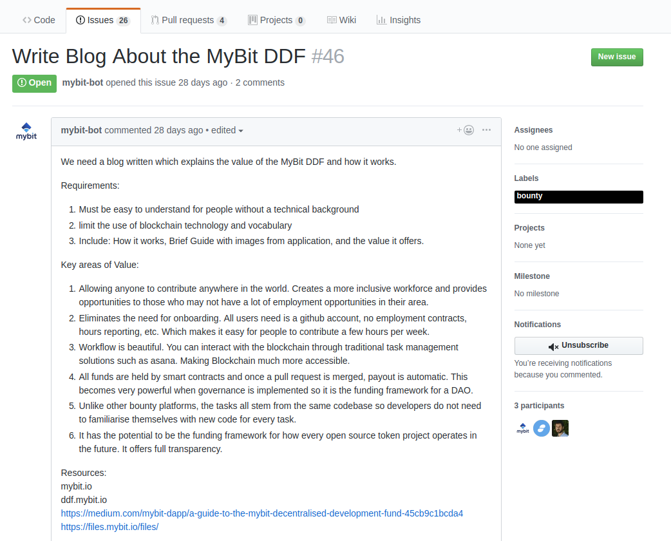

1. Bob reads all of the requirements and thinks he is a suitable candidate to complete the task. He expresses interest on [Gitcoin.co](https://gitcoin.co/) and begins working on the task. After feeling the work is at a quality standard, he submits his preliminary proposal - in this case, since it is a blog post, he shares a *docx* or *doc* file -.

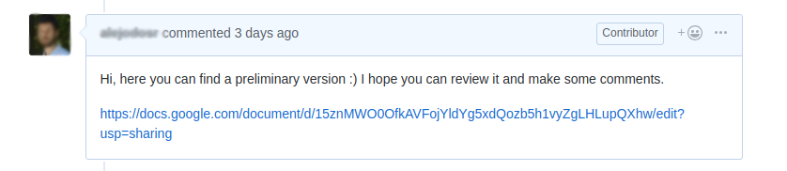

1. There are a few iterations of comments and corrections made by both the assigned supervisor of the task and Bob.

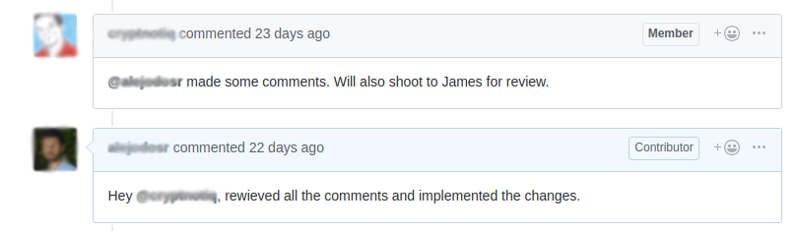

1. A final version is completed and Bob is ready to do a *pull request*. First, Bob has to *fork* the repository.

*(If you are not familiar with pull requests, please review the details* [*here*](https://medium.com/mybit-dapp/a-guide-to-the-mybit-decentralised-development-fund-45cb9c1bcda4))

1. Bob uploads his file and submits a *pull request*.

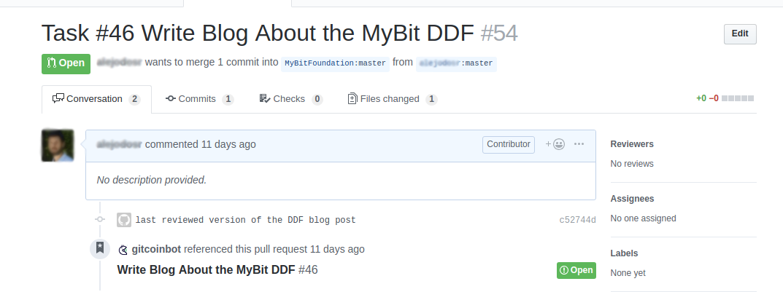

1. The *pull request* gets merged and Bob’s payment gets approved through [Gitcoin](https://gitcoin.co/issue/MyBitFoundation/MyBit.marketing/46/1964) platform.

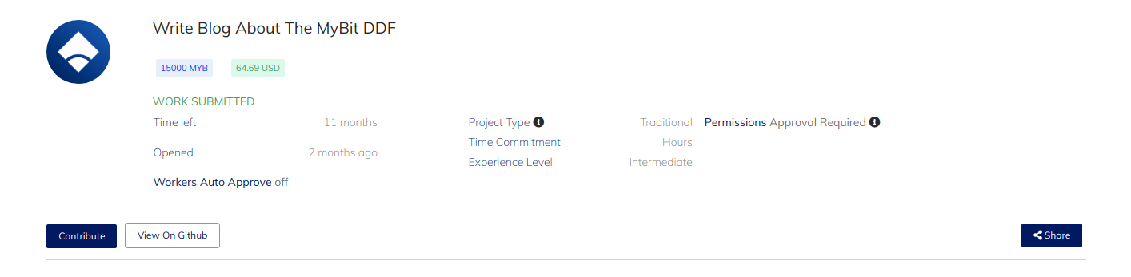

I know, it was very easy and frictionless.

At this point, Bob has successfully contributed to the MyBit Network and has consequently been rewarded for this action. All without requiring any paperwork, or designated position within the hierarchy of the company.

At the end of the day, the main goal of the MyBit DDF is to rapidly scale development of the MyBit Network while providing a platform where talented people can earn money by creating value. The increased growth and efficiency added to the MyBit Network through DDF contributions has the potential to forge powerful, decentralised and consumer focused tools that can empower people to take control of their financial future.

Following this philosophy, the MyBit Network will become fully decentralised over time, making it completely unstoppable in its ability to reward people for completing tasks.

This is just the beginning for the MyBit DDF. It will remain a key focus for the MyBit development team and will continue to evolve over the coming months and years.

For all of the latest updates and any comments or questions, reach out to us on Telegram.

Until next time!

The MyBit Team