Report about Pwelch

|  |  |
| --- | --- |
| Report  Names: Fanny Grosselin | Verification  Name: Yohan Attal  Date:  Signature: |
| History of modifications:   * *Creation 20/01/2017* : Fanny Grosselin   Description of the changes in MBT_PWelchComputer and MBT_Fourier in order to have the same results than with the pwelch of Matlab. | |

Introduction :

This document lists and describes the changes induces in MBT_PWelchComputer and MBT_Fourier in order to converge to the same result than with pwelch of Matlab.

1. Comparison of the psd with a signal with 250 datapoints.

[psdM,fM] = pwelch(inputData, [],[],[],250)

VS

initial MBT_PWelchComputer and initial MBT_Fourier

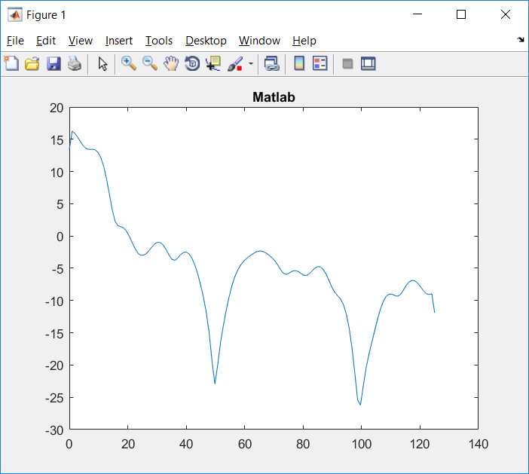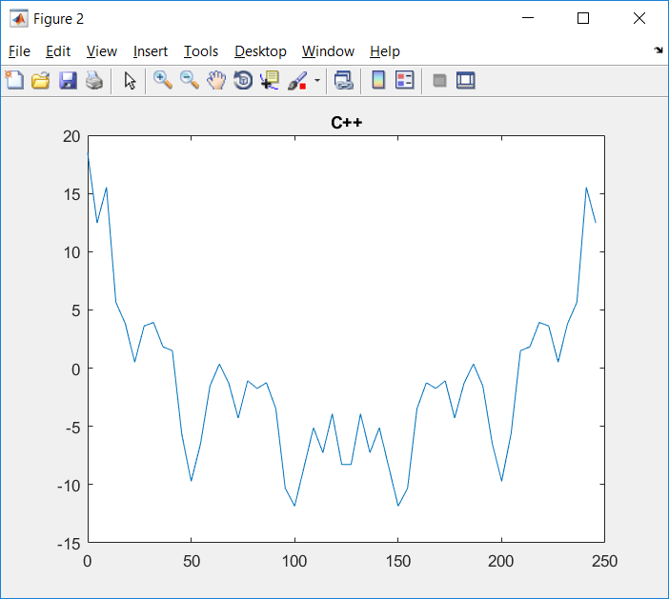

Size of frequency vector : 1x129 (from 0 to 125Hz) 1x55 (from 0 to 245,45Hz)

[psdM,fM] = pwelch(inputData, [],[],[],250)

VS

First change of MBT_PWelchComputer and initial MBT_Fourier

**First change of MBT_PWelchComputer.cpp:**

const float PI_F=3.14159265358979f;

switch (m_windowType) {

case RECT:

return 1;

break;

case HANN:

//return (1.0 - cos(2.0 * PI_F * n / windowLength)) / 2.0;

return (1.0 - cos(2.0 * PI_F * n / (windowLength-1))) / 2.0; // Fanny Grosselin 2017/01/10 (windowLength-1) instead of windowLength

break;

case HAMMING:

//return 0.54 - 0.46 * cos(2.0 * PI_F * n / windowLength);

return 0.54 - 0.46 * cos(2.0 * PI_F * n / (windowLength-1)); // Fanny Grosselin 2017/01/10 (windowLength-1) instead of windowLength

break;

default:

break;

}

**Explainations:**

w = hamming(L) returns an L-point symmetric Hamming window in the column vector w. L should be a positive integer. The coefficients of a Hamming window are computed from the following equation.

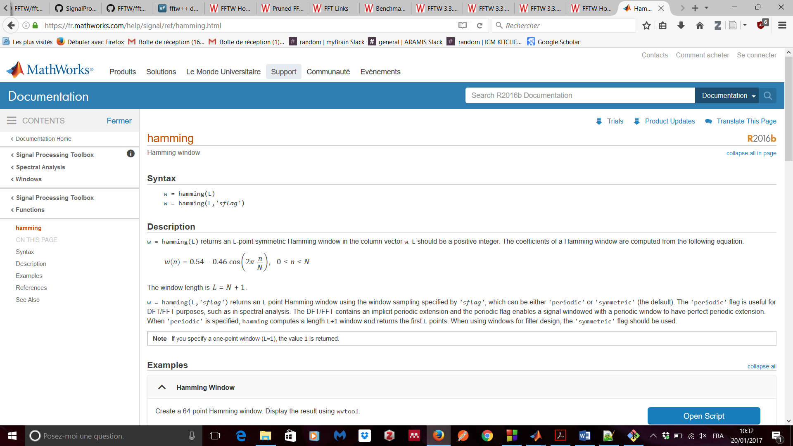

The window length is L=N+1.

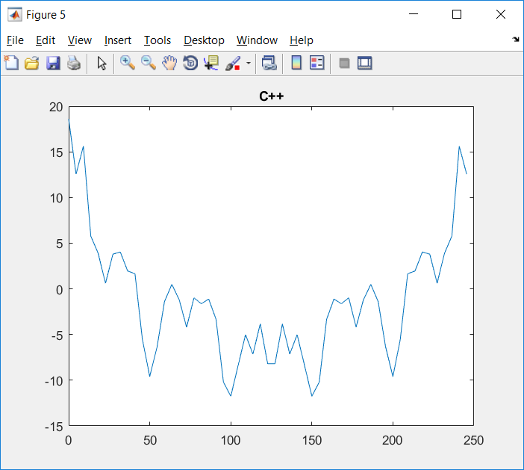

Size of frequency vector : 1x129 (from 0 to 125Hz) 1x55 (from 0 to 245,45Hz)

[psdM,fM] = pwelch(inputData, [],[],[],250)

VS

Second change of MBT_PWelchComputer and initial MBT_Fourier

**Second change of MBT_PWelchComputer.cpp:**

Zero-padding of each segment.

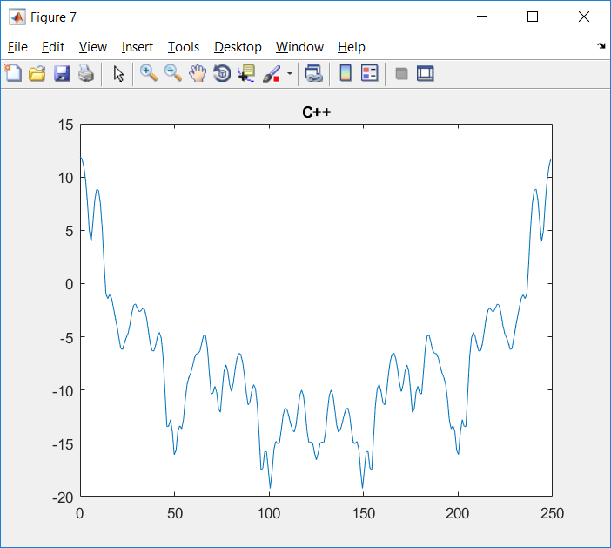

Size of frequency vector : 1x129 (from 0 to 125Hz) 1x256 (from 0 to 245,45Hz)

[psdM,fM] = pwelch(inputData, [],[],[],250)

VS

Second change of MBT_PWelchComputer and First change of MBT_Fourier

**First change of MBT_Fourier.cpp:**

Change ceil to floor in the computation of powerOfTwoLength in MBT_FourierBluestein::bluesteinConvolutionParallel.

No change concerning the plot.

[psdM,fM] = pwelch(inputData, [],[],[],250)

VS

Second change of MBT_PWelchComputer and Second change of MBT_Fourier

**Second change of MBT_Fourier.cpp:**

Zero-padding instead of padding by the mirror of the signal in MBT_FourierBluestein::workerBluesteinConvolutionParallelB and MBT_FourierBluestein::bluesteinConvolutionParallel

No change concerning the plot.

[psdM,fM] = pwelch(inputData, [],[],[],250)

VS

Third change of MBT_PWelchComputer and Second change of MBT_Fourier

**Third change of MBT_PWelchComputer.cpp:**

Compute the one-sided spectrum.

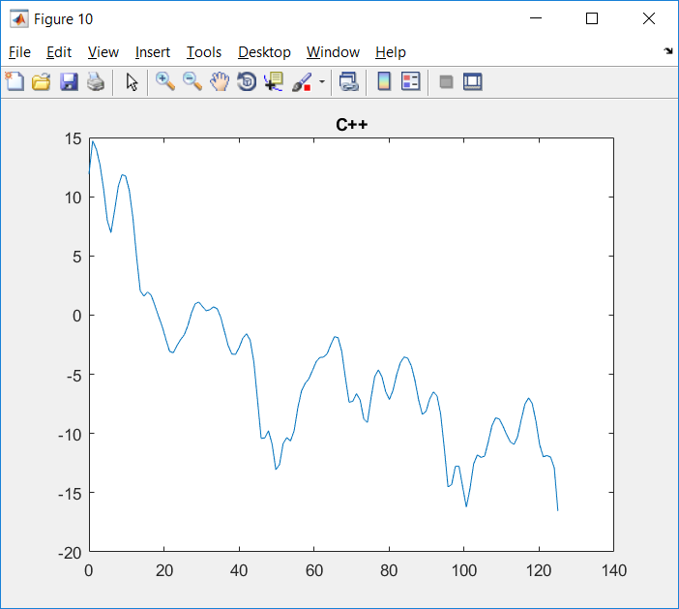

Same frequency vector : 1x129 (from 0 to 125Hz)

[psdM,fM] = pwelch(inputData, [],[],[],250)

VS

Fourth change of MBT_PWelchComputer and Second change of MBT_Fourier

**Fourth change of MBT_PWelchComputer.cpp:**

Correct the complexSignal generation: computeWindow should be called with i and not window because "n" of computeWindow should be in [0:windowLength-1] and not in [0:windowNumber].

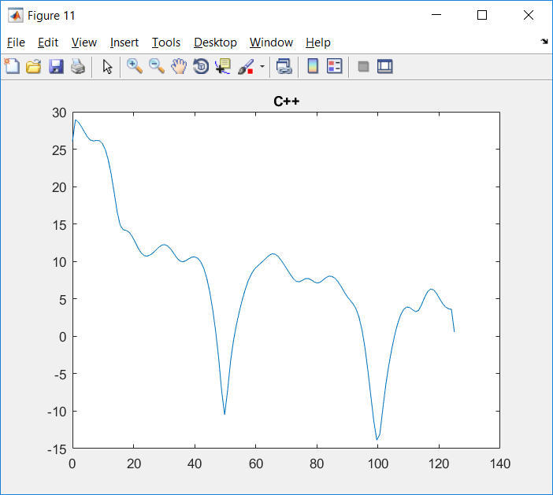

Same frequency vector : 1x129 (from 0 to 125Hz)

[psdM,fM] = pwelch(inputData, [],[],[],250)

VS

Fifth change of MBT_PWelchComputer and Second change of MBT_Fourier

**Fifth change of MBT_PWelchComputer.cpp:**

Compensate the power of the Hamming window by dividing the power by the power of the window.

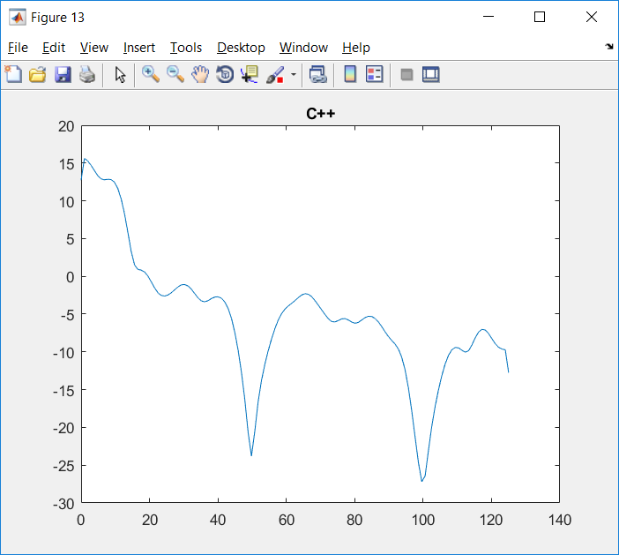

Same frequency vector : 1x129 (from 0 to 125Hz)

1. Comparison of the psd with a signal with 5000 datapoints.

[psdM,fM] = pwelch(inputData, [],[],[],250)

VS

Fifth change of MBT_PWelchComputer and Second change of MBT_Fourier

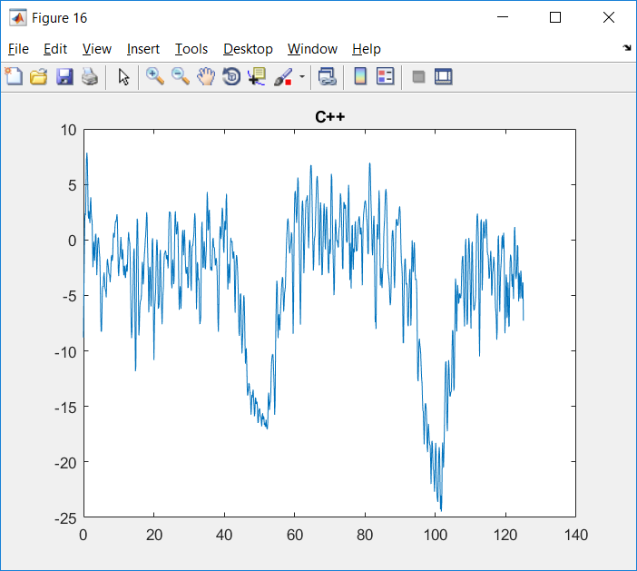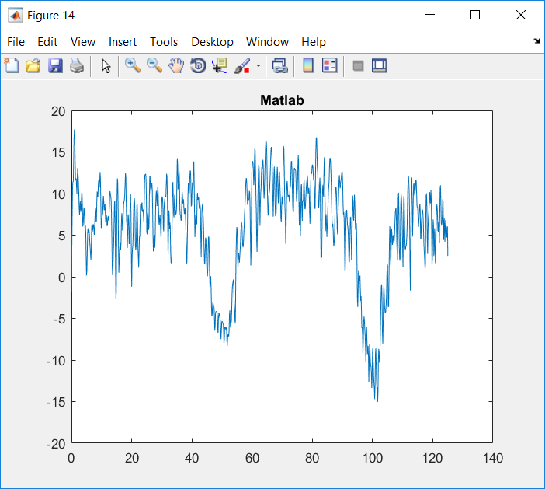

Same frequency vector : 1x1025 (from 0 to 125Hz)

[psdM,fM] = pwelch(inputData, [],[],[],250)

VS

Sixth change of MBT_PWelchComputer and Second change of MBT_Fourier

**Sixth change of MBT_PWelchComputer.cpp:**

Divide the power by samplingRate like in Matlab.

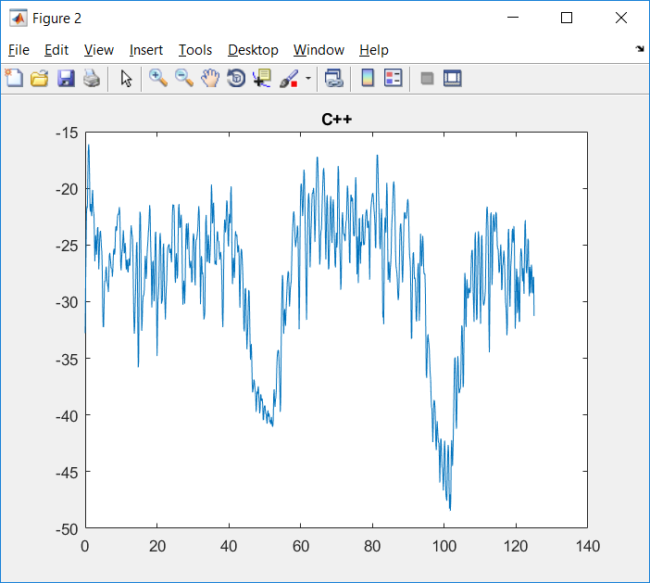

Same frequency vector : 1x1025 (from 0 to 125Hz)

[psdM,fM] = pwelch(inputData, [],[],[],250)

VS

Seventh change of MBT_PWelchComputer and Second change of MBT_Fourier

**Seventh change of MBT_PWelchComputer.cpp:**

Add a new method to compute fft and use it instead of MBT_Fourier::forwardBluesteinFFT.

This new nethod was found here: <http://stackoverflow.com/questions/10121574/safe-and-fast-fft>

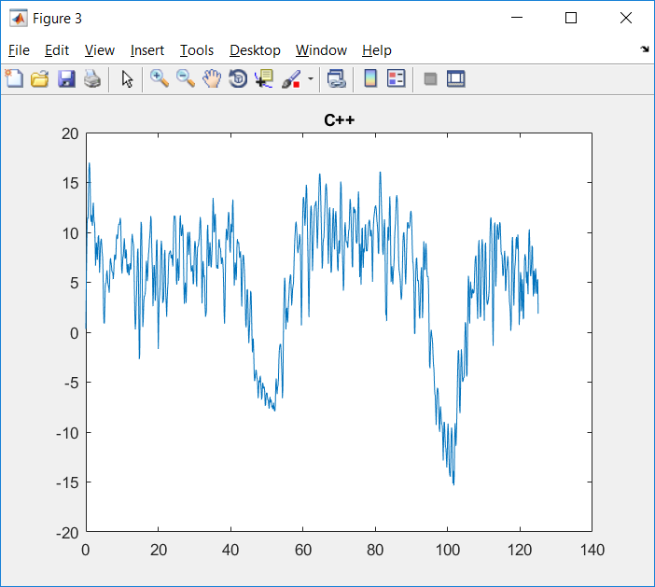

Same frequency vector : 1x1025 (from 0 to 125Hz)

For a signal of 250 datapoints:

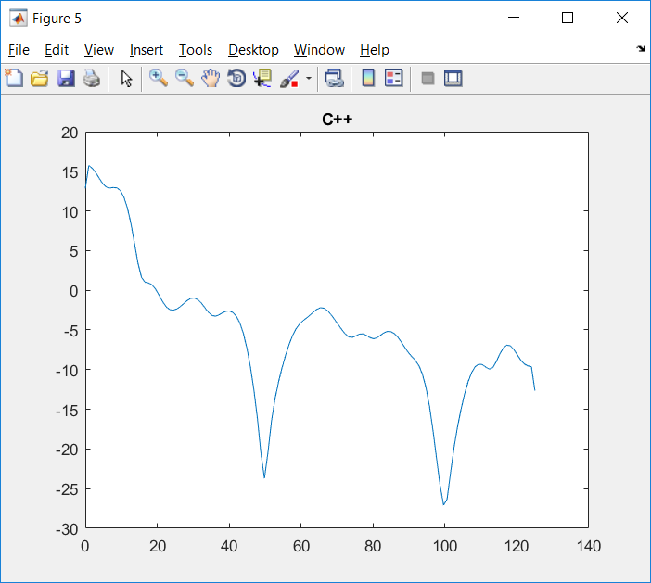

Conclusion: almost the same trend at the same level but not exactly exactly the same values.

See below the little differences:



1. Comparison of the psd with a signal with 160000 datapoints.

160000 datapoints ~ 10.667min

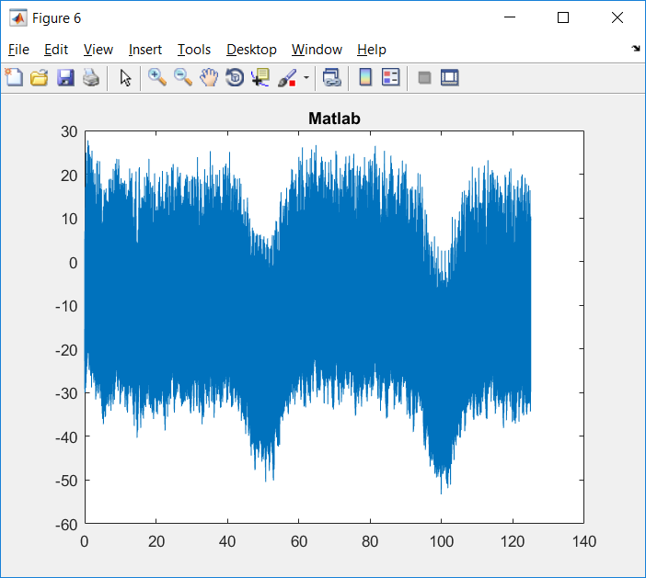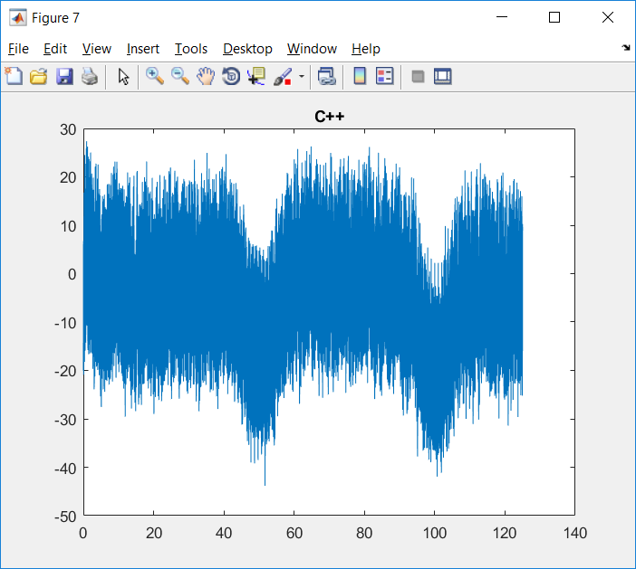

Same frequency vector : 1x32769(from 0 to 125Hz)

In C++, a such signal need 213,856s = 3.56min to compute fft…

1. Adjustement of MBT_Fourier to have the same result than with fft

.

[psdM,fM] = pwelch(inputData, [],[],[],250)

VS

Seventh change of MBT_PWelchComputer and Third change of MBT_Fourier

**Third change of MBT_Fourier.cpp:**

void **MBT_Fourier::forwardBluesteinFFT**(std::vector<std::complex<float> >& inputData, const MBT_FourierOptions option)

{

MBT_FourierBluestein::bluestein(inputData, getExponentSign(option));

//forwardScaling(inputData, option); //No done in fft of <http://stackoverflow.com/questions/10121574/safe-and-fast-fft>

}

template<typename T>

void **MBT_Fourier::radix2Reorder**(std::vector<T>& inputData)

{

int j = 0;

for (int i = 0; i < inputData.size() - 1; i++)

{

//Swap values

if (i < j)

{

T temp = inputData[i];

inputData[i] = inputData[j];

inputData[j] = temp;

}

//int len = (int)inputData.size();

int len = (int)inputData.size()/2; // like in <http://stackoverflow.com/questions/10121574/safe-and-fast-fft>

//do // Comment by Fanny Grosselin on 2017/01/20

//{ // Comment by Fanny Grosselin on 2017/01/20

//len >>= 1; // Comment by Fanny Grosselin on 2017/01/20

j ^= len;

//} // Comment by Fanny Grosselin on 2017/01/20

while ((j & len) == 0)

{// add these lines like in <http://stackoverflow.com/questions/10121574/safe-and-fast-fft>

len/=2;

j^=len;

};

}

}

void **MBT_Fourier::radix2Step**(std::vector<std::complex<float> >& inputData, const int exponentSign, const int levelSize, const int indexInLevel)

{

// Twiddle Factor

const float PI_F=3.14159265358979f;

float exponent = (exponentSign * indexInLevel) * PI_F / levelSize;

std::complex<float> w (cos(exponent), sin(exponent));

//int step = levelSize << 1; // Commented by Fanny Grosselin 2017/01/20

//for (int i = indexInLevel; i < inputData.size(); i += step)

for (int i = indexInLevel; i < inputData.size(); i += 2*levelSize) // like on <http://stackoverflow.com/questions/10121574/safe-and-fast-fft>

{

std::complex<float> value = inputData[i];

std::complex<float> modifier = w * inputData[i + levelSize];

inputData[i] = value + modifier;

inputData[i + levelSize] = value - modifier;

}

}

Signal of 250 datapoints:

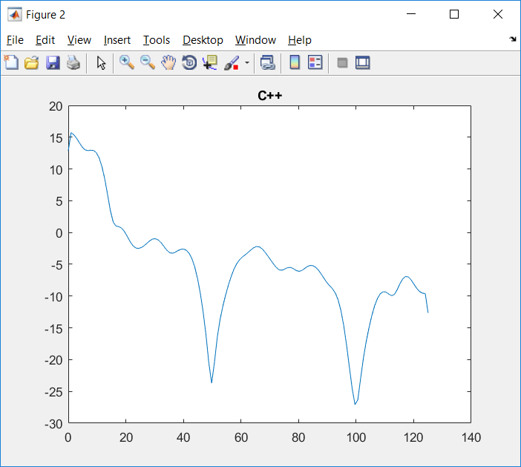

Signal of 5000 datapoints:

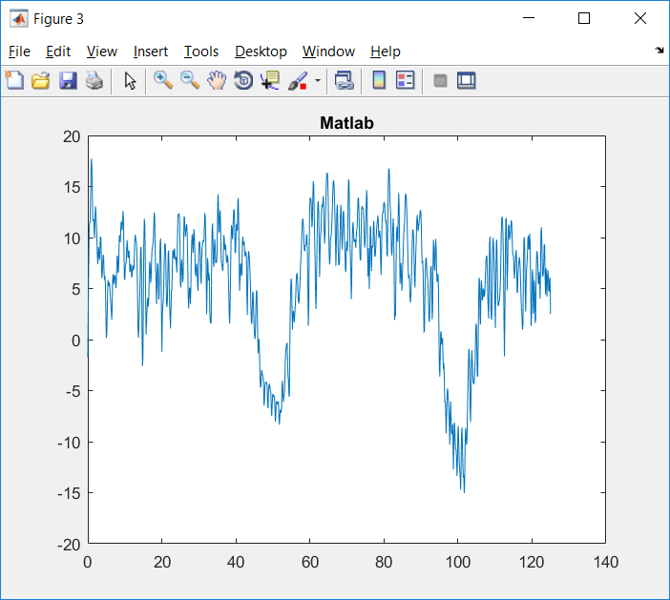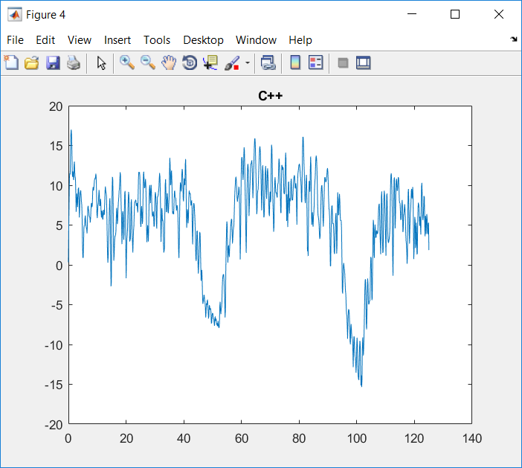

Signal of 160000 datapoints:

