**SQL92标准语句Mycat支持测试**

**（基于Oracle和MySQL数据库）**

2015-04-22

测试环境

操作系统：CentOS release 5.10 (Final)

CPU信息：Intel(R) Core(TM) i3-3110M CPU @ 2.40GHz

Oracle版本：10.2.0

MySQL版本：5.5.27，InnoDB 1.1.8

Mycat 版本信息：BuildTime 2015-03-18

MavenVersion 1.4-dev

目录

一、数据定义命令测试 6

1、CREATE TABLE 创建一个数据库表 6

（1）Oracle环境测试 6

（2）MySQL环境测试 7

2、DROP TABLE 从数据库中删除表 8

（1）Oracle环境测试 8

（2）MySQL环境测试 9

3、ALTER TABLE 修改数据库表结构 10

（1）Oracle环境测试 11

（2）MySQL环境测试 13

4、CREATE VIEW 创建一个视图 14

（1）Oracle环境测试 14

（2）MySQL环境测试 15

5、DROP VIEW 从数据库中删除视图 17

（1）Oracle环境测试 17

（2）MySQL环境测试 18

6、CREATE INDEX 为数据库表创建一个索引 18

（1）Oracle环境测试 19

（2）MySQL环境测试 19

7、DROP INDEX 从数据库中删除索引 21

（1）Oracle环境测试 22

（2）MySQL环境测试 23

8、CREATE PROCEDURE 创建一个存储过程 24

（1）Oracle环境测试 24

（2）MySQL环境测试 25

二、数据操作命令测试 25

1、SELECT 从数据库表中检索数据行和列 25

（1）Oracle环境测试 26

（2）MySQL环境测试 26

2、INSERT 向数据库表添加新数据行 27

（1）Oracle环境测试 27

（2）MySQL环境测试 28

3、DELETE 从数据库表中删除数据行 29

（1）Oracle环境测试 29

（2）MySQL环境测试 29

4、UPDATE 更新数据库表中的数据 30

（1）Oracle 环境测试 30

（2）MySQL环境测试 31

5、TRUNCATE 删除表中所有行，仍保持表的完整性 32

（1）Oracle环境测试 33

（2）MySQL环境测试 33

6、SELECT 查询条件关键字 34

（1）Oracle环境测试 35

（2）MySQL环境测试 38

7、SELECT子查询与表连接查询 41

（1）Oracle环境测试 42

（2）MySQL环境测试 43

8、FUNCTION 统计函数 45

（1）Oracle环境测试 45

（2）MySQL环境测试 47

9、FUNCTION 字符串函数 49

（1）Oracle环境测试 50

（2）MySQL环境测试 54

10、FUNCTION 日期函数 59

（1）Oracle环境测试 60

（2）MySQL环境测试 61

三、SQL92测试总结 63

1、测试问题汇总 63

（1）DROP TABLE 从数据库中删除表 63

（2）ALTER TABLE 修改数据库表结构 63

（3）CREATE VIEW 创建一个视图 64

（4）DROP VIEW 从数据库中删除视图 65

（5）DROP INDEX 从数据库中删除索引（MySQL也不支持） 65

（6）CREATE PROCEDURE 创建一个存储过程（MySQL也不支持） 65

（7）DELETE 从数据库表中删除数据行 65

（8）SELECT子查询与表连接查询 65

（9）FUNCTION 字符串函数 66

（10）FUNCTION 日期函数 66

2、测试结论 66

# 一、数据定义命令测试

## 1、CREATE TABLE 创建一个数据库表

测试语句：

create table employee (id int not null primary key,name varchar(100),sharding_id int not null);

explain create table company(id int not null primary key,name varchar(100));

测试结果：支持该语句

测试过程：

### （1）Oracle环境测试

#### 1）操作employee表

mysql> explain create table employee (id int not null primary key,name varchar(100),sharding_id int not null);

+-----------+-----------------------------------------------------------------+

|DATA_NODE|SQL |

+-----------+-----------------------------------------------------------------+

| dn1 | create table employee (id int not null primary key,name varchar(100),sharding_id int not null) |

| dn2 | create table employee (id int not null primary key,name varchar(100),sharding_id int not null) |

+-----------+-----------------------------------------------------------------+

2 rows in set (0.00 sec)

mysql> create table employee (id int not null primary key,name varchar(100),sharding_id int not null);

Query OK, 0 rows affected (0.09 sec)

OK!

#### 2）操作company表

mysql> explain create table company(id int not null primary key,name varchar(100));

+-----------+-----------------------------------------------------------------+

|DATA_NODE|SQL |

+-----------+-----------------------------------------------------------------+

| dn1 | create table company(id int not null primary key,name varchar(100))

| dn2 | create table company(id int not null primary key,name varchar(100))

+-----------+-----------------------------------------------------------------+

2 rows in set (0.00 sec)

mysql> create table company(id int not null primary key,name varchar(100));

Query OK, 0 rows affected (0.30 sec)

OK!

### （2）MySQL环境测试

#### 1）操作employee表

mysql> explain create table employee (id int not null primary key,name varchar(100),sharding_id int not null);

+-----------+-----------------------------------------------------------------+

|DATA_NODE|SQL |

+-----------+-----------------------------------------------------------------+

| dn1 | create table employee (id int not null primary key,name varchar(100),sharding_id int not null) |

| dn2 | create table employee (id int not null primary key,name varchar(100),sharding_id int not null) |

+-----------+-----------------------------------------------------------------+

2 rows in set (0.00 sec)

mysql> create table employee (id int not null primary key,name varchar(100),sharding_id int not null);

Query OK, 0 rows affected (0.17 sec)

#### 2）操作company表

mysql> explain create table company(id int not null primary key,name varchar(100));

+-----------+-----------------------------------------------------------------+

|DATA_NODE|SQL |

+-----------+-----------------------------------------------------------------+

| dn1 | create table company(id int not null primary key,name varchar(100))

| dn2 | create table company(id int not null primary key,name varchar(100))

| dn3 | create table company(id int not null primary key,name varchar(100))

+-----------+-----------------------------------------------------------------+

3 rows in set (0.00 sec)

mysql> create table company(id int not null primary key,name varchar(100));

Query OK, 0 rows affected (0.32 sec)

## 2、DROP TABLE 从数据库中删除表

测试语句：explain drop table company;

测试结果：支持该语句

测试过程：

### （1）Oracle环境测试

#### 1）操作employee表

mysql> explain drop table employee;

+-----------+---------------------+

| DATA_NODE | SQL |

+-----------+---------------------+

| dn1 | drop table employee |

| dn2 | drop table employee |

+-----------+---------------------+

2 rows in set (0.00 sec)

mysql> drop table employee;

Query OK, 0 rows affected (0.17 sec)

OK!

#### 2）操作company表

mysql> explain drop table company;

+-----------+--------------------+

| DATA_NODE | SQL |

+-----------+--------------------+

| dn1 | drop table company |

| dn2 | drop table company |

+-----------+--------------------+

2 rows in set (0.02 sec)

mysql> drop table company;

Query OK, 0 rows affected (3.95 sec)

OK!

注意：如果只有一个节点dn1有表company，另一个节点dn2没有（可能意外删除），执行该语句报错，但实际已经删除dn1上的company表。

java.sql.SQLException: ORA-00942: table or view does not exist

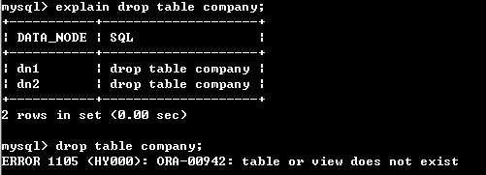

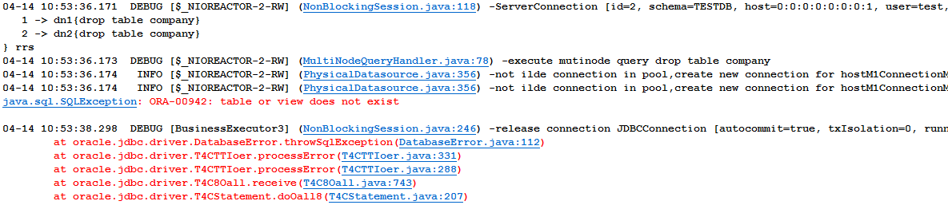

### （2）MySQL环境测试

#### 1）操作employee表

mysql> explain drop table employee;

+-----------+---------------------+

| DATA_NODE | SQL |

+-----------+---------------------+

| dn1 | drop table employee |

| dn2 | drop table employee |

+-----------+---------------------+

2 rows in set (0.06 sec)

mysql> drop table employee;

Query OK, 0 rows affected (0.11 sec)

#### 2）操作company表

mysql> explain drop table company;

+-----------+--------------------+

| DATA_NODE | SQL |

+-----------+--------------------+

| dn1 | drop table company |

| dn2 | drop table company |

| dn3 | drop table company |

+-----------+--------------------+

3 rows in set (0.02 sec)

mysql> drop table company;

Query OK, 0 rows affected (0.36 sec)

## 3、ALTER TABLE 修改数据库表结构

测试语句：

--添加索引

explain alter table employee add index IDX_EMP_NAME (name);

create index IDX_EMP_NAME on employee(name);

--删除索引

explain alter table employee drop index IDX_EMP_NAME;

drop index IDX_EMP_NAME;

--添加唯一约束

explain alter table employee add unique EMP_NAME(name);（MySQL写法）

explain alter table employee add constraint EMP_UNIQUE unique(name);（Oracle写法）

--添加字段

explain alter table employee add age int;

--修改列名

explain alter table employee change name newname varchar(100);（MySQL写法）

explain alter table employee change name newname varchar2(100);

explain alter table employee rename column name to newname;（Oracle写法）

explain alter table employee rename name to newname;

--删除字段

explain alter table employee drop age;

--添加非空约束

explain alter table employee modify name constraint NAME_NOT_NULL not null; （Oracle写法）

explain alter table employee add constraint name check(name is not null); （MySQL语法）

explain alter table employee modify name varchar(2) not null;  （MySQL语法）

测试结果：

MySQL支持以上功能，Oracle只支持少部分功能，不支持添加唯一约，不支持修改列名，不支持删除字段

测试过程：

### （1）Oracle环境测试

mysql> alter table employee add index IDX_EMP_NAME (name);

ERROR 1105 (HY000): ORA-00904: invalid identifier

mysql> create index IDX_EMP_NAME on employee(name);

Query OK, 0 rows affected (0.09 sec)

OK!

mysql> alter table employee add unique EMP_NAME(name);

ERROR 1105 (HY000): ORA-00906: missing left parenthesis

mysql> explain alter table employee add constraint EMP_UNIQUE unique(name);

ERROR 1064 (HY000): com.alibaba.druid.sql.parser.ParserException: TODO UNIQUE unique

mysql> explain alter table employee add age int;

+-----------+----------------------------------+

| DATA_NODE | SQL |

+-----------+----------------------------------+

| dn1 | alter table employee add age int |

| dn2 | alter table employee add age int |

+-----------+----------------------------------+

2 rows in set (0.00 sec)

mysql> alter table employee add age int;

Query OK, 0 rows affected (0.01 sec)

OK!

mysql> alter table employee change name newname varchar2(100);

ERROR 1105 (HY000): ORA-01735: invalid ALTER TABLE option

mysql> alter table employee change name newname varchar(100);

ERROR 1105 (HY000): ORA-01735: invalid ALTER TABLE option

mysql> alter table employee rename column name to newname;

ERROR 1064 (HY000): com.alibaba.druid.sql.parser.ParserException: error COLUMN

mysql> alter table employee rename name to newname;

ERROR 14155 (HY000): ORA-14155: missing PARTITION or SUBPARTITION keyword

mysql> alter table employee drop age;

ERROR 1105 (HY000): ORA-00905: missing keyword

mysql> explain alter table employee modify name constraint NAME_NOT_NULL not null;

ERROR 1064 (HY000): com.alibaba.druid.sql.parser.ParserException: error CONSTRAINT

mysql> explain alter table employee add constraint name check(name is not null);

ERROR 1064 (HY000): com.alibaba.druid.sql.parser.ParserException: TODO CHECK check

mysql> explain alter table employee modify name varchar(2) not null;

+-----------+------------------------------------------------------+

| DATA_NODE | SQL |

+-----------+------------------------------------------------------+

| dn1 | alter table employee modify name varchar(2) not null |

| dn2 | alter table employee modify name varchar(2) not null |

+-----------+------------------------------------------------------+

2 rows in set (0.00 sec)

mysql> alter table employee modify name varchar(2) not null;

Query OK, 0 rows affected (0.03 sec)

OK!

### （2）MySQL环境测试

mysql> alter table employee add index IDX_EMP_NAME (name);

Query OK, 0 rows affected (0.31 sec)

Records: 0 Duplicates: 0 Warnings: 0

mysql> create index IDX_EMP_NAME3 on employee(name);

Query OK, 0 rows affected (0.26 sec)

Records: 0 Duplicates: 0 Warnings: 0

mysql> alter table employee drop index IDX_EMP_NAME;

Query OK, 0 rows affected (0.23 sec)

Records: 0 Duplicates: 0 Warnings: 0

mysql> drop index IDX_EMPLOYEE_NAME;

ERROR 1064 (42000): You have an error in your SQL syntax; check the manual that corresponds to your MySQL server version for the right syntax to use near '' at line 1

mysql> alter table employee add unique EMP_NAME(name);

Query OK, 0 rows affected (0.23 sec)

Records: 0 Duplicates: 0 Warnings: 0

mysql> explain alter table employee add constraint EMP_UNIQUE unique(name);

ERROR 1064 (HY000): com.alibaba.druid.sql.parser.ParserException: TODO UNIQUE unique

mysql> alter table employee add age int;

Query OK, 1 row affected (0.46 sec)

Records: 0 Duplicates: 0 Warnings: 0

mysql> alter table employee change name newname varchar(100);

Query OK, 1 row affected (0.39 sec)

Records: 1 Duplicates: 0 Warnings: 0

mysql> alter table employee drop age;

Query OK, 1 row affected (0.42 sec)

Records: 1 Duplicates: 0 Warnings: 0

mysql> explain alter table employee modify name constraint NAME_NOT_NULL not null;

ERROR 1064 (HY000): com.alibaba.druid.sql.parser.ParserException: error CONSTRAINT

mysql> alter table employee modify name varchar(2) not null;

Query OK, 1 row affected (0.59 sec)

Records: 0 Duplicates: 0 Warnings: 0

## 4、CREATE VIEW 创建一个视图

测试语句：

explain create view v_comp as select * from company;

explain create view v_emp as select * from employee;

测试结果：支持该语句, 但须在schema.xml添加该视图（使用table标签）

测试过程：

### （1）Oracle环境测试

mysql> explain create view v_comp as select * from company;

+-----------------+-----------------------------------------------------------+

| DATA_NODE | SQL |

+-----------------+-----------------------------------------------------------+

| dn1 | create view v_comp as select * from company |

| dn2 | create view v_comp as select * from company |

+-----------------+-----------------------------------------------------------+

1. rows in set (0.00 sec)

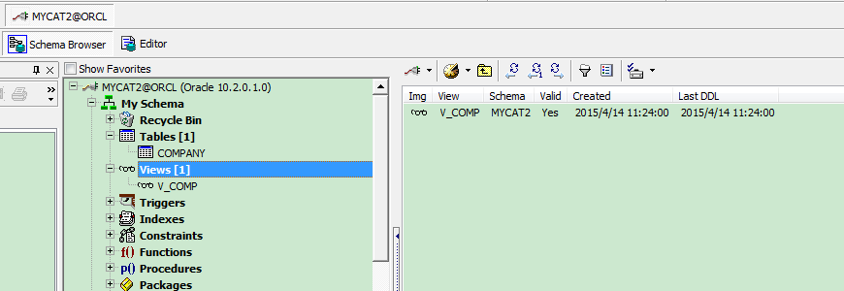

### （2）MySQL环境测试

在schema.xml中添加标签

<table name="v_comp" primaryKey="ID" type="global" dataNode="dn1,dn2,dn3" />

mysql> explain create view v_comp as select * from company;

+-----------+---------------------------------------------+

| DATA_NODE | SQL |

+-----------+---------------------------------------------+

| dn1 | create view v_comp as select * from company |

| dn2 | create view v_comp as select * from company |

| dn3 | create view v_comp as select * from company |

+-----------+---------------------------------------------+

3 rows in set (0.01 sec)

mysql> create view v_comp as select * from company;

Query OK, 0 rows affected (0.14 sec)

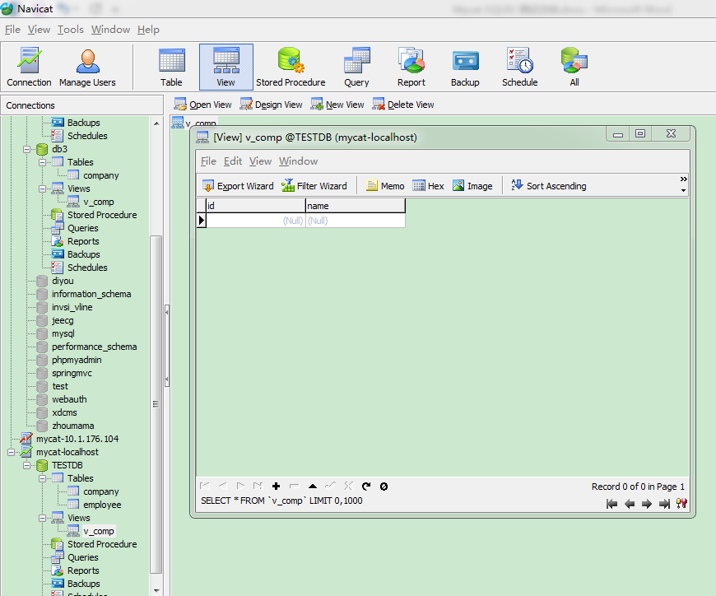

若不加标签，也可以执行成功，但打开视图时报错，如下图所示：

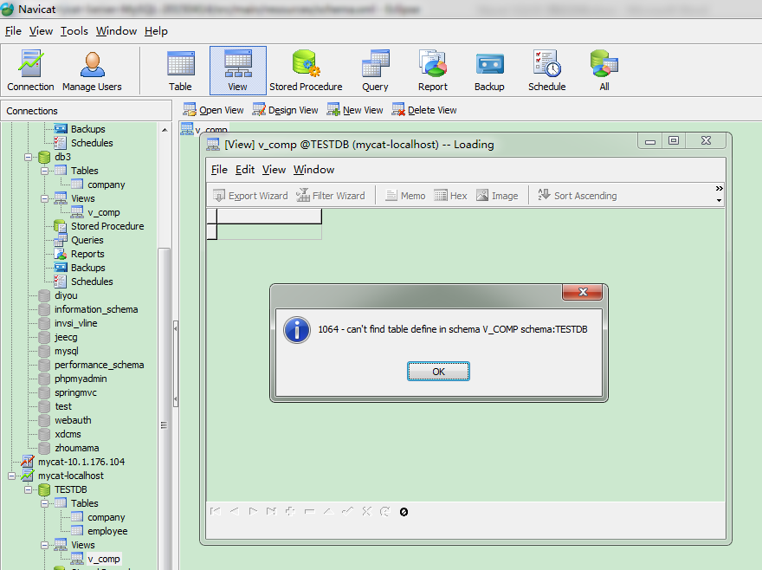

## 5、DROP VIEW 从数据库中删除视图

测试语句：

explain drop view v_comp;

测试结果：支持该语句，但须在schema.xml添加该视图（使用table标签），方法见下文

测试过程：

### （1）Oracle环境测试

在schema.xml中添加以下语句：

<table name="v_comp" primaryKey="ID" type="global" dataNode="dn1,dn2" />

mysql> explain drop view v_comp;

+-----------------+--------------------------+

| DATA_NODE | SQL |

+-----------------+--------------------------+

| dn1 | drop view v_comp |

| dn2 | drop view v_comp |

+-----------------+--------------------------+

2 rows in set (0.00 sec)



### （2）MySQL环境测试

在schema.xml中添加以下语句：

<table name="v_comp" primaryKey="ID" type="global" dataNode="dn1,dn2,dn3" />

mysql> explain drop view v_comp;

+-----------+------------------+

| DATA_NODE | SQL |

+-----------+------------------+

| dn1 | drop view v_comp |

| dn2 | drop view v_comp |

| dn3 | drop view v_comp |

+-----------+------------------+

3 rows in set (0.17 sec)

mysql> drop view v_comp;

Query OK, 0 rows affected (0.01 sec)

## 6、CREATE INDEX 为数据库表创建一个索引

测试语句：

explain create index IDX_COMPANY_NAME on company(name);

explain create index IDX_EMPLOYEE_NAME on employee(name);

测试结果：支持该语句

测试过程：

### （1）Oracle环境测试

#### 1）操作employee表

mysql> explain create index IDX_EMPLOYEE_NAME on employee(name);

+-----------+--------------------------------------------------+

| DATA_NODE | SQL |

+-----------+--------------------------------------------------+

| dn1 | create index IDX_EMPLOYEE_NAME on employee(name) |

| dn2 | create index IDX_EMPLOYEE_NAME on employee(name) |

+-----------+--------------------------------------------------+

2 rows in set (0.00 sec)

mysql> create index IDX_EMPLOYEE_NAME on employee(name);

Query OK, 0 rows affected (0.06 sec)

OK!

#### 2）操作company表

mysql> explain create index IDX_COMPANY_NAME on company(name);

+-----------+------------------------------------------------+

| DATA_NODE | SQL |

+-----------+------------------------------------------------+

| dn1 | create index IDX_COMPANY_NAME on company(name) |

| dn2 | create index IDX_COMPANY_NAME on company(name) |

+-----------+------------------------------------------------+

2 rows in set (0.00 sec)

mysql> create index IDX_COMPANY_NAME on company(name);

Query OK, 0 rows affected (0.05 sec)

OK!

### （2）MySQL环境测试

#### 1）操作employee表

mysql> explain create index IDX_EMPLOYEE_NAME on employee(name);

+-----------+--------------------------------------------------+

| DATA_NODE | SQL |

+-----------+--------------------------------------------------+

| dn1 | create index IDX_EMPLOYEE_NAME on employee(name) |

| dn2 | create index IDX_EMPLOYEE_NAME on employee(name) |

+-----------+--------------------------------------------------+

2 rows in set (0.00 sec)

mysql> create index IDX_EMPLOYEE_NAME on employee(name);

Query OK, 0 rows affected (0.30 sec)

Records: 0 Duplicates: 0 Warnings: 0

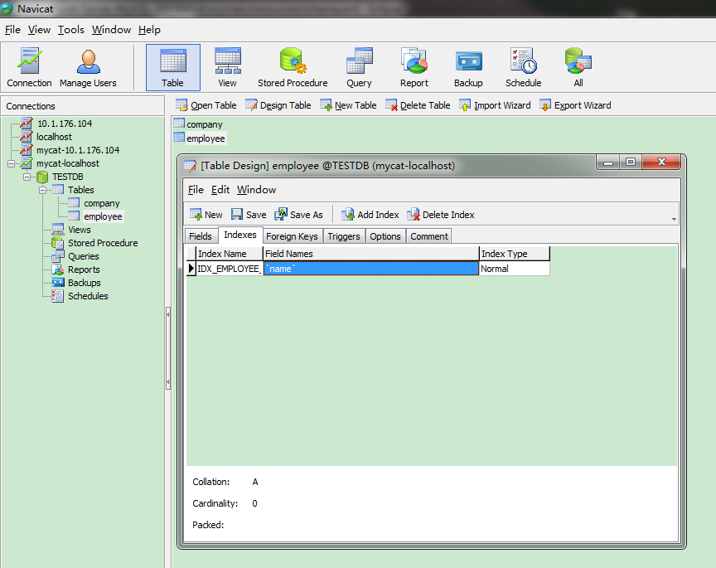

#### 2）操作company表

mysql> explain create index IDX_COMPANY_NAME on company(name);

+-----------+------------------------------------------------+

| DATA_NODE | SQL |

+-----------+------------------------------------------------+

| dn1 | create index IDX_COMPANY_NAME on company(name) |

| dn2 | create index IDX_COMPANY_NAME on company(name) |

| dn3 | create index IDX_COMPANY_NAME on company(name) |

+-----------+------------------------------------------------+

3 rows in set (0.00 sec)

mysql> create index IDX_COMPANY_NAME on company(name);

Query OK, 0 rows affected (0.41 sec)

Records: 0 Duplicates: 0 Warnings: 0

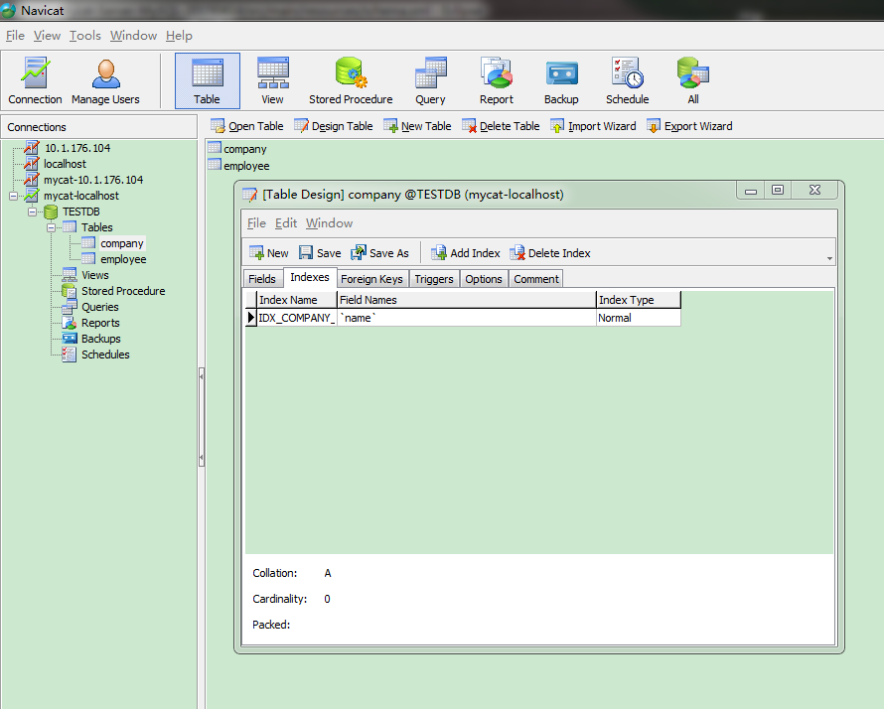

## 7、DROP INDEX 从数据库中删除索引

测试语句：

explain drop index IDX_COMPANY_NAME;

explain drop index IDX_EMPLOYEE_NAME;

测试结果：存在异常，无法在全部节点同时执行删除，执行计划不确定。第一次执行命令在一个节点执行了删除索引，再次执行命令在另一个节点执行。Oracle和MySQL都存在该问题。

测试过程：

### （1）Oracle环境测试

mysql> explain drop index IDX_COMPANY_ID;

+------------------+-------------------------------------------+

| DATA_NODE | SQL |

+------------------+-------------------------------------------+

| dn2 | drop index IDX_COMPANY_ID |

+------------------+-------------------------------------------+

1 row in set (0.00 sec)

mysql> explain drop index IDX_COMPANY_ID;

+------------------+-------------------------------------------+

| DATA_NODE | SQL |

+------------------+-------------------------------------------+

| dn1 | drop index IDX_COMPANY_ID |

+------------------+-------------------------------------------+

1 row in set (0.00 sec)

mysql> drop index IDX_COMPANY_ID;

Query OK, 0 rows affected (0.10 sec)

OK!

在另一个节点执行

mysql> explain drop index IDX_COMPANY_ID;

+-----------+---------------------------+

| DATA_NODE | SQL |

+-----------+---------------------------+

| dn1 | drop index IDX_COMPANY_ID |

+-----------+---------------------------+

1 row in set (0.00 sec)

mysql> explain drop index IDX_COMPANY_ID;

+-----------+---------------------------+

| DATA_NODE | SQL |

+-----------+---------------------------+

| dn2 | drop index IDX_COMPANY_ID |

+-----------+---------------------------+

1 row in set (0.00 sec)

mysql> drop index IDX_COMPANY_ID;

Query OK, 0 rows affected (0.07 sec)

OK!

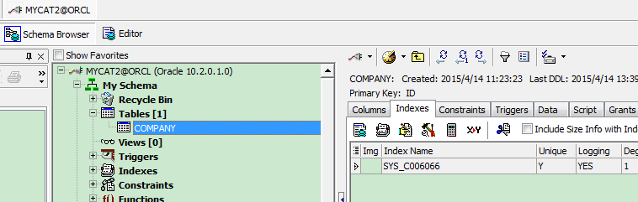

### （2）MySQL环境测试

mysql> explain drop index IDX_EMPLOYEE_NAME;

+-----------+------------------------------+

| DATA_NODE | SQL |

+-----------+------------------------------+

| dn1 | drop index IDX_EMPLOYEE_NAME |

+-----------+------------------------------+

1 row in set (0.00 sec)

mysql> explain drop index IDX_EMPLOYEE_NAME;

+-----------+------------------------------+

| DATA_NODE | SQL |

+-----------+------------------------------+

| dn2 | drop index IDX_EMPLOYEE_NAME |

+-----------+------------------------------+

1 row in set (0.00 sec)

mysql> explain drop index IDX_COMPANY_NAME;

+-----------+-----------------------------+

| DATA_NODE | SQL |

+-----------+-----------------------------+

| dn1 | drop index IDX_COMPANY_NAME |

+-----------+-----------------------------+

1 row in set (0.00 sec)

mysql> explain drop index IDX_COMPANY_NAME;

+-----------+-----------------------------+

| DATA_NODE | SQL |

+-----------+-----------------------------+

| dn2 | drop index IDX_COMPANY_NAME |

+-----------+-----------------------------+

1 row in set (0.00 sec)

## 8、CREATE PROCEDURE 创建一个存储过程

测试语句：

create or replace procedure mycat2.pro_insertComp is

begin

insert into company(id,name) values(3,'tiens');

commit;

end pro_insertComp;

CREATE PROCEDURE GreetWorld() SELECT CONCAT(@greeting,'World');

SET @greeting='Hello';

CALL GreetWorld();

测试结果：不支持创建存储过程

测试过程：

### （1）Oracle环境测试

单独在一个数据库节点中，执行存储计划可以成功，但在Mycat中执行失败。

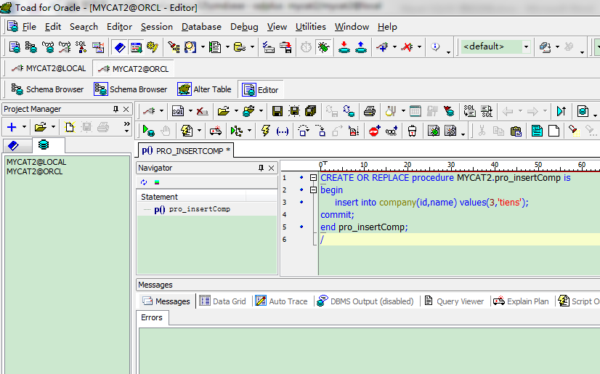

mysql> CREATE OR REPLACE procedure MYCAT2.pro_insertComp is

-> begin

-> insert into company(id,name) values(3,'tiens');

ERROR 1064 (HY000): com.alibaba.druid.sql.parser.ParserException: TODO PROCEDURE

### （2）MySQL环境测试

单独在一个数据库节点中，执行存储计划可以成功，但在Mycat中执行失败。

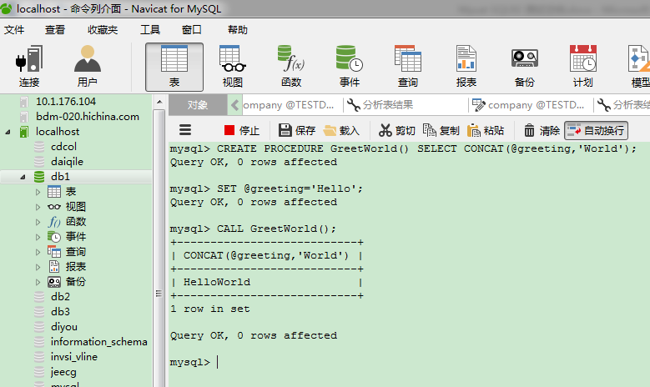

mysql> CREATE PROCEDURE GreetWorld() SELECT CONCAT(@greeting,'World');

-> SET @greeting='Hello';

-> CALL GreetWorld();

-> CALL GreetWorld();

# 二、数据操作命令测试

## 1、SELECT 从数据库表中检索数据行和列

测试语句：

explain select * from employee;

explain select * from company;

测试结果：支持该语句

测试过程：

### （1）Oracle环境测试

#### 1）操作employee表

mysql> explain select * from employee;

+-----------+--------------------------------------------+

| DATA_NODE | SQL |

+-----------+--------------------------------------------+

| dn1 | SELECT * FROM employee WHERE ROWNUM <= 100 |

| dn2 | SELECT * FROM employee WHERE ROWNUM <= 100 |

+-----------+--------------------------------------------+

2 rows in set (0.36 sec)

mysql> select * from employee;

Empty set (0.18 sec)

#### 2）操作company表

全局表在每一个节点的数据相同，因此可在任意节点执行查询。

mysql> explain select * from company;

+-----------+---------------------------------+

| DATA_NODE | SQL |

+-----------+---------------------------------+

| dn2 | SELECT * FROM company LIMIT 100 |

+-----------+---------------------------------+

1 row in set (0.00 sec)

mysql> select * from company;

Empty set (0.00 sec)

### （2）MySQL环境测试

#### 1）操作employee表

mysql> explain select * from employee;

+-----------+----------------------------------+

| DATA_NODE | SQL |

+-----------+----------------------------------+

| dn1 | SELECT * FROM employee LIMIT 100 |

| dn2 | SELECT * FROM employee LIMIT 100 |

+-----------+----------------------------------+

2 rows in set (0.00 sec)

mysql> select * from employee;

Empty set (0.00 sec)

#### 2）操作company表

mysql> explain select * from company;

+-----------+-------------------------------------------+

| DATA_NODE | SQL |

+-----------+-------------------------------------------+

| dn2 | SELECT * FROM company WHERE ROWNUM <= 100 |

+-----------+-------------------------------------------+

1 row in set (0.00 sec)

mysql> select * from company;

Empty set (0.01 sec)

## 2、INSERT 向数据库表添加新数据行

测试语句：

explain insert into employee(id,name,sharding_id) values(1,'znl',10000);

explain insert into company(id,name) values(1,'znl');

测试结果：支持该语句

测试过程：

### （1）Oracle环境测试

#### 1）操作employee表

mysql> explain insert into employee(id,name,sharding_id) values(1,'znl',10000);

+-----------+-----------------------------------------------------------------+

| DATA_NODE | SQL |

+-----------+-----------------------------------------------------------------+

| dn1 | insert into employee(id,name,sharding_id) values(1,'znl',10000) |

+-----------+-----------------------------------------------------------------+

1 row in set (0.09 sec)

#### 2）操作company表

mysql> explain insert into company(id,name) values(1,'znl');

+-----------+----------------------------------------------+

| DATA_NODE | SQL |

+-----------+----------------------------------------------+

| dn1 | insert into company(id,name) values(1,'znl') |

| dn2 | insert into company(id,name) values(1,'znl') |

+-----------+----------------------------------------------+

2 rows in set (0.00 sec)

### （2）MySQL环境测试

#### 1）操作employee表

mysql> explain insert into employee(id,name,sharding_id) values(1,'znl',10000);

+-----------+-----------------------------------------------------------------+

| DATA_NODE | SQL |

+-----------+-----------------------------------------------------------------+

| dn1 | insert into employee(id,name,sharding_id) values(1,'znl',10000) |

+-----------+-----------------------------------------------------------------+

1 row in set (0.00 sec)

mysql> insert into employee(id,name,sharding_id) values(1,'znl',10000);

Query OK, 1 row affected (0.08 sec)

#### 2）操作company表

mysql> explain insert into company(id,name) values(1,'znl');

+-----------+----------------------------------------------+

| DATA_NODE | SQL |

+-----------+----------------------------------------------+

| dn1 | insert into company(id,name) values(1,'znl') |

| dn2 | insert into company(id,name) values(1,'znl') |

| dn3 | insert into company(id,name) values(1,'znl') |

+-----------+----------------------------------------------+

3 rows in set (0.00 sec)

mysql> insert into company(id,name) values(1,'znl');

Query OK, 3 rows affected (0.10 sec)

## 3、DELETE 从数据库表中删除数据行

测试语句：explain delete from employee where id=1;

explain delete from company where id=1;

测试结果：Oracle环境不支持该语句，MySQL环境支持该语句

测试过程：

### （1）Oracle环境测试

mysql> explain delete from employee where id=1;

ERROR 1064 (HY000): com.alibaba.druid.sql.parser.ParserException: ERROR. token : DELETE, pos :6



### （2）MySQL环境测试

#### 1）操作employee表

mysql> explain delete from employee where id=1;

+-----------+---------------------------------+

| DATA_NODE | SQL |

+-----------+---------------------------------+

| dn2 | delete from employee where id=1 |

| dn1 | delete from employee where id=1 |

+-----------+---------------------------------+

2 rows in set (0.04 sec)

mysql> delete from employee where id=1;

Query OK, 1 row affected (0.06 sec)

#### 2）操作company表

mysql> explain delete from company where id=1;

+-----------+--------------------------------+

| DATA_NODE | SQL |

+-----------+--------------------------------+

| dn1 | delete from company where id=1 |

| dn2 | delete from company where id=1 |

| dn3 | delete from company where id=1 |

+-----------+--------------------------------+

3 rows in set (0.00 sec)

mysql> delete from company where id=1;

Query OK, 3 rows affected (0.10 sec)

## 4、UPDATE 更新数据库表中的数据

测试语句：

explain update employee set name='newname' where id=1;

explain update company set name='newname' where id=1;

测试结果：支持该语句

测试过程：

### （1）Oracle 环境测试

#### 1）操作employee表

mysql> explain update employee set name='newname' where id=1;

+-----------+-----------------------------------------------+

| DATA_NODE | SQL |

+-----------+-----------------------------------------------+

| dn2 | update employee set name='newname' where id=1 |

| dn1 | update employee set name='newname' where id=1 |

+-----------+-----------------------------------------------+

2 rows in set (0.00 sec)

mysql> update employee set name='newname' where id=1;

Query OK, 0 rows affected (0.31 sec)

OK!

#### 2）操作company表

mysql> explain update company set name='newname' where id=1;

+-----------+----------------------------------------------+

| DATA_NODE | SQL |

+-----------+----------------------------------------------+

| dn1 | update company set name='newname' where id=1 |

| dn2 | update company set name='newname' where id=1 |

+-----------+----------------------------------------------+

2 rows in set (0.00 sec)

mysql> update company set name='newname' where id=1;

Query OK, 0 rows affected (0.02 sec)

OK!

### （2）MySQL环境测试

#### 1）操作employee表

mysql> explain update employee set name='newname' where id=1;

+-----------+-----------------------------------------------+

| DATA_NODE | SQL |

+-----------+-----------------------------------------------+

| dn2 | update employee set name='newname' where id=1 |

| dn1 | update employee set name='newname' where id=1 |

+-----------+-----------------------------------------------+

2 rows in set (0.04 sec)

mysql> update employee set name='newname' where id=1;

Query OK, 1 row affected (0.04 sec)

Rows matched: 1 Changed: 1 Warnings: 0

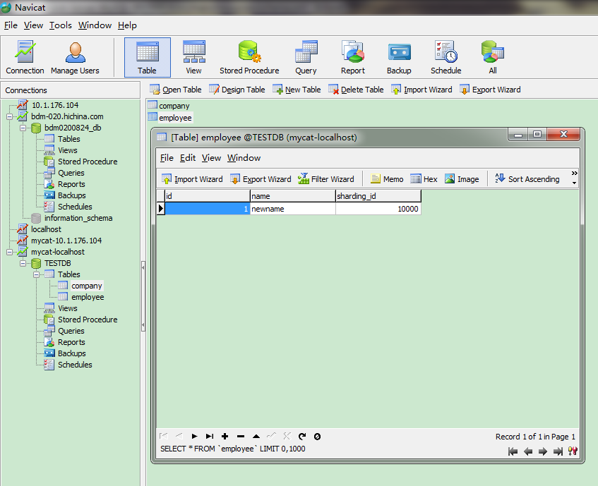

#### 2）操作company表

mysql> explain update company set name='newname' where id=1;

+-----------+----------------------------------------------+

| DATA_NODE | SQL |

+-----------+----------------------------------------------+

| dn1 | update company set name='newname' where id=1 |

| dn2 | update company set name='newname' where id=1 |

| dn3 | update company set name='newname' where id=1 |

+-----------+----------------------------------------------+

3 rows in set (0.00 sec)

mysql> update company set name='newname' where id=1;

Query OK, 3 rows affected (0.11 sec)

Rows matched: 1 Changed: 1 Warnings: 0

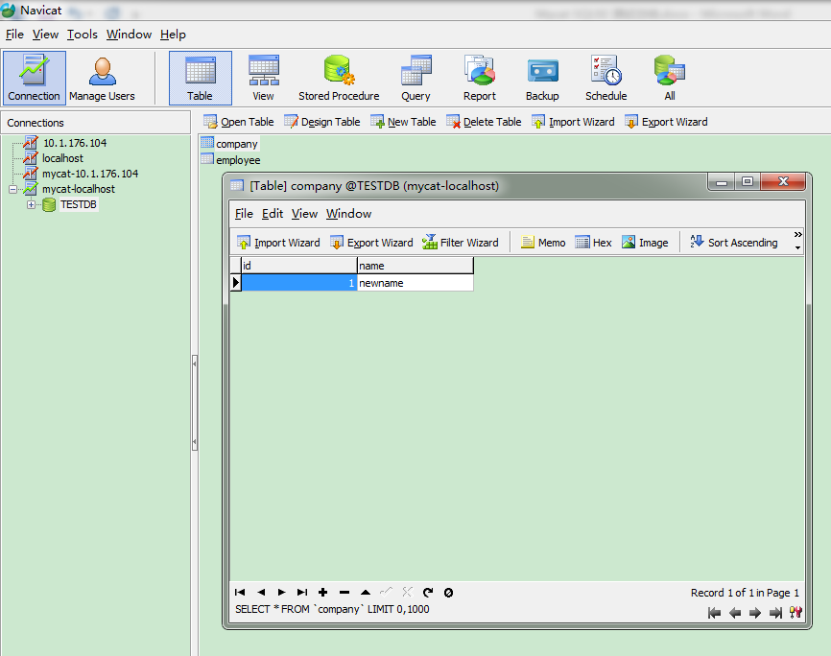

## 5、TRUNCATE 删除表中所有行，仍保持表的完整性

测试语句：explain truncate table employee;

explain truncate table company;

测试结果：支持该语句

测试过程：

### （1）Oracle环境测试

#### 1）操作employee表

mysql> explain truncate table employee;

+-----------+-------------------------+

| DATA_NODE | SQL |

+-----------+-------------------------+

| dn1 | truncate table employee |

| dn2 | truncate table employee |

+-----------+-------------------------+

2 rows in set (0.00 sec)

mysql> truncate table employee;

Query OK, 0 rows affected (0.04 sec)

OK!

#### 2）操作company表

mysql> explain truncate table company;

+-----------+------------------------+

| DATA_NODE | SQL |

+-----------+------------------------+

| dn1 | truncate table company |

| dn2 | truncate table company |

+-----------+------------------------+

2 rows in set (0.00 sec)

mysql> truncate table company;

Query OK, 0 rows affected (0.01 sec)

OK!

### （2）MySQL环境测试

#### 1）操作employee表

mysql> explain truncate table employee;

+-----------+-------------------------+

| DATA_NODE | SQL |

+-----------+-------------------------+

| dn1 | truncate table employee |

| dn2 | truncate table employee |

+-----------+-------------------------+

2 rows in set (0.00 sec)

mysql> truncate table employee;

Query OK, 0 rows affected (0.30 sec)

#### 1）操作company表

mysql> explain truncate table company;

+-----------+------------------------+

| DATA_NODE | SQL |

+-----------+------------------------+

| dn1 | truncate table company |

| dn2 | truncate table company |

| dn3 | truncate table company |

+-----------+------------------------+

3 rows in set (0.00 sec)

mysql> truncate table company;

Query OK, 0 rows affected (0.21 sec)

## 6、SELECT 查询条件关键字

测试语句：

explain select * from employee where id=1;

explain select * from employee where name='a';

explain select * from employee where name like '%a%';

explain select * from employee where name='a' or name='b';

explain select * from employee where id<100;

explain select * from employee where id between 1 and 100;

explain select * from employee where id in (1,3,5);

explain select * from employee order by id asc;

explain select distinct name from employee;

explain select * from employee group by name;

explain select * from employee group by name having count(*) = 2;

测试结果：支持以上命令，“distinct”命令转化为“group by”

测试过程：

### （1）Oracle环境测试

mysql> explain select * from employee where id=1;

+-----------+-----------------------------------+

| DATA_NODE | SQL |

+-----------+-----------------------------------+

| dn2 | select * from employee where id=1 |

| dn1 | select * from employee where id=1 |

+-----------+-----------------------------------+

2 rows in set (0.00 sec)

mysql> select * from employee where id=1;

Empty set (0.11 sec)

mysql> explain select * from employee where name='a';

+-----------+------------------------------------------------------------+

| DATA_NODE | SQL |

+-----------+------------------------------------------------------------+

| dn2 | SELECT * FROM employee WHERE name = 'a' AND ROWNUM <= 100 |

| dn1 | SELECT * FROM employee WHERE name = 'a' AND ROWNUM <= 100 |

+-----------+------------------------------------------------------------+

2 rows in set (0.06 sec)

mysql> select * from employee where name='a';

Empty set (0.12 sec)

mysql> explain select * from employee where name like '%a%';

+-----------+-----------------------------------------------------------------+

| DATA_NODE | SQL |

+-----------+-----------------------------------------------------------------+

| dn1 | SELECT * FROM employee WHERE name LIKE '%a%'AND ROWNUM <= 100 |

| dn2 | SELECT * FROM employee WHERE name LIKE '%a%'AND ROWNUM <= 100 |

+-----------+-----------------------------------------------------------------+

2 rows in set (0.01 sec)

mysql> select * from employee where name like '%a%';

Empty set (0.04 sec)

mysql> explain select * from employee where name='a' or name='b';

+-----------+-----------------------------------------------------------------+

|DATA_NODE |SQL |

+-----------+-----------------------------------------------------------------+

| dn2 | SELECT * FROM employee WHERE (name = 'a' OR name = 'b') AND ROWNUM <= 100 |

| dn1 | SELECT * FROM employee WHERE (name = 'a' OR name = 'b')AND ROWNUM <= 100 |

+-----------+-----------------------------------------------------------------+

2 rows in set (0.00 sec)

mysql> select * from employee where name='a' or name='b';

Empty set (0.01 sec)

mysql> explain select * from employee where id<100;

+-----------+----------------------------------------------------------+

| DATA_NODE | SQL |

+-----------+----------------------------------------------------------+

| dn1 | SELECT * FROM employee WHERE id < 100 AND ROWNUM <= 100 |

| dn2 | SELECT * FROM employee WHERE id < 100 AND ROWNUM <= 100 |

+-----------+----------------------------------------------------------+

2 rows in set (0.00 sec)

mysql> select * from employee where id<100;

Empty set (0.06 sec)

mysql> explain select * from employee where id between 1 and 100;

+-----------+---------------------------------------------------+

| DATA_NODE | SQL |

+-----------+---------------------------------------------------+

| dn2 | select * from employee where id between 1 and 100 |

| dn1 | select * from employee where id between 1 and 100 |

+-----------+---------------------------------------------------+

2 rows in set (0.00 sec)

mysql> select * from employee where id between 1 and 100;

Empty set (0.01 sec)

mysql> explain select * from employee where id in (1,3,5);

+-----------+--------------------------------------------+

| DATA_NODE | SQL |

+-----------+--------------------------------------------+

| dn2 | select * from employee where id in (1,3,5) |

| dn1 | select * from employee where id in (1,3,5) |

+-----------+--------------------------------------------+

2 rows in set (0.00 sec)

mysql> select * from employee where id in (1,3,5);

Empty set (0.01 sec)

mysql> explain select * from employee order by id asc;

+-----------+-----------------------------------------------------------------+

|DATA_NODE |SQL |

+-----------+-----------------------------------------------------------------+

| dn1 | SELECT XX.*, ROWNUM AS RN FROM (SELECT * FROM employee ORDER BY id ASC) XX WHERE ROWNUM <= 100 |

| dn2 | SELECT XX.*, ROWNUM AS RN FROM (SELECT * FROM employee ORDER BY id ASC) XX WHERE ROWNUM <= 100 |

+-----------+-----------------------------------------------------------------+

2 rows in set (0.01 sec)

mysql> select * from employee order by id asc;

Empty set (0.01 sec)

mysql> explain select * from employee where id=(select id from employee where name='a');

+-----------+-----------------------------------------------------------------+

|DATA_NODE |SQL |

+-----------+-----------------------------------------------------------------+

| dn2 | SELECT * FROM employee WHERE id = (SELECT id FROM employee WHERE name = 'a') AND ROWNUM <= 100 |

| dn1 | SELECT * FROM employee WHERE id = (SELECT id FROM employee WHERE name = 'a') AND ROWNUM <= 100 |

+-----------+-----------------------------------------------------------------+

2 rows in set (0.01 sec)

mysql> select * from employee where id=(select id from employee where name='a');

Empty set (0.04 sec)

mysql> explain select distinct name from employee;

+-----------+-----------------------------------------------------------------+

|DATA_NODE|SQL |

+-----------+-----------------------------------------------------------------+

| dn1 | SELECT XX.*, ROWNUM AS RN FROM (SELECT name FROM employee GROUP BY name) XX WHERE ROWNUM <= 100 |

| dn2 | SELECT XX.*, ROWNUM AS RN FROM (SELECT name FROM employee GROUP BY name) XX WHERE ROWNUM <= 100 |

+-----------+-----------------------------------------------------------------+

2 rows in set (0.00 sec)

mysql> select distinct name from employee;

Empty set (0.05 sec)

mysql> explain select name from employee group by name;

+-----------+-----------------------------------------------------------------+

|DATA_NODE|SQL |

+-----------+-----------------------------------------------------------------+

| dn1 | SELECT XX.*, ROWNUM AS RN FROM (SELECT name FROM employee GROUP BY name) XX WHERE ROWNUM <= 100 |

| dn2 | SELECT XX.*, ROWNUM AS RN FROM (SELECT name FROM employee GROUP BY name) XX WHERE ROWNUM <= 100 |

+-----------+-----------------------------------------------------------------+

2 rows in set (0.00 sec)

mysql> select name from employee group by name;

Empty set (0.01 sec)

mysql> explain select name from employee group by name having count(*)=2;

+-----------+-----------------------------------------------------------------+

|DATA_NODE|SQL |

+-----------+-----------------------------------------------------------------+

| dn1 | SELECT XX.*, ROWNUM AS RN FROM (SELECT name FROM employee GROUP BY name HAVING COUNT(*) = 2) XX WHERE ROWNUM <= 100 |

| dn2 | SELECT XX.*, ROWNUM AS RN FROM (SELECT name FROM employee GROUP BY name HAVING COUNT(*) = 2) XX WHERE ROWNUM <= 100 |

+-----------+-----------------------------------------------------------------+

2 rows in set (0.00 sec)

mysql> select name from employee group by name having count(*)=2;

Empty set (0.01 sec)

### （2）MySQL环境测试

mysql> explain select * from employee where id=1;

+-----------+-----------------------------------+

| DATA_NODE | SQL |

+-----------+-----------------------------------+

| dn2 | select * from employee where id=1 |

| dn1 | select * from employee where id=1 |

+-----------+-----------------------------------+

2 rows in set (0.00 sec)

mysql> select * from employee where id=1;

Empty set (0.00 sec)

mysql> explain select * from employee where name='a';

+-----------+---------------------------------------------------+

| DATA_NODE | SQL |

+-----------+---------------------------------------------------+

| dn2 | SELECT * FROM employee WHERE name = 'a' LIMIT 100 |

| dn1 | SELECT * FROM employee WHERE name = 'a' LIMIT 100 |

+-----------+---------------------------------------------------+

2 rows in set (0.05 sec)

mysql> select * from employee where name='a';

Empty set (0.00 sec)

mysql> explain select * from employee where name like '%a%';

+-----------+--------------------------------------------------------+

| DATA_NODE | SQL |

+-----------+--------------------------------------------------------+

| dn1 | SELECT * FROM employee WHERE name LIKE '%a%' LIMIT 100 |

| dn2 | SELECT * FROM employee WHERE name LIKE '%a%' LIMIT 100 |

+-----------+--------------------------------------------------------+

2 rows in set (0.01 sec)

mysql> select * from employee where name like '%a%';

Empty set (0.00 sec)

mysql> explain select * from employee where name='a' or name='b';

+-----------+-----------------------------------------------------------------+

|DATA_NODE | SQL |

+-----------+-----------------------------------------------------------------+

| dn2 | SELECT * FROM employee WHERE name = 'a' OR name = 'b' LIMIT 100 |

| dn1 | SELECT * FROM employee WHERE name = 'a' OR name = 'b' LIMIT 100 |

+-----------+-----------------------------------------------------------------+

2 rows in set (0.00 sec)

mysql> select * from employee where name='a' or name='b';

Empty set (0.00 sec)

mysql> explain select * from employee where id<100;

+-----------+-------------------------------------------------+

| DATA_NODE | SQL |

+-----------+-------------------------------------------------+

| dn1 | SELECT * FROM employee WHERE id < 100 LIMIT 100 |

| dn2 | SELECT * FROM employee WHERE id < 100 LIMIT 100 |

+-----------+-------------------------------------------------+

2 rows in set (0.00 sec)

mysql> select * from employee where id<100;

Empty set (0.00 sec)

mysql> explain select * from employee where id between 1 and 100;

+-----------+---------------------------------------------------+

| DATA_NODE | SQL |

+-----------+---------------------------------------------------+

| dn2 | select * from employee where id between 1 and 100 |

| dn1 | select * from employee where id between 1 and 100 |

+-----------+---------------------------------------------------+

2 rows in set (0.00 sec)

mysql> select * from employee where id between 1 and 100;

Empty set (0.00 sec)

mysql> explain select * from employee where id in (1,3,5);

+-----------+--------------------------------------------+

| DATA_NODE | SQL |

+-----------+--------------------------------------------+

| dn2 | select * from employee where id in (1,3,5) |

| dn1 | select * from employee where id in (1,3,5) |

+-----------+--------------------------------------------+

2 rows in set (0.00 sec)

mysql> select * from employee where id in (1,3,5);

Empty set (0.00 sec)

mysql> explain select * from employee order by id asc;

+-----------+--------------------------------------------------+

| DATA_NODE | SQL |

+-----------+--------------------------------------------------+

| dn1 | SELECT * FROM employee ORDER BY id ASC LIMIT 100 |

| dn2 | SELECT * FROM employee ORDER BY id ASC LIMIT 100 |

+-----------+--------------------------------------------------+

2 rows in set (0.01 sec)

mysql> select * from employee order by id asc;

Empty set (0.01 sec)

mysql> explain select * from employee where id=(select id from employee where name='a');

+-----------+------------------------------------------------------------------|DATA_NODE |SQL |

+-----------+------------------------------------------------------------------

| dn2 | SELECT * FROM employee WHERE id = (SELECT id FROM employee WHERE name = 'a') LIMIT 100 |

| dn1 | SELECT * FROM employee WHERE id = (SELECT id FROM employee WHERE name = 'a') LIMIT 100 |

+-----------+------------------------------------------------------------------

2 rows in set (0.00 sec)

mysql> select * from employee where id=(select id from employee where name='a');

Empty set (0.00 sec)

mysql> explain select distinct name from employee;

+-----------+---------------------------------------------------+

| DATA_NODE | SQL |

+-----------+---------------------------------------------------+

| dn1 | SELECT name FROM employee GROUP BY name LIMIT 100 |

| dn2 | SELECT name FROM employee GROUP BY name LIMIT 100 |

+-----------+---------------------------------------------------+

2 rows in set (0.00 sec)

mysql> select distinct name from employee;

Empty set (0.00 sec)

mysql> explain select * from employee group by name having count(*) = 2;

+-----------+-----------------------------------------------------------------+

|DATA_NODE|SQL |

+-----------+-----------------------------------------------------------------+

| dn1 | SELECT * FROM employee GROUP BY name HAVING COUNT(*) = 2 LIMIT 100 | dn2 | SELECT * FROM employee GROUP BY name HAVING COUNT(*) = 2 LIMIT 100

+-----------+-----------------------------------------------------------------+

2 rows in set (0.00 sec)

mysql> select * from employee group by name having count(*) = 2;

Empty set (0.00 sec)

## 7、SELECT子查询与表连接查询

测试语句：

explain select * from employee e, company c where e.id += c.id;

explain select * from employee e left join company c on e.id = c.id;

explain select * from employee e, company c where e.id =+ c.id;

explain select * from employee e right join company c on e.id = c.id;

explain select * from employee union select * from employee;

explain select * from employee union all select * from employee;

explain select * from employee where id=(select id from employee where name='a');

测试结果：支持以上表连接和子查询功能，符号“+=”、符号“=+”不支持，可使用left join和right join 代替

测试过程：

### （1）Oracle环境测试

mysql> explain select * from employee where id=(select id from employee where name='a');

+-----------+-----------------------------------------------------------------+

|DATA_NODE |SQL |

+-----------+-----------------------------------------------------------------+

| dn2 | SELECT * FROM employee WHERE id = (SELECT id FROM employee WHERE name = 'a') AND ROWNUM <= 100 |

| dn1 | SELECT * FROM employee WHERE id = (SELECT id FROM employee WHERE name = 'a') AND ROWNUM <= 100 |

+-----------+-----------------------------------------------------------------+

2 rows in set (0.01 sec)

mysql> select * from employee where id=(select id from employee where name='a');

Empty set (0.04 sec)

mysql> explain select * from employee e, company c where e.id += c.id;

ERROR 1064 (HY000): com.alibaba.druid.sql.parser.ParserException: ERROR. token : EQ, pos : 49

mysql> explain select * from employee e left join company c on e.id = c.id;

+-----------+-------------------------------------------------------------+

| DATA_NODE | SQL |

+-----------+-------------------------------------------------------------+

| dn2 | select * from employee e left join company c on e.id = c.id |

| dn1 | select * from employee e left join company c on e.id = c.id |

+-----------+-------------------------------------------------------------+

2 rows in set (0.25 sec)

mysql> select * from employee e left join company c on e.id = c.id;

Empty set (0.31 sec)

mysql> explain select * from employee e, company c where e.id =+ c.id;

ERROR 1064 (HY000): com.alibaba.druid.sql.parser.ParserException: TODO

mysql> explain select * from employee e right join company c on e.id = c.id;

+-----------+--------------------------------------------------------------+

| DATA_NODE | SQL |

+-----------+--------------------------------------------------------------+

| dn2 | select * from employee e right join company c on e.id = c.id |

| dn1 | select * from employee e right join company c on e.id = c.id |

+-----------+--------------------------------------------------------------+

2 rows in set (0.00 sec)

mysql> select * from employee e right join company c on e.id = c.id;

Empty set (0.01 sec)

mysql> explain select * from employee union all select * from employee;

+-----------+---------------------------------------------------------+

| DATA_NODE | SQL |

+-----------+---------------------------------------------------------+

| dn1 | select * from employee union all select * from employee |

| dn2 | select * from employee union all select * from employee |

+-----------+---------------------------------------------------------+

2 rows in set (0.00 sec)

mysql> select * from employee union all select * from employee;

Empty set (0.05 sec)

### （2）MySQL环境测试

mysql> explain select * from employee where id=(select id from employee where name='a');

+-----------+------------------------------------------------------------------|DATA_NODE |SQL |

+-----------+------------------------------------------------------------------

| dn2 | SELECT * FROM employee WHERE id = (SELECT id FROM employee WHERE name = 'a') LIMIT 100 |

| dn1 | SELECT * FROM employee WHERE id = (SELECT id FROM employee WHERE name = 'a') LIMIT 100 |

+-----------+------------------------------------------------------------------

2 rows in set (0.00 sec)

mysql> select * from employee where id=(select id from employee where name='a');

Empty set (0.00 sec)

mysql> explain select * from employee e, company c where e.id += c.id;

ERROR 1064 (HY000): com.alibaba.druid.sql.parser.ParserException: ERROR. token : EQ, pos : 49



mysql> explain select * from employee e left join company c on e.id = c.id;

+-----------+-------------------------------------------------------------+

| DATA_NODE | SQL |

+-----------+-------------------------------------------------------------+

| dn2 | select * from employee e left join company c on e.id = c.id |

| dn1 | select * from employee e left join company c on e.id = c.id |

+-----------+-------------------------------------------------------------+

2 rows in set (0.00 sec)

mysql> select * from employee e left join company c on e.id = c.id;

Empty set (0.09 sec)

mysql> explain select * from employee e, company c where e.id =+ c.id;

ERROR 1064 (HY000): com.alibaba.druid.sql.parser.ParserException: TODO



mysql> explain select * from employee e right join company c on e.id = c.id;

+-----------+--------------------------------------------------------------+

| DATA_NODE | SQL |

+-----------+--------------------------------------------------------------+

| dn2 | select * from employee e right join company c on e.id = c.id |

| dn1 | select * from employee e right join company c on e.id = c.id |

+-----------+--------------------------------------------------------------+

2 rows in set (0.00 sec)

mysql> select * from employee e right join company c on e.id = c.id;

Empty set (0.00 sec)

mysql> explain select * from employee union select * from employee;

+-----------+-----------------------------------------------------+

| DATA_NODE | SQL |

+-----------+-----------------------------------------------------+

| dn1 | select * from employee union select * from employee |

| dn2 | select * from employee union select * from employee |

+-----------+-----------------------------------------------------+

2 rows in set (0.00 sec)

mysql> select * from employee union select * from employee;

Empty set (0.00 sec)

mysql> explain select * from employee union all select * from employee;

+-----------+---------------------------------------------------------+

| DATA_NODE | SQL |

+-----------+---------------------------------------------------------+

| dn1 | select * from employee union all select * from employee |

| dn2 | select * from employee union all select * from employee |

+-----------+---------------------------------------------------------+

2 rows in set (0.00 sec)

mysql> select * from employee union all select * from employee;

Empty set (0.00 sec)

mysql> explain select * from employee union select * from employee;

+-----------+-----------------------------------------------------+

| DATA_NODE | SQL |

+-----------+-----------------------------------------------------+

| dn1 | select * from employee union select * from employee |

| dn2 | select * from employee union select * from employee |

+-----------+-----------------------------------------------------+

2 rows in set (0.01 sec)

mysql> select * from employee union select * from employee;

Empty set (0.04 sec)

## 8、FUNCTION 统计函数

测试语句：

explain select avg(id) as avgId from employee;

explain select max(id) as maxId from employee;

explain select min(id) as minId from employee;

explain select count(id) from employee;

explain select sum(id) as sumId from employee;

测试结果：支持以上测试统计函数

测试过程：

### （1）Oracle环境测试

mysql> explain select avg(id) as avgId from employee;

+-----------+-----------------------------------------------------------------+

|DATA_NODE|SQL |

+-----------+-----------------------------------------------------------------+

| dn1 | SELECT SUM(id) AS avgIdSUM, COUNT(id) AS avgIdCOUNT FROM employee

WHERE ROWNUM <= 100 |

| dn2 | SELECT SUM(id) AS avgIdSUM, COUNT(id) AS avgIdCOUNT FROM employee

WHERE ROWNUM <= 100 |

+-----------+-----------------------------------------------------------------+

2 rows in set (0.00 sec)

mysql> select avg(id) as avgId from employee;

Query OK (21.00 sec)

mysql> explain select max(id) as maxId from employee;

+-----------+-----------------------------------------------------------+

| DATA_NODE | SQL |

+-----------+-----------------------------------------------------------+

| dn1 | SELECT MAX(id) AS maxId FROM employee WHERE ROWNUM <= 100 |

| dn2 | SELECT MAX(id) AS maxId FROM employee WHERE ROWNUM <= 100 |

+-----------+-----------------------------------------------------------+

2 rows in set (0.00 sec)

mysql> select max(id) as maxId from employee;

Query OK (21.00 sec)

mysql> explain select min(id) as minId from employee;

+-----------+-----------------------------------------------------------+

| DATA_NODE | SQL |

+-----------+-----------------------------------------------------------+

| dn1 | SELECT MIN(id) AS minId FROM employee WHERE ROWNUM <= 100 |

| dn2 | SELECT MIN(id) AS minId FROM employee WHERE ROWNUM <= 100 |

+-----------+-----------------------------------------------------------+

2 rows in set (0.00 sec)

mysql> select min(id) as minId from employee;

Query OK (21.01 sec)

mysql> explain select count(id) from employee;

+-----------+--------------------------------------------------------------+

| DATA_NODE | SQL |

+-----------+--------------------------------------------------------------+

| dn1 | SELECT COUNT(id) AS COUNT0 FROM employee WHERE ROWNUM <= 100 |

| dn2 | SELECT COUNT(id) AS COUNT0 FROM employee WHERE ROWNUM <= 100 |

+-----------+--------------------------------------------------------------+

2 rows in set (0.00 sec)

mysql> select count(id) from employee;

Query OK (21.02 sec)

mysql> explain select sum(id) as sumId from employee;

+-----------+-----------------------------------------------------------+

| DATA_NODE | SQL |

+-----------+-----------------------------------------------------------+

| dn1 | SELECT SUM(id) AS sumId FROM employee WHERE ROWNUM <= 100 |

| dn2 | SELECT SUM(id) AS sumId FROM employee WHERE ROWNUM <= 100 |

+-----------+-----------------------------------------------------------+

2 rows in set (0.00 sec)

mysql> select sum(id) as sumId from employee;

Query OK (21.00 sec)

### （2）MySQL环境测试

mysql> explain select avg(id) as avgId from employee;

+-----------+-----------------------------------------------------------------+

|DATA_NODE|SQL |

+-----------+-----------------------------------------------------------------+

| dn1 | SELECT SUM(id) AS avgIdSUM, COUNT(id) AS avgIdCOUNT FROM employee

LIMIT 100 |

| dn2 | SELECT SUM(id) AS avgIdSUM, COUNT(id) AS avgIdCOUNT FROM employee

LIMIT 100 |

+-----------+-----------------------------------------------------------------+

2 rows in set (0.00 sec)

mysql> select avg(id) as avgId from employee;

+-------+

| AVGID |

+-------+

| 0 |

+-------+

1 row in set (0.00 sec)

mysql> explain select max(id) as maxId from employee;

+-----------+-------------------------------------------------+

| DATA_NODE | SQL |

+-----------+-------------------------------------------------+

| dn1 | SELECT MAX(id) AS maxId

FROM employee

LIMIT 100 |

| dn2 | SELECT MAX(id) AS maxId

FROM employee

LIMIT 100 |

+-----------+-------------------------------------------------+

2 rows in set (0.00 sec)

mysql> select max(id) as maxId from employee;

+-------+

| maxId |

+-------+

| NULL |

+-------+

1 row in set (0.00 sec)

mysql> explain select min(id) as minId from employee;

+-----------+-------------------------------------------------+

| DATA_NODE | SQL |

+-----------+-------------------------------------------------+

| dn1 | SELECT MIN(id) AS minId FROM employee LIMIT 100 |

| dn2 | SELECT MIN(id) AS minId FROM employee LIMIT 100 |

+-----------+-------------------------------------------------+

2 rows in set (0.00 sec)

mysql> select min(id) as minId from employee;

+-------+

| minId |

+-------+

| NULL |

+-------+

1 row in set (0.00 sec)

mysql> explain select count(id) from employee;

+-----------+----------------------------------------------------+

| DATA_NODE | SQL |

+-----------+----------------------------------------------------+

| dn1 | SELECT COUNT(id) AS COUNT0 FROM employee LIMIT 100 |

| dn2 | SELECT COUNT(id) AS COUNT0 FROM employee LIMIT 100 |

+-----------+----------------------------------------------------+

2 rows in set (0.00 sec)

mysql> select count(id) from employee;

+--------+

| COUNT0 |

+--------+

| 0 |

+--------+

1 row in set (0.05 sec)

mysql> explain select sum(id) as sumId from employee;

+-----------+-------------------------------------------------+

| DATA_NODE | SQL |

+-----------+-------------------------------------------------+

| dn1 | SELECT SUM(id) AS sumId FROM employee LIMIT 100 |

| dn2 | SELECT SUM(id) AS sumId FROM employee LIMIT 100 |

+-----------+-------------------------------------------------+

2 rows in set (0.01 sec)

mysql> select sum(id) as sumId from employee;

+-------+

| sumId |

+-------+

| NULL |

+-------+

1 row in set (0.00 sec)

## 9、FUNCTION 字符串函数

测试语句：

--函数返回字符表达式最左端字符的 ASCII 码值

explain select ASCII(name) as ascii from employee where id = 1;

--函数用于将 ASCII 码转换为字符

explain select name, CHAR(ASCII(name)) from employee e where id = 1;

--函数把字符串全部转换为小写

explain select LOWER(name) from employee e where id = 1;

--函数把字符串全部转换为大写

explain select UPPER(name) from employee e where id = 1;

--函数把数值型数据转换为字符型数据

explain select STR(id) from employee e where id = 1;

--函数把字符串头部的空格去掉

explain select name, LTRIM (name) from employee e where id = 1;

--函数把字符串尾部的空格去掉

explain select name, RTRIM (name) from employee e where id = 1;

--函数返回部分字符串

explain select name, LEFT (name, 2) from employee e where id = 1;

explain select name, RIGHT(name, 2) from employee e where id = 1;

explain select name, SUBSTRING (name, 1, 3) from employee e where id = 1;

explain select name, SUBSTRING (name, 2) from employee e where id = 1;

--函数返回被替换了指定子串的字符串

explain select replace('abc123g', '123', 'def');

--数据类型转换函数

explain select CAST(100+99 as char);

explain select CONVERT('abc' USING utf8);

测试结果：

Oracle不支持CHAR函数，该函数用于将 ASCII 码转换为字符；不支持STR函数，该函数把数值型数据转换为字符型数据；不支持LEFT()函数,Right()函数；不支持SUBSTRING，支持SUBSTR，用法与SUBSTRING相同;不支持REPLACE函数；不支持CONVERT，支持to_char()函数。

MySQL不支持函数STR()，该函数把数值型数据转换为字符型数据。

测试过程：

### （1）Oracle环境测试

mysql> explain select ASCII(name) as ascii from employee where id = 1;

+-----------+--------------------------------------------------------+

| DATA_NODE | SQL |

+-----------+--------------------------------------------------------+

| dn2 | select ASCII(name) as ascii from employee where id = 1 |

| dn1 | select ASCII(name) as ascii from employee where id = 1 |

+-----------+--------------------------------------------------------+

2 rows in set (0.00 sec)

mysql> select ASCII(name) as ascii from employee where id = 1;

+-------+

| ASCII |

+-------+

| 122 |

+-------+

1 row in set (0.04 sec)

mysql> select name, CHAR(ASCII(name)) from employee e where id = 1;

ERROR 1105 (HY000): ORA-00936: missing expression

mysql> explain select LOWER(name) from employee e where id = 1;

+-----------+-------------------------------------------------+

| DATA_NODE | SQL |

+-----------+-------------------------------------------------+

| dn2 | select LOWER(name) from employee e where id = 1 |

| dn1 | select LOWER(name) from employee e where id = 1 |

+-----------+-------------------------------------------------+

2 rows in set (0.00 sec)

mysql> select LOWER(name) from employee e where id = 1;

+-------------+

| LOWER(NAME) |

+-------------+

| znl |

+-------------+

1 row in set (0.03 sec)

mysql> explain select UPPER(name) from employee e where id = 1;

+-----------+-------------------------------------------------+

| DATA_NODE | SQL |

+-----------+-------------------------------------------------+

| dn2 | select UPPER(name) from employee e where id = 1 |

| dn1 | select UPPER(name) from employee e where id = 1 |

+-----------+-------------------------------------------------+

2 rows in set (0.00 sec)

mysql> select UPPER(name) from employee e where id = 1;

+-------------+

| UPPER(NAME) |

+-------------+

| ZNL |

+-------------+

1 row in set (0.01 sec)

mysql> select STR(id) from employee e where id = 1;

ERROR 1105 (HY000): ORA-00904: "STR": invalid identifier

mysql> explain select name, LTRIM (name) from employee e where id = 1;

+-----------+--------------------------------------------------------+

| DATA_NODE | SQL |

+-----------+--------------------------------------------------------+

| dn2 | select name, LTRIM (name) from employee e where id = 1 |

| dn1 | select name, LTRIM (name) from employee e where id = 1 |

+-----------+--------------------------------------------------------+

2 rows in set (0.00 sec)

mysql> select name, LTRIM (name) from employee e where id = 1;

+------+-------------+

| NAME | LTRIM(NAME) |

+------+-------------+

| znl | znl |

+------+-------------+

1 row in set (0.04 sec)

mysql> explain select name, RTRIM (name) from employee e where id = 1;

+-----------+--------------------------------------------------------+

| DATA_NODE | SQL |

+-----------+--------------------------------------------------------+

| dn2 | select name, RTRIM (name) from employee e where id = 1 |

| dn1 | select name, RTRIM (name) from employee e where id = 1 |

+-----------+--------------------------------------------------------+

2 rows in set (0.00 sec)

mysql> select name, RTRIM (name) from employee e where id = 1;

+------+-------------+

| NAME | RTRIM(NAME) |

+------+-------------+

| znl | znl |

+------+-------------+

1 row in set (0.02 sec)

mysql> select name, LEFT (name, 2) from employee e where id = 1;

ERROR 1105 (HY000): ORA-00904: "LEFT": invalid identifier

mysql> select name, RIGHT(name, 2) from employee e where id = 1;

ERROR 1105 (HY000): ORA-00904: "RIGHT": invalid identifier

mysql> select name, SUBSTRING (name, 1, 3) from employee e where id = 1;

ERROR 1105 (HY000): ORA-00904: "SUBSTRING": invalid identifier

mysql> select name, SUBSTR (name, 1, 3) from employee e where id = 1;

+------+------------------+

| NAME | SUBSTR(NAME,1,3) |

+------+------------------+

| znl | znl |

+------+------------------+

1 row in set (0.01 sec)

mysql> explain select name, SUBSTR (name, 2) from employee e where id = 1;

+-----------+------------------------------------------------------------+

| DATA_NODE | SQL |

+-----------+------------------------------------------------------------+

| dn2 | select name, SUBSTR (name, 2) from employee e where id = 1 |

| dn1 | select name, SUBSTR (name, 2) from employee e where id = 1 |

+-----------+------------------------------------------------------------+

2 rows in set (0.00 sec)

mysql> select name, SUBSTR (name, 2) from employee e where id = 1;

+------+----------------+

| NAME | SUBSTR(NAME,2) |

+------+----------------+

| znl | nl |

+------+----------------+

1 row in set (0.01 sec)

mysql> explain select replace('abc123g', '123', 'def');

+-----------+-----------------------------------------+

| DATA_NODE | SQL |

+-----------+-----------------------------------------+

| dn2 | select replace('abc123g', '123', 'def') |

+-----------+-----------------------------------------+

1 row in set (0.00 sec)

mysql> select replace('abc123g', '123', 'def');

ERROR 923 (HY000): ORA-00923: FROM keyword not found where expected

mysql> explain select CAST(100+99 as int) from employee;

+-----------+----------------------------------------------------------------+

| DATA_NODE | SQL |

+-----------+----------------------------------------------------------------+

| dn1 | SELECT CAST(100 + 99 AS int) FROM employee WHERE ROWNUM <= 100 |

| dn2 | SELECT CAST(100 + 99 AS int) FROM employee WHERE ROWNUM <= 100 |

+-----------+----------------------------------------------------------------+

2 rows in set (0.00 sec)

mysql> select CAST(100+99 as int) from employee;

+-------------------+

| CAST(100+99ASINT) |

+-------------------+

| 199 |

| 199 |

+-------------------+

2 rows in set (0.01 sec)

mysql> explain select CONVERT('abc' USING utf8) from employee;

ERROR 1064 (HY000): syntax error, expect RPAREN, actual USING USING

mysql> select CONVERT('abc' USING utf8) from employee;

ERROR 1064 (HY000): syntax error, expect RPAREN, actual USING USING

mysql> explain select to_char(1234,'99999999') from company;

+-----------+-----------------------------------------------------------------+

|DATA_NODE| SQL |

+-----------+-----------------------------------------------------------------+

| dn2 | SELECT to_char(1234, '99999999') FROM company WHERE ROWNUM <= 100

+-----------+-----------------------------------------------------------------+

1 row in set (0.00 sec)

mysql> select to_char(1234,'99999999') from company;

+--------------------------+

| TO_CHAR(1234,'99999999') |

+--------------------------+

| 1234 |

+--------------------------+

1 row in set (0.06 sec)

mysql> explain select to_char(1234,'99999999') from employee;

+-----------+-----------------------------------------------------------------+

|DATA_NODE|SQL |

+-----------+-----------------------------------------------------------------+

| dn1 | SELECT to_char(1234, '99999999') FROM employee WHERE ROWNUM <= 100

| dn2 | SELECT to_char(1234, '99999999') FROM employeeWHERE ROWNUM <= 100

+-----------+-----------------------------------------------------------------+

2 rows in set (0.00 sec)

mysql> select to_char(1234,'99999999') from employee;

+--------------------------+

| TO_CHAR(1234,'99999999') |

+--------------------------+

| 1234 |

| 1234 |

+--------------------------+

2 rows in set (0.01 sec)

### （2）MySQL环境测试

mysql> explain select ASCII(name) as ascii from employee where id = 1;

+-----------+--------------------------------------------------------+

| DATA_NODE | SQL |

+-----------+--------------------------------------------------------+

| dn2 | select ASCII(name) as ascii from employee where id = 1 |

| dn1 | select ASCII(name) as ascii from employee where id = 1 |

+-----------+--------------------------------------------------------+

2 rows in set (0.01 sec)

mysql> select ASCII(name) as ascii from employee where id = 1;

+-------+

| ascii |

+-------+

| 108 |

+-------+

1 row in set (0.01 sec)

mysql> explain select name, CHAR(ASCII(name)) from employee e where id = 1;

+-----------+-------------------------------------------------------------+

| DATA_NODE | SQL |

+-----------+-------------------------------------------------------------+

| dn2 | select name, CHAR(ASCII(name)) from employee e where id = 1 |

| dn1 | select name, CHAR(ASCII(name)) from employee e where id = 1 |

+-----------+-------------------------------------------------------------+

2 rows in set (0.00 sec)

mysql> select name, CHAR(ASCII(name)) from employee e where id = 1;

+-----------+-------------------+

| name | CHAR(ASCII(name)) |

+-----------+-------------------+

| leader us | l |

+-----------+-------------------+

1 row in set (0.01 sec)

mysql> explain select LOWER(name) from employee e where id = 1;

+-----------+-------------------------------------------------+

| DATA_NODE | SQL |

+-----------+-------------------------------------------------+

| dn2 | select LOWER(name) from employee e where id = 1 |

| dn1 | select LOWER(name) from employee e where id = 1 |

+-----------+-------------------------------------------------+

2 rows in set (0.00 sec)

mysql> select LOWER(name) from employee e where id = 1;

+-------------+

| LOWER(name) |

+-------------+

| leader us |

+-------------+

1 row in set (0.00 sec)

mysql> explain select UPPER(name) from employee e where id = 1;

+-----------+-------------------------------------------------+

| DATA_NODE | SQL |

+-----------+-------------------------------------------------+

| dn2 | select UPPER(name) from employee e where id = 1 |

| dn1 | select UPPER(name) from employee e where id = 1 |

+-----------+-------------------------------------------------+

2 rows in set (0.00 sec)

mysql> select UPPER(name) from employee e where id = 1;

+-------------+

| UPPER(name) |

+-------------+

| LEADER US |

+-------------+

1 row in set (0.00 sec)

mysql> explain select STR(id) from employee e where id = 1;

+-----------+---------------------------------------------+

| DATA_NODE | SQL |

+-----------+---------------------------------------------+

| dn2 | select STR(id) from employee e where id = 1 |

| dn1 | select STR(id) from employee e where id = 1 |

+-----------+---------------------------------------------+

2 rows in set (0.00 sec)

mysql> select STR(id) from employee e where id = 1;

ERROR 1105 (HY000): FUNCTION db1.STR does not exist

mysql> explain select name, LTRIM (name) from employee e where id = 1;

+-----------+--------------------------------------------------------+

| DATA_NODE | SQL |

+-----------+--------------------------------------------------------+

| dn2 | select name, LTRIM (name) from employee e where id = 1 |

| dn1 | select name, LTRIM (name) from employee e where id = 1 |

+-----------+--------------------------------------------------------+

2 rows in set (0.00 sec)

mysql> select name, LTRIM (name) from employee e where id = 1;

+-----------+--------------+

| name | LTRIM (name) |

+-----------+--------------+

| leader us | leader us |

+-----------+--------------+

1 row in set (0.00 sec)

mysql> explain select name, RTRIM (name) from employee e where id = 1;

+-----------+--------------------------------------------------------+

| DATA_NODE | SQL |

+-----------+--------------------------------------------------------+

| dn2 | select name, RTRIM (name) from employee e where id = 1 |

| dn1 | select name, RTRIM (name) from employee e where id = 1 |

+-----------+--------------------------------------------------------+

2 rows in set (0.00 sec)

mysql> select name, RTRIM (name) from employee e where id = 1;

+-----------+--------------+

| name | RTRIM (name) |

+-----------+--------------+

| leader us | leader us |

+-----------+--------------+

1 row in set (0.00 sec)

mysql> explain select name, LEFT (name, 2) from employee e where id = 1;

+-----------+----------------------------------------------------------+

| DATA_NODE | SQL |

+-----------+----------------------------------------------------------+

| dn2 | select name, LEFT (name, 2) from employee e where id = 1 |

| dn1 | select name, LEFT (name, 2) from employee e where id = 1 |

+-----------+----------------------------------------------------------+

2 rows in set (0.00 sec)

mysql> select name, LEFT (name, 2) from employee e where id = 1;

+-----------+----------------+

| name | LEFT (name, 2) |

+-----------+----------------+

| leader us | le |

+-----------+----------------+

1 row in set (0.00 sec)

mysql> explain select name, RIGHT(name, 2) from employee e where id = 1;

+-----------+----------------------------------------------------------+

| DATA_NODE | SQL |

+-----------+----------------------------------------------------------+

| dn2 | select name, RIGHT(name, 2) from employee e where id = 1 |

| dn1 | select name, RIGHT(name, 2) from employee e where id = 1 |

+-----------+----------------------------------------------------------+

2 rows in set (0.00 sec)

mysql> select name, RIGHT(name, 2) from employee e where id = 1;

+-----------+----------------+

| name | RIGHT(name, 2) |

+-----------+----------------+

| leader us | us |

+-----------+----------------+

1 row in set (0.00 sec)

mysql> explain select name, SUBSTRING (name, 1, 3) from employee e where id = 1;

+-----------+-----------------------------------------------------------------+

|DATA_NODE | SQL |

+-----------+-----------------------------------------------------------------+

| dn2 | select name, SUBSTRING (name, 1, 3) from employee e where id = 1 |

| dn1 | select name, SUBSTRING (name, 1, 3) from employee e where id = 1 |

+-----------+-----------------------------------------------------------------+

2 rows in set (0.00 sec)

mysql> select name, SUBSTRING (name, 1, 3) from employee e where id = 1;

+-----------+------------------------+

| name | SUBSTRING (name, 1, 3) |

+-----------+------------------------+

| leader us | lea |

+-----------+------------------------+

1 row in set (0.00 sec)

mysql> explain select name, SUBSTRING (name, 2) from employee e where id = 1;

+-----------+---------------------------------------------------------------+

| DATA_NODE | SQL |

+-----------+---------------------------------------------------------------+

| dn2 | select name, SUBSTRING (name, 2) from employee e where id = 1 |

| dn1 | select name, SUBSTRING (name, 2) from employee e where id = 1 |

+-----------+---------------------------------------------------------------+

2 rows in set (0.00 sec)

mysql> select name, SUBSTRING (name, 2) from employee e where id = 1;

+-----------+---------------------+

| name | SUBSTRING (name, 2) |

+-----------+---------------------+

| leader us | eader us |

+-----------+---------------------+

1 row in set (0.00 sec)

mysql> explain select replace('abc123g', '123', 'def');

+-----------+-----------------------------------------+

| DATA_NODE | SQL |

+-----------+-----------------------------------------+

| dn2 | select replace('abc123g', '123', 'def') |

+-----------+-----------------------------------------+

1 row in set (0.00 sec)

mysql> select replace('abc123g', '123', 'def');

+----------------------------------+

| replace('abc123g', '123', 'def') |

+----------------------------------+

| abcdefg |

+----------------------------------+

1 row in set (0.00 sec)

mysql> explain select CAST(100+99 as char);

+-----------+-----------------------------+

| DATA_NODE | SQL |

+-----------+-----------------------------+

| dn2 | select CAST(100+99 as char) |

+-----------+-----------------------------+

1 row in set (0.00 sec)

mysql> select CAST(100+99 as char);

+----------------------+

| CAST(100+99 as char) |

+----------------------+

| 199 |

+----------------------+

1 row in set (0.00 sec)

mysql> explain select CONVERT('abc' USING utf8);

+-----------+----------------------------------+

| DATA_NODE | SQL |

+-----------+----------------------------------+

| dn2 | select CONVERT('abc' USING utf8) |

+-----------+----------------------------------+

1 row in set (0.00 sec)

mysql> select CONVERT('abc' USING utf8);

+---------------------------+

| CONVERT('abc' USING utf8) |

+---------------------------+

| abc |

+---------------------------+

1 row in set (0.00 sec)

## 10、FUNCTION 日期函数

测试语句：

--函数返回YYYY-MM-DD中的日期值

select day('1998-02-03');（MySQL写法）

select to_char(sysdate,'dd') as nowDay from dual;（Oracle写法）

--函数返回YYYY-MM-DD中的月份值

select MONTH('1998-02-03');（MySQL写法）

select to_char(sysdate,'mm') as nowMonth from dual;（Oracle写法）

--函数返回YYYY-MM-DD中的年份值

select YEAR('1998-02-03');（MySQL写法）

select to_char(sysdate,'yyyy') as nowYear from dual;（Oracle写法）

--函数返回指定日期 date 加上指定的额外日期间隔 number 产生的新日期

select date_add(now(), interval 2 day);

--函数返回两个指定日期的差值

select datediff(now(), '2015-04-19'), datediff(now(), '2015-04-20');

--函数以字符串的形式返回日期的指定部分

select DATENAME(day, now()) as 'YEAR'

--函数以 DATETIME 的缺省格式返回系统当前的日期和时间

select GETDATE();

select to_date(sysdate,'yyyy-mm-dd hh24:mi:ss') from dual

测试结果：Mycat对函数部分支持（包括字符串函数），分别与Oracle和MySQL的SQL语法规则相同。

测试过程：

### （1）Oracle环境测试

mysql> select to_char(sysdate,'dd') as nowDay from dual;

+--------+

| NOWDAY |

+--------+

| 22 |

+--------+

1 row in set (0.01 sec)

mysql> select to_char(sysdate,'mm') as nowMonth from dual;

+----------+

| NOWMONTH |

+----------+

| 04 |

+----------+

1 row in set (0.01 sec)

mysql> select to_char(sysdate,'yyyy') as nowYear from dual;

+---------+

| NOWYEAR |

+---------+

| 2015 |

+---------+

1 row in set (0.01 sec)

mysql> select to_date(sysdate,'yyyy-mm-dd hh24:mi:ss') from dual;

+-----------------------------------------+

| TO_DATE(SYSDATE,'YYYY-MM-DDHH24:MI:SS') |

+-----------------------------------------+

| 2015-04-22 15:42:31.0 |

+-----------------------------------------+

1 row in set (0.00 sec)

### （2）MySQL环境测试

mysql> select day('1998-02-03');

+-------------------+

| day('1998-02-03') |

+-------------------+

| 3 |

+-------------------+

1 row in set (0.00 sec)

mysql> select MONTH('1998-02-03');

+---------------------+

| MONTH('1998-02-03') |

+---------------------+

| 2 |

+---------------------+

1 row in set (0.00 sec)

mysql> select YEAR('1998-02-03');

+--------------------+

| YEAR('1998-02-03') |

+--------------------+

| 1998 |

+--------------------+

1 row in set (0.00 sec)

mysql> select date_add(now(), interval 2 day);

+---------------------------------+

| date_add(now(), interval 2 day) |

+---------------------------------+

| 2015-04-22 14:49:19 |

+---------------------------------+

1 row in set (0.00 sec)

mysql> select datediff(now(), '2015-04-19'), datediff(now(), '2015-04-20');

+-------------------------------+-------------------------------+

| datediff(now(), '2015-04-19') | datediff(now(), '2015-04-20') |

+-------------------------------+-------------------------------+

| 1 | 0 |

+-------------------------------+-------------------------------+

1 row in set (0.00 sec)

mysql> select DATENAME(day, now()) as 'YEAR';

ERROR 1305 (42000): FUNCTION db2.DATENAME does not exist

mysql> select GETDATE();

ERROR 1305 (42000): FUNCTION db1.GETDATE does not exist

mysql> select NOW();

+---------------------+

| NOW() |

+---------------------+

| 2015-04-21 13:47:58 |

+---------------------+

1 row in set (0.00 sec)

# 三、SQL92测试总结

## 1、测试问题汇总

### （1）DROP TABLE 从数据库中删除表

Oracle和MySQL都支持该功能，有一个需要注意的地方：

如果只有一个节点dn1有表company，另一个节点dn2没有（可能意外删除），执行该语句报错，但实际已经删除dn1上的company表。

java.sql.SQLException: ORA-00942: table or view does not exist





### （2）ALTER TABLE 修改数据库表结构

**1）添加索引功能，Oracle只支持B写法，MySQL两种写法都支持**

A、explain alter table employee add index IDX_EMP_NAME (name);

B、explain create index IDX_EMP_NAME on employee(name);

**2）删除索引功能，Oracle只支持B写法，MySQL只支持A写法**

A、explain alter table employee drop index IDX_EMP_NAME;

B、explain drop index IDX_EMP_NAME;

**3）添加唯一约束功能，Oracle 两种写法都不支持，MySQL只支持A写法**

A、explain alter table employee add unique EMP_NAME(name);（MySQL写法）

B、explain alter table employee add constraint EMP_UNIQUE unique(name);（Oracle写法）

**4）修改列名功能，Oracle 两种写法都不支持，MySQL只支持A写法**

A、explain alter table employee change name newname varchar(100);（MySQL写法）

B、explain alter table employee rename column name to newname;（Oracle写法）

**5）删除字段功能，Oracle不支持，MySQL支持A写法**

A、explain alter table employee drop age;

**6）添加非空约束，Oracle和MySQL都只支持B写法，都不支持constraint关键字**

A、explain alter table employee modify name constraint NAME_NOT_NULL not null; （Oracle写法）

B、explain alter table employee modify name varchar(2) not null;

### （3）CREATE VIEW 创建一个视图

Oracle和MySQL都支持该功能，但须在schema使用table标签添加该视图

在schema.xml中添加标签

<table name="v_comp" primaryKey="ID" type="global" dataNode="dn1,dn2,dn3" />



### （4）DROP VIEW 从数据库中删除视图

Oracle和MySQL都支持该功能，但须在schema使用table标签添加该视图

在schema.xml中添加标签

<table name="v_comp" primaryKey="ID" type="global" dataNode="dn1,dn2,dn3" />

### （5）DROP INDEX 从数据库中删除索引（MySQL也不支持）

Oracle和MySQL都存在异常，无法在全部节点同时执行删除，执行计划不确定。第一次执行命令在一个节点执行了删除索引，再次执行命令在另一个节点执行。Oracle和MySQL都存在该问题。

### （6）CREATE PROCEDURE 创建一个存储过程（MySQL也不支持）

Oracle和MySQL都不支持创建存储过程。

### （7）DELETE 从数据库表中删除数据行

Oracle环境不支持该功能，MySQL环境支持该功能

### （8）SELECT子查询与表连接查询

Oracle和MySQL都支持子查询和表连接查询，但符号“+=”、符号“=+”不支持，可使用left join和right join 代替

### （9）FUNCTION 字符串函数

Oracle不支持CHAR函数，该函数用于将 ASCII 码转换为字符；不支持STR函数，该函数把数值型数据转换为字符型数据；不支持LEFT()函数,Right()函数；不支持SUBSTRING，支持SUBSTR，用法与SUBSTRING相同;不支持REPLACE函数；不支持CONVERT，支持to_char()函数。

MySQL不支持函数STR()，该函数把数值型数据转换为字符型数据。

### （10）FUNCTION 日期函数

Mycat对函数部分支持（包括字符串函数），分别与Oracle和MySQL的SQL语法规则相同。

## 2、测试结论

在本次测试中MySQL环境只有删除索引和创建存储过程问题。Oracle环境比较严重的问题是不支持DELETE命令，另外对ALTER命令支持较差。Mycat对函数部分支持，分别与Oracle和MySQL的SQL语法规则相同。

有任何问题请与我联系，欢迎与大家交流

王金剑 微信：life3721com QQ：1526330277 邮件：acsebt@qq.com