
RAMAIAH
INSTITUTE OF TECHNOLOGY
USN | 1 | M | S

(Autonomous Institute, Affiliated to VTU)
Bangalore – 560 054

SUPPLEMENTARY SEMESTER EXAMINATIONS – AUGUST 2017

Course & Branch | : | B.E.–Information Science & Engineering | Semester | : | III
Subject | : | Data Structures | Max. Marks | : | 100
Subject Code | : | IS333 | Duration | : | 3 Hrs

Instructions to the Candidates:
- Answer one full question from each unit.

 |  | UNIT – I
1. | a) | Develop a C program to read and display 5 students informations (Name, USN, Semester, Sub-1-Marks, Sub-2-Marks) using array of structures concept. | CO1 | (07)
 | b) | Define recursion. Develop a C program to find multiplication of two positive integers using recursion. | CO1 | (08)
 | c) | Convert infix expression ((A+(B-C)*D)^E+F) to its equivalent postfix using stack. | CO1 | (05)
2. | a) | Develop C functions to perform PUSH and POP operations on stack using array. | CO1 | (06)
 | b) | Design an algorithm to evaluate postfix expression using stack. | CO1 | (07)
 | c) | Develop a recursive function to solve tower of hanoi problem. And trace the function for the 3 discs. | CO1 | (07)
 |  | UNIT – II
3. | a) | Highlight the limitation of linear queue. Explain with example how that can be overcome using circular queue. | CO2 | (06)
 | b) | Develop a C program to implement circular queue. | CO2 | (09)
 | c) | Explain descending priority queue with an example. | CO2 | (05)
4. | a) | Develop a C program to implement linear queue. | CO2 | (10)
 | b) | How priority queue is differ from linear queue? Develop C functions to perform insertion and deletion operations on ascending priority queue. | CO2 | (10)
 |  | UNIT – III
5. | a) | Pictorially demonstrate the following operations on singly linked list:  - Insertion of newnode at position=4.  - Deletion of last node from the list. | CO3 | (06)
 | b) | How can an ordinary queue be represented using a Circular linked list? Design C routines for linked implementation of ordinary queue operations, insertion and deletion. | CO3 | (10)
 | c) | Design a C code to reverse a Singly Linked List | CO3 | (04)
6. | a) | Differentiate between singly linked list and doubly linked list. | CO3 | (05)
 | b) | Write the C representation of a node in doubly linked list. | CO3 | (05)
 | c) | Design a C routine for:  - To count the number of nodes in a circular linked list.  - To create ordered singly linked list. | CO3 | (10)
 |  | UNIT – IV
7. | a) | Define the following with a neat diagram:  - Graph (Directed and Undirected)  - Binary tree  - Strictly binary tree  - Complete binary tree  - Almost complete binary tree. | CO4 | (10)
 | b) | Write a C program to implement stacks using Singly Linked List. | CO4 | (10)
8. | a) | For the given trees write the inorder, preorder and postorder (Indicate all the steps of traversing): | C04 | (12)
 | 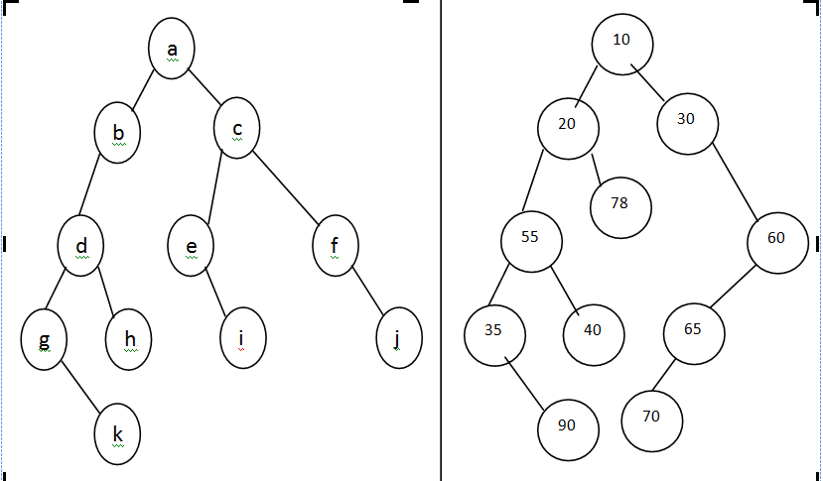
 | b) | Write a C program to create a tree and insert an element into a binary tree. | CO4 | (08)
 |  | UNIT – V
9. | a) | Define file structure. Explain physical and logical files with examples. | CO5 | (07)
 | b) | Develop a C++ function to search for a node in a B-Tree. | CO5 | (05)
 | c) | Discuss hashing with chained progressive overflow. | CO5 | (08)
10. | a) | Define B-Tree. Explain with an example the creation of B-Tree. | CO5 | (08)
 | b) | What is collision? Explain the different ways of reducing the number of collisions in hashing. | CO5 | (08)
 | c) | Define B+ Tree. Mention the two significant advantages of B+ Tree over B Tree. | CO5 | (04)

****************

