
RAMAIAH
INSTITUTE OF TECHNOLOGY
USN | 1 | M | S

(Autonomous Institute, Affiliated to VTU)
Bangalore – 560 054

SUPPLEMENTARY SEMESTER EXAMINATIONS – AUGUST 2017

Course & Branch | : | B.E.–Information Science & Engineering | Semester | : | III
Subject | : | Discrete Mathematical Structures | Max. Marks | : | 100
Subject Code | : | IS314 | Duration | : | 3 Hrs

Instructions to the Candidates:
- Answer one full question from each unit.

 |  | UNIT – I
1. | a) | i)For any three sets A, B and C prove that:  (A-B)-C = A-(BUC) = (A-C)-(B-C)  ii) Construct the truth tables to determine whether the given statement is tautology,contigency or an absurdity.  I)(~p)V(p⇔q) II)~(p⇒q) ∧~p |  | CO1 | (10)
 | b) | Prove the statement is true by using mathematical induction:  1² + 4² + 7² +………..+(3n-2)² = ½ n (6n² – 3n -1) |  | CO1 | (05)
 | c) | Show that the following argument is valid  [p ∧ (p ⇒ q) ∧ (s ∨ r) ∧ (r ⇒ ¬q)] ⇔ (s ∨ t) |  | CO1 | (05)
2. | a) | In a sample of 100 logic chips, 23 have a defect D1, 26 have a defect D2, 30 have a defect D3, 7 have defects D1 & D2, 8 have defects D1 & D3, 10 have defects D2 & D3, and 3 have all the three defects. Compute the number of chips having  - At least one defect ii) No defect. |  | CO1 | (05)
 | b) | i) Let S= {0, 1} give the regular expression corresponding to the regular set given {00, 010, 0110, 01110,…..)  ii) Let S= {0,1}. Give the regular expression corresponding to the regular set given:  I) {00,010,0110,01110,……….} II).{0,001,000,00001,00000,0000001,….}  III) Let A = { +, , a, b}. Show that the following expression is regular expression over A: 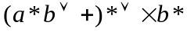 |  | CO1 | (10)
 | c) | Prove that n² is even if and only if n is even using indirect method of proof |  | CO1 | (05)
 |  | UNIT - II
3. | a) | i. How many four-digit numbers can be formed using the digits 2, 4, 6 and 8 when repetitions of digits are allowed.  ii. Four boys picked up 30 mangoes. In how many ways can they divide them if all the mangoes are identical? |  | CO2 | (04)
 | b) | i. Solve the recurrence relations for:  a). b_{n} = -3b_{n-1} – 2b_{n-2}, b₁=-2, b₂=4  b). d_{n} = 4d_{n-1} – 4d_{n-2}, d₁=1,d₂=7  ii. Let A={1, 2, 3, 4} and R={(1, 1), (1, 2), (2, 1),(2, 2), (3, 4),  (4, 3), (3, 3), (4, 4)}, Determine A/R. |  | CO2 | (08)
 | c) | Let A={a, b, c, d, e} and let R & S be the relation on A described by: |  | CO2 | (08)
 |  | M_{R} = 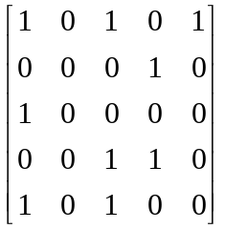 | M_{S}=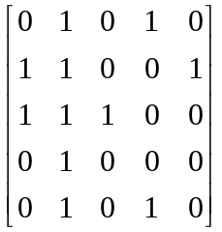
 |  | Use Warshall’s algorithm to compute the transitive closure of RUS.
4. | a) | i. Show that if five points are selected in a square whose sides have length 1 inch, at least two of the points must be no more than √2 inches apart.  ii. Solve the recurrence relation d_{n} = 2d_{n-1} – d_{n-2} with the initial condition d₁= 1.5 and d₂= 3. |  | CO2 | (06)
 | b) | i. Let R be a relation whose digraph is given in the following figure  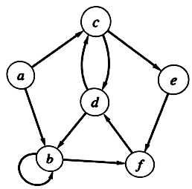  Find R, M_{R} , all paths of length 3, a cycle starting at vertex d  ii. Let A={1, 2, 3, 4} and let R={(a,b) ε AXA / a divides b}  IS R symmetric, asymmetric or antisymmetric? |  | CO2 | (06)
 | c) | Let A={a, b, c, d, e} and let R & S be the relation on A described by: |  | CO2 | (08)
1 1 1 0 0  M_{R} = 1 1 1 0 0  1 1 1 0 0  0 0 0 1 1  0 0 0 1 1 | 1 0 0 0 0  M_{S} = 0 1 1 1 0  0 1 1 1 0  0 1 1 1 0  0 0 0 0 1
Use Warshall’s algorithm to compute the transitive closure of R U S.

 |  | UNIT – III
5. | a) | i. Let A & B are sets & a function from A to B are given. Determine whether the function is one to one OR onto ( or both or neither)  a). A=B=R X R; f((a, b)) = (a+b, a-b)  b). A= R, B={x / x is real and x>= 0}; f(a) = a²  ii. Let f(x, y) = (2x – y, x – 2y), (x, y) ε R X R  a). Show that f is one to one  b). Find f^{-l} |  | CO3 | (08)
 | b) | i. Prove that A poset has at most one greatest element and at most one least element.  ii. From the given diagraph find, all upper bounds of B, all lower bounds of B, the least upper bound of B and the greatest lower bound of B.  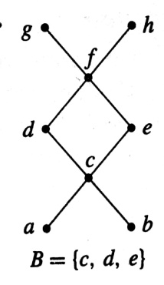 |  | CO3 | (08)
 | c) | Let f be the function from the set X= {2, 3, 4, 5, 6, 7} into the set Y= {0, 1 2, 3, 4} defined by f(x) = 2x (mod 5). Write f as a set of ordered pairs. Is f one-one or onto Y? |  | CO3 | (04)
6. | a) | i. Determine whether the relation R is a partial order on the set A.  i) A= Z and _{a} R _{b} if and only if a = 2b.  ii) A = Z, and _{a} R _{b} if and only if b² l a.  ii. Determine the Hasse diagram of the relation on A = {1, 2, 3, 4, 5} whose matrix is shown:  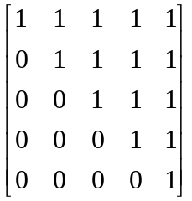 |  | CO3 | (08)
 | b) | Let A= { 1, 2, 3, 4, 5, 6} and given:  Find, i. p₃ o p₁ ii. p₁^{-|} o p₂ ^{-|} iii. p₁ o p_{2.} |  | CO3 | (06)
  P₁ = | 1 2 3 4 5 6 | P₂ = | 1 2 3 4 5 6 | P₃ = | 1 2 3 4 5 6
  P₁ = | 3 4 1 2 6 5 | P₂ = | 2 3 1 5 4 6 | P₃ = | 6 3 2 5 4 1
 | c) | i. Determine whether the given Hasse diagrams represents a lattice. |  | CO3 | (06)
  a)  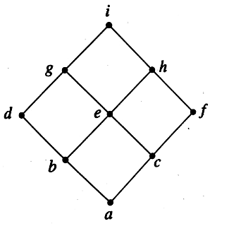 | b)  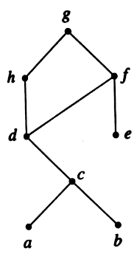
 |  | UNIT – IV
7. | a) | What are isomorphic graphs? Determine whether the given pair of graphs is isomorphic. Exhibit an isomorphism or provide a rigorous argument that none exists.  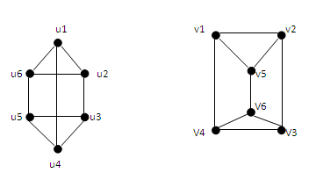 |  | CO4 | (10)
 | b) | Explain the various applications of graphs. |  | CO4 | (05)
 | c) | Determine whether each of these graphs is strongly connected or if not, whether it is weakly connected.  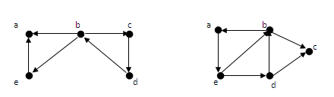  - (ii) |  | CO4 | (05)
8. | a) | Define the following and give one example for each. (i) Euler path (ii)Euler circuit (iii) Hamilton path (iv) Hamilton circuit. |  | CO4 | (08)
 | b) | Explain any two graph models |  | CO4 | (04)
 | c) | What is semigroup? Determine whether the set together with the binary operation is a semigroup, monoid or neither.  (i)Z⁺, where a* b is defined as max{a, b}  (ii) Z⁺, where a * b is defined as a  (iii)P(S), with S as a set, where * is defined as intersection. |  | CO4 | (08)
 |  | UNIT – V
9. | a) | What is a Field? List the different properties of Field. |  | CO5 | (05)
 | b) | Find the multiplicative inverse of 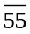in Z₁₉₆. |  | CO5 | (05)
 | c) | Let ‘G’ be the set of all non zero real numbers and let a*b = ab/2. Show that (G,*) is an abelian group. |  | CO5 | (10)
10. | a) | Consider the (2,6) encoding function ‘e’  e(00) = 000000 e(10)=101010  e(01) = 011110 e(11)=111000  - Find the minimum distance of ‘e’  - How many errors will ‘e’ detect? |  | CO5 | (08)
 | b) | Consider the (6, 7) parity check code. For each of the following received word determine whether an error will be detected.  i)1101010 ii) 1010011. |  | CO5 | (04)
 | c) | Let m-2, n=5  Determine the group code e_{H}:B² -> B⁵ |  | CO5 | (08)
   | 1 | 1 | 0
   | 0 | 1 | 1
  H = | 1 | 0 | 0
   | 0 | 1 | 0
   | 0 | 0 | 1

****************

