**The Experiment Report of Machine Learning**



**SUBJECT: SOFTWARE ENGINEERING**

**October 24, 2018**

***Grade:***

**Undergraduate**

***Student ID：***

**201630664673**

***Supervisor:***

**Mingkui Tan**

***Author:***

**Yi Lan**

**SCHOOL: SCHOOL OF SOFTWARE ENGINEERING**

[1]Linear Regression and Gradient Descent

Two methods (Closed-formed and Gradient Descent) are used in this experiment to implement linear regression. All code is written with python and tested in python3 platform.

# INTRODUCTION

Different from linear classification, the target values of linear regression are discrete, and the model’s responsibility is to use the feature values to predict a value which should be as close as the actual value. However, the linear classification model just needs to try its best to put the sample in correct side.

Simple linear regression describes the linear relationship between a predictor variable, plotted on the x-axis, and a response variable, plotted on the y-axis. The goal of linear regression is to learn a hypothesis/model $f:X↦Y$

This experiment aims to implement linear regression using two methods in the “Linear Regression” section of the machine learning course, and experience the effects of various hyperparameters on model training and explore how to train a better model.

# METHODS AND THEORY

Define:

Input space: $X=R^{m}$, means features, covariates, predictors, etc.

Output space: $Y$, can be many different types of predictions.

Goal model: a hypothesis/model $f:X↦Y$

In supervised learning, we set the input, output pairs with the given dataset:



and what we want is the “best” model based on *D*.

Predict $\hat{y}$ for unseen x based on f(x).

About model function $f\left(X;W\right)$, we define:

* Parameters:
* Input: **x**, where
* Model function:

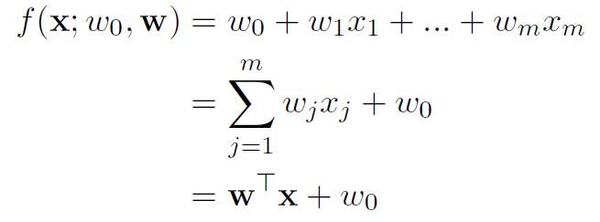

We use *Loss Function* to measure the performance of our linear regression model. In this experiment, we use *Least Squared Loss* as loss function:

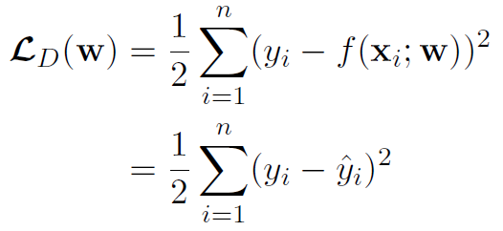

Our training goal is to find minimizer of least squared loss:

$$w^{*}=\arg{\min_{w}L_{D}\left(w\right)}$$

1. **Closed-form Solution for Linear Regression**

For least squared loss function

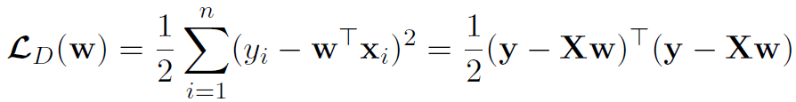

Therefore

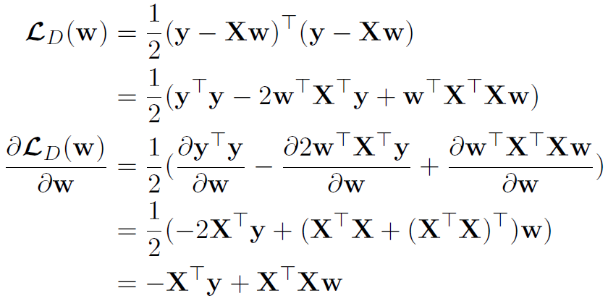

And then

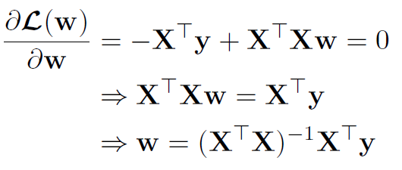

Finally, we solve for optimal parameters **w\***

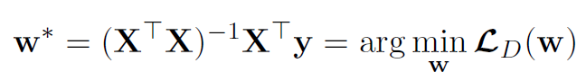

1. **Gradient Descent for Linear Regression**

As for some critical issues in closed-form solution, for example, many matrices are not invertible, so we have to find another solution to deal with this case and make linear regression more easily.

Learning based on *Gradient Descent* is done through optimization. The main tool is *Gradients* (vector of partial derivatives):

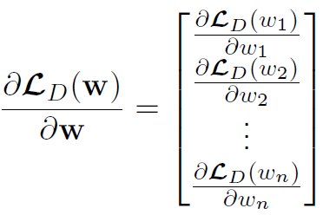

We use $d=-\frac{∂L_{D}\left(w\right)}{∂w}$ as the direction of optimization and minimize loss by repeated gradient steps:

* 1. Compute gradient of loss with respect to parameters $\frac{∂L_{D}\left(w\right)}{∂w}$
  2. Update parameters with learning rate $η$:

$$w^{'}→w-η\frac{∂L_{D}\left(w\right)}{∂w}$$

Learning rate $η$ has a large impact on convergence. if $η$ is large, the loss curve would be oscillatory and may even diverge. On the other hand, too small $η$ would make loss curve converge too slowly.

# Experiment

**Data Set Source:** <https://www.csie.ntu.edu.tw/~cjlin/libsvmtools/datasets/regression/housing_scale>

The data set includes 526 samples with 123 features and 1 target value.

**Experiment Steps:**

1. **Closed-form Solution**
   1. Load and preprocess the experiment data.
   2. Initialize model parameters 1-diemond matrix as ones.
   3. Code the compute formula.
   4. Calculate the model parameters and update it.
   5. Using the trained model to calculate the training loss and testing loss.
   6. Output result.
2. **Gradient Descent Solution**
   1. Load and preprocess the experiment data.
   2. Define and initialize hyper-parameters: learning rate and the max epochs of training.
   3. Initialize model parameters 1-diemond matrix as ones.
   4. Code the *Least Squared Loss* function and define it.
   5. Calculate gradient $G$ toward loss function from all samples.
   6. Update model parameters using $w^{'}=w-ηG$. $η$ is learning rate.
   7. Calculate the training loss and testing loss using current model. Record them.
   8. Output monitor information.
   9. Repeat (e) to (h) until the circulation end.
   10. Drawing graph of training losses and testing losses, as well as with the number of iterations.

**Experiment Hyper-parameters Selection Scheme:**

1. Closed-form Solution

Train Loss: 4530.4540

Test Loss: 1095.7302

1. Gradient Descent Solution

|  |  |  |  |
| --- | --- | --- | --- |
| Learning rate | Max epochs | Train loss | Test loss |
| 0.00200 | 50 | 3.3268E+47 | 3.3268E+47 |
| 100 | 9.7480E+89 | 9.7480E+89 |
| 150 | 2.8563E+132 | 2.8563E+132 |
| 200 | 8.3694E+174 | 8.3694E+174 |
| 250 | 2.4523E+217 | 2.4523E+217 |
| 300 | 7.1857E+259 | 7.1857E+259 |
| 0.00100 | 50 | 4.2372E+03 | 4.2372E+03 |
| 100 | 4.1128E+03 | 4.1128E+03 |
| 150 | 4.0807E+03 | 4.0807E+03 |
| 200 | 4.0703E+03 | 4.0703E+03 |
| 250 | 4.0667E+03 | 4.0667E+03 |
| 300 | 4.0654E+03 | 4.0654E+03 |
| 0.00050 | 50 | 4.6992E+03 | 4.6992E+03 |
| 100 | 4.2393E+03 | 4.2393E+03 |
| 150 | 4.1518E+03 | 4.1518E+03 |
| 200 | 4.1132E+03 | 4.1132E+03 |
| 250 | 4.0924E+03 | 4.0924E+03 |
| 300 | 4.0808E+03 | 4.0808E+03 |
| 0.00010 | 50 | 9.1925E+03 | 9.1925E+03 |
| 100 | 6.8748E+03 | 6.8748E+03 |
| 150 | 5.6868E+03 | 5.6868E+03 |
| 200 | 5.0579E+03 | 5.0579E+03 |
| 250 | 4.7134E+03 | 4.7134E+03 |
| 300 | 4.5171E+03 | 4.5171E+03 |
| 0.00005 | 50 | 3.3268E+47 | 3.3268E+47 |
| 100 | 9.7480E+89 | 9.7480E+89 |
| 150 | 2.8563E+132 | 2.8563E+132 |
| 200 | 8.3694E+174 | 8.3694E+174 |
| 250 | 2.4523E+217 | 2.4523E+217 |
| 300 | 7.1857E+259 | 7.1857E+259 |
| 0.00001 | 50 | 4.2372E+03 | 4.2372E+03 |
| 100 | 4.1128E+03 | 4.1128E+03 |
| 150 | 4.0807E+03 | 4.0807E+03 |
| 200 | 4.0703E+03 | 4.0703E+03 |
| 250 | 4.0667E+03 | 4.0667E+03 |
| 300 | 4.0654E+03 | 4.0654E+03 |

We can see that when learning rate is 0.001 and the number of epochs is 250, the loss curve can converge best and fast.

|  |  |  |
| --- | --- | --- |
| epoch | Train loss | Test loss |
| 1st | 93517.2296 | 93517.2296 |
| 10th | 8222.1024 | 8222.1024 |
| 20th | 4763.9566 | 4763.9566 |
| 30th | 4252.8098 | 4252.8098 |
| 40th | 4082.9357 | 4082.9357 |
| 50th | 4006.0401 | 4006.0401 |
| 60th | 3963.2036 | 3963.2036 |
| 70th | 3935.7319 | 3935.7319 |
| 80th | 3916.5539 | 3916.5539 |
| 90th | 3902.4888 | 3902.4888 |
| 110th | 3891.8628 | 3891.8628 |
| 120th | 3883.6808 | 3883.6808 |
| 130th | 3877.2977 | 3877.2977 |
| 140th | 3872.2704 | 3872.2704 |
| 150th | 3868.2818 | 3868.2818 |
| 160th | 3865.0986 | 3865.0986 |
| 170th | 3862.5453 | 3862.5453 |
| 180th | 3860.4882 | 3860.4882 |
| 190th | 3858.8241 | 3858.8241 |
| 200th | 3857.4726 | 3857.4726 |
| 210th | 3856.3709 | 3856.3709 |
| 220th | 3855.4693 | 3855.4693 |
| 230th | 3854.7284 | 3854.7284 |
| 240th | 3854.1173 | 3854.1173 |
| 250th | 3853.6111 | 3853.6111 |

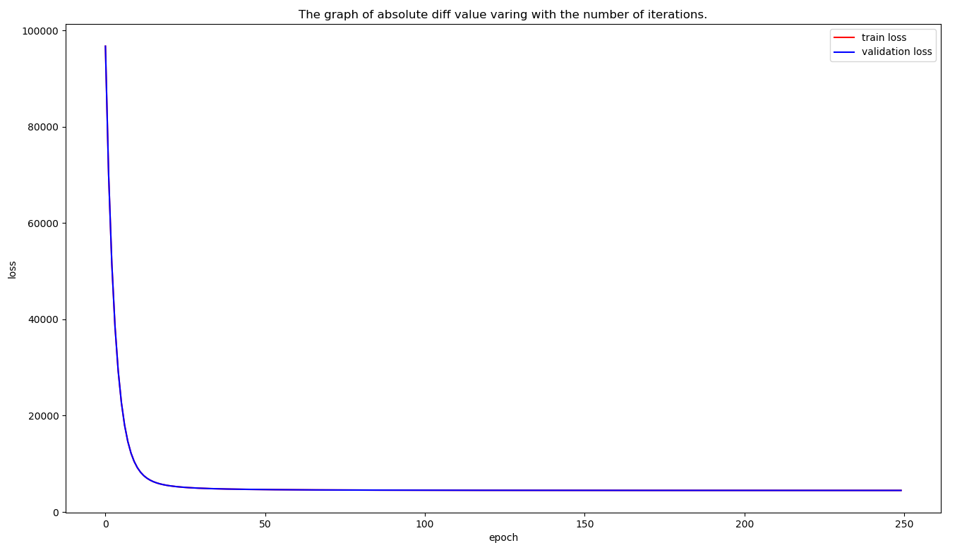

# conclusion

Obviously, the final loss of closed-form solution is less than which comes from gradient descent solution. However, in most cases, it’s impossible to use this solution as many matrices are not invertible. Even invertible, when they are so complex that calculate their invertible matrices will cost much time and lots of memory for the matrix product.

Therefore, we need some more common solutions for most cases. Gradient descent solution is one of them. Calculating the inverse of matrix is unnecessary which can reduce a lot of computation. On the other hand, gradient descent solution can only find the locally optimal solution, but not the global optimal solution. It needs more improvement.

1.