Harlow's Accidental Journey – Storyline rev.18 10.24.2026
Title locked 10.8.2026: Harlow’s Accidental Journey. (Working project name: Harlow’s Big Adventure / HBA.) Final copy — rev.18 10.24.2026. “Original visual reference” images are Mom’s early art; “Current character reference” thumbnails are the latest canonical designs, including Mom’s “special appearances” Easter-egg characters.
Changes in this rev: Rev.18 — Gold Finals edition: storyline text is Rev.17 verbatim (no story changes); character cards removed; storyboard art replaced with the 24 gold-final spreads.
Page 1
Hey there! I'm Harlow, a laid-back Ragdoll cat living the good life in sunny Long Beach, California with my best human friend, Lois. My favorite pastimes boil down to eating, sleeping, and eating some more. I want to share a wild, unexpected journey I had recently — not a story about cat curiosity, but one about the kindness and generosity of strangers. I think you're going to love it.
Spread 1 — Gold Final S01-AY
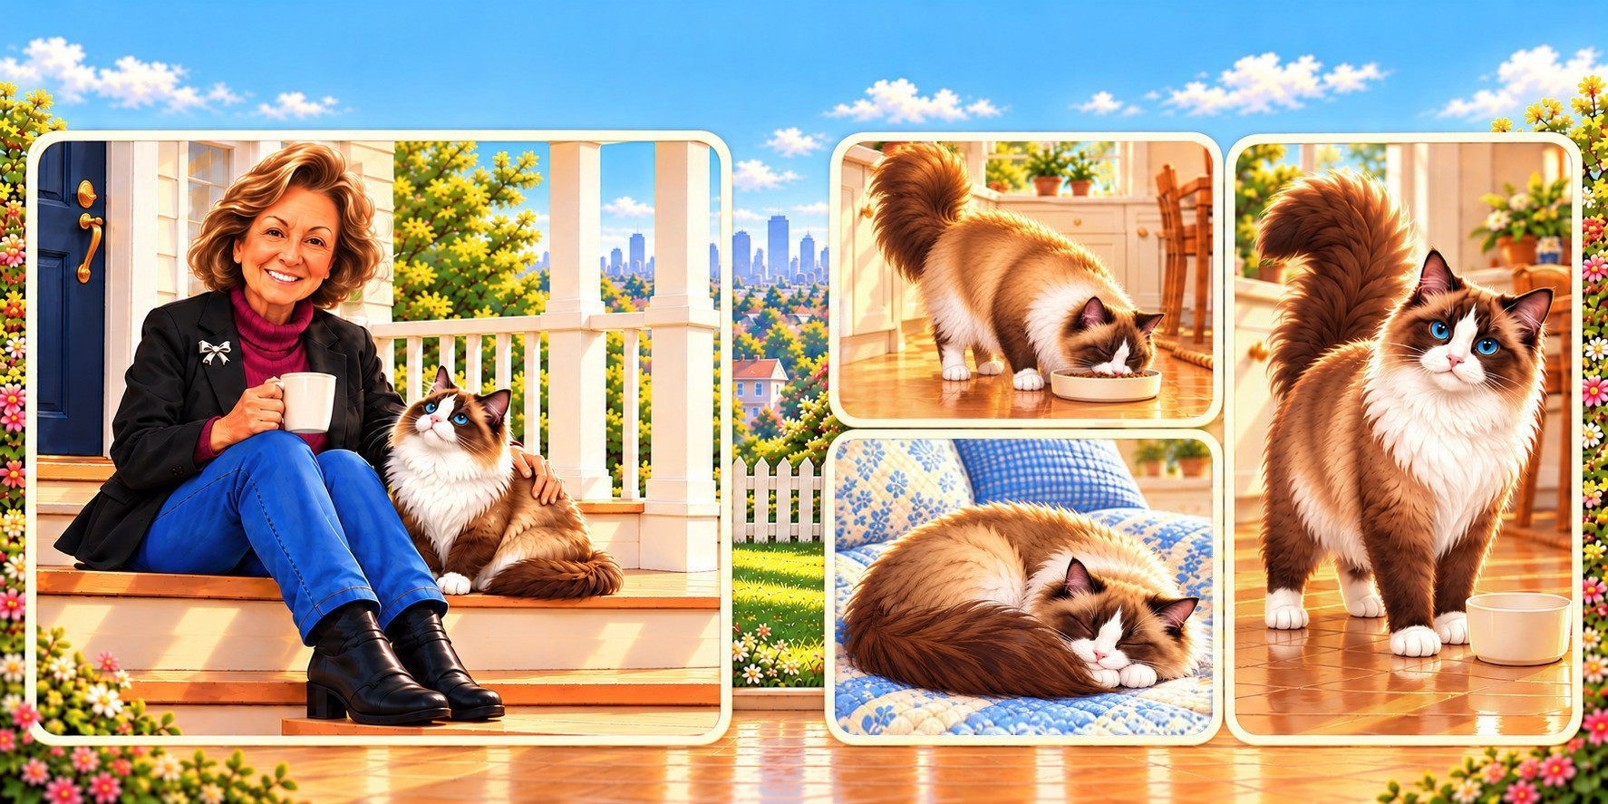
Page 2
A few days ago, Lois asked, “Hey Harlow, how would you like to drive out to Farrelli Farms for some fresh fruits and veggies and enjoy the country scenery?” That sounded awesome to me, so we hopped into her classic ’65 Mustang for a nice day trip to the country.
Spread 2 — Gold Final S02-AF
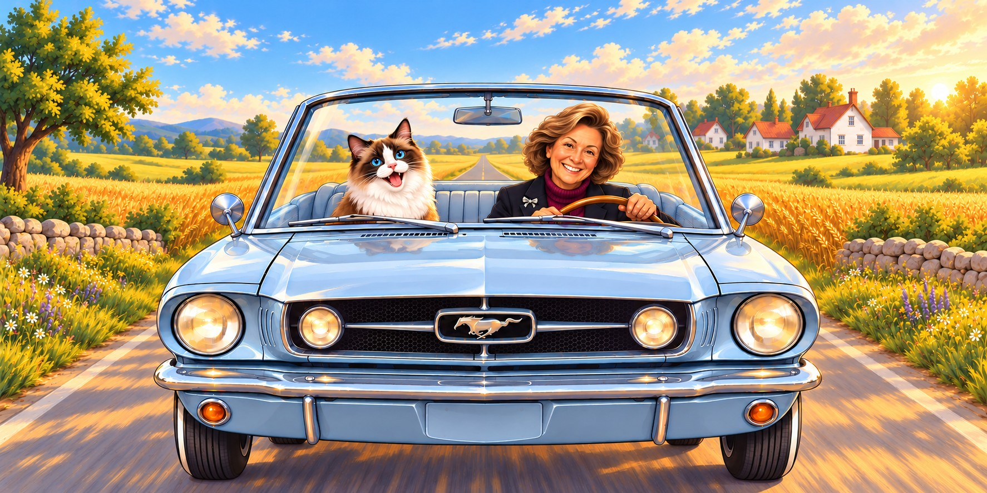
Farm Visit
Page 3
“Ah, we finally made it,” I sighed, taking in the rolling green fields as we pulled into Farrelli Farms. Lois was practically shaking with excitement, her eyes locked on a vibrant display of heirloom tomatoes and fresh berries. Seeing her completely mesmerized and in her element, I smiled and decided to wander off to stretch my legs.
Spread 3 — Gold Final S03-T
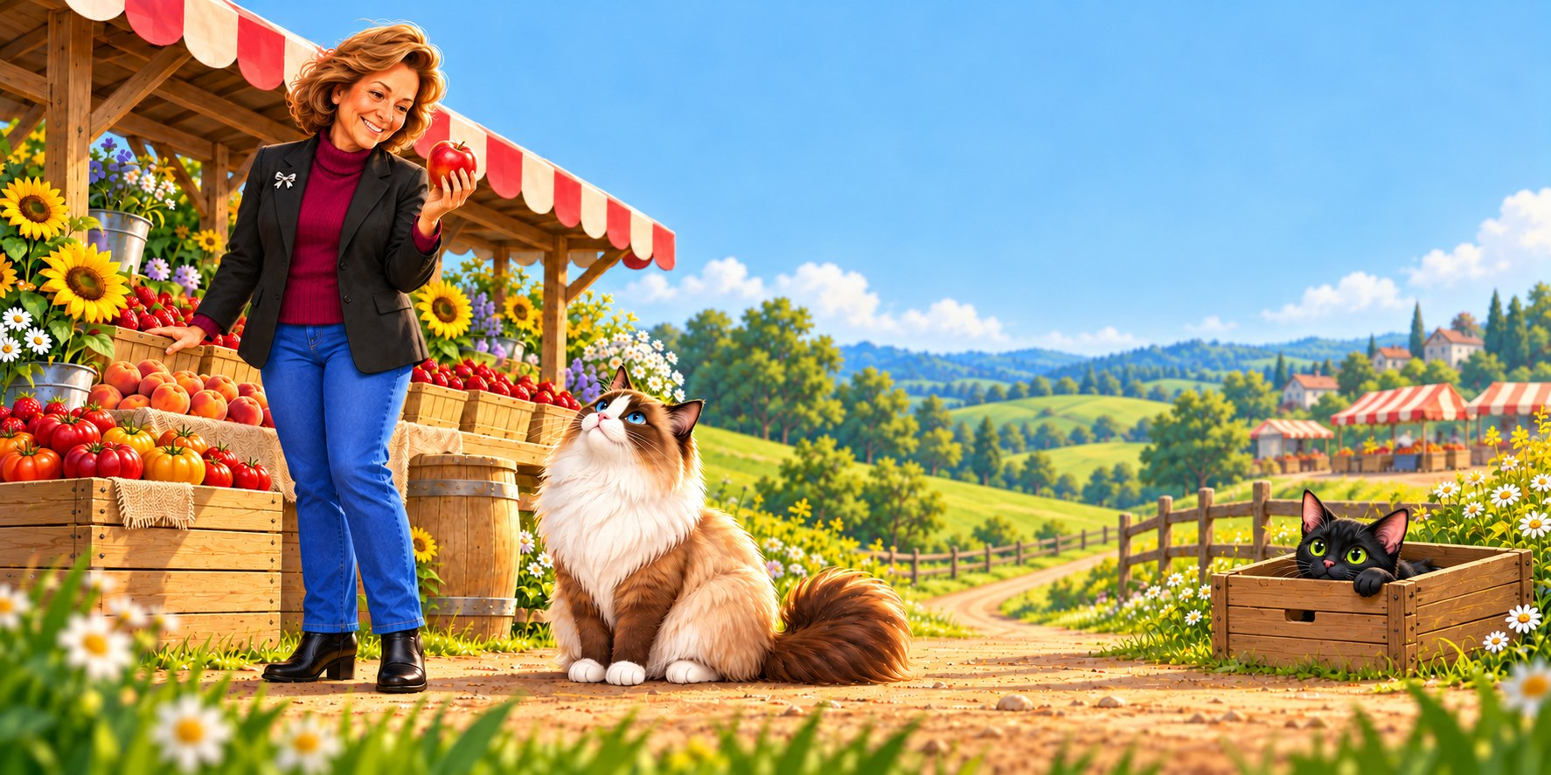
Page 4
“Phew, it's toasty today!” grunted Sweet Pea the pig, splashing in a big muddy puddle. “Come on in! The mud is where it's at to beat the heat.” I crept to the edge, then jumped back, wrinkling my nose. “I appreciate the tip, but have you seen my coat? This fur does not do mud.” “Are you sure? It feels amazing!” Sweet Pea snorted, wiggling happily. “I'll find another way to cool off,” I said. “Lovely meeting you — catch you later!”
Spread 4 — Gold Final S04-M
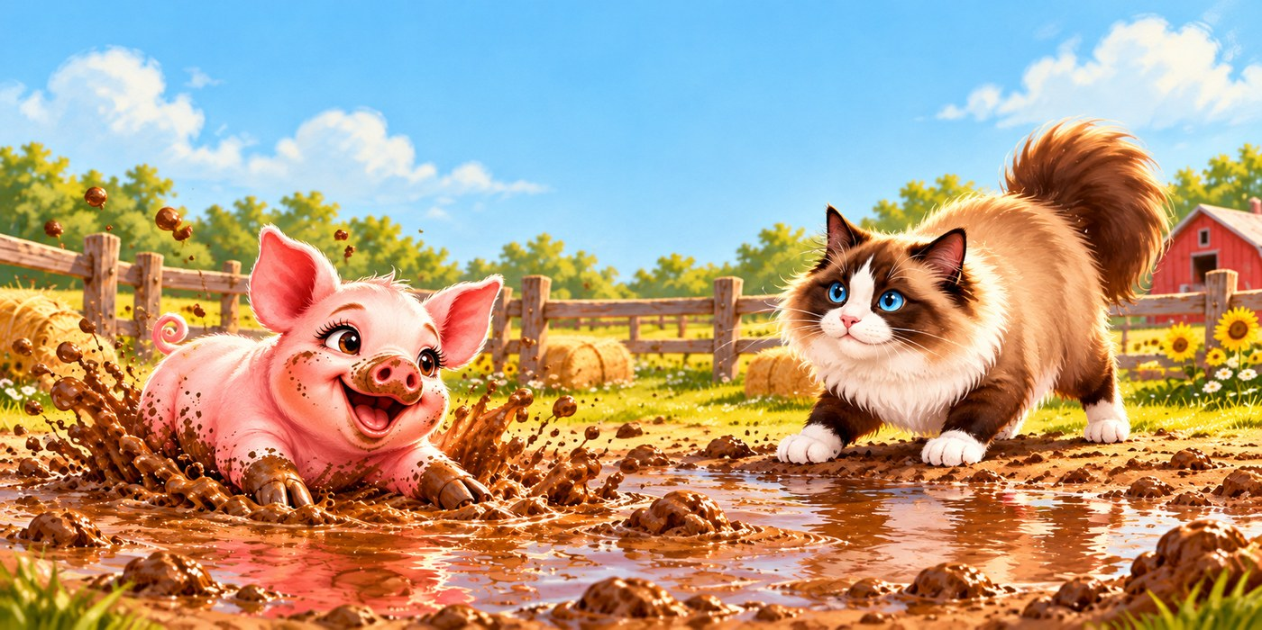
Page 5
I soon spotted a pond, where Mama Fiona and her ducklings — Missi, Sammi, and Lili — swam over to greet me. “Oh honey, you look miserable!” Fiona said, seeing how hot and dusty I was from riding in the convertible. “Come take a dip — you’ll feel so refreshed!” Normally a cat avoids water at all costs, but desperate times call for desperate measures. I took a breath and hopped in — it felt amazing! I scrambled out, shook my fur dry, thanked Fiona and her girls, and set off again.
Spread 5 — Gold Final S05-V
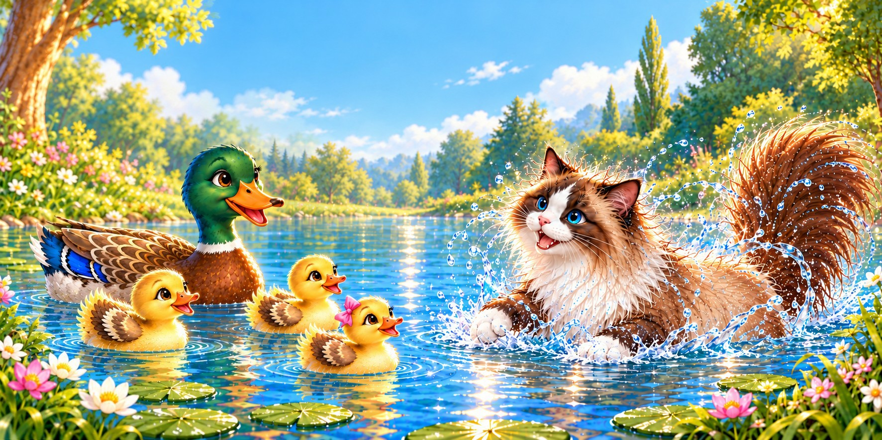
Page 6
After a while, I realized I'd wandered far from Lois. Molly the donkey and her baby, Albie, trotted over, sensing I was lost. “Feeling turned around, little guy?” Molly chuckled. “Take a look at our big ears — let them remind you to listen to your surroundings in tight spots.” I swiveled my ears like radar dishes and caught the sound of people talking. “That's brilliant! Thank you, Molly!” I called, nodding to her and Albie as I hurried toward the voices.
Spread 6 — Gold Final S06-AB
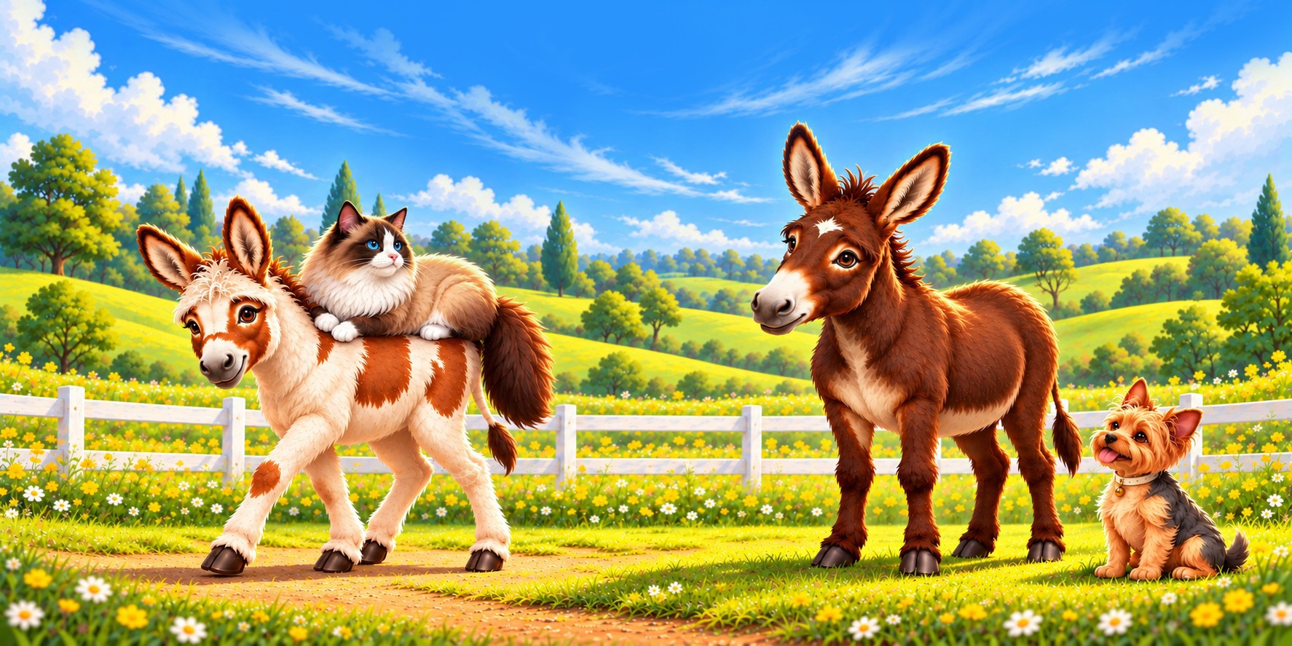
Page 7
As I zipped along, I heard giggling that was coming straight from Chester, a retired racehorse! “What’s so funny?” I asked, baffled. “Well,” Chester chuckled, “I was a bit startled by you and started chuckling. You see, life on the racetrack could get pretty tough — but I always found something to laugh about to get me through. Always keep your sense of humor, no matter what life hands you!” “I’ll remember that!” I smiled, heading toward the voices with a grin on my face.
Spread 7 — Gold Final S07-AQ
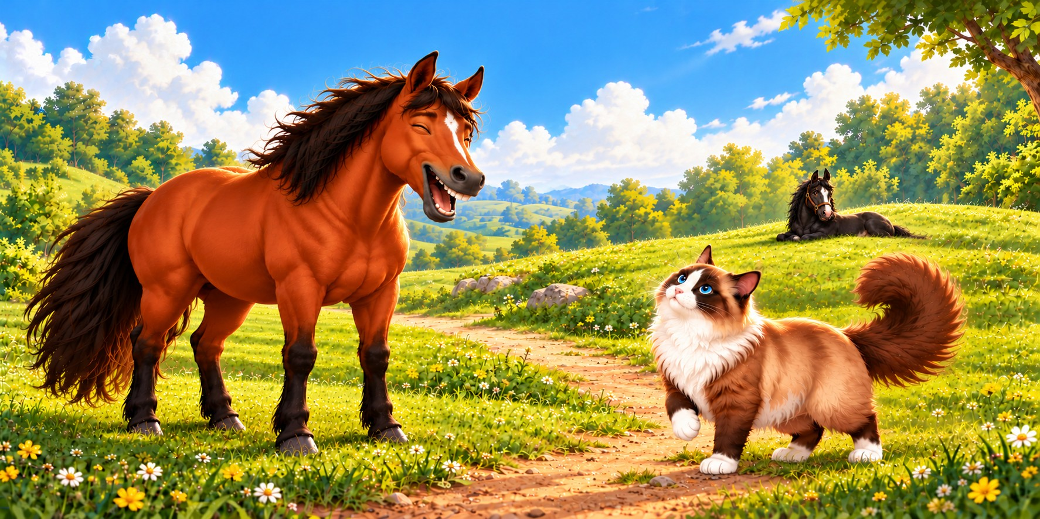
Page 8
Hearing voices ahead, I got so excited that I stopped paying attention. I completely missed a bright red pickup truck being loaded with fruit and vegetable crates for a city delivery. In the rush, farm hands accidentally scooped me up and loaded me into the back. Before I knew it, the engine roared to life, and we were speeding off toward the big city. Yikes!
Spread 8 — Gold Final S08-AG
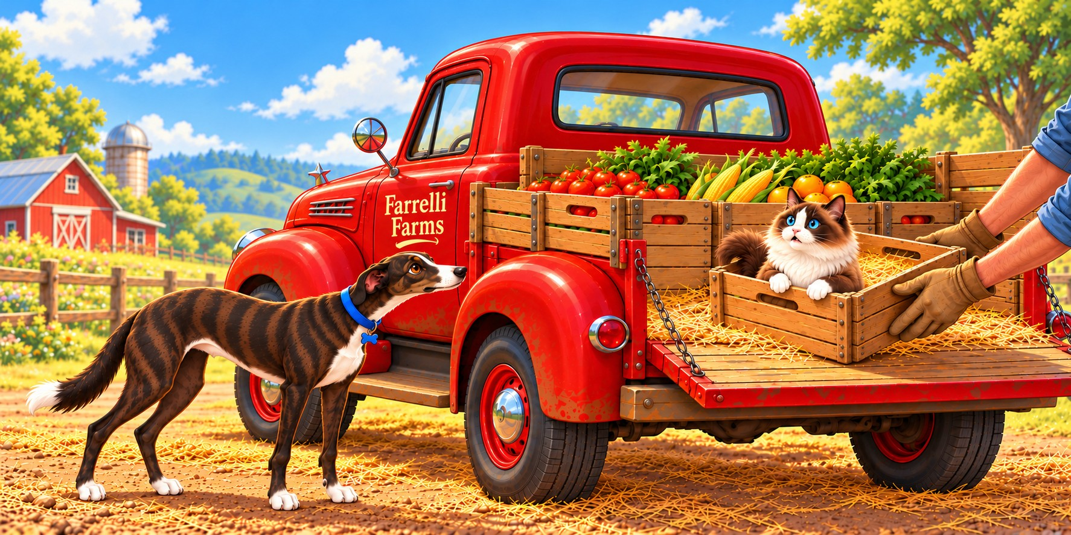
City Visit
Page 9
With the truck flying down the highway, I hunkered down until we finally rolled into the bustling city hours later. The second the engine stopped, I bolted. I was free—but looking up at the towering buildings in this unfamiliar city with roaring traffic, my stomach dropped. I was completely lost and had no idea how to get home.
Spread 9 — Gold Final S09-AO
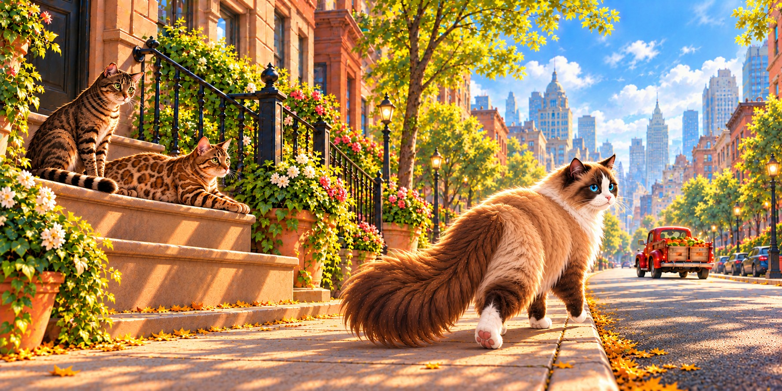
Page 10
As I wandered the city sidewalks, my stomach started to rumble. I darted down an alley and spotted Philly the rat, eating a slice of pizza. As hunger beat out fear — I timidly asked for a bite, and Philly grinned, pushing the box over. “Sure thing! Help yourself, man.” As we munched, he puffed out his chest. “I’m a big deal — I’ve been in the papers for my pizza heists.” “No way! You’re a pro,” I said. “Would you please teach me your ways?” Philly’s sly smile said yes — masterclass time.
Spread 10 — Gold Final S10-T
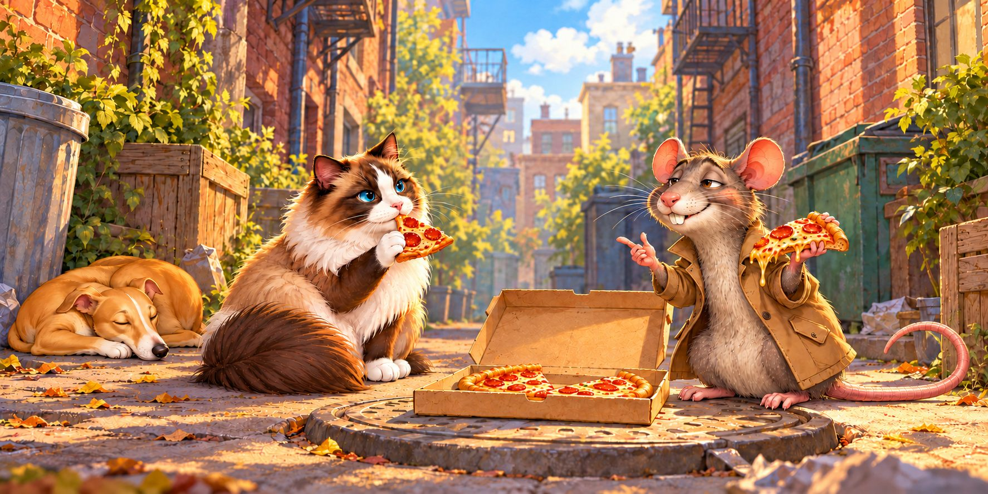
Page 11
Stuffed and grateful for Philly’s help, I wandered into Midtown Park to find a quiet spot and figure out a way back home to Long Beach. I spotted an elegant dog with her owner and piped up, “Hey there! I’m Harlow. Could you help me find my way back to Long Beach?” Penelope the Afghan Hound snobbishly tossed her head and replied, “I’m much too busy to talk to you.”—though she wasn’t doing anything at all. A nearby stray calico couldn't be bothered to help either.
Spread 11 — Gold Final S11-L
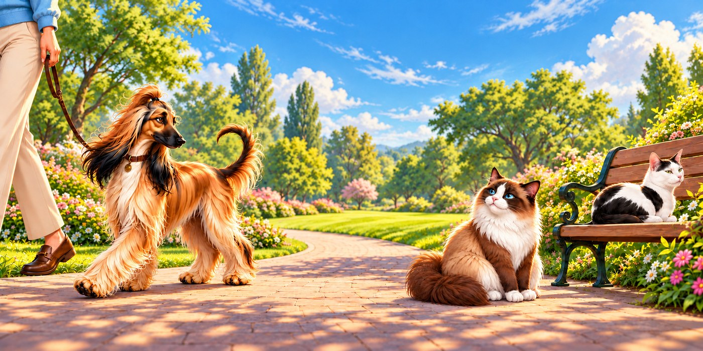
Page 12
My faith was taking a hit after Penelope. In a rougher part of town, I spotted Otis the coyote who was scruffy but friendly. “Hey there, my friend, can I help you out?” he asked. I sighed with relief. “Yes, thank you! Do you know how to get to Long Beach?” Otis shook his head. “I wish I could help, but I’ve lived on these streets for so long I don’t know anywhere else. Good luck — and never let your guard down around here.” I thanked him and headed off.
Spread 12 — Gold Final S12-AK
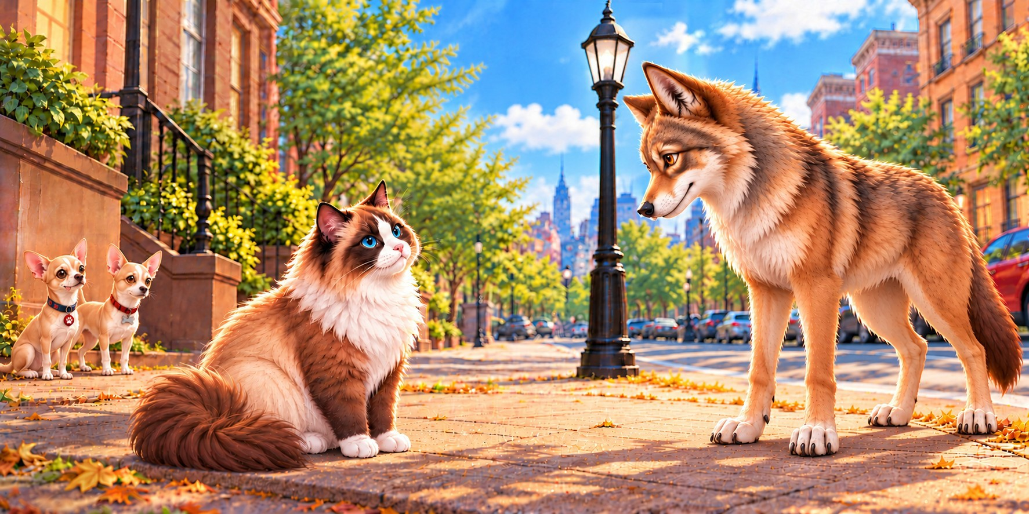
Page 13
Feeling braver with Otis’ tip, I started asking for help. Gideon the pigeon swooped down from a high ledge. “You look lost, buddy. Where are you headed?” he chirped. “I’m trying to get back to Long Beach — can you help?” I asked. “It’s a long shot, but the baseball park a few blocks over might have someone who can,” he said, pointing towards the ballpark. “That’s the best I can do — I’m a city bird, and I never leave town. Best of luck!” Grateful, I set off at once.
Spread 13 — Gold Final S13-Q
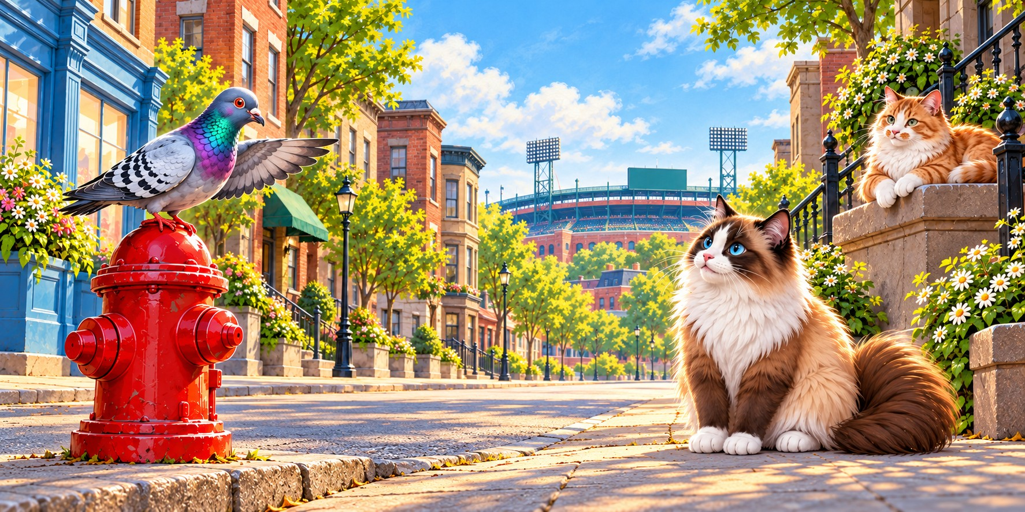
Baseball Park Visit
Page 14
Finding the ballpark was a breeze, and I slipped in unnoticed. I heard frantic chittering over the crowd — a nervous squirrel was scrambling up a tall pole. “Hey, I’m Harlow!” I called. “What’s the emergency?” “I’m Chippy, and I’m racing up this pole for peanuts!” he squeaked. “Peanuts sound amazing! Teach me to pole-climb?” Chippy squinted down. “Sure — but you’d do better on the ground, where fans drop buttery popcorn everywhere.” The floor was a giant treasure hunt! “Fair point!” I thanked him and scampered off.
Spread 14 — Gold Final S14-M
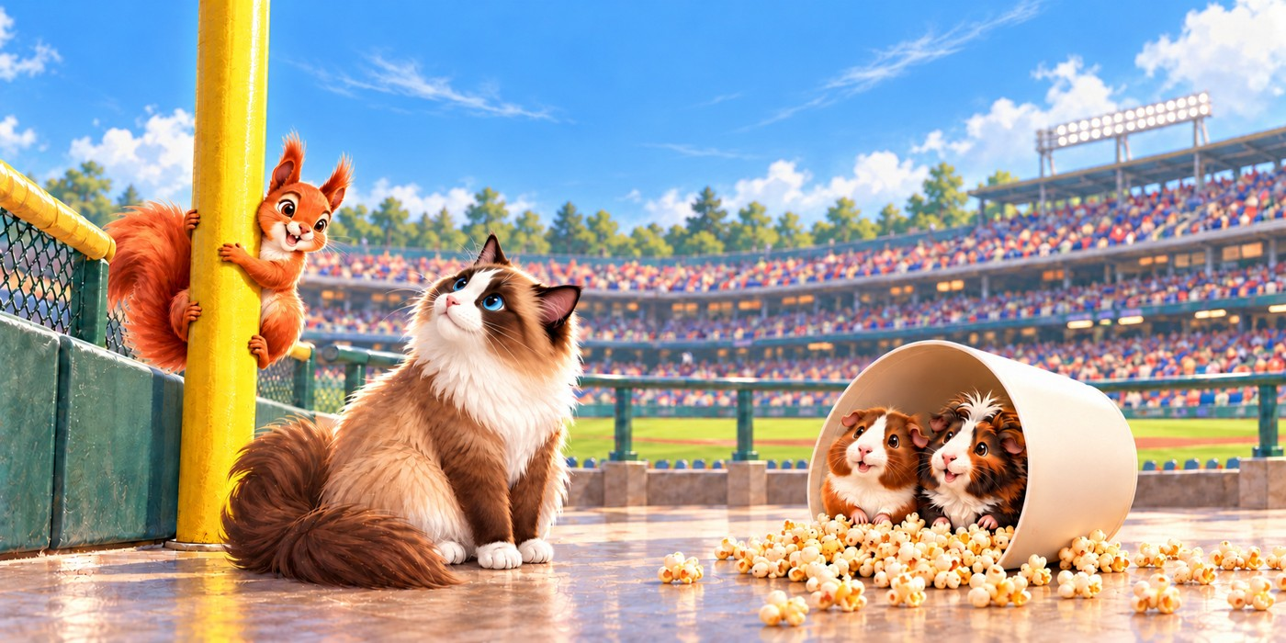
Page 15
I'd never seen a baseball game — guys in matching pajamas just tossed a ball around. Suddenly the ground shook. Boom, boom, boom! Out charged a colossal fuzzy bear-like character, waving giant paws. “HELLO EVERYBODY! I'm The Hibernator, your team mascot! Who's ready for fun?!” he roared. “I AM!” I yelled, waving my paws. Even doubting I'd ever get back to Lois, I remembered Chester's golden rule: always keep a sense of humor, no matter what — even if life hands you a giant fuzzy bear!
Spread 15 — Gold Final S15-X
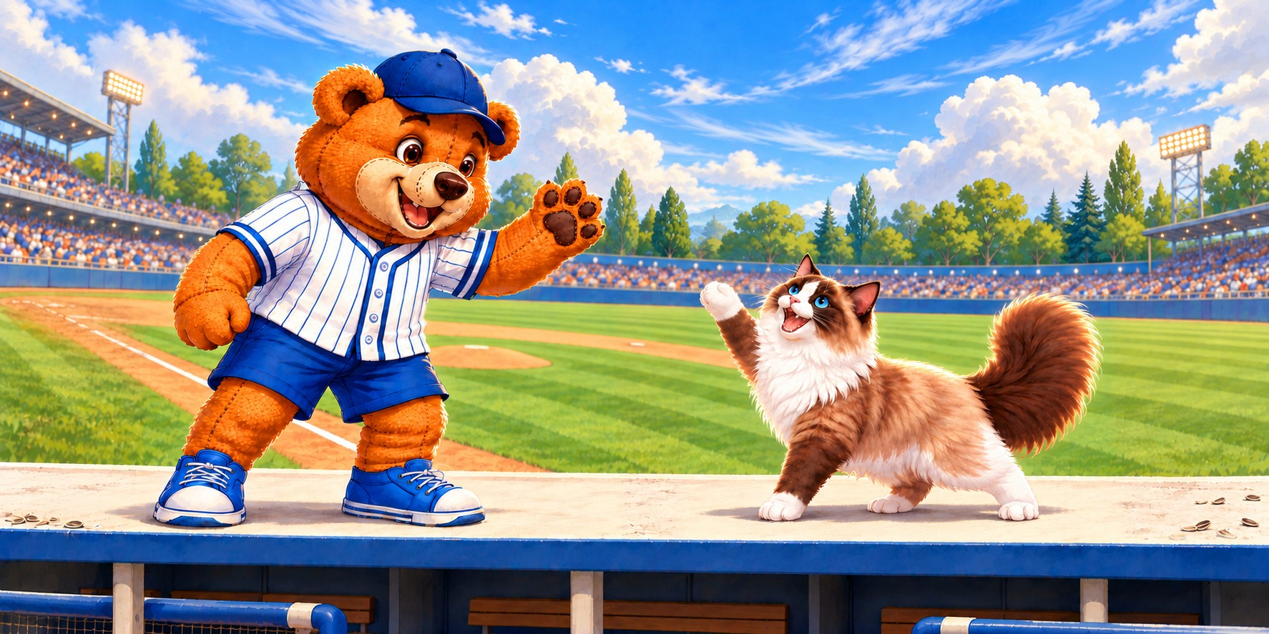
Page 16
After the show, fear and loneliness crept back in. In the stands, a friendly face caught my eye. “Howdy,” he said. “I'm Edward the Emotional Support Dog, and this is my friend, Jon. You look a little down in the dumps.” “I'm totally lost,” I confessed. “I'm so sorry,” Edward said. “With patience and persistence, you'll find help. Come give me a hug if you want.” I didn't hesitate — I gave Edward the biggest hug ever and instantly felt better.
Spread 16 — Gold Final S16-O
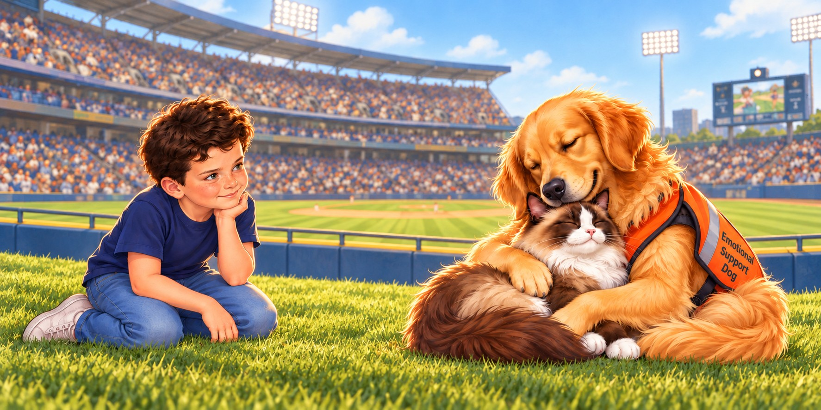
Page 17
Feeling better but parched, I wandered to the snack shack, where workers left water bowls out for pets. As I lapped it up, I heard buzzing overhead. “What's a cat like you doing at a ballpark?” asked Jasmine the bumblebee. “Trying to get back to Long Beach,” I answered. Jasmine lit up. “No way! I know Long Beach — just follow my buzz!” One last sip, and off we went.
Spread 17 — Gold Final S17-U
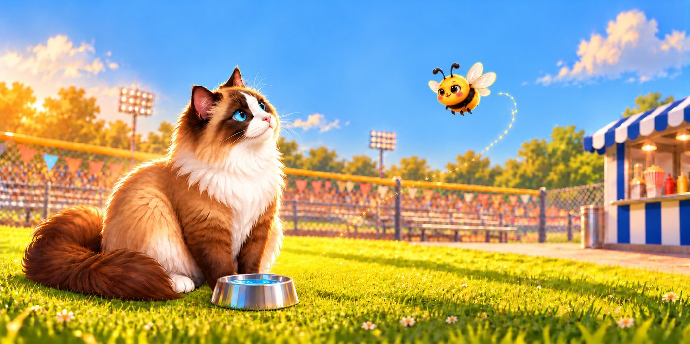
Beach Visit
Page 18
Jasmine led me to the sand and buzzed off, leaving me gazing at the gorgeous ocean. A crab was walking sideways along the shore. “Are you alright?” I asked. “You’re moving strangely.” “I’m fine — that’s just how we roll. I’m Babs,” she shot back. “I’m Harlow, trying to get back home,” I said. Babs sighed. “Sorry, I can’t help — we crabs only walk sideways and can’t see straight ahead. But here’s a tip: always look in every direction before crossing streets.” I thanked her and continued on down the beach.
Spread 18 — Gold Final S18-V
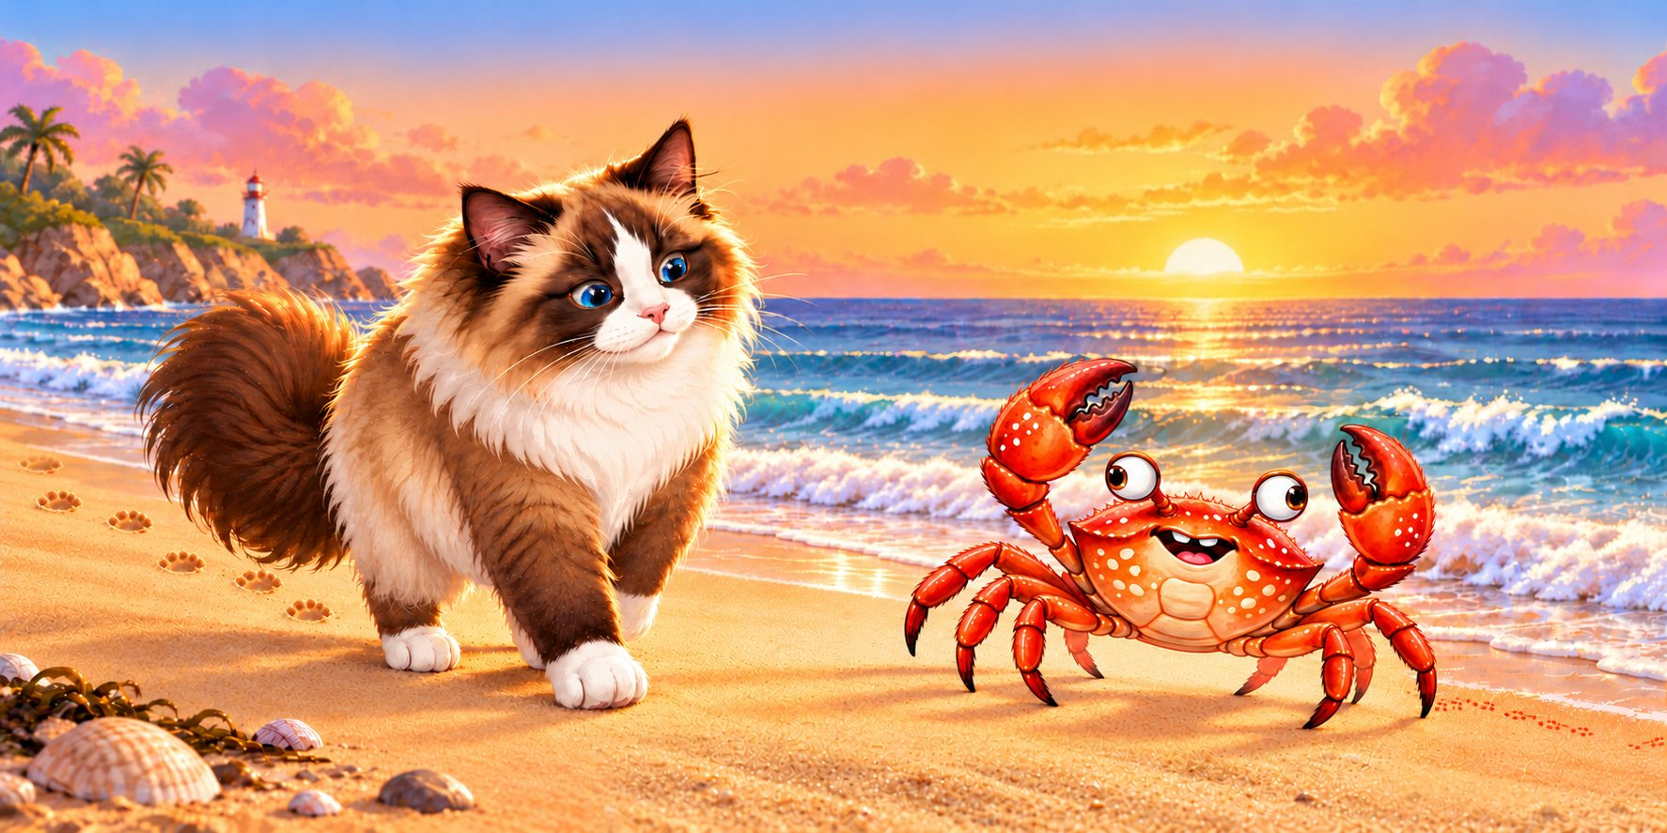
Page 19
I'd never seen the ocean, so I crept to the water's edge. Suddenly a giant shark surged out! Finnegan the shark was just as spooked by me. Once we caught our breath, I shared my tale of woe. “I wish I could help, but I can't leave the water,” Finnegan said. “Remember: the ocean is dangerous if you don't know it. If you don't know — don't go!” “Thanks, Finnegan, I'll remember that,” I said, heading back to dry land.
Spread 19 — Gold Final S19-R
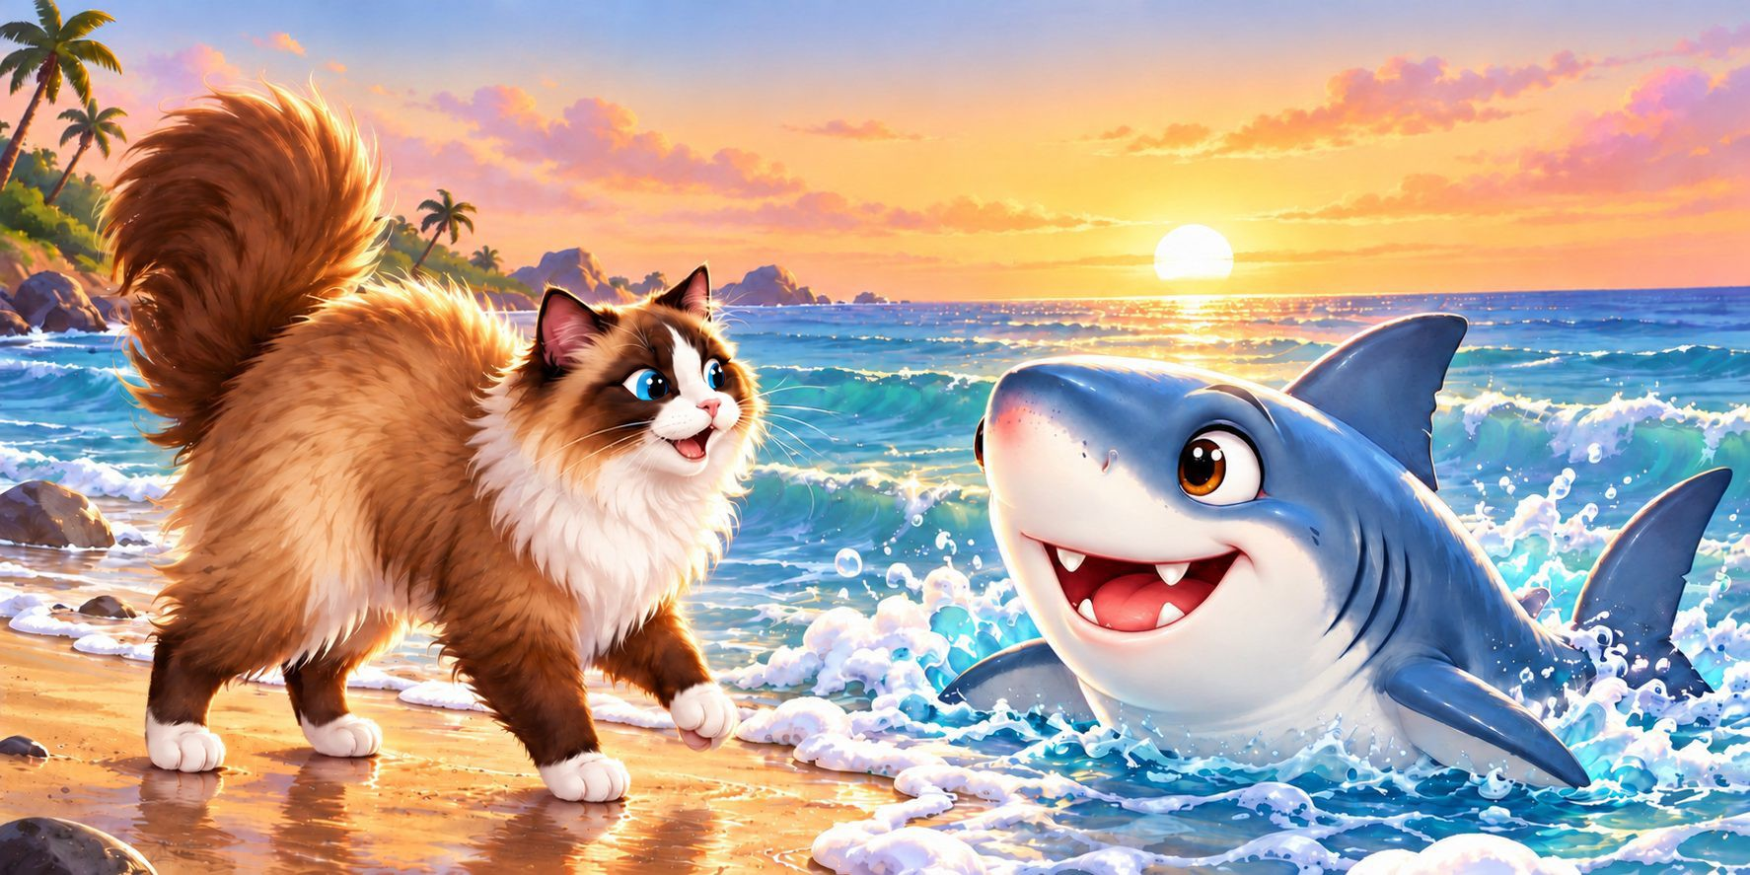
Page 20
As I was walking, I suddenly tripped over something round and lumpy — a penguin napping on the sunny beach! “SQUAWK!” Pebbles the penguin bolted upright, feathers ruffled. “Can’t you see I was napping?!” “I’m so sorry!” I blurted. “Aren’t you a million miles from home?” Pebbles slumped. “Yeah. I took a wrong turn at a glacier, and now I’m totally lost.” “I’m in the same boat — though your trip home is longer than mine,” I sighed. “Good luck, buddy. I hope you find your way home soon!”
Spread 20 — Gold Final S20-J
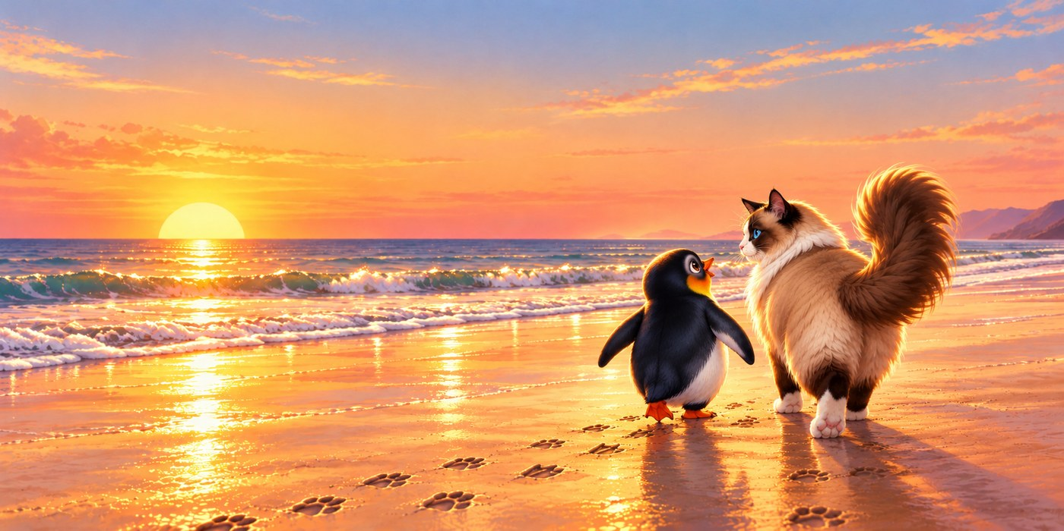
Page 21
Feeling a massive shadow sweep over me, I spotted a pelican circling down. “Hey little fella, you look exhausted and lost. Can I help?” she called. “Yes, please!” I squeaked. “I live in Long Beach, but I’m lost.” “Say no more!” she smiled. “I’m Helga — I’ll scoop you into my throat pouch, and you can watch for familiar places. I’ll drop you at the start of your road. That’s as close as I can get without leaving the ocean.” Breathing easier, I replied, “That’s beyond perfect. I can’t thank you enough!”
Spread 21 — Gold Final S21-X
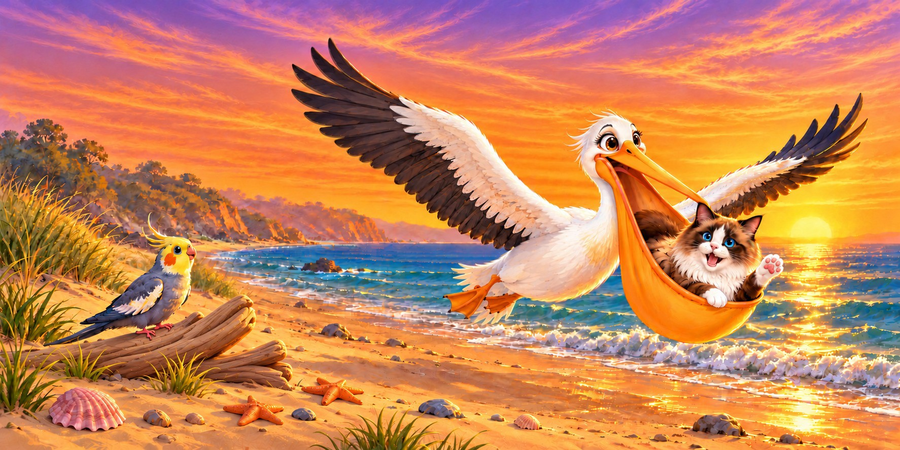
Page 22
Helga gently lowered me down and I started to recognize some familiar sites around me. But even better, I felt a strong sensation that I wasn't walking alone. Could it be that Guardian Angels have been with me this whole time? I wondered, feeling a wave of peace. I nodded toward the sky in silent thanks to my invisible caretakers—and right on cue, my house finally came into view!
Spread 22 — Gold Final S22-AQ
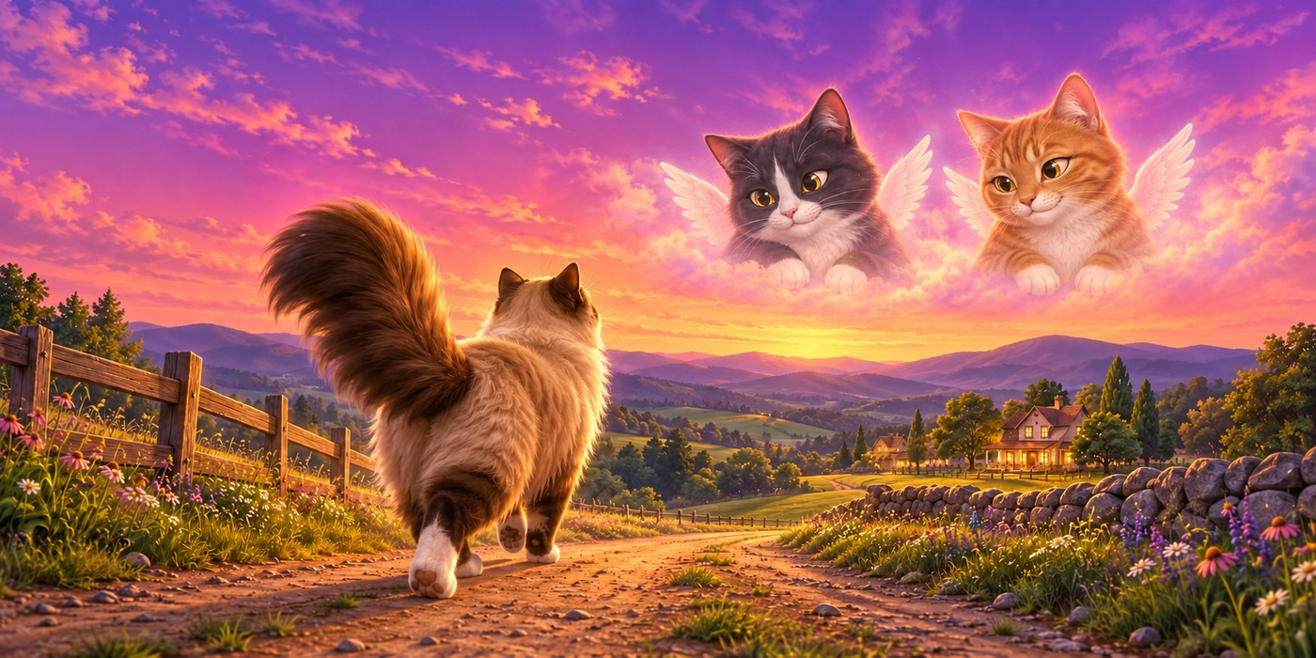
Page 23
There it was, right in plain sight—MY HOME! “Hooray! I’m finally home!” I shrieked, quivering with excitement. Lois must have heard my paws on the porch, because she whipped the door open and scooped me up into the biggest, tightest hug. “Oh, my darling Harlow, where have you been?!” she gasped, eyes shining. “I was out of my mind with worry, but I’m so happy you’re back. Come inside—I’ve got a delicious tuna dinner waiting for you!”
Spread 23 — Gold Final S23-AJ
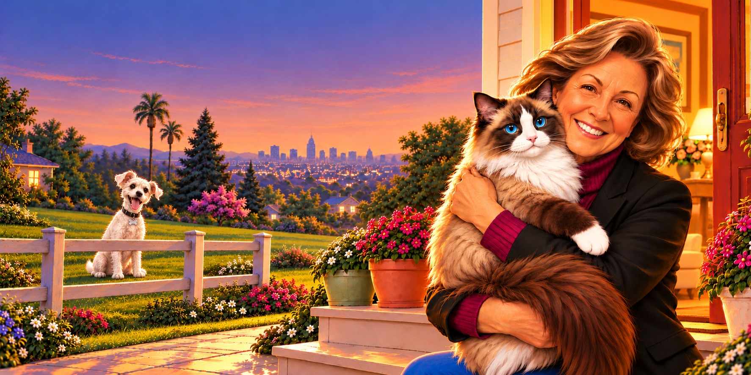
Page 24
Settled warmly in front of my cozy fireplace, I looked back on everything that happened. I was completely blown away by how kind and helpful total strangers had been. Since I couldn't repay them, I decided to pay it forward at the very first chance I got. Looking toward the corner near the fireplace, I spotted my first lucky recipient. "I see you over there, my little chum," I whispered with a smile. "How would you like some cheese?"
Spread 24 — Gold Final S24-AD
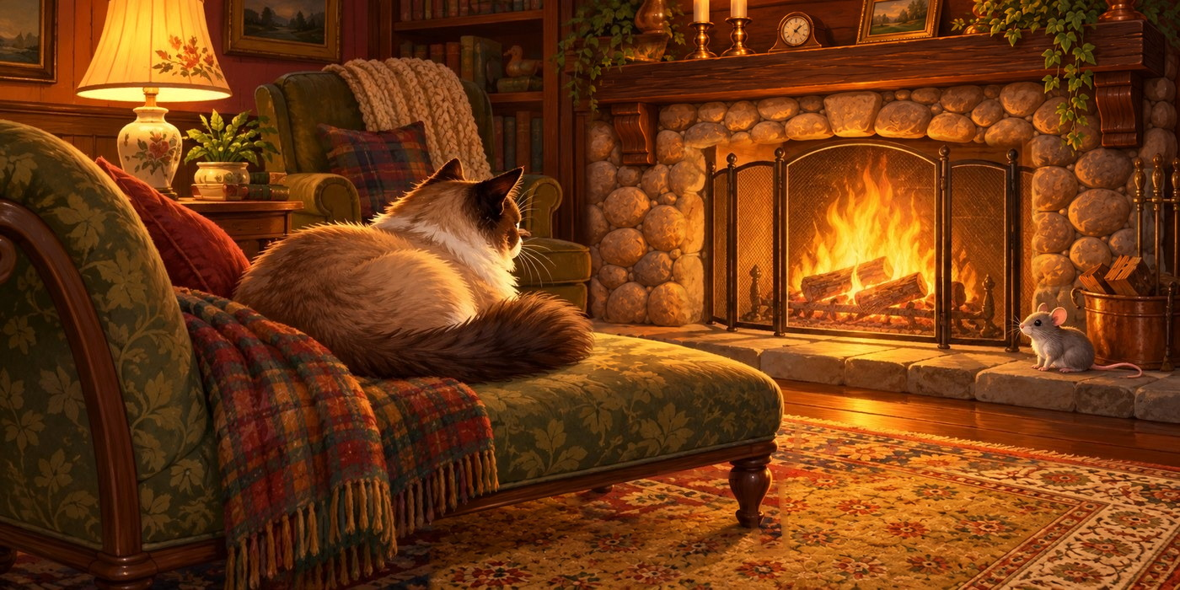
The End

Special Appearances — Easter-Egg Cast
From Mom’s original draft: hidden friends tucked into scenes throughout the book.
- Nero the cat — marketplace with Lois (p.3)
- Dallas the Yorkie — with Molly & Albie on the farm (p.6)
- Dynamite the pony — with Chester the laughing horse (p.7)
- Paco the greyhound — with the red pick-up truck (p.8)
- French Fry the dog — with Philly the rat in the city (p.10)
- Endeavor the calico cat — with Penelope in the city (p.11)
- Chowder & Monkey the Chihuahuas — with Otis the coyote (p.12)
- Tiger the cat — with Gideon the pigeon (p.13)
- Nicholas & Norman the guinea pigs — with Chippy at the baseball park (p.14)
- Cash the cockatiel — with Helga on the beach (p.21)
- Mittens the cat — ghostly guardian angel on the road home (p.22)
- Teddy the cat — ghostly guardian angel on the road home (p.22)
- Wally the dog — in the neighbor’s yard, watching Harlow come home (p.23)

Change History
How this storyline document has changed, rev by rev. A rev freezes once it is shared; changes batch into the next rev.
Rev. 8 — October 12, 2026: Lois's final story edits applied (pages 8, 18, 20, 21). Story text locked.
Rev. 9 — October 12, 2026: Verified master copy of Rev. 8 issued; no content changes.
Rev. 10 — October 12, 2026: Character reference portraits updated to the current cast portraits.
Rev. 11 — October 13, 2026: Remaining reference portraits aligned to the cast; Ducklings (page 5) and Jon-Boy (page 16) references added.
Rev. 12 — October 13, 2026: Final cast portrait set throughout — Gideon, Finnegan, Nero, Mittens, Chowder, Teddy, Lois, and Jon-Boy in the finished cast style. Change history and page footer added.
Rev. 13 — October 13, 2026: Lois’s wording revisions applied on ten pages (2, 5, 7, 10, 12, 13, 14, 18, 20, 21). The boy’s reference portrait is now JJ Boy (Lois’s pick, drawn from Jon’s childhood photo). Two typos in her batch corrected at Jon’s direction (pages 13 and 21).
Rev. 14 — October 13, 2026: The Little Mouse added — Lois confirmed the last page’s “little chum” is a new mouse, not Philly the rat; his portrait (drawn and banked October 13) joins the last page’s character references.
Rev. 15 — October 13, 2026: Formatting only, at Lois’s request — page breaks added so each story page keeps its paragraph and character pictures together on one page in the PDF. No text changes.
Rev. 16 — October 13, 2026: Formatting tweak — Page 1’s three original pictures sized smaller so all of Page 1 fits on one PDF page. Also tonight: Lois confirmed the little mouse needs no other name — “Little Mouse” is his name.
Rev. 17 — October 13, 2026: Wally — Lois’s best friend’s real dog — added as an Easter-egg character on Page 23 (the homecoming): portrait added to Page 23’s character references and a line on the Special Appearances page. Portrait drawn from his real photos and banked the same night.
Rev. 18 — October 24, 2026: Gold Finals edition. Storyline text is Rev.17 verbatim (no story changes); character cards removed; storyboard art replaced with the 24 gold-final spreads.
Art note — Page 9 (S09-AO): the gold-final art now includes the Easter-egg cats KitKat and Nala in the picture — at the window/steps, daytime, Harlow awake, the truck driving off (Lois’s placement decision, October 17, 2026). They are unnamed in the story text, the same treatment as Wally on page 23.

