Building An AI Model To Support Lung Disease Diagnosis And Explanation From Chest X-Ray Images
VO Thi-My-Duyen¹[0000-1111-2222-3333] and PHAN Thi-Xuan-Trang²[1111-2222-3333-4444]
¹ Faculty of Information Technology, Nam Can Tho University, Can Tho City, Viet Nam
² Springer Heidelberg, Tiergartenstr. 17, 69121 Heidelberg, Germany
duyen224719@student.nctu.edu.vn, ptxtrang@nctu.edu.vn
Abstract. Chest radiography is a widely used screening modality for common infectious thoracic diseases, but deep learning classifiers are frequently criticized as black-box systems whose decisions are difficult to verify in clinical contexts. This paper presents an explainability-focused study that applies and quantitatively compares four post-hoc explanation methods — Grad-CAM, Grad-CAM++, Integrated Gradients, and Occlusion Sensitivity — on a ResNet101V2 transfer-learning model trained for four-class chest X-ray classification (COVID-19, Normal, Pneumonia, Tuberculosis). The model is trained on a public Kaggle dataset of frontal-view radiographs organized into train/validation/test splits and achieves an overall accuracy of 0.9390, macro precision of 0.9586, macro recall of 0.9511, and macro F1-score of 0.9538 on the held-out test set of 771 images. The primary contribution is the systematic application and side-by-side visualization of the four explanation methods for representative correctly-classified images from each disease class, demonstrating that Grad-CAM and Grad-CAM++ produce concentrated class-discriminative activation regions, while Integrated Gradients yields a more distributed pixel-level attribution map, and Occlusion Sensitivity directly quantifies the prediction drop when critical patches are masked. Quantitative evaluation uses Deletion-AUC and Insertion-AUC faithfulness metrics to provide an objective comparison of explanation reliability. Class-wise analysis shows that most remaining errors occur between Normal and Pneumonia, motivating targeted XAI inspection of these two classes.
Keywords: Chest X-ray classification, COVID-19, Pneumonia, Tuberculosis, ResNet101V2, Transfer learning, Explainable AI, Grad-CAM, Integrated Gradients, Occlusion Sensitivity, Deletion-AUC, Insertion-AUC.
- Introduction
In recent years, Artificial Intelligence (AI) has become an important technological approach in healthcare, particularly in medical image analysis and clinical decision support. Among different medical imaging modalities, chest X-ray imaging remains one of the most widely used techniques for observing lung-related abnormalities because it is relatively fast, accessible, and low-cost. Chest X-ray images are commonly used to support the diagnosis of respiratory diseases such as COVID-19, pneumonia, and pulmonary tuberculosis. However, manual interpretation of chest X-ray images requires professional medical expertise and may be affected by image quality, workload, and similarities among disease manifestations. Therefore, there is an increasing demand for AI-based systems that can assist in analyzing chest X-ray images and provide preliminary decision support for lung disease classification.
Despite the rapid development of medical imaging technologies, lung disease diagnosis from chest X-ray images remains a challenging task. Several respiratory diseases may present visually similar patterns, including opacity, consolidation, infiltrative regions, or abnormal lung shadows. For example, pneumonia and COVID-19 may both produce cloudy or diffuse opacity patterns, while tuberculosis may present local or subtle abnormalities that are difficult to distinguish from normal lung regions in some cases. In addition, chest X-ray datasets often contain variations in image brightness, contrast, patient positioning, and acquisition conditions. These factors make automated lung disease classification a complex computer vision problem that requires robust feature extraction, reliable classification, and careful interpretation of model outputs.
Deep learning has achieved significant progress in medical image classification, especially through Convolutional Neural Networks (CNNs). CNN-based models can automatically learn hierarchical image features from raw image data, ranging from low-level patterns such as edges and textures to high-level disease-related representations. In chest X-ray analysis, recent studies have demonstrated the effectiveness of deep learning for classifying respiratory diseases from radiographic images. Kiche et al. (2024) proposed a CNN-based model for classifying pneumonia, tuberculosis, and COVID-19 from chest X-ray images and evaluated the model using accuracy, sensitivity, specificity, AUC-ROC, and confusion matrices. Kabir et al. (2024) applied AI-driven knowledge distillation to detect COVID-19, pneumonia, and tuberculosis from radiographs while reducing model complexity for practical deployment. Jain et al. (2025) investigated several CNN and ensemble deep learning architectures for detecting COVID-19, pneumonia, and tuberculosis, showing that ResNet-based architectures can achieve strong performance in chest disease classification.
Among deep learning architectures, ResNet has become one of the most influential CNN models because of its residual learning mechanism. Residual connections allow information to pass through shortcut paths, helping the network reduce the vanishing gradient problem and maintain stable learning in deeper architectures. Instead of directly learning a complete transformation, residual blocks learn the difference between the input and the desired output. This design makes ResNet suitable for extracting complex visual patterns from medical images. In this study, ResNet101 is selected as the main classification model because it provides a deep feature extraction structure and is suitable for chest X-ray image classification. By using transfer learning, the model can reuse visual knowledge learned from large-scale image datasets and adapt it to the target lung disease classification task.
However, high classification performance alone is not sufficient for AI applications in healthcare. Deep learning models are often considered “black-box” models because their internal decision-making processes are difficult for users to understand. In medical contexts, this limitation is especially important because users need not only a predicted label but also an explanation of why the model produces that result. A model that predicts COVID-19, Normal, Pneumonia, or Tuberculosis without showing which image regions influenced the prediction may reduce user trust and limit practical interpretability. Therefore, Explainable AI (XAI) techniques are necessary to improve transparency and provide visual evidence of the image regions that contribute to the model’s decision.
Recent studies have increasingly emphasized the role of Explainable AI in chest X-ray classification. Bhandari et al. (2022) applied deep learning and XAI for explanatory classification of chest X-ray images into COVID-19, pneumonia, tuberculosis, and normal categories. Naz et al. (2023) proposed an explainable AI-enabled framework for interpreting pulmonary diseases using chest radiographs. Chatterjee et al. (2024) investigated several interpretability techniques for deep COVID-19 and pneumonia classification using chest X-ray images. These studies indicate that XAI is not only an additional visualization tool but also an important component for improving transparency, reliability, and user understanding in medical AI systems.
In this study, four Explainable AI techniques are used to support the interpretation of ResNet101 predictions: Grad-CAM, Grad-CAM++, Integrated Gradients, and Occlusion Sensitivity. Grad-CAM generates heatmaps by using gradient information from convolutional layers to highlight important image regions related to a target class. Grad-CAM++ extends this approach by improving localization when multiple relevant regions appear in the same image. Integrated Gradients estimates the contribution of input pixels by accumulating gradients along a path from a baseline image to the original image. Occlusion Sensitivity provides an intuitive explanation by masking different image regions and observing changes in the model’s prediction probability. By combining these methods, the proposed system provides multiple perspectives for understanding how the model processes chest X-ray images.
Although previous studies have explored deep learning for chest X-ray classification, several limitations remain. Many studies focus mainly on classification accuracy and provide limited explanation of the prediction process. Some systems are developed only at the experimental model level without a simple interface for uploading images, viewing prediction results, and observing model explanations. In addition, several existing studies apply only one or two XAI techniques, which may provide a limited view of the model’s behavior. These limitations indicate the need for a system that combines classification performance, interpretability, and practical interface design.
To address these limitations, this study proposes an AI-based system to support lung disease diagnosis and explanation from chest X-ray images. The system classifies chest X-ray images into four categories: COVID-19, Normal, Pneumonia, and Tuberculosis. ResNet101 is used as the main deep learning model for feature extraction and classification. The system also integrates Explainable AI techniques, including Grad-CAM, Grad-CAM++, Integrated Gradients, and Occlusion Sensitivity, to visualize important image regions related to the prediction. In addition, a web-based interface is developed to allow users to upload chest X-ray images, receive prediction results, view class probabilities, and observe explanation outputs.
The main contributions of this study are threefold. First, it develops a ResNet101-based deep learning model for four-class lung disease classification from chest X-ray images. Second, it integrates multiple XAI techniques to improve the interpretability of model predictions and provide visual explanations for classification results. Third, it designs a web-based demonstration system that connects the trained model with a user interface, enabling practical image upload, prediction visualization, and explanation display. The system is intended to support research and educational purposes and should not be considered a replacement for professional medical diagnosis.
The remainder of this paper is organized as follows. Section 2 presents related studies on chest X-ray image analysis, deep learning, ResNet-based architectures, and Explainable AI techniques. Section 3 describes the materials and methods, including dataset preparation, image preprocessing, model architecture, training process, evaluation metrics, and XAI implementation. Section 4 presents the experimental results, including classification performance, confusion matrix analysis, and XAI visualization. Section 5 discusses the findings, limitations, and practical implications of the proposed system. Finally, Section 6 concludes the paper and outlines future research directions.
- Project Management and Delay Management
Chest X-ray image analysis has become an important research direction in medical artificial intelligence because chest radiography is widely used to support the diagnosis of respiratory diseases. Compared with several other medical imaging modalities, chest X-ray imaging is relatively fast, accessible, and low-cost. It is commonly used to observe lung abnormalities related to COVID-19, pneumonia, tuberculosis, and other thoracic diseases. However, manual interpretation of chest X-ray images requires professional medical expertise and may be affected by image quality, workload, and the similarity of radiographic patterns among different lung diseases. These challenges have encouraged the development of computer-aided diagnosis systems based on deep learning.
Deep learning, particularly Convolutional Neural Networks (CNNs), has shown strong performance in medical image classification because it can automatically learn visual features from raw image data. In chest X-ray classification, CNN-based models extract hierarchical features from images, beginning with low-level visual patterns such as edges and textures and progressing to high-level disease-related representations. This capability allows deep learning models to handle variations in brightness, contrast, patient position, and disease manifestation better than traditional handcrafted feature extraction methods. Therefore, CNN-based approaches have become widely used in the automatic classification of respiratory diseases from chest X-ray images.
Recent studies have demonstrated the effectiveness of deep learning in detecting and classifying COVID-19, pneumonia, and tuberculosis from chest X-ray images. Kiche et al. (2024) proposed a CNN-based approach for classifying pneumonia, tuberculosis, and COVID-19 from chest X-ray images and evaluated the model using accuracy, sensitivity, specificity, AUC-ROC, and confusion matrices. Their work also compared CNN performance with traditional machine learning methods such as Support Vector Machines, Decision Trees, and XGBoost. Kabir et al. (2024) introduced an AI-driven knowledge distillation approach for detecting COVID-19, pneumonia, and tuberculosis from radiographs. Their method reduced model complexity by transferring knowledge from a larger teacher model to a smaller student model, which is useful for real-time deployment in mobile, web, and cloud-based medical applications. Jain et al. (2025) further investigated multiple deep learning architectures, including MobileNetV2, ResNet50, VGG19, and DenResCov-19, for detecting COVID-19, pneumonia, and tuberculosis from chest X-ray images. Their results showed that ResNet-based models achieved strong performance in several disease classification tasks, supporting the relevance of residual learning architectures for chest X-ray analysis.
Although recent deep learning models have achieved promising classification performance, prediction accuracy alone is not sufficient for medical AI applications. Deep learning models are often considered black-box models because their internal decision-making processes are difficult to understand. In healthcare-related applications, this limitation is critical because users need to know not only what class the model predicts but also why the model produces that prediction. Without explanation, a high-confidence prediction may still be difficult to trust, especially when the output is used for diagnosis support. Therefore, Explainable AI (XAI) has become an essential component in medical image classification systems.
Explainable AI aims to make AI model predictions more transparent, interpretable, and useful for human users. In chest X-ray analysis, XAI techniques can highlight image regions that influence the model’s prediction, helping users understand whether the model focuses on meaningful lung areas or irrelevant image artifacts. Bhandari et al. (2022) emphasized the use of deep learning and XAI for explanatory classification of chest X-ray images into COVID-19, pneumonia, tuberculosis, and normal categories. Similarly, Ifty et al. (2024) investigated explainable lung disease classification from chest X-ray images and considered multiple lung disease categories, including viral pneumonia, bacterial pneumonia, COVID-19, tuberculosis, and normal lungs. These studies show that XAI is not only an additional visualization feature but also an important method for improving interpretability and trust in AI-assisted medical diagnosis.
Among XAI techniques, Grad-CAM is one of the most widely used methods for visual explanation in CNN-based image classification. Grad-CAM uses gradient information from the final convolutional layers to generate a heatmap that highlights the image regions most relevant to a target class. In chest X-ray diagnosis, Grad-CAM can help visualize whether the model focuses on lung regions that contribute to the predicted disease class. Ihongbe et al. (2024) evaluated visual XAI systems, including Grad-CAM, in chest radiology imaging and considered medical practitioners’ feedback in terms of comprehensibility, confidence, and clinical relevance. This supports the use of Grad-CAM as a practical technique for visualizing CNN decision regions in medical image diagnosis.
Grad-CAM++ extends the original Grad-CAM method by improving the localization of class-discriminative regions, especially when multiple relevant regions appear in the same image. This is useful for chest X-ray images because abnormal signs may appear in more than one lung region or may be distributed across different areas. Naz et al. (2023) proposed an explainable AI-enabled framework for interpreting pulmonary diseases from chest radiographs and used a transfer-learning-based ResNet50 model with explanation methods for pulmonary disease interpretation. The use of Grad-CAM++ in such contexts is relevant to this study because it supports more detailed localization of important regions than standard heatmap visualization.
Integrated Gradients is another important XAI technique that explains a model’s prediction by estimating the contribution of input features. Instead of relying only on the final convolutional feature maps, Integrated Gradients accumulates gradients along a path from a baseline image to the original input image. This allows the method to assign importance scores to input pixels and provides a pixel-level explanation of the prediction. Chatterjee et al. (2024) explored several interpretability techniques for COVID-19 and pneumonia classification using chest X-ray images, including Integrated Gradients and occlusion-based methods. Their work demonstrates the importance of comparing different interpretability techniques rather than relying on a single explanation method.
Occlusion Sensitivity provides an intuitive way to evaluate the importance of image regions by systematically masking parts of the input image and observing how the model’s output probability changes. If masking a specific region causes a significant drop in the predicted probability, that region is considered important for the model’s decision. This method is particularly useful for validating whether the model depends on clinically meaningful regions or irrelevant background areas. Sufian et al. (2024) applied transfer learning and explainable AI in thoracic X-ray diagnostics, showing the importance of interpretability in pulmonary radiography. In this study, Occlusion Sensitivity is used together with other XAI methods to provide an additional perspective on the image regions that influence ResNet101 predictions.
Based on the above studies, this research focuses not only on classifying chest X-ray images but also on explaining the model’s decisions through multiple XAI techniques. The proposed system uses ResNet101 as the main classification model for four classes: COVID-19, Normal, Pneumonia, and Tuberculosis. After prediction, Grad-CAM, Grad-CAM++, Integrated Gradients, and Occlusion Sensitivity are applied to provide visual explanations. This combination allows the system to output both numerical results, such as class probabilities, and visual evidence, such as heatmaps and region-importance maps. Therefore, the proposed approach aims to improve both prediction performance and interpretability in AI-supported lung disease diagnosis.
To contextualize the proposed approach within recent studies, Table 1 presents a comparison of related works in terms of domain, method, model or technique, XAI focus, and relevance to this study.
Table 1. Comparison of Related Studies.
Author(s) | Domain | Method | Explainable AI Focus
Bhandari et al. (2022) | CXR disease classifiction | Deep learning, Grad-CAM, LIME, SHAP | Uses XAI to explain COVID-19, Pneumonia, TB, and Normal classification
Naz et al. (2023) | Pulmonary disease interpretation | ResNet50, Grad-CAM++, SHAP | Applies XAI for interpreting pulmonary disease predictions
Kiche et al. (2024) | CXR classification | CNN, SVM, Decision Tree, XGBoost | Classifies Pneumonia, Tuberculosis, and COVID-19 from chest X-rays
Kabir et al. (2024) | Respiratory disease detection | Knowledge distillation, deep learning | Detects COVID-19, Pneumonia, and TB with efficient deployment focus
Chatterjee et al. (2024) | CXR interpretability | Integrated Gradients, Occlusion, Saliency | Compares several XAI techniques for COVID-19 and Pneumonia classification
Jain et al. (2025) | Chest disease detection | MobileNetV2, ResNet50,  VGG19, DenResCov-19 | Shows strong CNN performance for COVID-19, Pneumonia, and TB detection
- Design of the AI-Integrated Project Management System
To operationalize AI-assisted lung disease classification and explanation, the proposed solution is designed as an AI-supported chest X-ray diagnosis system that combines deep learning-based prediction with visual interpretability. The system is developed to support the classification of chest X-ray images into four categories: COVID-19, Normal, Pneumonia, and Tuberculosis. In addition to producing prediction results, the system integrates Explainable AI (XAI) techniques to highlight image regions that influence the model’s decision. This design allows the system to provide both numerical outputs, such as class probabilities, and visual explanations, such as heatmaps and region-importance maps.
The overall architecture follows a client-server structure. The client side is implemented as a web-based user interface that allows users to upload chest X-ray images, view prediction results, observe class probabilities, and access explanation outputs. The server side is implemented as a backend service that receives uploaded images, performs preprocessing, executes the trained deep learning model, and returns the prediction results to the interface. The trained ResNet101 model acts as the main classification component, while the XAI module is responsible for generating explanation outputs using Grad-CAM, Grad-CAM++, Integrated Gradients, and Occlusion Sensitivity. This separation allows the web interface to remain simple and user-friendly while the backend manages the computational tasks.
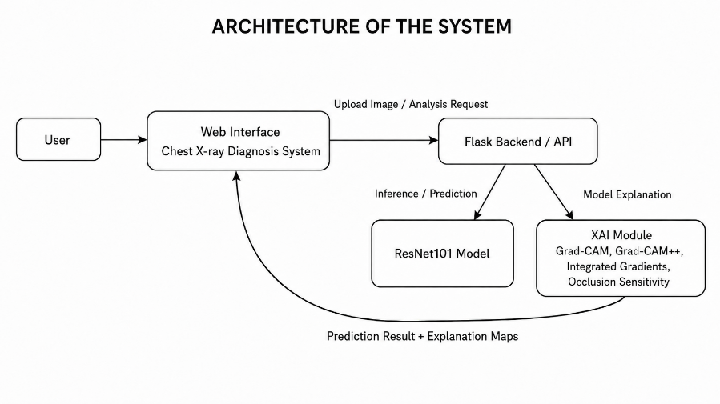
Fig. 1. Simple architecture of the proposed AI-supported chest X-ray diagnosis and explanation system. The figure shows the interaction between the user, web interface, Flask backend/API, ResNet101 classification model, and XAI module for generating prediction results and explanation maps.
The proposed system is designed as an AI-supported chest X-ray diagnosis and explanation system. It allows users to upload chest X-ray images through a web interface, processes the images in the backend, performs classification using a trained ResNet101 model, and generates visual explanations through Explainable AI techniques. The system aims to provide both prediction results and interpretable visual evidence to support lung disease classification.
The overall workflow begins when a user uploads a chest X-ray image. The backend receives the image and performs preprocessing, including RGB conversion, resizing, normalization, and reshaping the image into the input format required by the model. The preprocessed image is then forwarded to the ResNet101 classifier. The model produces a probability distribution across four target classes: COVID-19, Normal, Pneumonia, and Tuberculosis. The class with the highest probability is selected as the final prediction, and the confidence score is returned to the web interface.
The system consists of several main functional modules. The Image Upload Module allows users to select and preview chest X-ray images before analysis. The Image Preprocessing Module prepares the input image for model inference. The Deep Learning Classification Module performs prediction using the trained ResNet101 model. The Prediction Result Module displays the predicted class, confidence score, and class probabilities in an understandable format. The Result Visualization Module presents the uploaded image and prediction results through the web interface. A simple History Module can also store recent analysis results for demonstration and review purposes.
A key component of the proposed system is the Explainable AI Module. This module generates visual explanations to help users understand which image regions influence the model’s decision. Grad-CAM and Grad-CAM++ are used to create heatmaps that highlight class-discriminative regions. Integrated Gradients estimates the contribution of input pixels to the prediction, while Occlusion Sensitivity evaluates the importance of image regions by masking different patches and observing changes in prediction probability. These techniques provide complementary views of the model’s decision-making process.

After the prediction stage, the XAI workflow is executed to produce visual explanation outputs. Grad-CAM and Grad-CAM++ use gradient information from convolutional feature maps to identify important regions related to the predicted class. Integrated Gradients analyzes pixel-level contribution by accumulating gradients from a baseline image to the original image. Occlusion Sensitivity identifies influential regions by measuring the prediction changes caused by masking specific image areas. By combining multiple explanation methods, the system avoids relying on a single interpretation technique and provides a broader understanding of the model’s behavior.
The proposed system is intended for research and educational purposes. It supports preliminary analysis of chest X-ray images and improves the transparency of AI predictions through visual explanations. However, the system does not replace professional medical diagnosis. The predicted labels and XAI visualizations should be considered supportive information only. XAI heatmaps indicate regions that influence the model’s decision, but they do not automatically confirm the presence of clinical lesions.
Overall, the proposed design integrates deep learning classification, Explainable AI visualization, and web-based interaction into a unified system. ResNet101 provides the main feature extraction and classification backbone, while Grad-CAM, Grad-CAM++, Integrated Gradients, and Occlusion Sensitivity improve interpretability. This design supports the objective of building an AI model that not only predicts lung disease categories from chest X-ray images but also explains the visual basis of its decisions.
- ResNet101-Based Classification and Explainable AI Analysis
This section presents the ResNet101-based classification approach and the Explainable AI analysis used in the proposed system. The main objective is to classify chest X-ray images into four classes, including COVID-19, Normal, Pneumonia, and Tuberculosis, while also providing visual explanations for the prediction results. The methodology follows a deep learning pipeline consisting of image preprocessing, feature extraction, classification, model evaluation, and post-hoc explanation generation.
The input of the system is a chest X-ray image uploaded through the web interface. Before being passed into the classification model, the image is preprocessed to ensure consistency and compatibility with the ResNet101 architecture. The preprocessing stage includes converting the image into RGB format, resizing it to the required input size, normalizing pixel values, and reshaping the image into the tensor format required by the model. Pixel normalization is performed to scale the input values into the range [0, 1], as shown below:
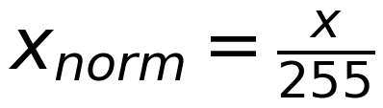 (1)
where x represents the original pixel value and x_norm represents the normalized pixel value. This process helps reduce numerical variation and improves the stability of model inference. Data augmentation techniques such as rotation, flipping, zooming, and brightness adjustment can also be applied during training to improve the generalization ability of the model and reduce overfitting.
Convolution is the core operation used in convolutional neural networks to extract visual features from images. It applies a learnable filter or kernel to the input image and produces feature maps that highlight important visual patterns such as edges, textures, and disease-related structures. Given an input image I and a convolutional kernel K of size f × f, the convolution operation can be expressed as:
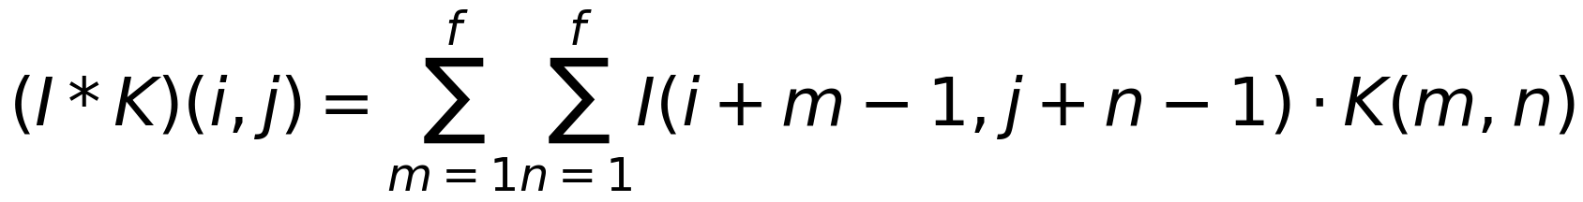 (2)
where (i, j) denotes the spatial position in the output feature map, I represents the input image, and K represents the convolutional kernel. Through multiple convolutional layers, the model learns hierarchical representations, where earlier layers capture low-level features and deeper layers capture more abstract disease-related patterns.
Pooling is used after convolutional layers to reduce the spatial dimensions of feature maps while preserving important information. This operation helps reduce computational complexity, control overfitting, and improve spatial invariance. Max pooling selects the maximum value within a local region of the feature map. For a pooling window of size p × p and stride s, the max pooling operation can be written as:
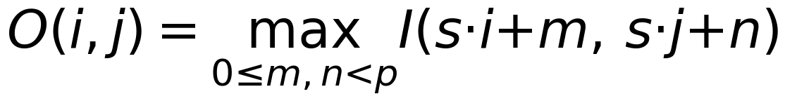 (3)
where O(i, j) is the pooled output value, I is the input feature map, p is the pooling window size, and s is the stride. By reducing feature map size, pooling allows the model to focus on the most important extracted features while decreasing the number of computations.
In the proposed system, ResNet101 is used as the main classification model. ResNet101 is selected because of its residual learning mechanism, which allows deep neural networks to be trained more effectively. In very deep networks, the vanishing gradient problem may reduce the ability of earlier layers to learn useful features. ResNet solves this problem by using residual connections, also known as skip connections, which allow information to flow directly across layers. Instead of learning a direct mapping H(x), a residual block learns a residual function F(x), and the output can be expressed as:
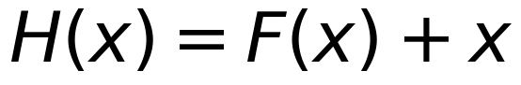 (4)
where x denotes the input of the residual block, F(x) represents the residual mapping learned by the convolutional layers, and H(x) is the output of the residual block. This structure allows information to flow more effectively through the network and enables deeper feature extraction. In this study, ResNet101 is used as the main feature extraction backbone, and the final classification layers are adjusted to output four disease categories.
The final layer of the model uses the Softmax activation function to convert raw output scores into class probabilities. Given the raw score z_i for class i, the Softmax probability is calculated as follows:
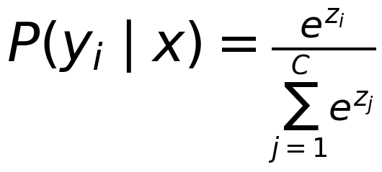 (5)
where P(y_i | x) is the predicted probability of class i given the input image x, z_i is the raw output score for class i, and C is the total number of classes. In this study, C = 4, corresponding to COVID-19, Normal, Pneumonia, and Tuberculosis. The predicted class is selected as the class with the highest probability:
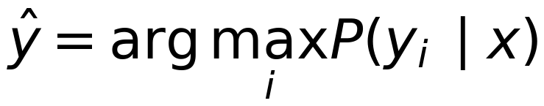 (6)
For multi-class classification, categorical cross-entropy is used as the loss function. This loss function measures the difference between the true class label and the predicted probability distribution:
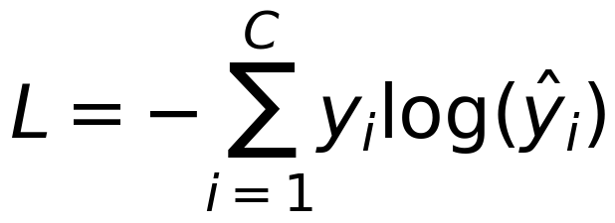 (7)
where y_i is the true label value and y_hat_i is the predicted probability for class i. During training, the model minimizes this loss by updating its parameters through backpropagation. A lower loss value indicates that the predicted probability distribution is closer to the true label distribution.
The performance of the trained model is evaluated using Accuracy, Precision, Recall, F1-score, and Confusion Matrix. These metrics provide a more complete assessment of model performance than accuracy alone. Accuracy measures the proportion of correctly classified samples among all samples:
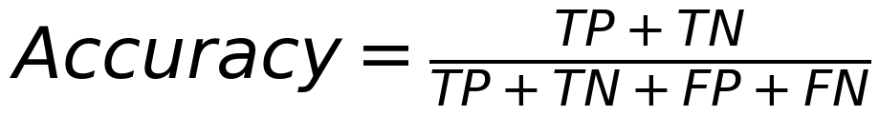 (8)
Precision measures how many predicted positive samples are actually correct:
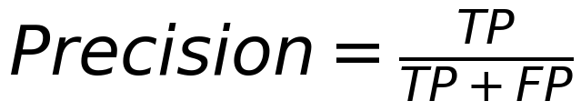 (9)
Recall measures how many actual positive samples are correctly detected:
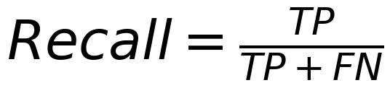 (10)
F1-score is the harmonic mean of Precision and Recall:
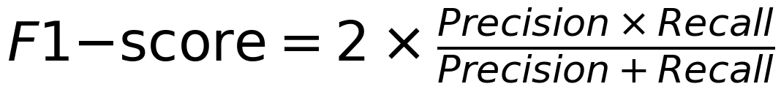 (8)
where TP, TN, FP, and FN represent true positives, true negatives, false positives, and false negatives, respectively. In addition, the confusion matrix is used to observe how samples from each actual class are classified by the model. This is useful for identifying misclassification patterns, especially between visually similar diseases such as COVID-19 and Pneumonia or between Normal and abnormal chest X-ray images.
Although ResNet101 can provide strong classification performance, its internal decision-making process is difficult to interpret directly. This limitation is important in medical image analysis because users need not only a predicted label but also an explanation of why the model makes that prediction. Therefore, the proposed system integrates Explainable AI techniques to provide visual interpretation of the classification results.
Four Explainable AI techniques are used in this study: Grad-CAM, Grad-CAM++, Integrated Gradients, and Occlusion Sensitivity. Grad-CAM generates a heatmap by using gradient information from convolutional layers to highlight image regions that contribute strongly to the predicted class. Grad-CAM++ improves this approach by producing more precise localization when multiple important regions appear in the same image. Integrated Gradients estimates the contribution of input pixels by accumulating gradients from a baseline image to the original image. Occlusion Sensitivity explains the prediction by masking different image regions and observing how the prediction probability changes.
Table 2. Explainable AI Techniques Used in the Proposed System.
XAI Technique | Explanation Type | Purpose in This Study
Grad-CAM | Heatmap-based explanation | Highlights important convolutional regions related to the predicted class
Grad-CAM++ | Improved heatmap explanation | Provides more detailed localization of important image regions
Integrated Gradients | Pixel-level attribution | Estimates the contribution of pixels to the prediction
Occlusion Sensitivity | Region masking analysis | Measures how masking image regions changes prediction probability

The XAI workflow is performed after the ResNet101 model produces the prediction result. First, the input image is processed by the trained model to obtain the predicted class and class probabilities. Then, the predicted class is used as the target class for explanation generation. Grad-CAM and Grad-CAM++ produce heatmaps based on convolutional feature maps, while Integrated Gradients and Occlusion Sensitivity provide attribution from different perspectives. The generated explanation maps are displayed together with the original image, predicted label, confidence score, and class probabilities.
The use of multiple XAI techniques is important because each method explains the model in a different way. Grad-CAM and Grad-CAM++ focus on high-level convolutional feature regions, Integrated Gradients provides pixel-level attribution, and Occlusion Sensitivity evaluates the importance of image regions through perturbation. By combining these methods, the system avoids relying on only one explanation technique and provides a broader view of the model’s decision-making behavior.
However, XAI results must be interpreted carefully. Heatmaps and attribution maps show regions that influence the model’s prediction, but they do not automatically confirm the presence of clinical lesions. Therefore, the proposed system is designed for research and educational support. The predicted labels and XAI visualizations should be considered supportive information and should not replace professional medical diagnosis.
Overall, the proposed ResNet101-based classification and XAI framework allows the system to provide both prediction and explanation. The ResNet101 model classifies chest X-ray images into COVID-19, Normal, Pneumonia, and Tuberculosis, while the XAI module generates visual evidence to support interpretation. This combination improves the transparency of the system and supports the objective of building an AI model that not only predicts lung disease categories but also explains the visual basis of its decisions.
- System Evaluation and Discussion
The proposed AI-supported chest X-ray diagnosis and explanation system was evaluated based on classification performance, confusion matrix analysis, Explainable AI visualization, and practical system integration. The evaluation aims to determine whether the ResNet101-based model can classify chest X-ray images into four categories, including COVID-19, Normal, Pneumonia, and Tuberculosis, while also providing interpretable visual explanations for its predictions.
The trained ResNet101 model was tested on an independent test set containing 771 chest X-ray images. The evaluation was performed using standard classification metrics, including Accuracy, Precision, Recall, F1-score, and Confusion Matrix. These metrics are important because chest X-ray images from different respiratory diseases may contain visually similar patterns, especially between COVID-19 and Pneumonia or between Normal and mild abnormal cases.
Table 3. Classification Performance of the ResNet101 Model.
Class | Precision | Recall | F1-score | Support
COVID-19 | 1.00 | 0.91 | 0.95 | 106
Normal | 0.88 | 0.91 | 0.90 | 234
Pneumonia | 0.94 | 0.94 | 0.94 | 390
Tuberculosis | 0.95 | 1.00 | 0.98 | 41
Accuracy |  |  | 0.93 | 771
Macro Average | 0.94 | 0.94 | 0.94 | 771
Weighted Average | 0.93 | 0.93 | 0.93 | 771
The evaluation results show that the proposed model achieved an overall accuracy of 93% on the test set. The macro average F1-score reached 0.94, indicating that the model performed well across all four classes rather than only favoring the majority class. The weighted average F1-score was 0.93, showing stable performance when the number of samples in each class is considered. Tuberculosis achieved the highest recall value of 1.00 and an F1-score of 0.98, while COVID-19 achieved a precision of 1.00 and an F1-score of 0.95. Pneumonia also showed balanced performance with precision and recall values of 0.94, and the Normal class obtained an F1-score of 0.90.
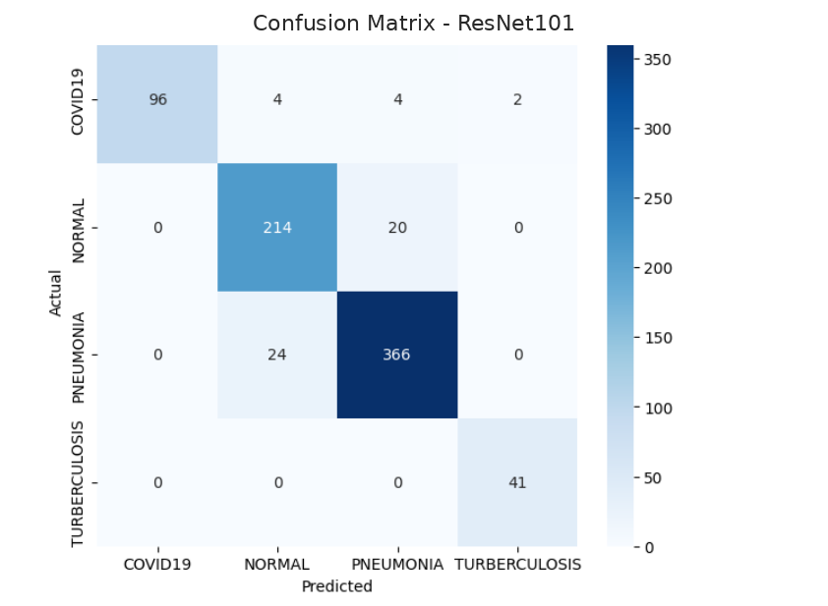
Fig. 2. Confusion Matrix of the ResNet101 Model.
The confusion matrix provides a more detailed view of the model’s classification behavior. For the COVID-19 class, 96 out of 106 images were correctly classified, while a small number of samples were misclassified as Normal, Pneumonia, or Tuberculosis. For the Normal class, 214 out of 234 samples were correctly classified, while 20 samples were misclassified as Pneumonia. For the Pneumonia class, 366 out of 390 samples were correctly classified, while 24 samples were misclassified as Normal. For the Tuberculosis class, all 41 samples were correctly classified as Tuberculosis.
Most prediction errors occurred between Normal and Pneumonia. This may be caused by subtle visual similarities between normal chest X-ray images and mild pneumonia cases. In some cases, pneumonia-related abnormalities may be weak or localized, making them difficult to distinguish from normal lung structures. Similarly, a small number of COVID-19 samples were confused with Pneumonia, which is reasonable because both diseases may present opacity or infiltrative patterns in chest X-ray images. Overall, the confusion matrix shows that the model can effectively distinguish most disease classes, but further improvement is still needed for visually similar cases.
In addition to classification performance, the proposed system was evaluated through Explainable AI visualization. Since deep learning models are often considered black-box models, visual explanation is necessary to help users understand which regions of the image influence the prediction. In this study, four XAI techniques were used: Grad-CAM, Grad-CAM++, Integrated Gradients, and Occlusion Sensitivity.
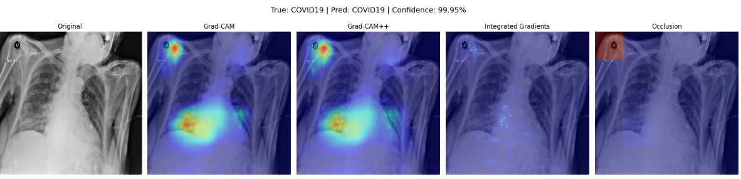
Fig. 3. Explainable AI Visualization Results.
The XAI visualization results show the original chest X-ray image together with explanation outputs generated by different techniques. Grad-CAM and Grad-CAM++ produce heatmaps that highlight important regions contributing to the predicted class. Integrated Gradients provides pixel-level attribution by estimating the contribution of input pixels to the prediction. Occlusion Sensitivity identifies influential image regions by masking different parts of the image and observing changes in prediction probability.
For the tested example, the model predicted the COVID-19 class with high confidence. The XAI outputs provided complementary visual explanations for this prediction. Grad-CAM and Grad-CAM++ highlighted regions that the model considered important at the convolutional feature level, while Integrated Gradients and Occlusion Sensitivity offered different perspectives on pixel-level and region-level influence. These visualizations help users observe the model’s attention areas and improve the interpretability of the prediction. However, the highlighted regions should not be interpreted as confirmed medical lesions. They only indicate image regions that influenced the model’s decision.
Table 4. Role of XAI Techniques in Model Interpretation.
XAI Technique | Output Type | Interpretation Role
Grad-CAM | Heatmap | Highlights important convolutional regions related to the predicted class
Grad-CAM++ | Improved heatmap | Provides more detailed localization of class-discriminative regions
Integrated Gradients | Pixel attribution map | Shows pixel-level contribution to the model’s prediction
Occlusion Sensitivity | Region importance map | Measures how masking image regions changes prediction confidence

The system was also evaluated from a practical implementation perspective. A web-based interface was developed to allow users to upload chest X-ray images, send analysis requests to the backend, and view prediction results. The backend loads the trained ResNet101 model, preprocesses the uploaded image, performs inference, and returns the predicted class, confidence score, and probability distribution. The interface then displays the uploaded image, prediction result, class probabilities, and explanation outputs. This integration demonstrates that the trained model can be connected to a simple application environment for demonstration and educational use.
The main advantage of the proposed system is that it combines classification and explanation in one workflow. Instead of only returning a predicted label, the system provides probability values and XAI visualizations. This makes the result more understandable for users and improves transparency. The use of multiple XAI techniques is also beneficial because each method explains the model from a different perspective. Grad-CAM and Grad-CAM++ focus on high-level convolutional features, Integrated Gradients analyzes pixel contribution, and Occlusion Sensitivity evaluates the effect of masking image regions.
Despite these advantages, several limitations remain. First, the dataset is limited to four classes and may not cover the full diversity of real-world chest X-ray cases. Second, the model was trained and evaluated on available dataset splits, so its performance may decrease when tested on images from different hospitals, imaging devices, or patient populations. Third, the XAI outputs provide visual explanations of model behavior, but they do not automatically confirm clinical abnormalities. Fourth, the current web system is designed mainly for demonstration and research purposes, not for direct clinical deployment.
Future work can improve the system in several directions. First, the model should be evaluated on larger and more diverse chest X-ray datasets to improve generalization. Second, additional lung diseases can be included to expand the diagnostic scope of the system. Third, model performance can be improved by comparing ResNet101 with other architectures such as DenseNet, EfficientNet, Vision Transformer, or ensemble models. Fourth, XAI evaluation can be strengthened by involving medical experts to assess whether the highlighted regions are clinically meaningful. Finally, the web-based system can be extended with user authentication, report generation, image storage, and integration with hospital information systems.
Overall, the evaluation results show that the proposed ResNet101-based system achieved strong classification performance and provided useful visual explanations through multiple XAI techniques. The combination of prediction results, probability scores, confusion matrix analysis, and explanation maps supports the objective of building an AI model that is not only accurate but also interpretable. Therefore, the proposed system has potential as a research and educational tool for supporting lung disease classification from chest X-ray images.
- Conclusion
This study proposed an AI-supported chest X-ray diagnosis and explanation system for classifying lung diseases into four categories: COVID-19, Normal, Pneumonia, and Tuberculosis. The system uses ResNet101 as the main deep learning model because of its strong feature extraction capability and suitability for image classification tasks. Experimental results showed that the proposed model achieved good performance, with an overall accuracy of 93% on the test set. The classification report and confusion matrix indicate that the model can effectively distinguish most disease classes, although some confusion still occurs between visually similar categories such as Normal and Pneumonia.
A key contribution of this study is the integration of Explainable AI techniques into the prediction workflow. Instead of only providing a predicted label, the system applies Grad-CAM, Grad-CAM++, Integrated Gradients, and Occlusion Sensitivity to generate visual explanations. These methods help users observe the image regions that influence the model’s decision, improving transparency and reducing the limitation of black-box prediction.
In addition, a web-based demonstration system was developed to support image upload, prediction display, probability visualization, and explanation output. This shows that the trained model can be integrated into a practical interface for research and educational purposes. However, the proposed system is not intended to replace professional medical diagnosis. The predicted results and XAI visualizations should be considered supportive information only.
Despite promising results, the study still has some limitations. The dataset is limited to four classes, and model performance may vary when applied to images from different hospitals or imaging devices. In addition, XAI heatmaps indicate regions that influence the model’s prediction but do not automatically confirm clinical lesions. Future work should evaluate the model on larger and more diverse datasets, include more lung disease categories, compare ResNet101 with other advanced architectures, and involve medical experts to assess the clinical relevance of the XAI results.

Overall, the proposed system demonstrates the potential of combining ResNet101-based classification with Explainable AI for transparent lung disease diagnosis support from chest X-ray images.

References
- Khiem, N. M., Quyen, P. N., Quang, T. D., & Anh-Khoi, N. H. (2026). Leveraging Deep Learning for Lung Disease Diagnosis and Classification Through X-ray Imaging. In N. Goyal, T. N. Nguyen, M. Lata, & G. A. Ogunmola (Eds.), Proceedings of the International Conference on Sustainable Computing. ICSC 2025. Lecture Notes in Electrical Engineering, 1530. Springer, Singapore, https://doi.org/10.1007/978-981-95-6063-9_16.
- Kiche, J., Mwaniki, I., Orowe, I., & Weke, P. (2024). Classification of pneumonia, tuberculosis and COVID-19 from chest X-ray images using convolution neural network model. International Journal of Statistics and Probability, 13(4), 42–63, https://doi.org/10.5539/ijsp.v13n4p42.
- Kabir, M. M., Mridha, M. F., Rahman, A., Hamid, M. A., & Monowar, M. M. (2024). Detection of COVID-19, pneumonia, and tuberculosis from radiographs using AI-driven knowledge distillation. Heliyon, 10(5), e26801, https://doi.org/10.1016/j.heliyon.2024.e26801.
- Jain, R., Bekele, S. K., Palaniappan, D., Parmar, K., P, R. B., & Trivedi, A. M. (2025). Detection of COVID-19, pneumonia, and tuberculosis using convolutional neural networks and ensemble of deep learning architectures. ASEAN Journal of Science and Technology Report, 28(1), e253662, https://doi.org/10.55164/ajstr.v28i1.253662.
- Bhandari, M., Shahi, T. B., Siku, B., & Neupane, A. (2022). Explanatory classification of CXR images into COVID-19, pneumonia and tuberculosis using deep learning and XAI. Computers in Biology and Medicine, 150, 106156, https://doi.org/10.1016/j.compbiomed.2022.106156.
- Patel, A. N., Murugan, R., Srivastava, G., Maddikunta, P. K. R., Yenduri, G., Gadekallu, T. R., & Chengoden, R. (2024). An explainable transfer learning framework for multi-classification of lung diseases in chest X-rays. Alexandria Engineering Journal, 98, 328–343, https://doi.org/10.1016/j.aej.2024.04.072.
- Sarker, S., Refat, S. R., Preotee, F. F., Shawon, T. R., & Tanvir, R. (2025). Comprehensive lung disease detection using deep learning models and hybrid chest X-ray data with explainable AI. arXiv preprint arXiv:2505.16028, https://arxiv.org/abs/2505.16028.
- Shah, S. T. H., Ashraf, M., & others. (2024). Data-driven classification and explainable-AI in the field of lung disease classification: A review. Frontiers in Big Data, 7, 1393758, https://doi.org/10.3389/fdata.2024.1393758.
- Ifty, T. T., Shafin, S. A., Shahriar, S. M., & Towhid, T. (2024). Explainable lung disease classification from chest X-ray images utilizing deep learning and XAI. arXiv preprint arXiv:2404.11428, https://arxiv.org/abs/2404.11428.
- Naz, Z., Khan, M. A., Tariq, U., Armghan, A., Alenezi, F., & Kadry, S. (2023). An explainable AI-enabled framework for interpreting pulmonary diseases from chest radiographs. Frontiers in Medicine, 9, 1116756, https://doi.org/10.3389/fmed.2022.1116756.
- Ihongbe, I. E., Fouad, H., Mahmoud, A., Elsayed, A., & others. (2024). Evaluating explainable artificial intelligence techniques in chest radiology imaging through a human-centered lens. PLOS ONE, 19(10), e0308758, https://doi.org/10.1371/journal.pone.0308758.
- Chatterjee, S., Saad, F., Sarasaen, C., Ghosh, S., Krug, V., Khatun, R., Mishra, R., Desai, N., Radeva, P., Rose, G., Stober, S., Speck, O., & Nürnberger, A. (2024). Exploration of interpretability techniques for deep COVID-19 classification using chest X-ray images. Journal of Imaging, 10(2), 45, https://doi.org/10.3390/jimaging10020045.
- Sufian, M. A., Ghosh, A., Sadi, M. S., & others. (2024). AI-driven thoracic X-ray diagnostics: Transformative transfer learning and explainable AI for chest disease classification. Journal of Personalized Medicine, 14(8), 856, https://doi.org/10.3390/jpm14080856.
- Termritthikun, C., Umer, A., Suwanwimolkul, S., Xia, F., & Lee, I. (2023). Explainable knowledge distillation for on-device chest X-ray classification. arXiv preprint arXiv:2305.06244. https://arxiv.org/abs/2305.06244.
- Rafferty, A., Ramaesh, R., & Rajan, A. (2024). Transparent and clinically interpretable AI for lung cancer detection in chest X-rays. arXiv preprint arXiv:2403.19444, https://arxiv.org/abs/2403.19444.
- Sriramkumar, R., & others. (2025). An explainable deep transfer learning approach with ensemble technique for chest X-ray classification. Telehealth and Medicine Today.
- Rahman, T. (2021). Tuberculosis (TB) chest X-ray database. Kaggle, https://www.kaggle.com/datasets/tawsifurrahman/tuberculosis-tb-chest-xray-dataset.
- Jtiptj. (2020). Chest X-Ray: Pneumonia, COVID-19, Tuberculosis. Kaggle, https://www.kaggle.com/datasets/jtiptj/chest-xray-pneumoniacovid19tuberculosis.
- Mooney, P. (2018). Chest X-Ray Images (Pneumonia). Kaggle. https://www.kaggle.com/datasets/paultimothymooney/chest-xray-pneumonia.
- TensorFlow. (2024). ResNet and ResNetV2 applications. TensorFlow Keras Applications Documentation, https://www.tensorflow.org/api_docs/python/tf/keras/applications.
- Flask. (2024). Uploading files. Flask Documentation, https://flask.palletsprojects.com/en/stable/patterns/fileuploads/.
- Pham, N. N., Trang, P. T. X., Thuy, T. T., & Khoi, N. H. A. (2023). Predicting edible and toxic mushrooms with multi-layer perceptron method in streaming data. Journal of Science and Development Economics, (25), 62–74.
- Tri, H. V. H., Trang, P. T. X., Duy, N. A., & Khoi, N. H. A. (2025). Predicting stress levels in the Stress-Lysis dataset using Sliding Window approach. Journal of Science and Development Economics, (33), 41–52.

