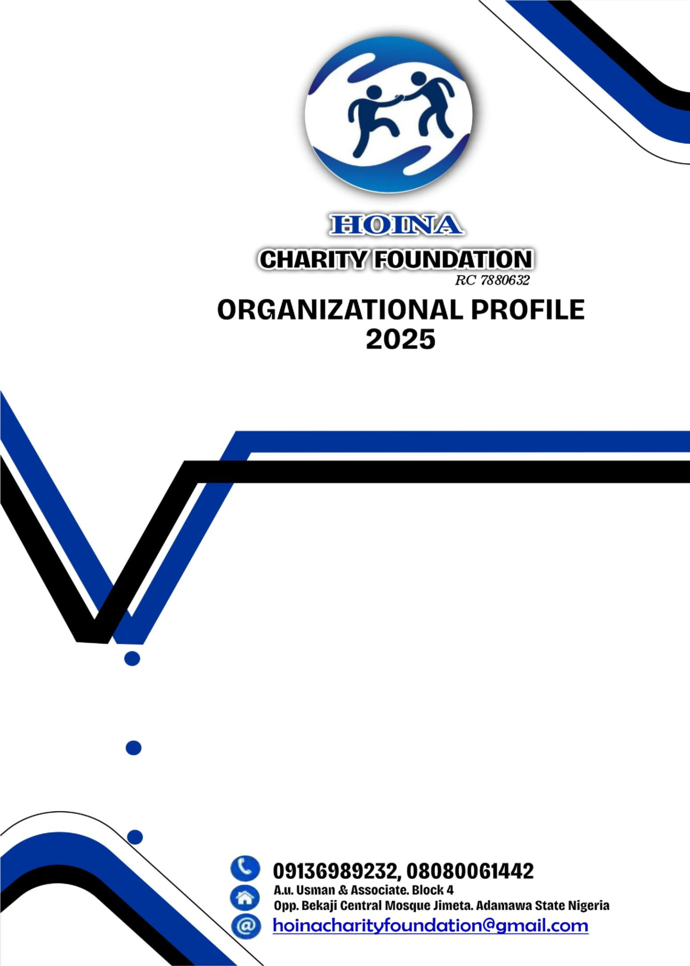

ORGANISATIONAL PROFILE OF HOINA CHARITY FOUNDATION
- ABOUT US
Hoina Charity Foundation is a youth-led humanitarian and development organization committed to advancing human rights, child protection, gender equality, peacebuilding, and humanitarian response.
The foundation was established out of lived experiences of resilience and a deep passion for social justice. We recognize that millions of children, women, and vulnerable populations face systemic barriers such as violence, discrimination, poverty, and lack of opportunities. Our mission is to address these challenges by empowering communities with knowledge, resources, and platforms to thrive with dignity.
At Hoina Charity Foundation, we believe that sustainable change is rooted in grassroots action, inclusive participation, and collaborative partnerships. Through advocacy, education, community engagement, and evidence-based interventions, we seek to build peaceful, just, and resilient societies.

VISION
A just and inclusive society where vulnerable communities thrive.

MISSION
To promote human rights, safeguard children, prevent gender-based violence, and foster peace through community-based humanitarian and development interventions.

SLOGAN
Sustainable development for a better tomorrow

OBJECTIVES
  - To provide humanitarian support to vulnerable individuals and communities affected by poverty, displacement, and social exclusion.
  - To promote access to education, skills acquisition, and livelihood opportunities for women, youth, and other at-risk groups.
  - To support child protection, gender equality, and the rights of women and girls through community-based interventions and advocacy.
  - To strengthen community resilience through capacity building, economic empowerment, and social development initiatives.
  - To foster partnerships and collaboration with government institutions, civil society organizations, and development partners.

CORE VALUES
- JUSTICE – Ensuring fairness, equality, and accountability.
- COMPASSION – Acting with empathy, care, and solidarity.
- PEACE – Building inclusive, safe, and cohesive communities.
- EMPOWERMENT – Enabling individuals and communities to lead change.

SECTORS OF INTERVENTION
Our programmes cut across critical humanitarian and development priorities:

CHILD RIGHTS & PROTECTION
  - Advocacy for safe education and child rights.
  - Campaigns against child labour, early marriage, and exploitation.
  - Psychosocial support and community-based protection systems.

GENDER-BASED VIOLENCE (GBV) PREVENTION & RESPONSE
  - Community sensitization and awareness programmes.
  - Safe spaces and referral pathways for survivors.
  - Legal, medical, and psychosocial support in collaboration with partners.
  - Policy advocacy for gender equality and survivor centered services.

PEACEBUILDING & CONFLICT RESOLUTION
  - Community dialogues and mediation initiatives.
  - Establishment of peace clubs and youth engagement in peace processes.
  - Awareness campaigns promoting tolerance, social cohesion, and nonviolence.

HUMANITARIAN RESPONSE & RESILIENCE
  - Emergency relief and basic assistance to crisis-affected communities.
  - Disaster preparedness and awareness campaigns.
  - Strengthening resilience of internally displaced persons (IDPs) and vulnerable households.

ENVIRONMENTAL HYGIENE & PUBLIC HEALTH
  - Hygiene and sanitation campaigns in flood-prone and underserved areas.
  - Community sensitization on disease prevention and healthy living.
  - Advocacy for safe water, sanitation, and waste management practices.

SUSTAINABLE DEVELOPMENT GOALS (SDGS)
Hoina Charity Foundation’s programs and interventions are aligned with the United Nations Sustainable Development Goals (SDGs), particularly the following:

SDG 1: No Poverty
Through skills acquisition and livelihood support, the Foundation contributes to reducing poverty by enhancing income-generating opportunities and economic resilience among vulnerable populations.

SDG 4: Quality Education
The Foundation promotes access to practical, inclusive, and lifelong learning opportunities through vocational training and capacity-building initiatives.

SDG 5: Gender Equality
Hoina Charity Foundation prioritizes the empowerment of women and girls by promoting equal access to skills training, economic opportunities, and protection from discrimination and harmful practices.

SDG 8: Decent Work and Economic Growth
By equipping beneficiaries with employable skills, the Foundation supports productive employment, entrepreneurship, and sustainable economic growth at community level.

APPROACH / METHODOLOGY
- We apply a holistic and rights-based approach to ensure long-term, sustainable change.
- Rights-Based Approach: All interventions are grounded in justice, dignity, and equity.
- Community-Driven Approach: Programmes are designed with and for the communities we serve.
- Collaborative & Inclusive Approach: We work closely with government, NGOs, civil society, and community stakeholders.
- Sustainability Approach: We prioritize long-term solutions that continue to impact communities beyond project timelines.

TARGET GROUPS
- Children and young people.
- Women and girls, particularly survivors of GBV.
- Conflict-affected populations and internally displaced persons (IDPs).
- Marginalized and vulnerable communities.

PAST & ONGOING INITIATIVES
Although a growing organization, Hoina Charity Foundation has implemented impactful grassroots initiatives, including:
- Child Rights Awareness Campaigns in vulnerable communities to promote child safety, education, and protection.
- GBV Awareness and Referral Pathways to connect survivors with psychosocial, legal, and medical support.
- Community Peace Clubs established to foster dialogue, reduce conflicts, and promote peaceful coexistence.
- Environmental Hygiene Projects including sanitation campaigns and flood preparedness awareness in disaster-prone communities.
These initiatives demonstrate our strong capacity for community mobilization and awareness creation, and our commitment to grassroots-driven humanitarian action.

GOVERNANCE & LEADERSHIP
Hoina Charity Foundation operates under a Board of Trustees that provides oversight and strategic guidance. Day-to-day management is led by an Executive Team, supported by a growing network of youth ambassadors who mobilize communities and drive programmes.
Our governance structure is built on the principles of accountability, transparency, and inclusivity, ensuring that resources are effectively managed and that the foundation remains true to its mission and values.

CONTACT INFORMATION
Hoina Charity Foundation
📍 Address: A.U. Usman & Associate
Block 4, Opp. Bekaji Central Mosque Jimeta/Yola Adamawa State
📧 Email: hoinacharityfoundation@gmail.com
📞 Phone: 08080061442/09136989232

