Basic Calculation

**Calculation:** Before used any Formula or Calculation we need to used Equal Sign (=)

**Type of Value**: 1. Direct Value

2. Address Value

Always prefer the Address values instead of the Direct value Calculation

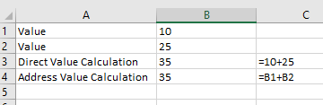

**Auto Sum:** either we can choose from home menu or we can press **alt+**

Address:

Address Range: Horizontal 

A1:D1

Vertical Address Range: B1:B8

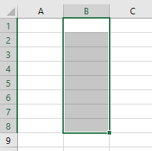

Rectangular Range: A1:C8

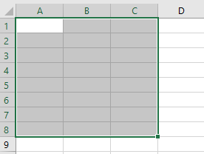

# Address Range are used in the Function

=Sum (A1:C8)

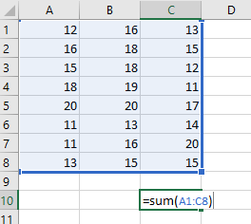

Type of Address:

1. Relative Address: Relative Address change According the cell change ex. A1
2. Absolute Address: Absolut address fix the Value it never changes either change your cell or not ex. $A$1

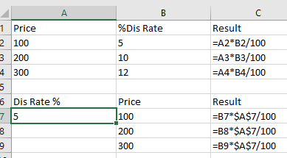

Note: Relative to Absolute Address:

Select Relative Address=> Press F4

# Multi sheet Calculation

### Perform calculation from one work sheet to another work sheet. It means getting value from another work sheet and perform operation on another work sheet

To get the Value form Another sheet first need to mention the **SheetName**! **CellAddress**

Ex.

=Data! A34

Above calculation get value from **“Data”** work sheet of Cell **“A34”**

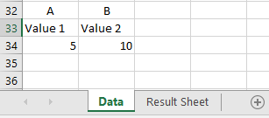

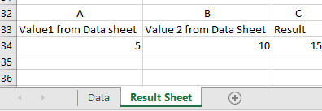

# Show Formula on Result Sheet

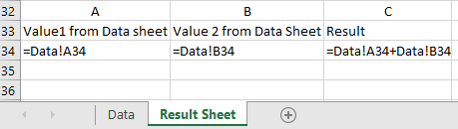

Above Calculation Data is a work sheet name where we get the data and A34 cell Address contain the Value