Review

# Proofing: -

It is used to check spelling and also find the synonymous of the any word.

## Spelling: -

It is used to check the spelling mistake and grammatical mistake of the existing file. It is mostly used frequently in MS Word.

Press F7 to start the spelling and Grammar checking

## Thesaurus: -

It is used to find the similar words which we specify in the search box, where we already put the man in the search box so there display many words related to man such as gentleman, guy, male etc.

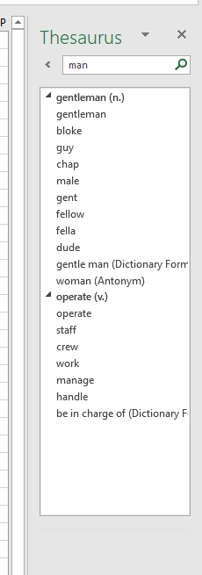

# Accessibility: -

It shows the easy accessibility of the work book content and also show default work sheet name and cell address where we can easily access the particular data, As given bellow.

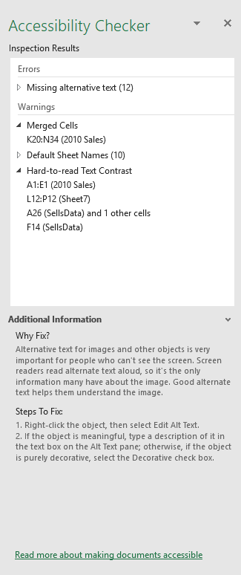

# Insights: -

It is the Smart lookup which need the internet connection**.**

Language: -

It is used to change the data form one language to another language but it is premium based and It is also requiring the internet connection

# Comments: -

It is used to given the additional information about any cell value so we can give the description about any cell. There we can add the new comment, delete, also travers/Visit the comment next and previous

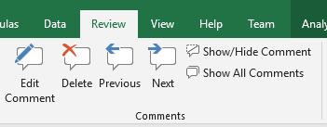

Select the Cell where we want to add comment =>Review Menu => New Comment

Now appear a box where we can put the description.

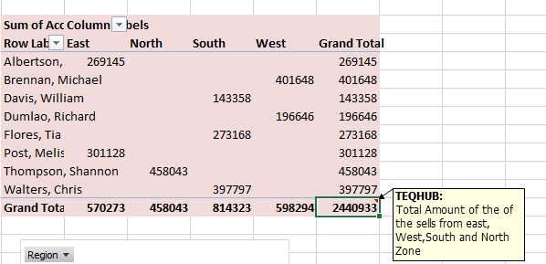

# Protect: -

## Protect sheet: -

It is used to lock the work sheet so we can’t change the data in that work sheet.

Protect Workbook: -

Protect work book it used to avoid the create new work sheet, delete work sheet, and rename the work sheet also we can’t change the color of the sheet tab, that means is used for restriction of the Structure of the work book.

#### Allow Edit Ranges: -

It is used to allowed the editing area, means that these areas are protected along with another password to work on that specific area. Where it not works the protect Password.

**Step 1:** Set the Background color for User: Teqhub and also User: Seema for better visibility

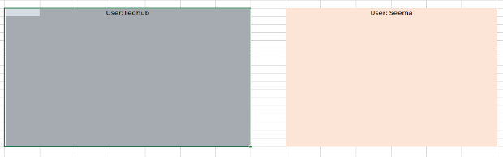

**Step 2:** Now we can set the password for both user: Teqhub and User: Seema with different Password to both users.

**Step 3:** After set the background color Select user: Teqhub area =>Review Menu => Allow Edit Range=>New Then display the New Range Dialog Box where we can set the Title and Password for user Teqhub

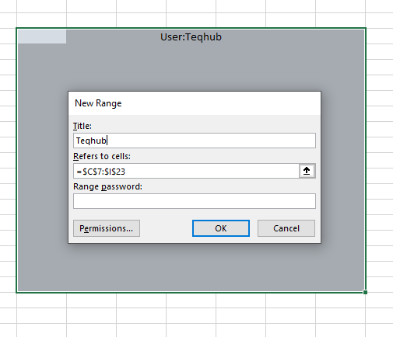

**Step 4:** Repeat the step 3 for another user: Seema

**Step 5:** Now we can protect the work sheet

Finally done.

So, we can assign the specific area for multiple user in a single work sheet different password

# Link:-