Data

# **Get & Transform Data:**

Get & Transform data is specially used for import the data and convert in to excel format. That can apply using given below option.

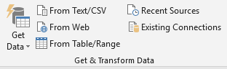

#### Get Data: -

We can import in data from other resources such as SQL Server, CSV file, Text File etc. in the current work sheet

#### From Text/CSV: -

It can only use import the data in current sheet specially form the Text or CSV (Commas Separate Value) file.

#### From Web: -

It is used to get the data form the website in to the current work sheet.

#### From Table/Range: -

It’s used to get data from current work sheet and convert into table.

#### Recent Sources: -

It shows all the resource which are used recently in current work sheet.

#### Existing Connections: -

It shows the all the connection where we are import the data in current work sheet.

#### **Queries & Connections**:

Refresh All: -This option is used to update the data connection. Where that can update the import data form connected file in the existing work sheet.

#### **Sort & Filter:**

Sort: -Arrange the records in ascending or descending Order.

Filter: -Filter the record similar type

Clear: -*It is used to* clear the filter and sort state for the current range of data

Reapply: -It is used to Reapply the filter and sort on the current range

Advance Filter: -It is used to filter the data form table on basis of specific criteria. Where we can apply multiple condition.

Criteria (Condition):

>= : - Greater or equal to

<= : - Less or equal to

== : - Equal to

Screen shoot:

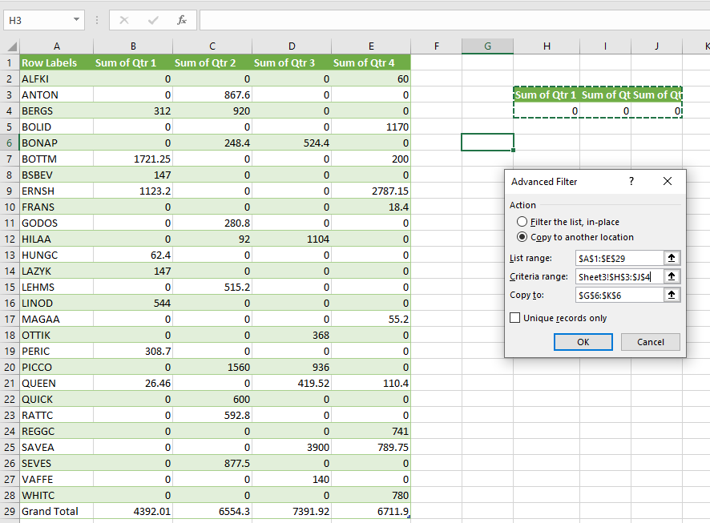

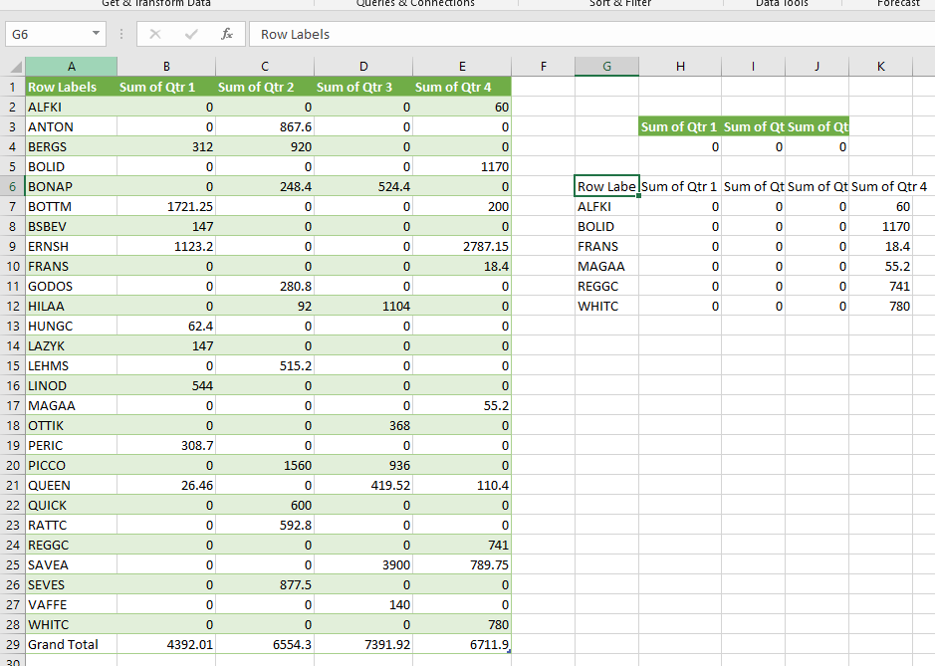

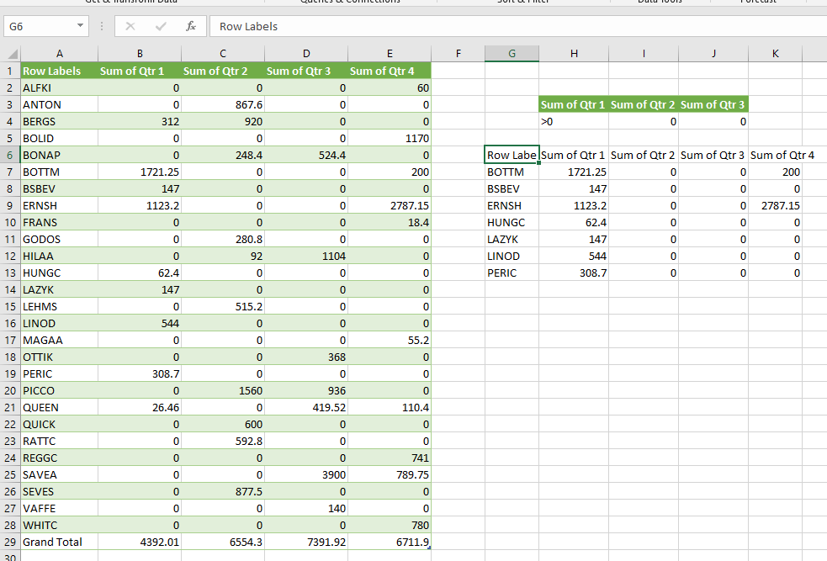

#### **Data Tools**:

#### Text to Column: -

It is used to separate the text into different column from single cell.

Name,age,address,email,contact

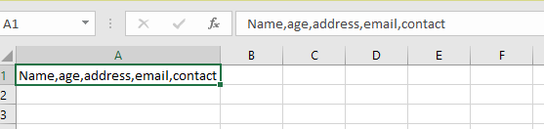

Above line are written in single cell if we want to separate into different cell the we used text to column.

Select A1 cell=>data menu=>text to Column

Then show the bellow wizard and follow the next till finish with following setting as show in wizard. Where select the Other Option and put the commas and finish it.

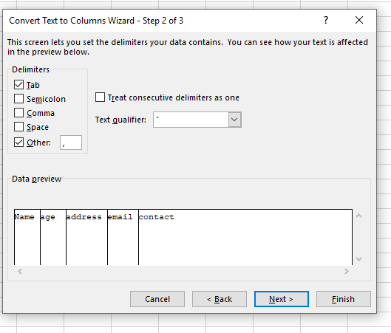

After finish it will be given result such as given bellow:

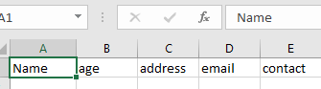

#### Flash Fill (CTRL+E): -

Before flash fill: It is used to fill the data automatically in current cell form another given existing cell.

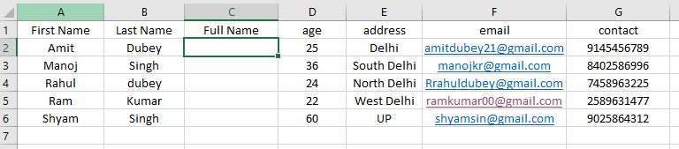

Put the Full Name in C2 cell: Amit Dubey=> After write full name select C2:C6=>Data Menu=>Flash fill

Now done as given bellow:

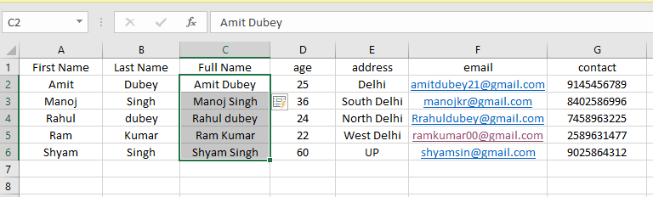

#### Remove Duplicates: -

Remove the Duplicate Record where it is consider the all column to check the duplicate. That means Consider the Selection Criteria for duplicate record with respect to column matching row wise.

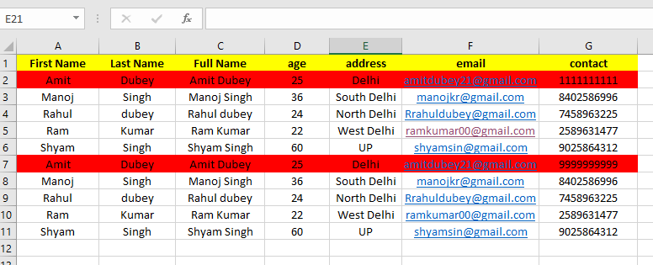

Select the table=> data => Remove Duplicate

Now Remove all the duplicate record.

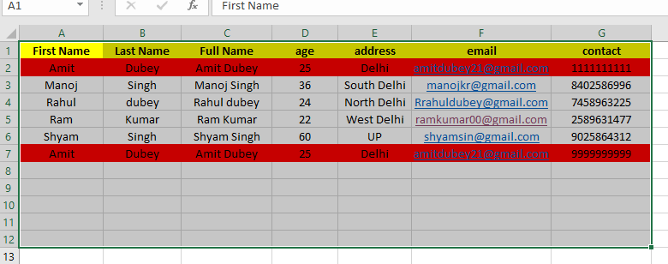

#### Data Validation: -

It is used for valid entry in the cell where we can specify the condition for input the data. That mean cell allowed only number, either specific length of the string in the particular cell

Validation for only number to specific range. Such as age should belong to 18 to 60

Steps:

Select range for validation=>Data Menu=>Data Validation=>show below and doing some setting, input message and also Error Alert. Where Error Alert specified the Alert type Such as warning, info or stop.

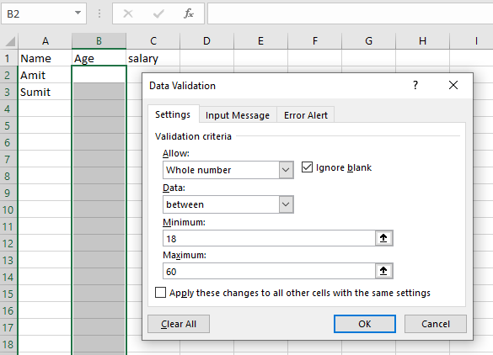

Warning and info can allow the data but if you allowed for that Invalid entry.

#### Consolidate: -

It is used for multiple sheet operation. That means we can get data from different sheet and perform the calculation on the current sheet.

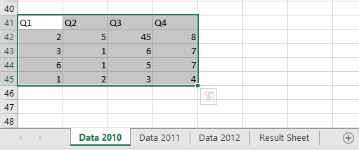

Above data are given in sheet Data 2010, Data 2011, and Data 2012 and we want to find total in Result Sheet such as given below.

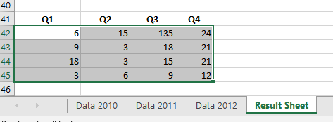

Step for Consolidate:

Choose range for consolidate=>data menu=>consolidation show below diagram

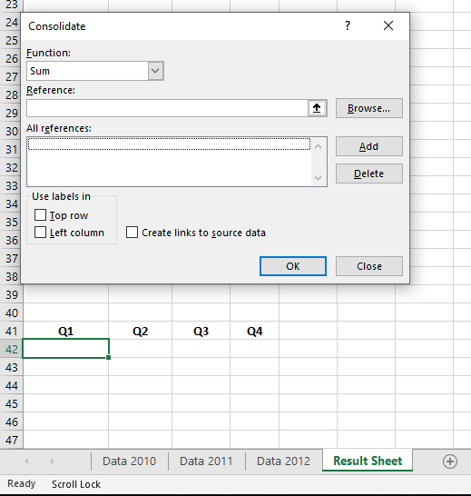

Step 1: Select the Data from “Data 10” and Press on **“Add”** Button

Step 2: Follow the Step 1 until finish your data selection mean given below

Again, need to select the “Data 11” Press “**Add”** Button

Step 3: Finally, Ok

Now done your data Consolidate i.e. Multi sheet operation.

#### Relationships: -

#### Go to The Power Pivot Window: -

#### **Forecast:**

#### What if Analysis:

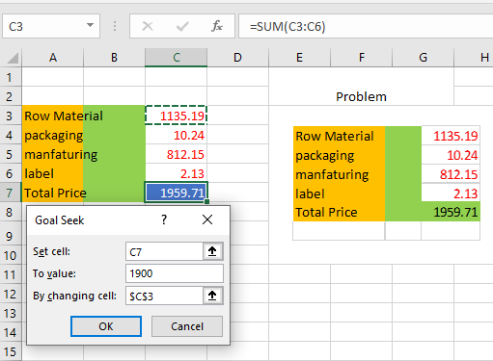

Goal Seek: **-** Goal seek need the formula value without formula value we can’t apply the goal seek. Where are need to mention the set cell such as (Total Price) 1959.71 and to Target Value: 1900 by changing cell: 1135.19

**Problem:**

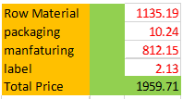

Prepared the table as given above: data menu-> What if analysis-> goal seek-> show below dialog need to set the requirement.

**Solution:**

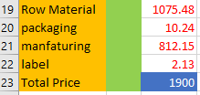

Data Table: -Data Table is required also formula where required Row value and Column value.

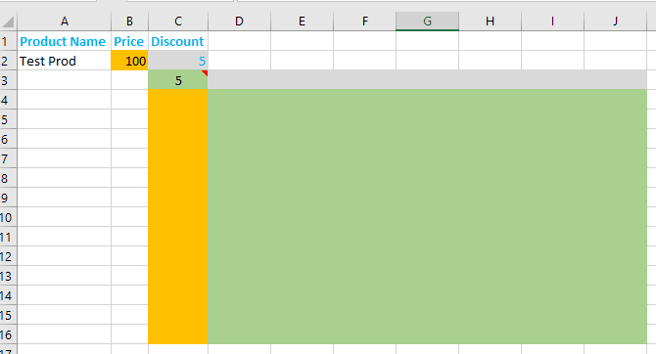

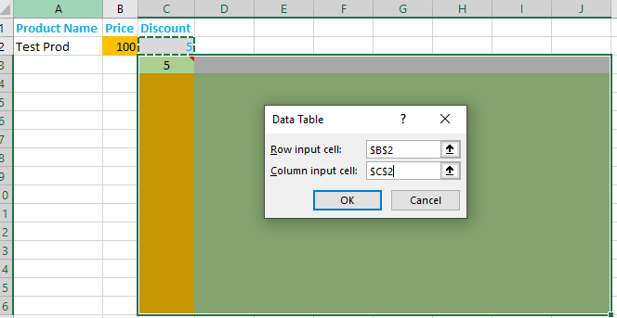

After click on

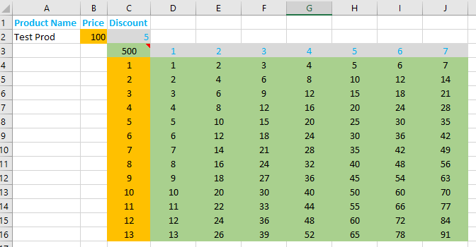

# **Outline**

Group: -It is used for grouping the similar type of records

Select the number of the records =>Data=>Group

Ungroup: - It is used for ungroup the record

Select the record which are already grouped => data=>ungroup

Subtotal: - To find the sum, average, count etc of similar records to specific column.

Note: Before Apply the subtotal ensure that all the record is in sorted order(ascending/descending). These are according subtotal column

Before sorting:

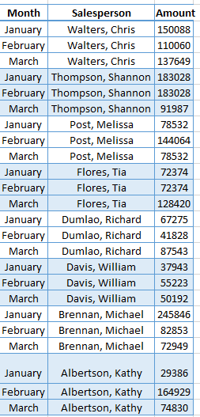

If we want to apply the subtotal according to Month column then all the record should be sorted according month as given below:

Select the Table Column and ctrl+shift+L to apply the sorting using filter

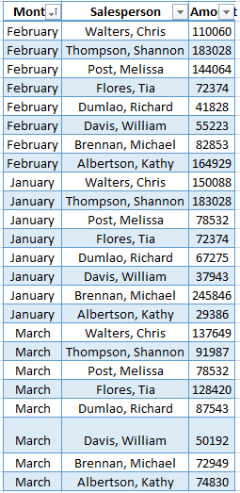

Finally done the sorting according to month now we can apply the subtotal

Select table=>data menu=>subtotal

Below the following dialog where specified the specific column to find the total of each change

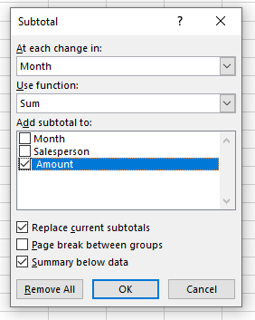

Now we can Select the sorted column form at each change in: Month

And Use function: sum/Average/Max/min etc

Also Add Subtotal: Column: Amount (which we want to calculate)

Now click on Ok button

