RMarkdown: Write for Science!

Michael A Barrowman

28/04/2020

# Introduction

Have you ever tried moving a table in Word? How about inserting an image into Google Docs? Switching between your stats program and report becoming a nightmare? Do you hate citations (Reference 2020)?

# What can we do?

This course will help you to transition smoothly into the world of RMarkdown, where you can do your statistical analysis and write your entire report/essay in a single document! RMarkdown takes care of things like formatting and figure/table placement for you without worrying about the nitty gritty, see Table 1 for details

Table 1: Here’s some data!

|  |  |
| --- | --- |
| x | y |
| 0.648 | 0.271 |
| 0.154 | 0.338 |
| 0.734 | 0.920 |
| 0.284 | 0.168 |
| 0.581 | 0.442 |
| 0.761 | 0.063 |

# What can we make?

RMarkdown also unifies your output: Word, PDF, Webpage, Presentations and Posters can all come out of a singe document with the touch of a button.

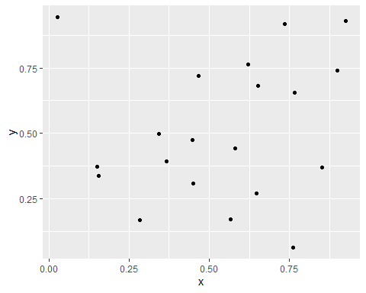

Figure 1: Plots are easy!

# How?

We combine elements of R (the statistical package) and Markdown (the way you format comments on Reddit) into one system and *knit* them into a document. For an example of what you’ll be able to produce after this session, see here:

* [HTML](Example.html) A html version of this file
* [PDF](Example.pdf) A pdf version of this file
* [Word](Example.docx) A Word version of this file

# References

Reference, Mr A. 2020. “I Hate Reference: How to Cite in Rmarkdown.”