Bring back power-supply (100 Marks)

Utopia located in the North Eastern Bharat is a serene town. Unfortunately, the town s power supply has been recently marred by floods.

While the power plant's core boiler has been repaired, its various fuel input needs some brain work. Can you bring back normalcy to this Town?

There are **4 types of fuel** that are supplied as input to the power plant: Petrol, Diesel, Kerosene, and Water (Coolant). But, they have to be filled in a logical way across the storage unit.

The storage unit carries elevations. Below diagram is an example of elevation map. The blue bar represents the elevation. Each elevation has a standard breadth of 1 unit while its height may vary.

**Definitions:**

***Congruent space***: The space available to fill the liquid in each elevation.

***Least congruent space***: The least volume of space within which a liquid can be filled. And it should follow the priority of Petrol occupying the least space; Diesel next; Kerosene next and finally water.

***Elevation***: The blue bar represented in the image is elevation. The height of the elevation decides the unit volume of fuel, the congruent space can hold.

**Note**: Same quantity of two or more fuels with 2 or more congruent spaces of equal volume doesn t exist in this problem.

**Filling rules:**

1. The filling should happen in the order of Petrol, Diesel, Kerosene, and Water.

2. **The first priority** should be given to **fill Petrol** in the least possible volume of congruent space elevations; **second priority**to**Diesel**; **Third priority**to**Kerosene**; **Fourth priority**to**Water** (coolant).

***For example***: Assume that Petrol is 4 liters, Diesel is 4 liters and Kerosene is 4 liters. And the available congruent spaces are Single elevation (4 liters),  Two elevations (2 liters each) and 4 elevations (1 liter each) then, the fuel filling according to their priority is, Petrol (4 liters) in Single  elevation; Diesel (4 liters) in Two elevations (2 liters each); Kerosene (4 liters) in 4 elevations (1 liter each).

3. The **congruent space accommodation** for each fuel should be **calculated by considering the quantity of fuel**. If for a given fuel quantity, the **given space doesn't fit**, then, that particular **fuel should not be filled**.

4. There are possibilities that **some fuels may not be accommodated in the given elevation map** ( depending on **Input 1**). In such cases, the output corresponding to that fuel should be **an** **empty square bracket or Zero. [ ]**

**Below is an example elevation map :**

The blue bar represents the elevation. Each elevation has a standard **breadth of 1 unit** while its height can vary.

**Input 1:** 3,0,0,2,0,4   (Total of 6 elevations in the below diagram)

**Input 2:** PETROL:10#DIESEL:5#KEROSENE:5#WATER:5   (Four fuels with corresponding quantity)

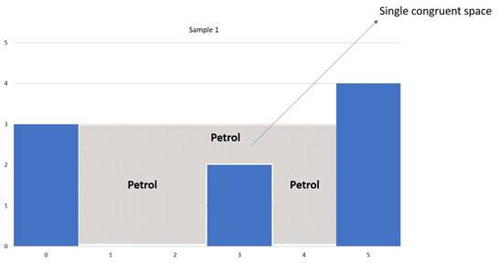

**Output :** [1,2,3,4],[],[],[]

**First square bracket** indicates **Petrol**, **second Diesel**, and **so on**. Empty square bracket means that there is not enough space to accommodate that particular fuel, since, the higher priority fuel [Petrol] has already occupied the available congruent space.

In the above output, Only Petrol fuel has been filled while the rest of the fuels (Diesel, Kerosene, and Water) are not filled due to lack of congruent spaces and they are represented by empty square brackets in the output.

**Input Format**

The First line will contain a string S, denoting the length of different elevations separated by comma.

The Second Line Will contain a string T, denoting the amount of Petrol, Diesel, Kerosene, and water.

**Constraints**

1 <= S <= 10^2

1 <= T <= 10^2

**Output Format**

Output a string denoting the index of spaces used for different fuels.

**Sample TestCase 1**

Input

0,2,0,2,1,0,1,3,2,1,2,1,2,0,1,0,2

PETROL:4#DIESEL:5#KEROSENE:2#WATER:2

Output

[4,5,6],[13,14,15],[2],[9,11]

Explanation

**Number of elevations (Input 1):**0,2,0,2,1,0,1,3,2,1,2,1,2,0,1,0,2 (In this example, there are a total of 17 elevations in the storage unit)

**Fuel quantity (Input 2):**PETROL:4#DIESEL:5#KEROSENE:2#WATER:2

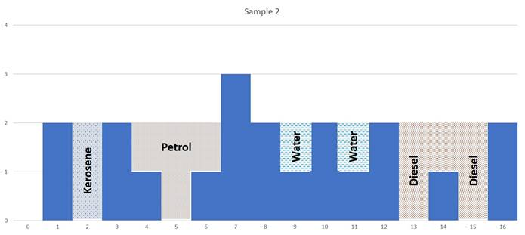

**Output:**[4,5,6],[13,14,15],[2],[9,11](The output is in the same order. 1st square bracket Petrol, 2nd square bracket, Diesel, and so on. The numbers inside represent the elevations covered)

In the above output,

**4 units of Petrol** has been filled in the congruent space [4,5,6], covering elevations 4,5 and 6.

**5 units of Diesel** has been filled in the next best possible congruent space [13, 14, 15]

**2 units of kerosene**has been filled in the next best possible congruent space [2]

**2 units of Water** has been filled in two elevations