**Module 5 Basic Test**

***Time given: 30 minutes***

***3 attempts given***

***No. of Questions: 2 (2 parts per question)***

***Total Marks issued: 64***

***Graded out of 64***

*Prerequisite knowledge:* (Do not need to look at lecture content to pass)

* Basic arithmetic (how to use a calculator, algebra)
* Week 1 stat1170 content

Going through the question/part, you will see it being either:

A chi-squared goodness-of-fit test is run to answer the research question.

OR  
A chi-squared test of independence is run to answer the research question.

----------------------------------------------------------------------------------------------------------------

If it is a goodness-of-fit test:

1 table is given. To determine the A value:

A = [Total Observed Count] – [every other value in the Observed Count row]

e.g. A = 126 – (33 + 29 + 34)

To determine the B value:  
  
B = [Total Expected Count] – [every other value in the Expected Count row]

e.g. 126 – (50.4 + 37.8 + 25.2)

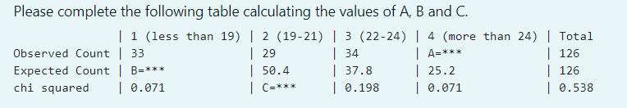

(***NOTE:*** there are variations in how they can display or show the graph. Please ensure that you check before calculating. The provided equations above will work for them) {Example screenshot shown below:}

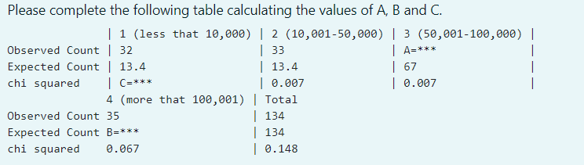

For null hypothesis, always choose the option stating:  
 “… **is** distributed according to the given table of probabilities.”

(PAY ATTENTION HERE – for goodness-of-fit)

|  |  |
| --- | --- |
| If p-value < 0.05  Decision of the test: “Reject H0”  Conclusion of the test: “There **is** evidence that… is **not distributed** according to the given table of probabilities” | If p-value >= 0.05  Decision of the test: “Do not reject H0”  Conclusion of the test: “There is **not enough** evidence that… is distributed differently than the given table of probabilities” |

---------------------------------------------------------------------------------------------------------------------------

If it is a test of independence:

3 tables are given. To determine the A value:  
  
A = [Total Observed Count] – [every other value in the Observed Count row]

e.g. 64 – (19 + 12 + 16)

To determine the B value: *(refer to following screenshot for further understanding)*

B = [(Total relevant row x total relevant column) / *total sums value*]

e.g. [ (62 x 33) / 126]

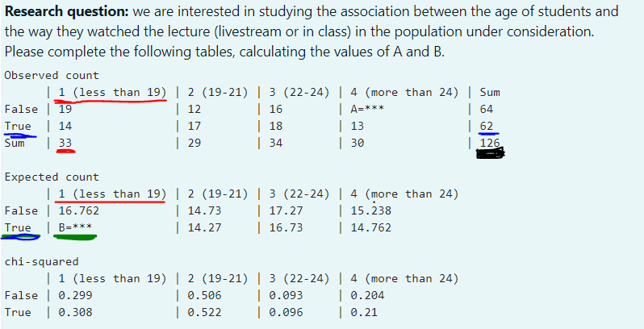

For null hypothesis, always choose the option stating:  
 “… are independent.”

(PAY ATTENTION HERE – for test of independence)

|  |  |
| --- | --- |
| If p-value < 0.05  Decision of the test: “Reject H0”  Conclusion of the test: “There **is** evidence that… **are** associated.” | If p-value => 0.05  Decision of the test: “Do not reject H0”  Conclusion of the test: “There **is not** evidence that… are associated.” |