Advanced SQL Semester Project - Restaurant database
Mason Romdenne, Nathan Krouth, Nicholas Fearing
Prepared by Mason Romdenne
Week 4 Deliverables - Item 3 - CRUD Stored Procedures
21 September 2026

Week 4 Item 3 - CRUD Stored Procedures - Testing Documentation
All of the code for this item is in one file, Week4_Item3_CRUD.sql, which was run as a whole against the Restaurant database in SQL Server Management Studio on the class VM (instance ADVSQL). Each object below shows who wrote it, the code, the test that was run, and a screenshot of the result. The TESTING section at the bottom of the .sql file is the testing code.
Every group member's work went in through a pull request on the group's GitHub repo (PRs #22, #23 and #24) and was reviewed and merged into this file.
The project says each procedure "should not generate any exceptions and all should return data."

Item 3 - CRUD stored procedures
Requirement: CRUD procedures on two tables, one procedure per action, named spN_Get/Insert/Update/Delete + table. The tables are Charities and KitchenDetails, chosen because nothing else has a foreign key pointing at them, so the DELETE procedures can run without breaking a relationship. The group split the work by action: Mason wrote SELECT and INSERT, Nicholas UPDATE, Nathan DELETE.
The project says each procedure "should not generate any exceptions and all should return data." Both tables have constraints a bad call would trip (a unique name on Charities, foreign keys on both, and a row that does not exist for update and delete), so every procedure checks for those first and returns a Rejected message instead of letting SQL Server throw. On a good call each returns the row it worked on, or for a delete what was deleted.
The tests below run a full cycle: insert a test charity and a test kitchen, update them, then delete them, so the tables finish exactly as they started (15 charities, 5 kitchens).

SELECT - spN_GetCharities and spN_GetKitchenDetails (Mason)
Each takes the primary key as an optional parameter. With no argument it returns every row, with an ID it returns that one row. Both join in the branch name, and the kitchen one also joins through Chefs to Employees for the lead chef's name.
CREATE PROCEDURE spN_GetCharities
@CharityID INT = NULL
AS
BEGIN
SET NOCOUNT ON;

SELECT c.CharityID,
c.CharityName AS 'Charity',
c.CharityType AS 'Type',
c.ContactName AS 'Contact',
c.PhoneNumber AS 'Phone',
c.City,
d.LocationName AS 'Donating Branch',
FORMAT(c.TotalDonatedValue, 'C', 'en-IE') AS 'Total Donated',
CASE WHEN c.IsActive = 1 THEN 'Yes' ELSE 'No' END AS 'Active',
c.CreationDate AS 'Created'
FROM Charities c
LEFT JOIN Demographic d ON c.DonatingLocationID = d.LocationID
WHERE (@CharityID IS NULL OR c.CharityID = @CharityID)
ORDER BY c.CharityName;
END;

Test
EXEC spN_GetCharities @CharityID = 9001;
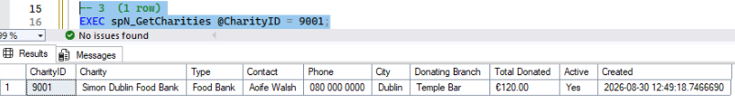
Figure 1: One charity returned when an ID is passed; with no argument all 15 come back.
CREATE PROCEDURE spN_GetKitchenDetails
@KitchenID INT = NULL
AS
BEGIN
SET NOCOUNT ON;

SELECT k.KitchenID,
d.LocationName AS 'Branch',
k.NumStoves AS 'Stoves',
k.AreaSqft AS 'Area (sq ft)',
k.MinCooks AS 'Min Cooks',
CONCAT(e.FirstName, ' ', e.LastName) AS 'Lead Chef',
c.ChefType AS 'Lead Chef Type',
k.FreezerCubicFeet AS 'Freezer (cu ft)',
k.LastInspectionDate AS 'Last Inspection',
CASE k.InspectionPassed
WHEN 1 THEN 'Passed'
WHEN 0 THEN 'Failed'
ELSE 'Not yet inspected'
END AS 'Inspection Result',
k.InspectionComments AS 'Inspection Comments',
k.CreationDate AS 'Created'
FROM KitchenDetails k
INNER JOIN Demographic d ON k.LocationID = d.LocationID
INNER JOIN Chefs c ON k.LeadChef = c.ChefID
INNER JOIN Employees e ON c.EmployeeID = e.EmployeeID
WHERE (@KitchenID IS NULL OR k.KitchenID = @KitchenID)
ORDER BY k.KitchenID;
END;

Test
EXEC spN_GetKitchenDetails @KitchenID = 3;
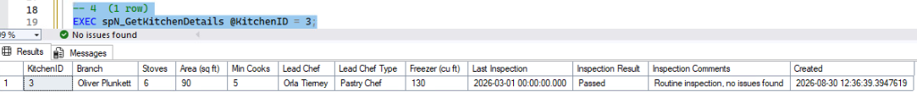
Figure 2: One kitchen returned, with the branch name and the lead chef's name joined in.

INSERT - spN_InsertCharities and spN_InsertKitchenDetails (Mason)
Every column a user can fill in is a parameter. CreationDate is not a parameter so its default fills in the insert time. Each checks the things that would break a constraint and returns the new row on success.
CREATE PROCEDURE spN_InsertCharities
@CharityName NVARCHAR(100),
@CharityType NVARCHAR(50) = NULL,
@ContactName NVARCHAR(100) = NULL,
@PhoneNumber NVARCHAR(20) = NULL,
@City NVARCHAR(50) = NULL,
@DonatingLocationID INT = NULL,
@TotalDonatedValue DECIMAL(10,2) = NULL,
@IsActive BIT = 1
AS
BEGIN
SET NOCOUNT ON;

IF @CharityName IS NULL OR LTRIM(RTRIM(@CharityName)) = ''
BEGIN
SELECT 'Rejected - a charity name is required.' AS 'Result';
RETURN 1;
END;

IF EXISTS (SELECT 1 FROM Charities WHERE CharityName = @CharityName)
BEGIN
SELECT CONCAT('Rejected - ', @CharityName, ' already exists.') AS 'Result';
RETURN 1;
END;

IF @DonatingLocationID IS NOT NULL
AND NOT EXISTS (SELECT 1 FROM Demographic WHERE LocationID = @DonatingLocationID)
BEGIN
SELECT CONCAT('Rejected - no location with ID ', @DonatingLocationID, '.') AS 'Result';
RETURN 1;
END;

IF @TotalDonatedValue < 0
BEGIN
SELECT 'Rejected - the donated total cannot be negative.' AS 'Result';
RETURN 1;
END;

INSERT INTO Charities
(CharityName, CharityType, ContactName, PhoneNumber, City,
DonatingLocationID, TotalDonatedValue, IsActive)
VALUES
(@CharityName, @CharityType, @ContactName, @PhoneNumber, @City,
@DonatingLocationID, @TotalDonatedValue, @IsActive);

-- return the new row so the ID and CreationDate show up
SELECT * FROM Charities WHERE CharityID = SCOPE_IDENTITY();
RETURN 0;
END;

Test - a good insert
EXEC spN_InsertCharities @CharityName = 'Week 4 Test Charity', @CharityType = 'Food Bank', @City = 'Galway', @DonatingLocationID = 1, @TotalDonatedValue = 250.00;
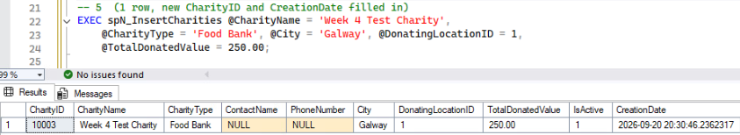
Figure 3: The new row comes back with CharityID and CreationDate filled in by the database, not passed in.

Test - the same name again
EXEC spN_InsertCharities @CharityName = 'Week 4 Test Charity';
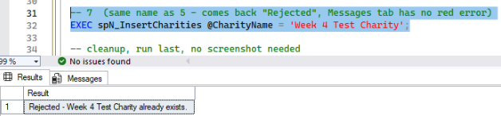
Figure 4: The unique constraint on CharityName would normally throw an error. The procedure returns a Rejected message instead, and the status bar shows no error.
CREATE PROCEDURE spN_InsertKitchenDetails
@LocationID INT,
@NumStoves INT,
@AreaSqft INT,
@MinCooks INT,
@LeadChef INT,
@FreezerCubicFeet INT,
@LastInspectionDate DATETIME = NULL,
@InspectionComments NVARCHAR(500) = NULL,
@InspectionPassed BIT = NULL
AS
BEGIN
SET NOCOUNT ON;

IF NOT EXISTS (SELECT 1 FROM Demographic WHERE LocationID = @LocationID)
BEGIN
SELECT CONCAT('Rejected - no location with ID ', ISNULL(@LocationID, 0), '.') AS 'Result';
RETURN 1;
END;

IF NOT EXISTS (SELECT 1 FROM Chefs WHERE ChefID = @LeadChef)
BEGIN
SELECT CONCAT('Rejected - no chef with ID ', ISNULL(@LeadChef, 0), '.') AS 'Result';
RETURN 1;
END;

IF ISNULL(@NumStoves, 0) <= 0 OR ISNULL(@AreaSqft, 0) <= 0
OR ISNULL(@MinCooks, 0) <= 0 OR ISNULL(@FreezerCubicFeet, 0) <= 0
BEGIN
SELECT 'Rejected - stoves, area, min cooks and freezer size must be above zero.' AS 'Result';
RETURN 1;
END;

INSERT INTO KitchenDetails
(LocationID, NumStoves, AreaSqft, MinCooks, LeadChef, FreezerCubicFeet,
LastInspectionDate, InspectionComments, InspectionPassed)
VALUES
(@LocationID, @NumStoves, @AreaSqft, @MinCooks, @LeadChef, @FreezerCubicFeet,
@LastInspectionDate, @InspectionComments, @InspectionPassed);

SELECT * FROM KitchenDetails WHERE KitchenID = SCOPE_IDENTITY();
RETURN 0;
END;

Test - a good insert
EXEC spN_InsertKitchenDetails @LocationID = 1, @NumStoves = 5, @AreaSqft = 80, @MinCooks = 4, @LeadChef = 501, @FreezerCubicFeet = 100, @InspectionComments = 'Week 4 test row';
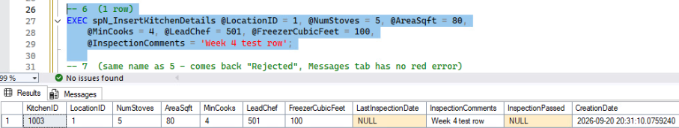
Figure 5: The new kitchen row returned with its KitchenID and CreationDate. The inspection columns were left off the call and came through as NULL.

UPDATE - spN_UpdateCharities and spN_UpdateKitchenDetails (Nicholas)
Both update at least three fields. spN_UpdateCharities takes the ID and IsActive, then four optional fields that keep the row's existing value when left off. spN_UpdateKitchenDetails records an inspection: the comments, pass/fail, and a date that defaults to the time of the update. Both check the row exists and return the updated row.
CREATE PROCEDURE spN_UpdateCharities
@CharityID INT,
@IsActive BIT,
@ContactName NVARCHAR(100) = NULL,
@PhoneNumber NVARCHAR(20) = NULL,
@CharityName NVARCHAR(100) = NULL,
@CharityType NVARCHAR(50) = NULL
AS
BEGIN
SET NOCOUNT ON;

IF NOT EXISTS (SELECT 1 FROM Charities WHERE CharityID = @CharityID)
BEGIN
SELECT CONCAT('Rejected - no charity with ID ', ISNULL(@CharityID, 0), '.') AS 'Result';
RETURN 1;
END;

IF @CharityName IS NOT NULL
AND EXISTS (SELECT 1 FROM Charities WHERE CharityName = @CharityName AND CharityID <> @CharityID)
BEGIN
SELECT CONCAT('Rejected - ', @CharityName, ' already exists.') AS 'Result';
RETURN 1;
END;

-- any parameter left off keeps the value already on the row
IF @ContactName IS NULL
SELECT @ContactName = ContactName FROM Charities WHERE CharityID = @CharityID;

IF @PhoneNumber IS NULL
SELECT @PhoneNumber = PhoneNumber FROM Charities WHERE CharityID = @CharityID;

IF @CharityName IS NULL
SELECT @CharityName = CharityName FROM Charities WHERE CharityID = @CharityID;

IF @CharityType IS NULL
SELECT @CharityType = CharityType FROM Charities WHERE CharityID = @CharityID;

BEGIN TRY
BEGIN TRAN;
UPDATE Charities
SET IsActive = @IsActive,
ContactName = @ContactName,
PhoneNumber = @PhoneNumber,
CharityName = @CharityName,
CharityType = @CharityType
WHERE CharityID = @CharityID;
COMMIT TRAN;
END TRY
BEGIN CATCH
IF @@TRANCOUNT > 0 ROLLBACK TRAN;
SELECT CONCAT('Rejected - ', ERROR_MESSAGE()) AS 'Result';
RETURN 1;
END CATCH;

-- return the updated row
SELECT * FROM Charities WHERE CharityID = @CharityID;
RETURN 0;
END;

Test
EXEC spN_UpdateCharities @CharityID = @TestCharity, @IsActive = 1, @ContactName = 'James Joyce', @PhoneNumber = '353 1 878 8547', @CharityName = 'Joyce Dublin Clinic', @CharityType = 'Free Clinic'; -- the test charity inserted above
Nicholas's original test ran the same update against charity 9001, before and after:
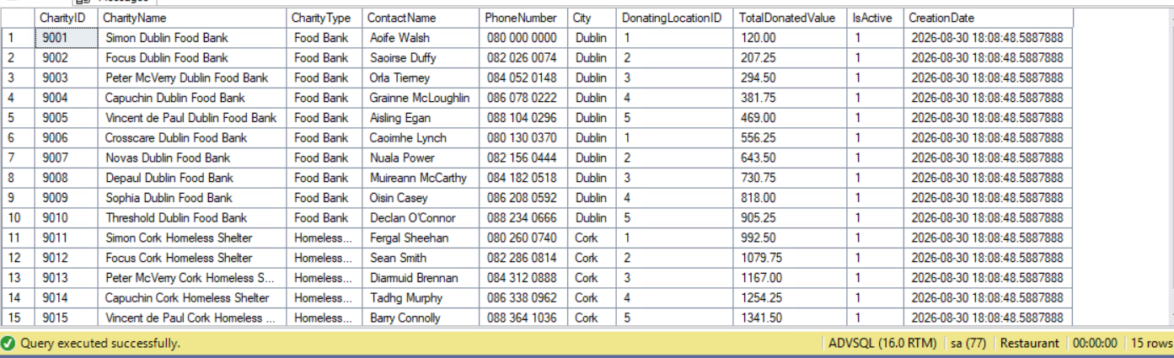
Figure 6: Charities before the update - 9001 is Simon Dublin Food Bank, contact Aoife Walsh.
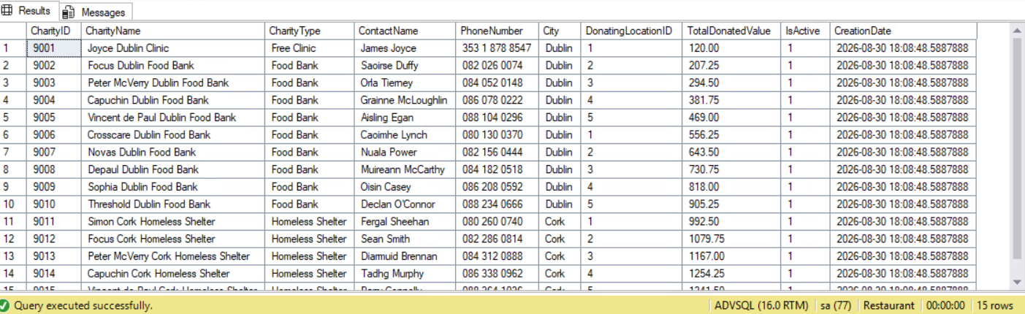
Figure 7: After the update - all four fields on 9001 changed and the other 14 rows untouched.
[ screenshot 3_update_charity.png goes here ]
Figure 8: The procedure returns the updated row.
CREATE PROCEDURE spN_UpdateKitchenDetails
@KitchenID INT,
@Comments NVARCHAR(500),
@InspectionPassed BIT,
@InspectionDate DATETIME = NULL
AS
BEGIN
SET NOCOUNT ON;

IF NOT EXISTS (SELECT 1 FROM KitchenDetails WHERE KitchenID = @KitchenID)
BEGIN
SELECT CONCAT('Rejected - no kitchen with ID ', ISNULL(@KitchenID, 0), '.') AS 'Result';
RETURN 1;
END;

IF @InspectionDate IS NULL
SELECT @InspectionDate = SYSDATETIME();

BEGIN TRY
BEGIN TRAN;
UPDATE KitchenDetails
SET InspectionComments = @Comments,
InspectionPassed = @InspectionPassed,
LastInspectionDate = @InspectionDate
WHERE KitchenID = @KitchenID;
COMMIT TRAN;
END TRY
BEGIN CATCH
IF @@TRANCOUNT > 0 ROLLBACK TRAN;
SELECT CONCAT('Rejected - ', ERROR_MESSAGE()) AS 'Result';
RETURN 1;
END CATCH;

-- return the updated row
SELECT * FROM KitchenDetails WHERE KitchenID = @KitchenID;
RETURN 0;
END;

Test
EXEC spN_UpdateKitchenDetails @KitchenID = @TestKitchen, @Comments = 'Insufficient fire suppression system.', @InspectionPassed = 0; -- the test kitchen inserted above
Nicholas's original test ran the same update against kitchen 2, before and after:
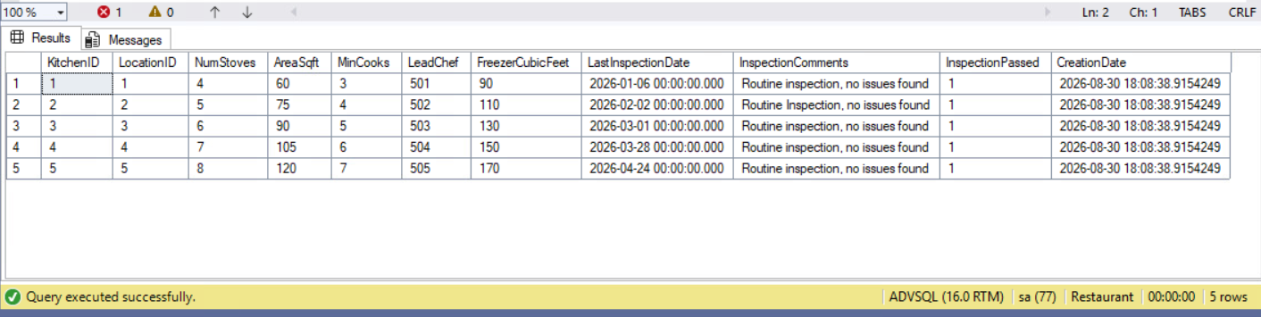
Figure 9: KitchenDetails before - kitchen 2 passed its 2 February inspection.
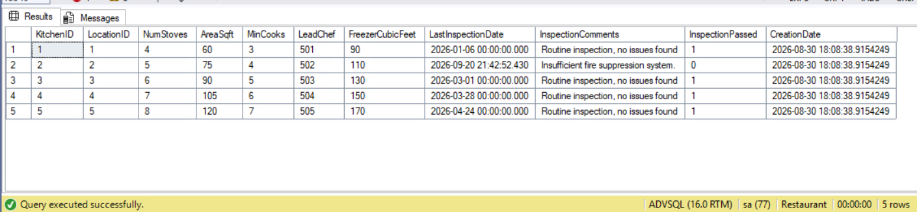
Figure 10: After - kitchen 2 now shows the new comment, InspectionPassed = 0, and the inspection date defaulted to the time of the update.
[ screenshot 3_update_kitchen.png goes here ]
Figure 11: The procedure returns the updated row.

DELETE - spN_DeleteCharities and spN_DeleteKitchenDetails (Nathan)
Each deletes one row by its primary key. No other table has a foreign key to Charities or KitchenDetails (chefs are tied to a branch through Demographic, not through the kitchen), so nothing has to be cleared first. Each checks the row exists and returns what it deleted along with the row count.
CREATE PROCEDURE spN_DeleteCharities
@CharityID INT
AS
BEGIN
SET NOCOUNT ON;

IF NOT EXISTS (SELECT 1 FROM Charities WHERE CharityID = @CharityID)
BEGIN
SELECT CONCAT('Rejected - no charity with ID ', ISNULL(@CharityID, 0), '.') AS 'Result';
RETURN 1;
END;

DECLARE @Name NVARCHAR(100) = (SELECT CharityName FROM Charities WHERE CharityID = @CharityID);

DELETE FROM Charities
WHERE CharityID = @CharityID;

DECLARE @Rows INT = @@ROWCOUNT;

SELECT CONCAT('Deleted charity ', @CharityID, ' - ', @Name, '.') AS 'Result',
@Rows AS 'Rows Deleted';
RETURN 0;
END;

Test
EXEC spN_DeleteCharities @CharityID = @TestCharity; -- the test charity inserted above
[ screenshot 3_delete_charity.png goes here ]
Figure 12: The test charity is deleted and the procedure reports which row went, with 1 row deleted. A bad ID returns a Rejected message.
CREATE PROCEDURE spN_DeleteKitchenDetails
@KitchenID INT
AS
BEGIN
SET NOCOUNT ON;

IF NOT EXISTS (SELECT 1 FROM KitchenDetails WHERE KitchenID = @KitchenID)
BEGIN
SELECT CONCAT('Rejected - no kitchen with ID ', ISNULL(@KitchenID, 0), '.') AS 'Result';
RETURN 1;
END;

DECLARE @Branch NVARCHAR(100) = (
SELECT d.LocationName
FROM KitchenDetails k
INNER JOIN Demographic d ON k.LocationID = d.LocationID
WHERE k.KitchenID = @KitchenID);

DELETE FROM KitchenDetails
WHERE KitchenID = @KitchenID;

DECLARE @Rows INT = @@ROWCOUNT;

SELECT CONCAT('Deleted kitchen ', @KitchenID, ' at ', @Branch, '.') AS 'Result',
@Rows AS 'Rows Deleted';
RETURN 0;
END;

Test
EXEC spN_DeleteKitchenDetails @KitchenID = @TestKitchen; -- the test kitchen inserted above
[ screenshot 3_delete_kitchen.png goes here ]
Figure 13: The test kitchen is deleted; Charities and KitchenDetails are back to 15 and 5 rows.

