Advanced SQL Semester Project - Restaurant database
Mason Romdenne, Nathan Krouth, Nicholas Fearing
Prepared by Mason Romdenne
Week 4 Deliverables - Items 1, 2 and 3
21 September 2026

Week 4 - Testing Documentation
All of the Week 4 code is in one file, Week4_Deliverables.sql, which was run as a whole against the Restaurant database in SQL Server Management Studio on the class VM (instance ADVSQL). Each object below shows who wrote it, the code, the test that was run, and a screenshot of the result. The TESTING section at the bottom of the .sql file is the testing code; it calls every procedure and leaves the tables exactly as they started.
Every group member's work went in through a pull request on the group's GitHub repo (PRs #22, #23 and #24) and was reviewed and merged into this file.
Money columns use FORMAT(value, 'C', 'en-IE'), which lets SQL Server supply the euro sign for the Irish locale rather than it being hardcoded.

Item 1 - Stored procedures
Requirement: five stored procedures, a through e. The project document names both b and c spN_RecipeDetails, so c is spN_DishDetails here.

1a - spN_ChefDetails (Mason)
"Return the chef(s) that have a preferred vendor and what item(s) these chefs prefer from these vendors. Also include the price for these items. Ensure the item price is in Irish Pounds and do NOT hardcode the euro dollar sign."
Our Week 2 schema had no link between a supplier and the items it sells, so this needed a new table first. SupplierIngredients is each vendor's catalogue with a price per item; the project document allows tables to be added as the project goes on. It is filled with 4 items per supplier (400 rows).

New table - SupplierIngredients
CREATE TABLE SupplierIngredients (
SupplierIngredientID INT IDENTITY(1,1) NOT NULL,
SupplierID INT NOT NULL,
IngredientID INT NOT NULL,
SupplierPrice DECIMAL(10,2) NOT NULL,
IsActive BIT NOT NULL DEFAULT 1,
CreationDate DATETIME2 NOT NULL DEFAULT SYSDATETIME(),

CONSTRAINT PK_SupplierIngredients PRIMARY KEY (SupplierIngredientID),
CONSTRAINT UQ_SupplierIngredients_SupplierIngredient
UNIQUE (SupplierID, IngredientID),
CONSTRAINT FK_SupplierIngredients_Suppliers FOREIGN KEY (SupplierID)
REFERENCES Suppliers (SupplierID),
CONSTRAINT FK_SupplierIngredients_Ingredients FOREIGN KEY (IngredientID)
REFERENCES Ingredients (IngredientID),
CONSTRAINT CK_SupplierIngredients_Price_Positive CHECK (SupplierPrice >= 0)
);

Procedure
CREATE PROCEDURE spN_ChefDetails
AS
BEGIN
SET NOCOUNT ON;

SELECT c.ChefID,
CONCAT(e.FirstName, ' ', e.LastName) AS 'Chef Name',
c.ChefType AS 'Chef Type',
s.SupplierName AS 'Preferred Vendor',
i.IngredientName AS 'Item',
FORMAT(si.SupplierPrice, 'C', 'en-IE') AS 'Item Price'
FROM Chefs c
INNER JOIN Employees e ON c.EmployeeID = e.EmployeeID
INNER JOIN Suppliers s ON c.PreferredSupplierID = s.SupplierID
INNER JOIN SupplierIngredients si ON s.SupplierID = si.SupplierID
INNER JOIN Ingredients i ON si.IngredientID = i.IngredientID
WHERE si.IsActive = 1
ORDER BY e.LastName, e.FirstName, i.IngredientName;
END;

Test
EXEC spN_ChefDetails;
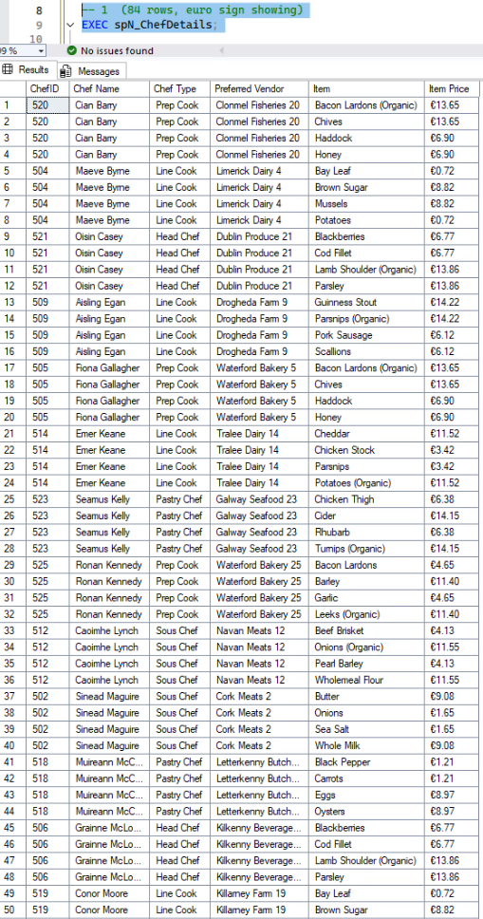
Figure 1: 84 rows, one per chef and item. 21 of the 25 chefs have a preferred vendor and each vendor carries 4 items. The euro sign in Item Price comes from FORMAT with the en-IE locale.

1b - spN_RecipeDetails (Nathan)
"Return the sum of the ingredients by recipe. Also included with this will be the recipe items. Ensure the totaldue is in Irish Pounds and do NOT hardcode the euro dollar sign."
Selects every ingredient line for each dish and tallies the cost. GROUP BY ROLLUP adds a subtotal row per dish (IngredientName is NULL) and one grand total row (both NULL), so the recipe items and the sum come back together in one result.
CREATE PROCEDURE spN_RecipeDetails
AS
BEGIN
SET NOCOUNT ON;

SELECT DishID, IngredientName,
FORMAT(SUM(IngredientCost * QuantityUsed), 'C', 'en-IE') AS RecipeCost
FROM Recipes r
JOIN Ingredients i
ON r.IngredientID = i.IngredientID
GROUP BY ROLLUP(DishID, IngredientName)
ORDER BY DishID;
END;

Test
EXEC spN_RecipeDetails;
[ screenshot 1b_recipes.png goes here ]
Figure 2: 141 rows: 100 ingredient lines, a subtotal for each of the 40 dishes, and the grand total at the top. Dish 1 (Irish Stew) costs 15.30 to make.

1c - spN_DishDetails (Nathan)
"Show me the ingredients used in each recipe and the prices listed for those dishes that use the ingredients."
Each dish, each ingredient in its recipe, and the menu price of the dish.
CREATE PROCEDURE spN_DishDetails
AS
BEGIN
SET NOCOUNT ON;

SELECT r.DishID, d.DishName, r.IngredientID, IngredientName,
FORMAT(Price, 'C', 'en-IE') AS DishCost
FROM Dishes d
JOIN Recipes r
ON d.DishID = r.DishID
JOIN Ingredients i
ON i.IngredientID = r.IngredientID
ORDER BY r.DishID, r.IngredientID;
END;

Test
EXEC spN_DishDetails;
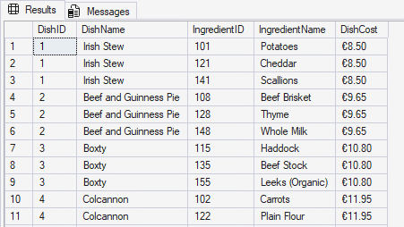
Figure 3: 100 rows, one per recipe line. Irish Stew uses potatoes, cheddar and scallions and sells for 8.50.

1d - spN_KitchenDetails (Nicholas)
"Show me the kitchen details. These details can either be all records or by individual chef."
Returns every column of KitchenDetails. The @LeadChef parameter is optional; with nothing passed it returns every kitchen, with a chef ID it returns only the kitchen that chef leads.
CREATE PROCEDURE spN_KitchenDetails
@LeadChef INT = NULL
AS
BEGIN
BEGIN TRY
SELECT *
FROM KitchenDetails
WHERE @LeadChef IS NULL OR @LeadChef = LeadChef;
END TRY
BEGIN CATCH
PRINT 'An error occured while searching for Chef #' +
CONVERT(varchar, @LeadChef, 1) + '.';
END CATCH
END;

Test - all kitchens
EXEC spN_KitchenDetails;
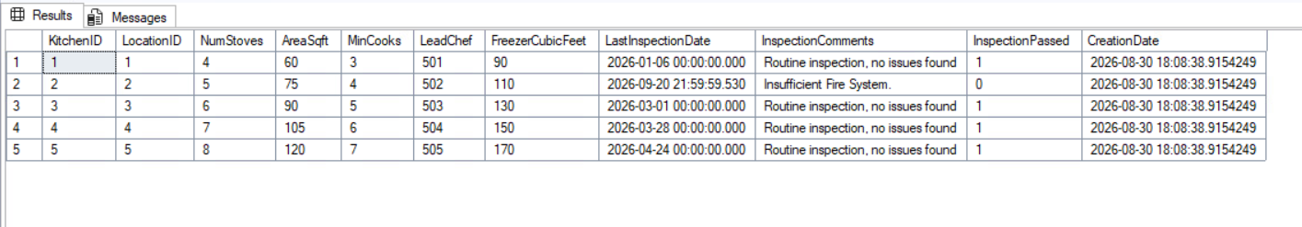
Figure 4: All 5 kitchens.

Test - by chef
EXEC spN_KitchenDetails @LeadChef = 503;
Figure 5: Only kitchen 3, the one led by chef 503.

1e - spN_CustomerDetails (Nathan)
"Return information on the customers that dine at the restaurant. This stored procedure should be able to run and return individual customer information."
Returns the customers with a formatted name. The @CustomerID parameter is optional; with nothing passed it lists all 100 customers, with an ID it returns that one customer.
CREATE PROCEDURE spN_CustomerDetails
@CustomerID INT = NULL
AS
BEGIN
SET NOCOUNT ON;

SELECT CustomerID, FirstName + ' ' + LastName AS CustName, Email, PhoneNumber,
PreferredTable, PreferredServer, PreferredRes, PreferredOrder,
Birthday
FROM Customers
WHERE @CustomerID IS NULL OR CustomerID = @CustomerID
ORDER BY CustName ASC;
END;

Test - all customers
EXEC spN_CustomerDetails;
[ screenshot 1e_customers.png goes here ]
Figure 6: All 100 customers, sorted by name.

Test - one customer
EXEC spN_CustomerDetails @CustomerID = 1;
[ screenshot 1e_customer_one.png goes here ]
Figure 7: One customer returned when an ID is passed.

Item 2 - Indexes
Requirement: an index on each of five Week 2 tables (items d, e, i, l and p), with the reason for the field chosen. Those are Charities, Dishes, Recipes, Transactions and Reservations. TransactionDetails is indexed as well since item l's order total is built from that table.
All are nonclustered because each table's primary key already created the one clustered index a table gets. INCLUDE adds columns to the index so a query can be answered without going back to the table.

d - Charities.DonatingLocationID (Mason)
DonatingLocationID is the foreign key to Demographic, so it is what the join and any "charities for this branch" filter run on, and SQL Server does not index foreign keys on its own. CharityID is already the primary key and CharityName already has a unique constraint. CharityName and TotalDonatedValue are included so the donation report is answered from the index.
CREATE NONCLUSTERED INDEX IX_Charities_DonatingLocationID
ON Charities (DonatingLocationID)
INCLUDE (CharityName, TotalDonatedValue);

e - Dishes.DishName, Price (Nicholas)
DishName and Price make a covering index for fnMenuPrices() from Week 3, which reads exactly those two columns, so the menu can be listed from the index alone.
CREATE NONCLUSTERED INDEX IX_Dishname_Price
ON Dishes (DishName, Price);

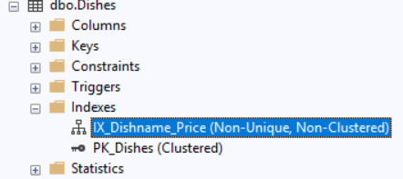
Figure 8: IX_Dishname_Price under Dishes in Object Explorer, next to the clustered primary key.

i - Recipes.DishID (Nathan)
DishID is mandatory when looking into this table to find all the ingredients belonging to a specific dish. IngredientID and QuantityUsed are included so the index works as a recipe book as well.
CREATE NONCLUSTERED INDEX IX_Recipes_DishID
ON Recipes (DishID)
INCLUDE (IngredientID, QuantityUsed);

l - Transactions.OrderDateTime (Mason)
The restaurant keeps three years of orders and nearly every question is a date range, which scans the whole table without an index on OrderDateTime. TransactionID and BillingNumber are already indexed by their constraints, and OrderChannel and PaymentMethod only have a few distinct values so an index on them would not narrow much. OrderTotal and OrderChannel are included since date queries sum and group by them.
CREATE NONCLUSTERED INDEX IX_Transactions_OrderDateTime
ON Transactions (OrderDateTime)
INCLUDE (OrderTotal, OrderChannel);

TransactionDetails.TransactionID as well: TransactionID is the foreign key back to the order, and "the lines on this bill" is the only way the table is read, but the primary key is TransactionDetailID so that lookup had no index. DishID, Quantity and UnitPrice are included so printing a bill only touches the index.
CREATE NONCLUSTERED INDEX IX_TransactionDetails_TransactionID
ON TransactionDetails (TransactionID)
INCLUDE (DishID, Quantity, UnitPrice);

p - Reservations.CustomerID (Nicholas)
CustomerID because it is both a foreign key and the column fnReservationFavoriteTable() from Week 3 joins on.
CREATE NONCLUSTERED INDEX IX_CustomerID
ON Reservations (CustomerID);

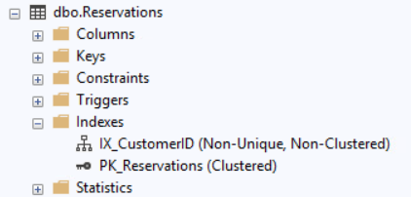
Figure 9: IX_CustomerID under Reservations in Object Explorer.

Test - sys.indexes
SELECT OBJECT_NAME(object_id) AS 'Table', name AS 'Index' FROM sys.indexes WHERE name LIKE 'IX[_]%' ORDER BY 1;
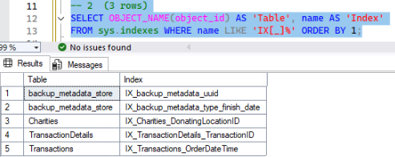
Figure 10: The three indexes on Charities, Transactions and TransactionDetails. The full run of Week4_Deliverables.sql creates all six; the two backup_metadata_store rows are SQL Server's own.

Item 3 - CRUD stored procedures
Requirement: CRUD procedures on two tables, one procedure per action, named spN_Get/Insert/Update/Delete + table. The tables are Charities and KitchenDetails, chosen because nothing else has a foreign key pointing at them, so the DELETE procedures can run without breaking a relationship. The group split the work by action: Mason wrote SELECT and INSERT, Nicholas UPDATE, Nathan DELETE.
The project says each procedure "should not generate any exceptions and all should return data." Both tables have constraints a bad call would trip (a unique name on Charities, foreign keys on both, and a row that does not exist for update and delete), so every procedure checks for those first and returns a Rejected message instead of letting SQL Server throw. On a good call each returns the row it worked on, or for a delete what was deleted.
The tests below run a full cycle: insert a test charity and a test kitchen, update them, then delete them, so the tables finish exactly as they started (15 charities, 5 kitchens).

SELECT - spN_GetCharities and spN_GetKitchenDetails (Mason)
Each takes the primary key as an optional parameter. With no argument it returns every row, with an ID it returns that one row. Both join in the branch name, and the kitchen one also joins through Chefs to Employees for the lead chef's name.
CREATE PROCEDURE spN_GetCharities
@CharityID INT = NULL
AS
BEGIN
SET NOCOUNT ON;

SELECT c.CharityID,
c.CharityName AS 'Charity',
c.CharityType AS 'Type',
c.ContactName AS 'Contact',
c.PhoneNumber AS 'Phone',
c.City,
d.LocationName AS 'Donating Branch',
FORMAT(c.TotalDonatedValue, 'C', 'en-IE') AS 'Total Donated',
CASE WHEN c.IsActive = 1 THEN 'Yes' ELSE 'No' END AS 'Active',
c.CreationDate AS 'Created'
FROM Charities c
LEFT JOIN Demographic d ON c.DonatingLocationID = d.LocationID
WHERE (@CharityID IS NULL OR c.CharityID = @CharityID)
ORDER BY c.CharityName;
END;

Test
EXEC spN_GetCharities @CharityID = 9001;
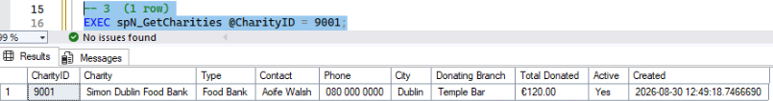
Figure 11: One charity returned when an ID is passed; with no argument all 15 come back.
CREATE PROCEDURE spN_GetKitchenDetails
@KitchenID INT = NULL
AS
BEGIN
SET NOCOUNT ON;

SELECT k.KitchenID,
d.LocationName AS 'Branch',
k.NumStoves AS 'Stoves',
k.AreaSqft AS 'Area (sq ft)',
k.MinCooks AS 'Min Cooks',
CONCAT(e.FirstName, ' ', e.LastName) AS 'Lead Chef',
c.ChefType AS 'Lead Chef Type',
k.FreezerCubicFeet AS 'Freezer (cu ft)',
k.LastInspectionDate AS 'Last Inspection',
CASE k.InspectionPassed
WHEN 1 THEN 'Passed'
WHEN 0 THEN 'Failed'
ELSE 'Not yet inspected'
END AS 'Inspection Result',
k.InspectionComments AS 'Inspection Comments',
k.CreationDate AS 'Created'
FROM KitchenDetails k
INNER JOIN Demographic d ON k.LocationID = d.LocationID
INNER JOIN Chefs c ON k.LeadChef = c.ChefID
INNER JOIN Employees e ON c.EmployeeID = e.EmployeeID
WHERE (@KitchenID IS NULL OR k.KitchenID = @KitchenID)
ORDER BY k.KitchenID;
END;

Test
EXEC spN_GetKitchenDetails @KitchenID = 3;
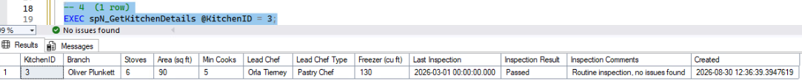
Figure 12: One kitchen returned, with the branch name and the lead chef's name joined in.

INSERT - spN_InsertCharities and spN_InsertKitchenDetails (Mason)
Every column a user can fill in is a parameter. CreationDate is not a parameter so its default fills in the insert time. Each checks the things that would break a constraint and returns the new row on success.
CREATE PROCEDURE spN_InsertCharities
@CharityName NVARCHAR(100),
@CharityType NVARCHAR(50) = NULL,
@ContactName NVARCHAR(100) = NULL,
@PhoneNumber NVARCHAR(20) = NULL,
@City NVARCHAR(50) = NULL,
@DonatingLocationID INT = NULL,
@TotalDonatedValue DECIMAL(10,2) = NULL,
@IsActive BIT = 1
AS
BEGIN
SET NOCOUNT ON;

IF @CharityName IS NULL OR LTRIM(RTRIM(@CharityName)) = ''
BEGIN
SELECT 'Rejected - a charity name is required.' AS 'Result';
RETURN 1;
END;

IF EXISTS (SELECT 1 FROM Charities WHERE CharityName = @CharityName)
BEGIN
SELECT CONCAT('Rejected - ', @CharityName, ' already exists.') AS 'Result';
RETURN 1;
END;

IF @DonatingLocationID IS NOT NULL
AND NOT EXISTS (SELECT 1 FROM Demographic WHERE LocationID = @DonatingLocationID)
BEGIN
SELECT CONCAT('Rejected - no location with ID ', @DonatingLocationID, '.') AS 'Result';
RETURN 1;
END;

IF @TotalDonatedValue < 0
BEGIN
SELECT 'Rejected - the donated total cannot be negative.' AS 'Result';
RETURN 1;
END;

INSERT INTO Charities
(CharityName, CharityType, ContactName, PhoneNumber, City,
DonatingLocationID, TotalDonatedValue, IsActive)
VALUES
(@CharityName, @CharityType, @ContactName, @PhoneNumber, @City,
@DonatingLocationID, @TotalDonatedValue, @IsActive);

-- return the new row so the ID and CreationDate show up
SELECT * FROM Charities WHERE CharityID = SCOPE_IDENTITY();
RETURN 0;
END;

Test - a good insert
EXEC spN_InsertCharities @CharityName = 'Week 4 Test Charity', @CharityType = 'Food Bank', @City = 'Galway', @DonatingLocationID = 1, @TotalDonatedValue = 250.00;
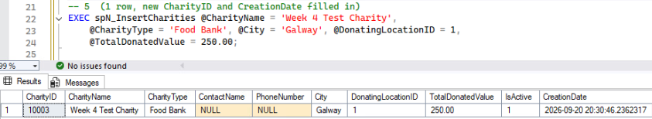
Figure 13: The new row comes back with CharityID and CreationDate filled in by the database, not passed in.

Test - the same name again
EXEC spN_InsertCharities @CharityName = 'Week 4 Test Charity';
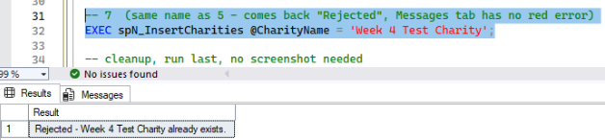
Figure 14: The unique constraint on CharityName would normally throw an error. The procedure returns a Rejected message instead, and the status bar shows no error.
CREATE PROCEDURE spN_InsertKitchenDetails
@LocationID INT,
@NumStoves INT,
@AreaSqft INT,
@MinCooks INT,
@LeadChef INT,
@FreezerCubicFeet INT,
@LastInspectionDate DATETIME = NULL,
@InspectionComments NVARCHAR(500) = NULL,
@InspectionPassed BIT = NULL
AS
BEGIN
SET NOCOUNT ON;

IF NOT EXISTS (SELECT 1 FROM Demographic WHERE LocationID = @LocationID)
BEGIN
SELECT CONCAT('Rejected - no location with ID ', ISNULL(@LocationID, 0), '.') AS 'Result';
RETURN 1;
END;

IF NOT EXISTS (SELECT 1 FROM Chefs WHERE ChefID = @LeadChef)
BEGIN
SELECT CONCAT('Rejected - no chef with ID ', ISNULL(@LeadChef, 0), '.') AS 'Result';
RETURN 1;
END;

IF ISNULL(@NumStoves, 0) <= 0 OR ISNULL(@AreaSqft, 0) <= 0
OR ISNULL(@MinCooks, 0) <= 0 OR ISNULL(@FreezerCubicFeet, 0) <= 0
BEGIN
SELECT 'Rejected - stoves, area, min cooks and freezer size must be above zero.' AS 'Result';
RETURN 1;
END;

INSERT INTO KitchenDetails
(LocationID, NumStoves, AreaSqft, MinCooks, LeadChef, FreezerCubicFeet,
LastInspectionDate, InspectionComments, InspectionPassed)
VALUES
(@LocationID, @NumStoves, @AreaSqft, @MinCooks, @LeadChef, @FreezerCubicFeet,
@LastInspectionDate, @InspectionComments, @InspectionPassed);

SELECT * FROM KitchenDetails WHERE KitchenID = SCOPE_IDENTITY();
RETURN 0;
END;

Test - a good insert
EXEC spN_InsertKitchenDetails @LocationID = 1, @NumStoves = 5, @AreaSqft = 80, @MinCooks = 4, @LeadChef = 501, @FreezerCubicFeet = 100, @InspectionComments = 'Week 4 test row';
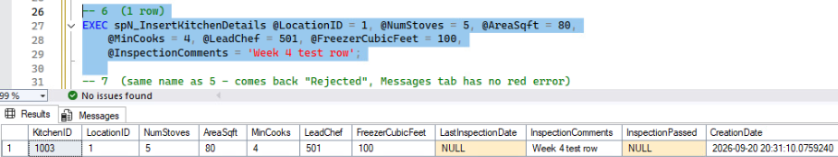
Figure 15: The new kitchen row returned with its KitchenID and CreationDate. The inspection columns were left off the call and came through as NULL.

UPDATE - spN_UpdateCharities and spN_UpdateKitchenDetails (Nicholas)
Both update at least three fields. spN_UpdateCharities takes the ID and IsActive, then four optional fields that keep the row's existing value when left off. spN_UpdateKitchenDetails records an inspection: the comments, pass/fail, and a date that defaults to the time of the update. Both check the row exists and return the updated row.
CREATE PROCEDURE spN_UpdateCharities
@CharityID INT,
@IsActive BIT,
@ContactName NVARCHAR(100) = NULL,
@PhoneNumber NVARCHAR(20) = NULL,
@CharityName NVARCHAR(100) = NULL,
@CharityType NVARCHAR(50) = NULL
AS
BEGIN
SET NOCOUNT ON;

IF NOT EXISTS (SELECT 1 FROM Charities WHERE CharityID = @CharityID)
BEGIN
SELECT CONCAT('Rejected - no charity with ID ', ISNULL(@CharityID, 0), '.') AS 'Result';
RETURN 1;
END;

IF @CharityName IS NOT NULL
AND EXISTS (SELECT 1 FROM Charities WHERE CharityName = @CharityName AND CharityID <> @CharityID)
BEGIN
SELECT CONCAT('Rejected - ', @CharityName, ' already exists.') AS 'Result';
RETURN 1;
END;

-- any parameter left off keeps the value already on the row
IF @ContactName IS NULL
SELECT @ContactName = ContactName FROM Charities WHERE CharityID = @CharityID;

IF @PhoneNumber IS NULL
SELECT @PhoneNumber = PhoneNumber FROM Charities WHERE CharityID = @CharityID;

IF @CharityName IS NULL
SELECT @CharityName = CharityName FROM Charities WHERE CharityID = @CharityID;

IF @CharityType IS NULL
SELECT @CharityType = CharityType FROM Charities WHERE CharityID = @CharityID;

BEGIN TRY
BEGIN TRAN;
UPDATE Charities
SET IsActive = @IsActive,
ContactName = @ContactName,
PhoneNumber = @PhoneNumber,
CharityName = @CharityName,
CharityType = @CharityType
WHERE CharityID = @CharityID;
COMMIT TRAN;
END TRY
BEGIN CATCH
IF @@TRANCOUNT > 0 ROLLBACK TRAN;
SELECT CONCAT('Rejected - ', ERROR_MESSAGE()) AS 'Result';
RETURN 1;
END CATCH;

-- return the updated row
SELECT * FROM Charities WHERE CharityID = @CharityID;
RETURN 0;
END;

Test
EXEC spN_UpdateCharities @CharityID = @TestCharity, @IsActive = 1, @ContactName = 'James Joyce', @PhoneNumber = '353 1 878 8547', @CharityName = 'Joyce Dublin Clinic', @CharityType = 'Free Clinic'; -- the test charity inserted above
Nicholas's original test ran the same update against charity 9001, before and after:
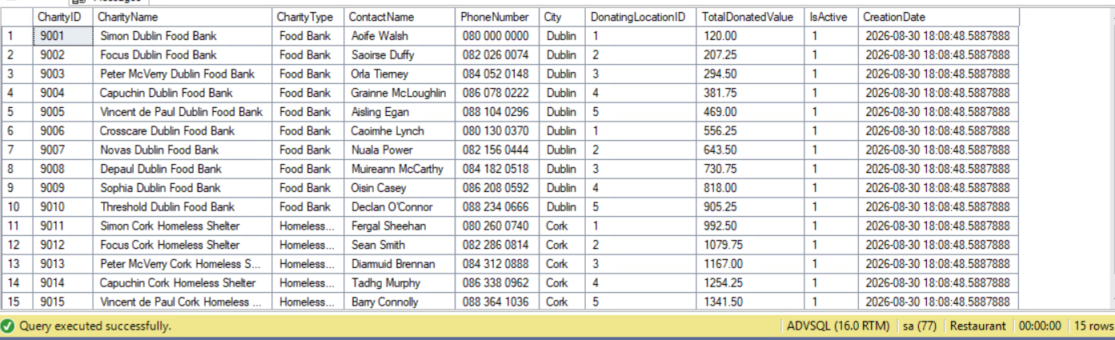
Figure 16: Charities before the update - 9001 is Simon Dublin Food Bank, contact Aoife Walsh.
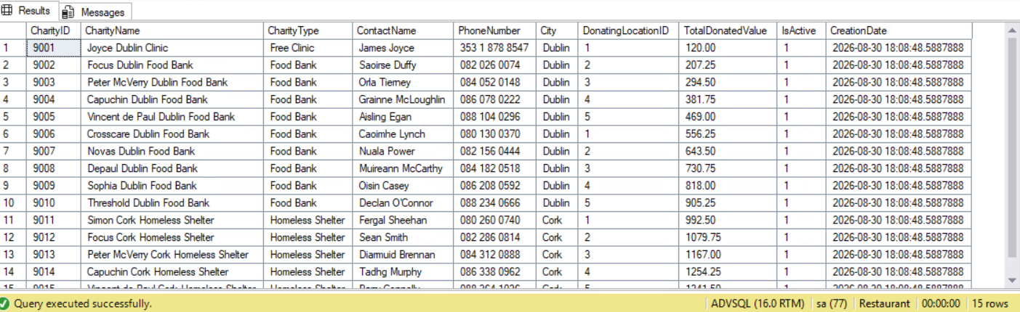
Figure 17: After the update - all four fields on 9001 changed and the other 14 rows untouched.
[ screenshot 3_update_charity.png goes here ]
Figure 18: The procedure returns the updated row.
CREATE PROCEDURE spN_UpdateKitchenDetails
@KitchenID INT,
@Comments NVARCHAR(500),
@InspectionPassed BIT,
@InspectionDate DATETIME = NULL
AS
BEGIN
SET NOCOUNT ON;

IF NOT EXISTS (SELECT 1 FROM KitchenDetails WHERE KitchenID = @KitchenID)
BEGIN
SELECT CONCAT('Rejected - no kitchen with ID ', ISNULL(@KitchenID, 0), '.') AS 'Result';
RETURN 1;
END;

IF @InspectionDate IS NULL
SELECT @InspectionDate = SYSDATETIME();

BEGIN TRY
BEGIN TRAN;
UPDATE KitchenDetails
SET InspectionComments = @Comments,
InspectionPassed = @InspectionPassed,
LastInspectionDate = @InspectionDate
WHERE KitchenID = @KitchenID;
COMMIT TRAN;
END TRY
BEGIN CATCH
IF @@TRANCOUNT > 0 ROLLBACK TRAN;
SELECT CONCAT('Rejected - ', ERROR_MESSAGE()) AS 'Result';
RETURN 1;
END CATCH;

-- return the updated row
SELECT * FROM KitchenDetails WHERE KitchenID = @KitchenID;
RETURN 0;
END;

Test
EXEC spN_UpdateKitchenDetails @KitchenID = @TestKitchen, @Comments = 'Insufficient fire suppression system.', @InspectionPassed = 0; -- the test kitchen inserted above
Nicholas's original test ran the same update against kitchen 2, before and after:
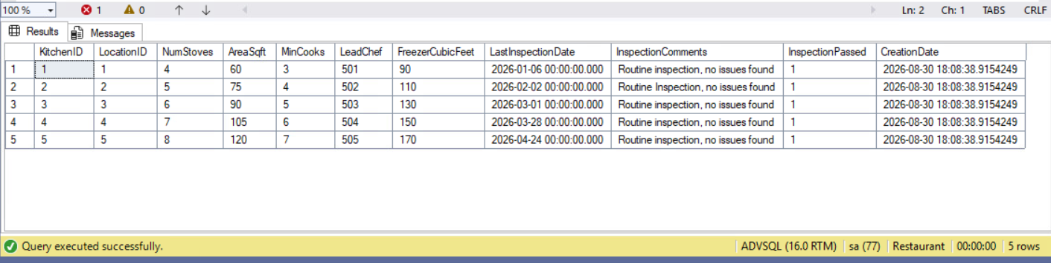
Figure 19: KitchenDetails before - kitchen 2 passed its 2 February inspection.
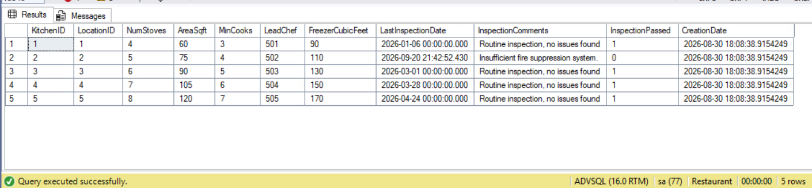
Figure 20: After - kitchen 2 now shows the new comment, InspectionPassed = 0, and the inspection date defaulted to the time of the update.
[ screenshot 3_update_kitchen.png goes here ]
Figure 21: The procedure returns the updated row.

DELETE - spN_DeleteCharities and spN_DeleteKitchenDetails (Nathan)
Each deletes one row by its primary key. No other table has a foreign key to Charities or KitchenDetails (chefs are tied to a branch through Demographic, not through the kitchen), so nothing has to be cleared first. Each checks the row exists and returns what it deleted along with the row count.
CREATE PROCEDURE spN_DeleteCharities
@CharityID INT
AS
BEGIN
SET NOCOUNT ON;

IF NOT EXISTS (SELECT 1 FROM Charities WHERE CharityID = @CharityID)
BEGIN
SELECT CONCAT('Rejected - no charity with ID ', ISNULL(@CharityID, 0), '.') AS 'Result';
RETURN 1;
END;

DECLARE @Name NVARCHAR(100) = (SELECT CharityName FROM Charities WHERE CharityID = @CharityID);

DELETE FROM Charities
WHERE CharityID = @CharityID;

DECLARE @Rows INT = @@ROWCOUNT;

SELECT CONCAT('Deleted charity ', @CharityID, ' - ', @Name, '.') AS 'Result',
@Rows AS 'Rows Deleted';
RETURN 0;
END;

Test
EXEC spN_DeleteCharities @CharityID = @TestCharity; -- the test charity inserted above
[ screenshot 3_delete_charity.png goes here ]
Figure 22: The test charity is deleted and the procedure reports which row went, with 1 row deleted. A bad ID returns a Rejected message.
CREATE PROCEDURE spN_DeleteKitchenDetails
@KitchenID INT
AS
BEGIN
SET NOCOUNT ON;

IF NOT EXISTS (SELECT 1 FROM KitchenDetails WHERE KitchenID = @KitchenID)
BEGIN
SELECT CONCAT('Rejected - no kitchen with ID ', ISNULL(@KitchenID, 0), '.') AS 'Result';
RETURN 1;
END;

DECLARE @Branch NVARCHAR(100) = (
SELECT d.LocationName
FROM KitchenDetails k
INNER JOIN Demographic d ON k.LocationID = d.LocationID
WHERE k.KitchenID = @KitchenID);

DELETE FROM KitchenDetails
WHERE KitchenID = @KitchenID;

DECLARE @Rows INT = @@ROWCOUNT;

SELECT CONCAT('Deleted kitchen ', @KitchenID, ' at ', @Branch, '.') AS 'Result',
@Rows AS 'Rows Deleted';
RETURN 0;
END;

Test
EXEC spN_DeleteKitchenDetails @KitchenID = @TestKitchen; -- the test kitchen inserted above
[ screenshot 3_delete_kitchen.png goes here ]
Figure 23: The test kitchen is deleted; Charities and KitchenDetails are back to 15 and 5 rows.

