SQL Advanced Programming
Group Project – Week 4: Indexes

-- Item B. Index on Dishes table.
I chose Dishname and Price to make a covering index for fnMenuPrices().
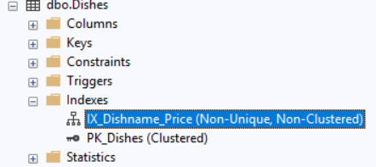

-- Item E. Index on Reservations table.
I chose CustomerID because it is both a FK and it is used in a join by fnReservationFavoriteTable().

