SQL Advanced Programming
Group Project – Week 4: CRUD Operations

-- Test 1. Update on KitchenDetails
Before:
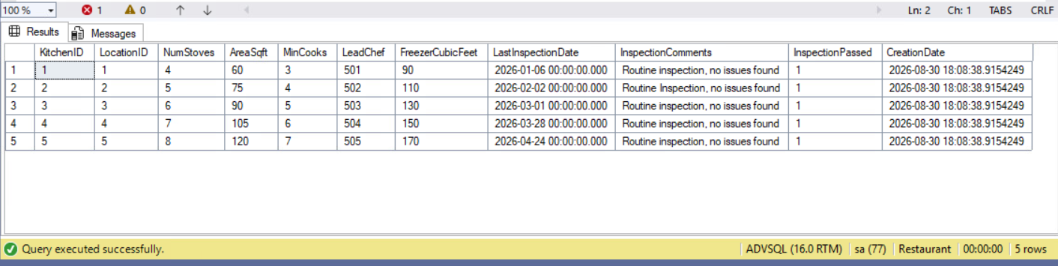
After query: exec spN_UpdateInspection 2, “Insufficient fire suppression system.”, 0;
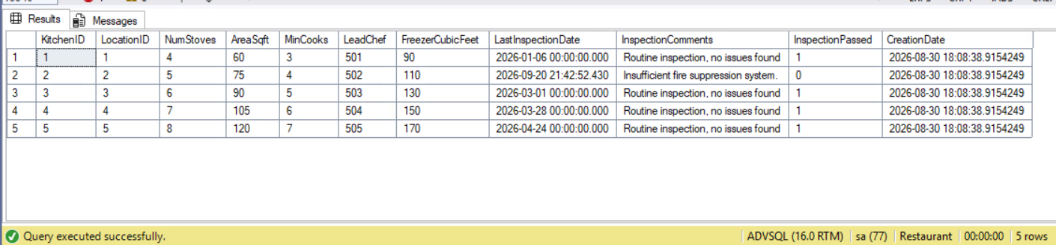
-- Test 2. Update on Charities
Before:
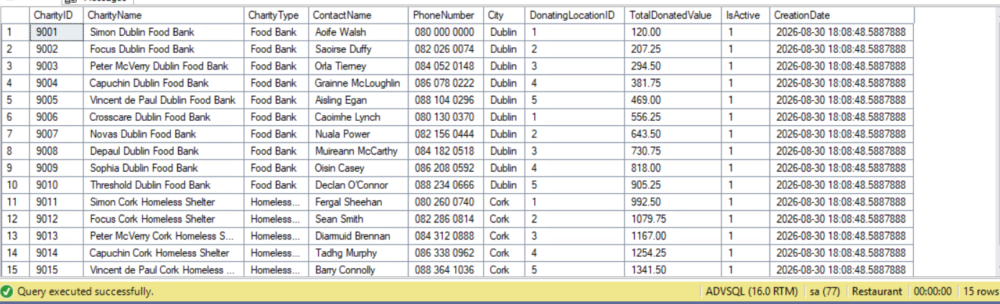
After query: exec spN_UpdateCharityInfo 9001, 1, “James Joyce”,
“353 1 878 8547”, “Joyce Dublin Clinic”, “Free Clinic”;
