SQL Advanced Programming
Group Project – Week 4: Stored Procedures

-- Item D. exec spN_KitchenDetails
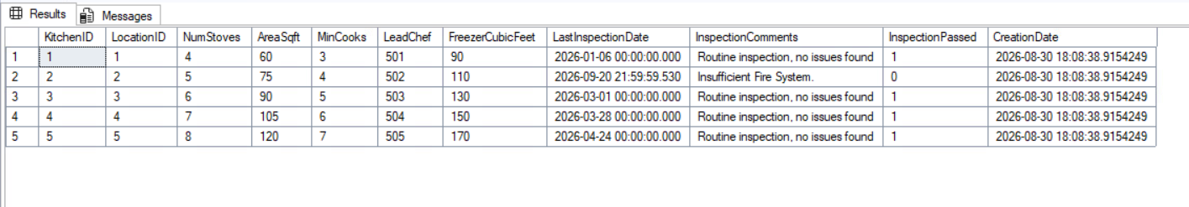
exec spN_KitchenDetails 503

