**15-437 Team 26 Project Specification**

Kappa Sigma Delta-Alpha Web Application

Rishi Ved <rnved> & Jake Stephens <jpstephe>

**Abstract**

This document clarifies and precisely defines the functionality of our web-application final project, as well as define the milestones for feature completion.

Table of Contents

1. Document Revisions3

2. Project Background3

3. Complete Product Backlog3

2.1 Registration Functionality3

2.2 Communications Functionality3

2.3 Task Functionality4

2.4 Deployment Functionality4

4. Sprint #1 Product Backlog4

5. Sprint #2 Product Backlog5

6. Post Sprint Product Backlog5

7. Data Models5

8. UI Mockups5

1. Document Revisions

Table 1: Document History

|  |  |  |  |
| --- | --- | --- | --- |
| Data | Revision History | Revision Class | Comments |
| 03/20/2015 | 1.0.0 | Major | Initial document. |

2. Project Background

The Kappa Sigma Delta-Alpha web-application will serve as a portal for the fraternity to communicate and operate. This web-application serves will give its users the ability to see each other’s contact information, assign/receive tasks, fine/receive fines, post/view the chapter forum, and view/edit the chapter Google calendar.

The current fraternity website does not allow for these functionalities and is outdated.

3. Complete Product Backlog

The items in the list below, and their associated descriptions, serve as a complete list of all functionality that we will add to our web-application.

2.1. Registration Functionality

* Registration via email confirmation – Registering users must provide an email address when registering. Next, the site admin will receive an email requesting their approval for the new user. Once this approval is made, the new user will be sent an email alerting them that their account is now activated and that they may login .

2.2 Communications Functionality

* Google Calendar viewing/editing – The fraternity utilizes Google calendar for event sharing and notifications. As such, this page on the web-application will allow users to view/edit the fraternity-wide Google calendar. Only users who have permissions to view/edit the calendar according the calendar permissions specified on Google will have access to this feature.
* Forum – This page will allow users to create new posts and comment on existing posts. Site admins will be able to moderate conversations by deleting posts and/or comments.
* Document Repository – We will allow users to upload and view documents. These documents will be stored on S3. These documents will include Chapter Bylaws, Standing Rules, Cleaning Guides, etc.
* Fines – Below are the features that fines encompass.
  + Users with “fining power” (Finer) will be be allowed to fine members of the fraternity (Finee).
  + Each fine will contain a comment specifying the reasoning behind the fine.
  + Finees will have the ability to complete their fine through Venmo. By clicking on a link, a new window will be opened, asking the user to authenticate to their Venmo account. Then a Venmo payment between the user that was fined and the Chapter Treasurer will be created. The user who was fined will be required to complete the charge.
  + The fine can be marked complete by site admins or finer.

2.3 Task Functionality

* Worksession Assignment Script – Each week there will be a script that runs to assign brothers their weekly cleaning sessions.
* Waitsession Assignment Script – Each week there will be a script that runs to assign brother their daily waiter sessions.

2.4 Deployment Functionality

* Heroku Deployment – The web-application will be deployed on heroku. It won’t be in the dev environment. Instead, it will be in a production environment.

4. Sprint #1 Product Backlog

The items in the list below serve as a complete list of all functionality that we will add to our web-application for Sprint #1. Their descriptions can be found in Section 3.

* Registration via email confirmation
* Google calendar viewing/editing
* Forum

The product owner for Sprint #1 will be Jake Stephens <jpstephe>.

5. Sprint #2 Product Backlog

The items in the list below serve as a compelte list of all the functionality that we will add to our web-application for Sprint #2. Their descriptions can be found in Section 3.

* Fines
* Document Repository
* Worksession Assignment Script
* Waitsession Assignment Script

The product owner for Sprint #2 will be Rishi Ved <rnved>.

6. Post Sprint Product Backlog

The items in the list below serve as a complete list of all the functionality that we will add to our web-application post Sprint #2 and prior to the Final Demo. Their descriptions can be found in Section 3.

* Heroku Deployment

The product owner for Post Sprint #2 items will be Jake Stephens <jpstephe>.

7. Data Models

The complete implementation of the data models used by our application can be found at team26/ksda/kapsig/ksda/models.py.

8. UI Mockups

Below is a complete set of HTML mockups for all non-trivial views within the application.

Table 2: Update Profile Template

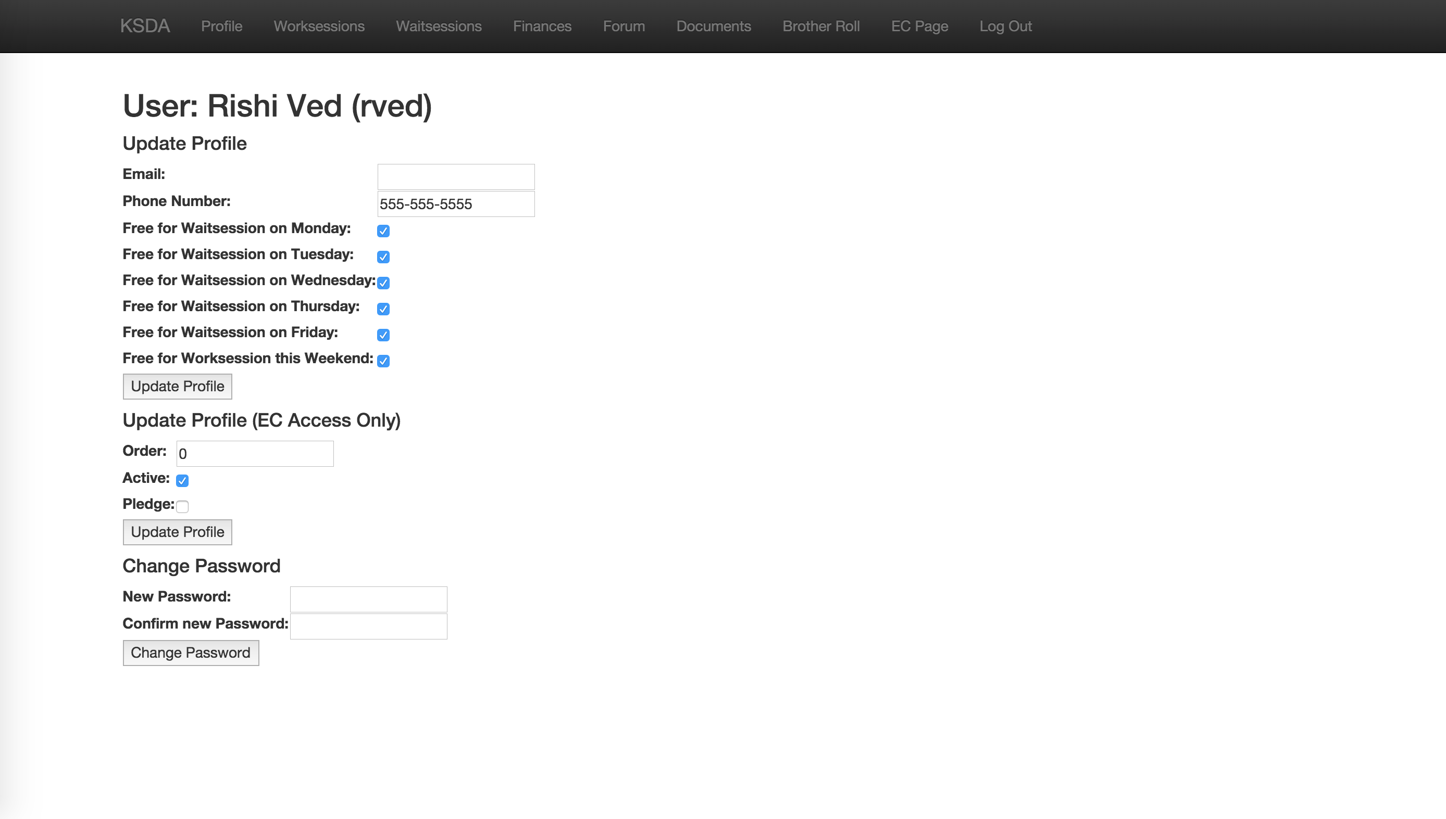

Table 3: Worksession Template

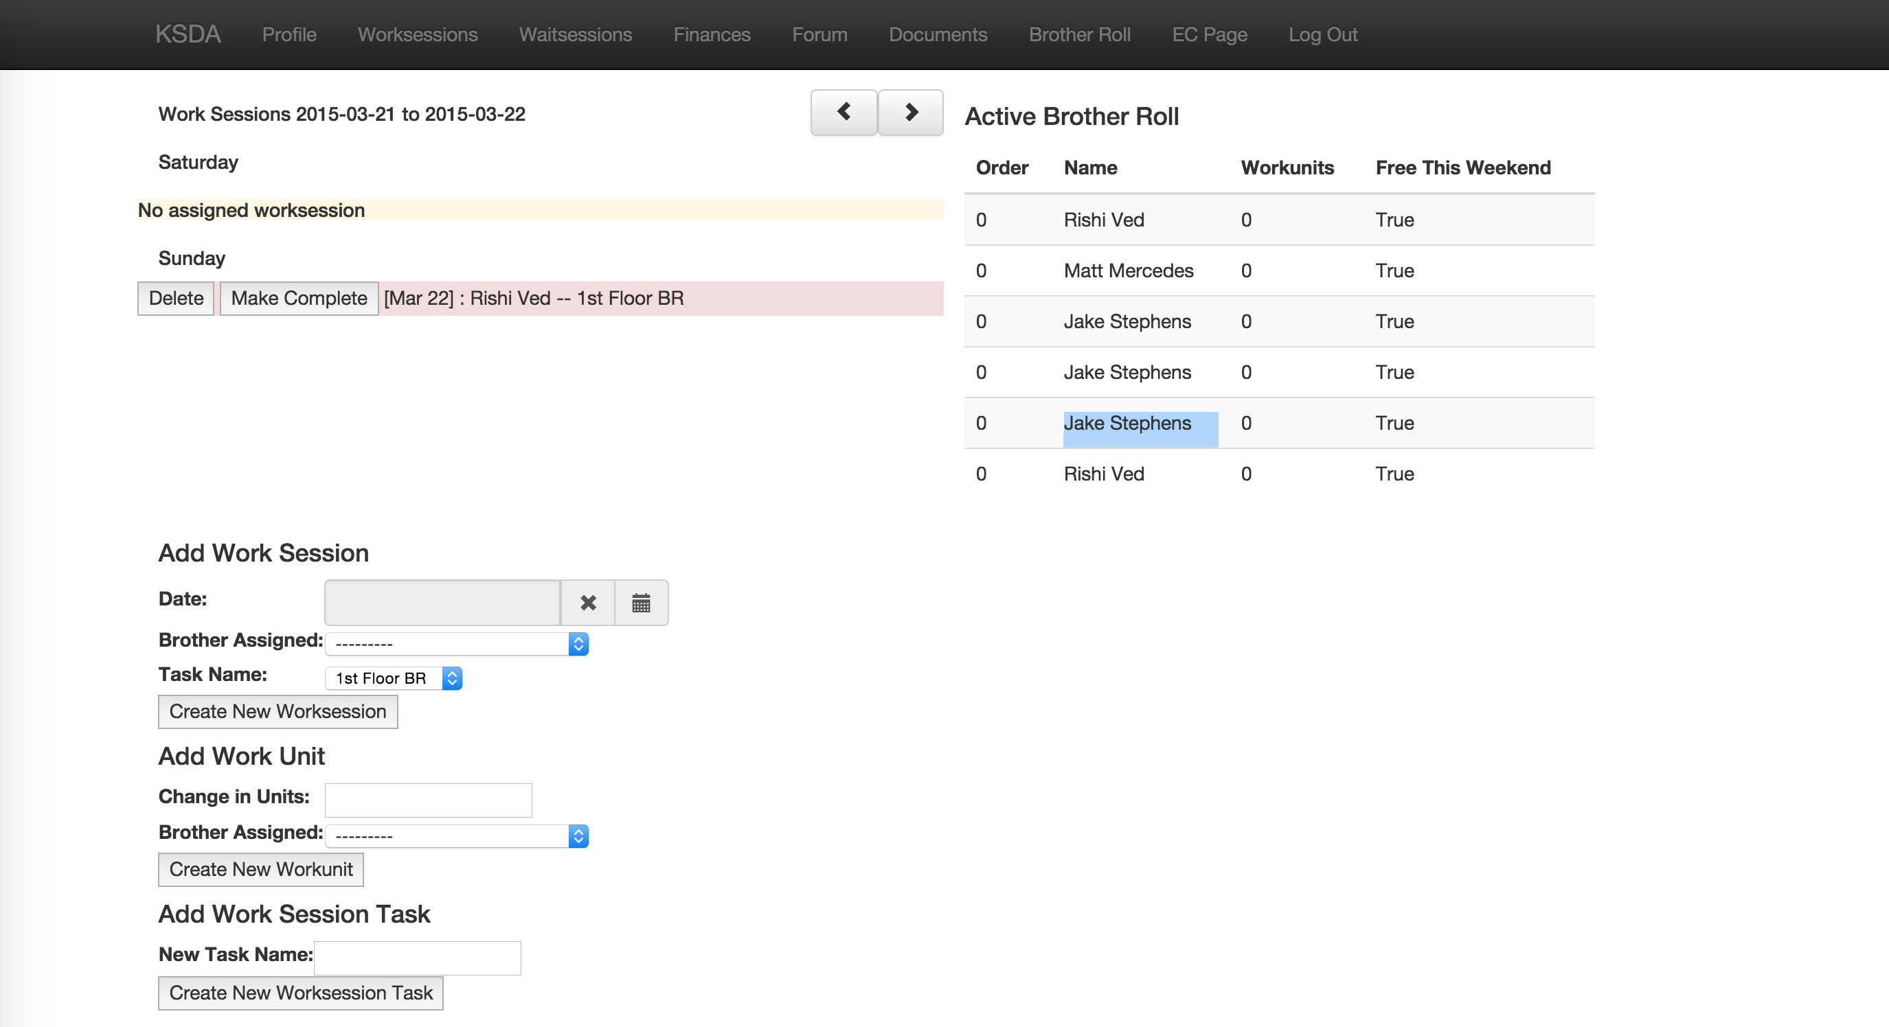

Table 4: Waitsession Template

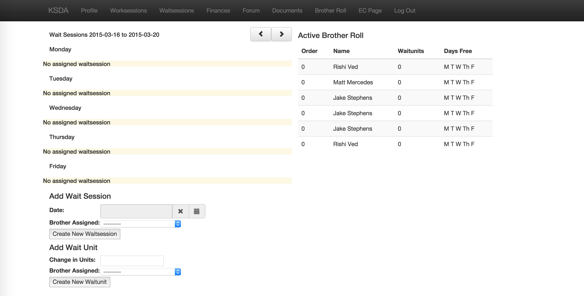

Table 5: Brother Roll Website

