Project: OpenWebNet Simulator
Design name: …
Document type: User Manual | Revision: 1.0
File name: 0000.doc
Abstract:

My Open simulator is a multiplatform Graphical simulator, it works on Windows, Linux and MAC OsX, that support the most common MyHome plant devices. MyOpen Simulator is an ideal companion for every system integrator or enthusiastic OpenWebNet developer that wants to test his application without building a real plant.

With this first delivery, MyOpen Simulator, is not yet able to support the whole set of Bticino MyHome devices but its modular and flexible architecture is ready to support more and more devices and functionalities that will be delivered soon.

REVISIONS
Rev. | Date | Description | Created | Verified | Approved
1.0 | 15/10/2012 | First Version | Bticino | Bticino | Bticino
2.0 | 13/11/2012 | Second revision | Bticino | Bticino | Bticino

REFERENCE
ID | Reference description | Link
[R1] | OpenWebNet_Community_0_general_v1_1_0_EN.doc
[R2]
[R3]

SUMMARY
1. Introduction 5
2. Getting started 5
2.1. System requirements 5
2.2. Windows Installer 5
2.3. Linux Installer 9
2.4. MAC-Installer 9
3. Start working with the simulator 9
3.1. Default configuration 9
3.2. Create a new plant 10
3.3. F411/x devices 11
3.4. CAMera devices 13
3.5. Gateway 14
3.6. F422 device 15
3.7. Generic devices 16
3.8. F520 device 19
4. License 21

PICTURES
Fig. 1 Installation: first screen 7
Fig. 2 Installation: select destination folder 7
Fig. 3 Installation: selection of the Start Menu Folder name 8
Fig. 4 Installation: Create a desktop icon 8
Fig. 5 Installation: Settings 9
Fig. 6 Installation: Completed 9
Fig. 7 Default configuration plant 11
Fig. 8 Plant name 11
Fig. 9 Din number 11
Fig. 10 Din number 12
Fig. 11 Empty plant 12
Fig. 12 F411/x creation 13
Fig. 13 Configuration panel 13
Fig. 14 Yellow led slot configured and status ON 14
Fig. 15 Red led slot not configured 14
Fig. 16 Black led slot configured and status OFF 14
Fig. 17 Cam creation 15
Fig. 18 CAMera configuration panel 15
Fig. 19 Yellow led slot configured and status ACTIVE 16
Fig. 20 Red led slot not configured 16
Fig. 21 Black led slot configured and status INACTIVE 16
Fig. 22 Gateway creation 16
Fig. 23 Gateway configuration panel 17
Fig. 24 F422 creation 17
Fig. 25 F422 configuration panel 18
Fig. 26 Generic device creation 18
Fig. 27 Generic device configuration panel 19
Fig. 28 F520 creation pannel 22
Fig. 29 F520 configuration panel 22
Fig. 30 daily configuration, in this case is rappresent the configuration of 1st january 23
Fig. 31 Daily Configuration, in this case is rappresent the defualt day configuration 24
Fig. 32 Monthly configuration, in this case is rappresent the configuartion of january 25
Fig. 33 Daily Configuration, in this case is rappresent the defualt day configuration 26
Fig. 34 You can set the value assumed in the past year 26
Fig. 35 Simulation control panel 27
Fig. 36 Simulation control manager 27

DICTIONARY
OpenWebNet Open Protocol for Electric Networks
Gateway Interface among Bticino SCS Field BUS and Ethernet Channel with public protocol

1 Introduction
MyOpenSimulator is software simulator that simulates the behavior of a Bticino Myhome automation system. The subsystems available to the user are, light ( WHO = 1 ) and multimedia system ( WHO = 6 ) limited to the camera subsystem.
The user can create a model of a plant in order to test how a real plant behaves when it is managed by an external application connected, to the simultator istsel, via OpenWebNet protocol.

2 Getting started
Actually only a subset of OpenWebNet functionality is supported; here below the related details:

- Light ( WHO = 1 )
Switch off ( WHAT = 0):
  - WHERE 0, general command, switch off all lighting points
  - WHERE 1 – 9, environment command, switch off all lighting points
  - WHERE #1 - #9, group command, sitch off all lighting points
  - WHERE 11 – 99, peer to peer command, switch off the specific light, with address A+PL
All riser are not supported
Switch on ( WHAT = 1):
  - WHERE 0, general command, switch off all lighting points
  - WHERE 1 – 9, environment command, switch off all lighting points
  - WHERE #1 - #9, group command, sitch off all lighting points
  - WHERE 11 – 99, peer to peer command, switch off the specific light, with address A+PL
Light Status ( WHO = #1 )
  - WHERE 0, general command, switch off all lighting points
  - WHERE 1 – 9, environment command, switch off all lighting points
  - WHERE #1 - #9, group command, sitch off all lighting points
  - WHERE 11 – 99, peer to peer command, switch off the specific light, with address A+PL

All other commands, including dimmer, are not supported.

- Multimedia ( WHO = 6 )
Receive video command ( WHAT = 0 ):
  - WHERE 4000 – 4099, peer to peer command, activate video camera with ID = WHERE – 4000 ( 0- 99 )
Free video channel ( WHAT = 9 ).

- Energy ( WHO = 18 )
Start sending daily totalizers on an hourly basis ( WHAT = 57 )
  - WHERE 5N, whit N = [1-255]
Start sending Average monthly on an hourly basis ( WHAT = 58 )
  - WHERE 5N, whit N = [1-255]
Start sending monthly totalizers current year on a daily basis ( WHAT = 59 )
  - WHERE 5N, whit N = [1-255]
Start sending monthly totalizers on a daily basis, last year compared( WHAT = 510 )
  - WHERE 5N, whit N = [1-255]
Start and Stop sending instantaneous consumption ( DIMENSION = #1200 )
  - WHERE 5N, whit N = [1-255]
Request the daily totalizers on an hourly basis ( DIMENSION = #511 )
  - WHERE 5N, whit N = [1-255]
Request active power( DIMENSION = #113 )
  - WHERE 5N, whit N = [1-255]
Request energy / unit Totalizer (DIMENSION = 51 )
  - WHERE 5N, whit N = [1-255]
Request Totalizer energy /units per month (DIMENSION = 52 )
  - WHERE 5N, whit N = [1-255]
Request partial Totalizer for current month ( DIMENSION = 53 )
  - WHERE 5N, whit N = [1-255]
Request partial Totalizer for current day ( DIMENSION = 54 )
  - WHERE 5N, whit N = [1-255]

3 System requirements
MyOpenSimulator need:

- Windows Windows XP, Windows Vista, Windows 7.

- Linux, Ubuntu 11.04 o superior, lib open ssl.

- MAC, Mac OSX Lion 10.6 o superior.

4 Windows Installer
- Download and execute the installation file “MyOpenSimulatorSetup.exe”.

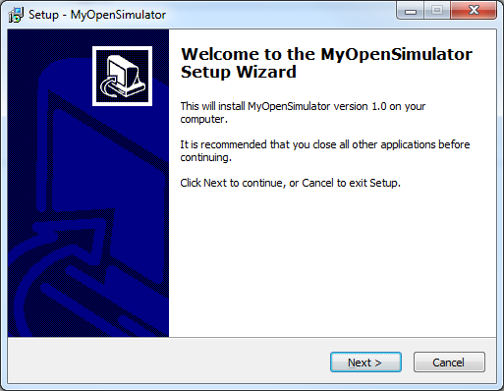
Fig. 1 Installation: first screen
- Click next and select folder where you would like to install the simulator.

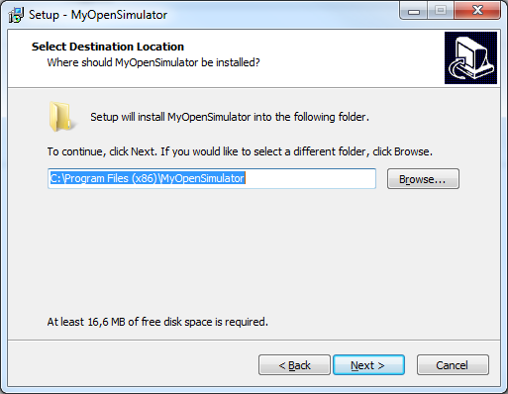
Fig. 2 Installation: select destination folder
- Select Start Menu Folder name (default is MyOpenSymulator). Flag “Don’t create a Start Menu Folder” if you would not have a Menu Folder.

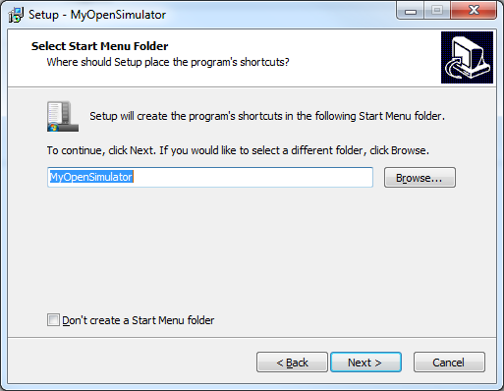
Fig. 3 Installation: selection of the Start Menu Folder name

- Flag “Create a desktop icon” if you would create a desktop short cut. Otherwise click next to complete the installation.

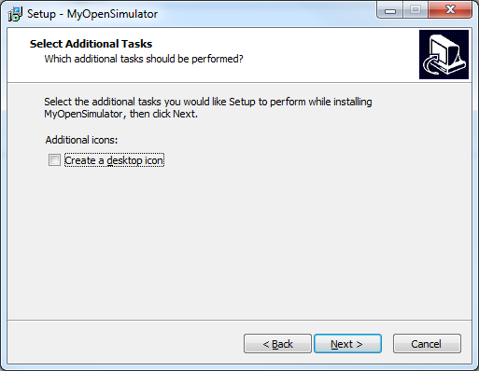
Fig. 4 Installation: Create a desktop icon
- Click install to complete the installation, back to change some installation setting or cancel to block the installation.

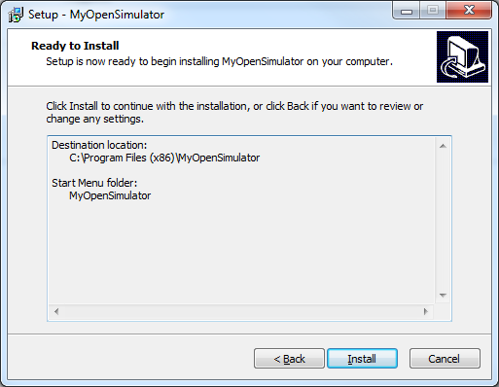
Fig. 5 Installation: Settings
- Click Finish to exit from installation procedure.

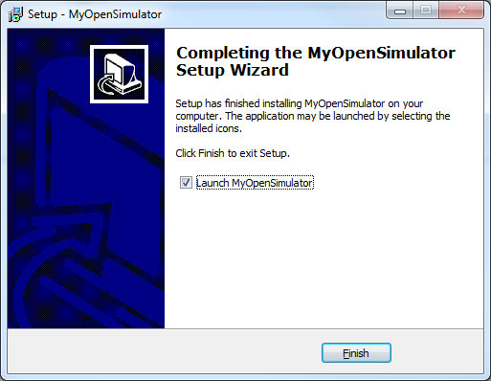
Fig. 6 Installation: Completed
- At the end of this procedure, you need to install Openssl library.

5 Linux Installer
- Download the linux installer (INSTALLER_MyOpenSimulator_Linux.tar.gz).
- Untar the file to your destination folder (tar -zxvf INSTALLER_MyOpenSimulator_Linux.tar.gz).
- Enter in MyOpenSimulator folder.
- Launch the script: ./MyOpenSimulator.sh .

6 MAC-Installer
- Download the APPLE installer (INSTALLER_MyOpenSimulator_MAC.tar.gz).
- Untar the file to your destination folder (tar -zxvf INSTALLER_MyOpenSimulator_MAC.tar.gz).
- Enter in MyOpenSimulator folder.
- Launch the script: ./MyOpenSimulator.sh .

7 Start working with the simulator
To start using the simulator you need to have the PC connected to a network, with a MyOpenWebNet simulator or with a home automation system.

8 Default configuration
- MyOpenSimulator starts with a default configuration.
- Gateway:
- IP Address = <PC IP Addr>
- Command Open Port = 20000
- Monitor Open Port = 20001
- Webserver (HTTP) Port = 8000
- Webserver (HTTPS) Port = 8001
- Ipcam gateway password = not configured
- F411/2:
- Slot1 : A=1, PL=1, G=1
- Slot2 : A=1, PL=2, G=1
- F411/2:
- Slot1 : A=2, PL=3, G=2
- Slot2 : A=2, PL=4, G=2
- F411/4:
- not configured.
- CAM:
- P : 1

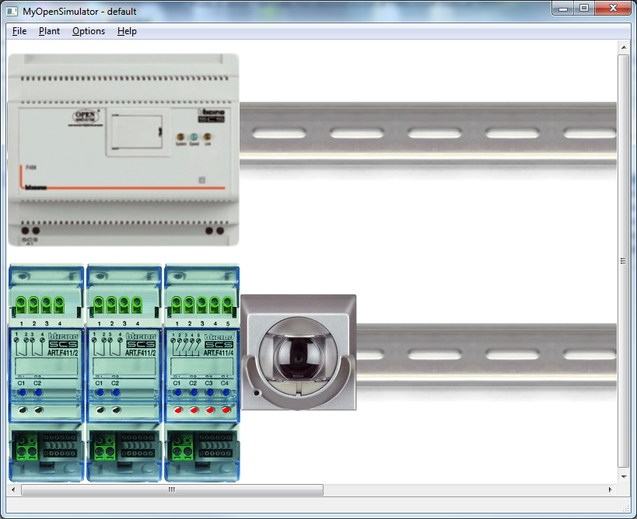
Fig. 7 Default configuration plant

9 Create a new plant

- Create a new plant

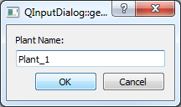
Fig. 8 Plant name
- Set number of din row

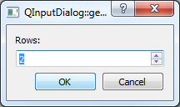
Fig. 9 Din number

- Set number of slot

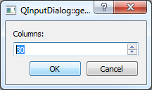
Fig. 10 Din number
- New empty plant, call Plant_1, with 2 DIN bar and 30 slot, is created

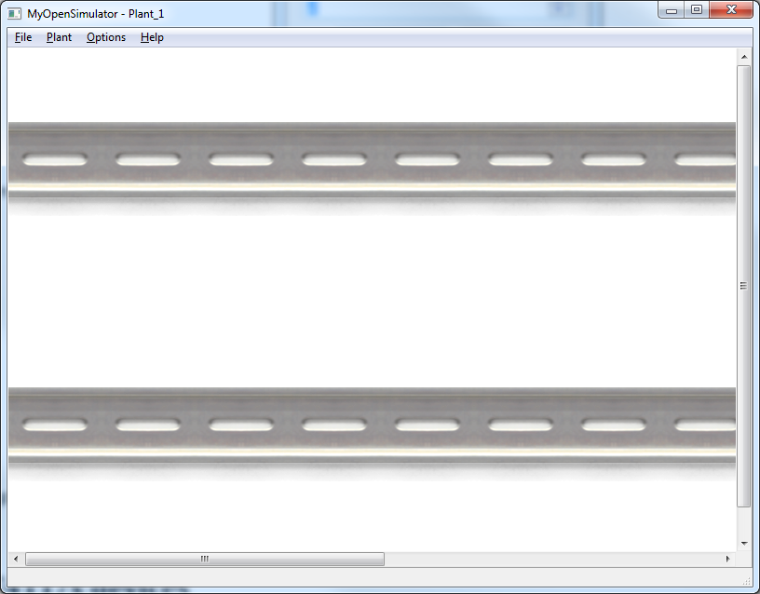
Fig. 11 Empty plant
- In order to add a new device to the plant select device and then add a gateway (F453) or a device (F411/x, CAM).
In a plant only one gateway can be present. If you want to add another gateway you have to remove the one present on plant before proceeding with the new one.

10 F411/x devices
- Add a F411/x device. Open Plant->Create NewDevice and select BTF411_x_DEV, to create a F411/1 or F411/2 or F411/4 device.

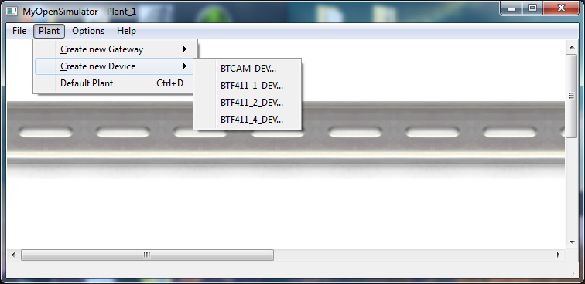
Fig. 12 F411/x creation

- Right click to enter the configuration menu. For F411/X Slot X can be configured. A=environment_ID, PL=lighting_point_ID, group=group_ID mode=PUL/NO_PUL (set device to pool to not respond at generic request, like generale on, generale off, etc.), bus=select bus to connect devices.
One tab for each slot (1 for F411/1, 2 F411/2 and 4 for F411/4). On each tab you are able to config the A, PL and group of the slot.

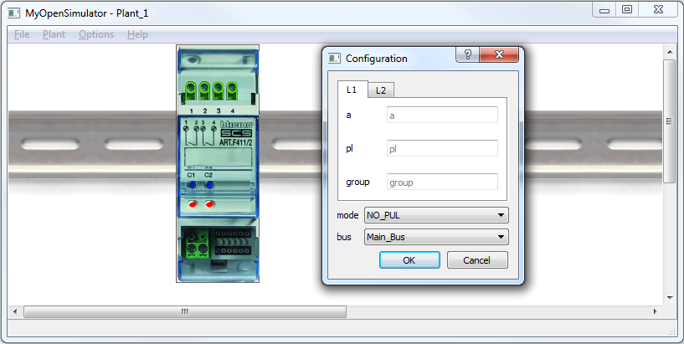
Fig. 13 Configuration panel
- The LED indicator of each slot can assume different colors:
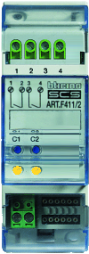  Fig. 14 Yellow led slot configured and status ON | 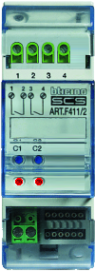  Fig. 15 Red led slot not configured | 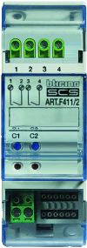  Fig. 16 Black led slot configured and status OFF
RED → BLACK: The slot is configured;
BLACK → YELLOW: Frame open received / Relative slot button has been clicked
YELLOW→ BLACK: Frame open received / Relative slot button has been clicked

- The following table shows management type, as described in “Open Web Net - WHO = 1 - Lightning” document. You can find to the following link http://www.myopen-legrandgroup.com/resources/own_protocol/m/own_documents/35507.aspx

*1*0*<where>##
*1*1*<where>##
*#1*<where>## | Light status request

11 CAMera devices
- Add a Camera device. Open Plant->Create New Device and select BTCAM_DEV, to create a Camera device.

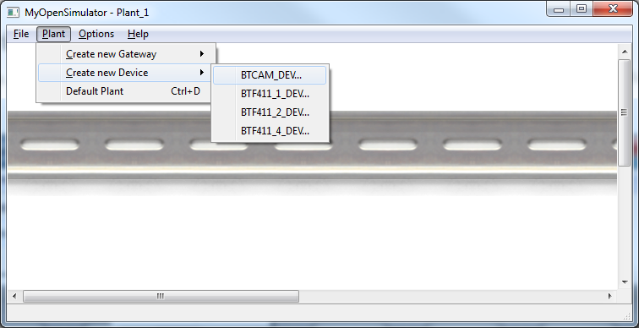
Fig. 17 Cam creation

- Right click to enter the configuration menu. You are able to set the Camera address and folder from which take the picture to show when a HTTP/HTTPS request is done through the gateway. P = camera address, DIR = folder to find camera snapshot.

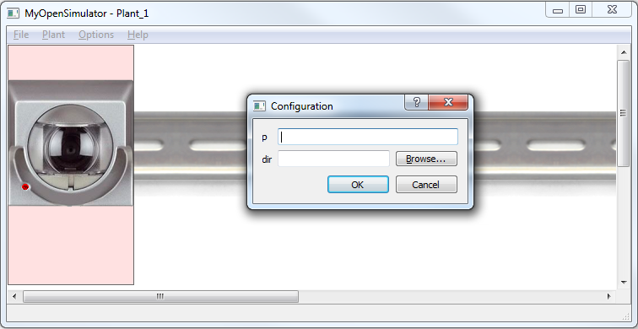
Fig. 18 CAMera configuration panel

- The led can assume different colors:

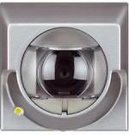  Fig. 19 Yellow led slot configured and status ACTIVE | 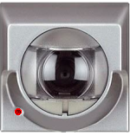  Fig. 20 Red led slot not configured | 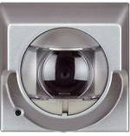  Fig. 21 Black led slot configured and status INACTIVE
RED → BLACK: The device is configured (ID has been set)
BLACK → YELLOW: “Received Video command” frame received (the cam is active and an http/https request to the webserver will be handled from the active webcam)
YELLOW→ BLACK: “Free video channel” frame received / Timeout expired (60s) /Another Cam has been activated.

- The following table shows management type:

*6*0*<where>*## | <where> = 4000 - 4099
*6*9*<where>*## | <where> = 4000 - 4099

12 Gateway
- Add a Gateway device. Open Plant->Create New Gateway and select BTOWNGTW, to create a F454.

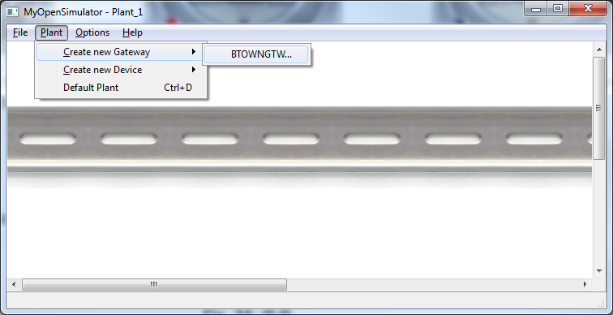
Fig. 22 Gateway creation
- Right click to enter the configuration menu. You are able to set the Gateway password, This password is used to have a higher level of security when requesting the snapshot camera.

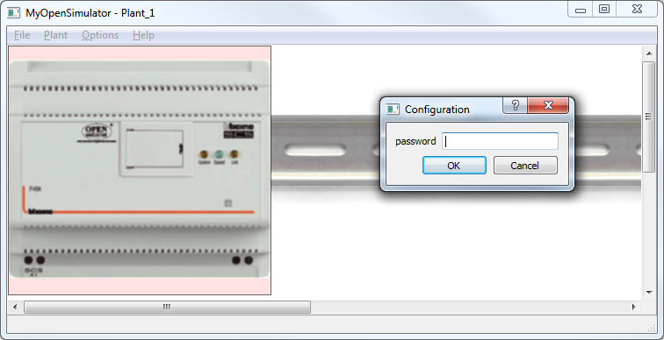
Fig. 23 Gateway configuration panel

13 F422 device
- Add a F422 device. Open Plant->Create NewDevice and select BTF422_DEV, to create an F422 device.
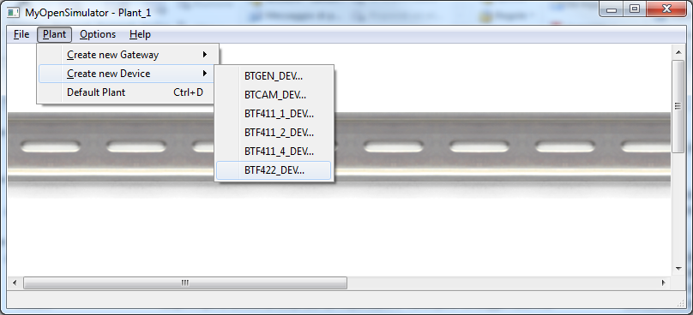
Fig. 24 F422 creation

- Right click to enter the configuration menu. For F422 can be configured. You can set I3 ( from 1 to 9), I4 (from 1 to 9) and that correspond to secondary BUS address. When F422 is configured, you can find in Plant_1 e new BUS call Bus_<I3><I4>.

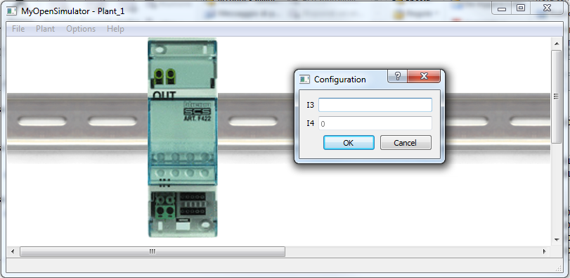
Fig. 25 F422 configuration panel

14 Generic devices
- Add a Generic device. Open Plant->Create NewDevice and select BTFGEN_DEV, to create a Generic device.

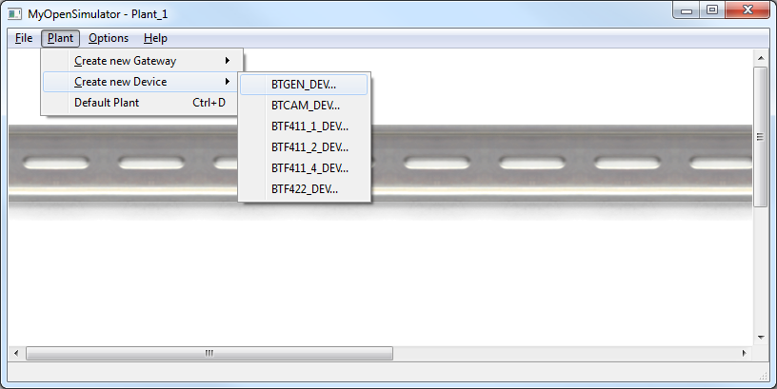
Fig. 26 Generic device creation
- Right click to enter the configuration menu. You are able to set Generic device xml source file and bus to connect that.

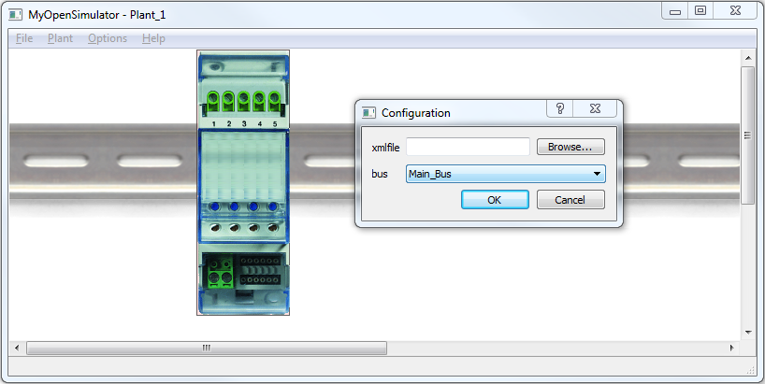
Fig. 27 Generic device configuration panel
- Xml structure

<?xml version="1.0" encoding="utf-8"?>
<xs:schema attributeFormDefault="unqualified" elementFormDefault="qualified" xmlns:xs="http://www.w3.org/2001/XMLSchema">
<xs:element name="SimulatorScenarios">
<xs:complexType>
<xs:sequence>
<xs:element maxOccurs="unbounded" name="Scenario">
<xs:complexType>
<xs:sequence>
<xs:element name="Trigger">
<xs:complexType>
<xs:sequence>
<xs:element name="Message">
<xs:complexType>
<xs:attribute name="chan" type="xs:string" use="required" />
<xs:attribute name="delay" type="xs:unsignedByte" use="required" />
<xs:attribute name="value" type="xs:string" use="required" />
<xs:attribute name="descr" type="xs:string" use="required" />
</xs:complexType>
</xs:element>
</xs:sequence>
</xs:complexType>
</xs:element>
<xs:element name="Actions">
<xs:complexType>
<xs:sequence>
<xs:element maxOccurs="unbounded" name="Action">
<xs:complexType mixed="true">
<xs:sequence>
<xs:element maxOccurs="unbounded" name="Message">
<xs:complexType>
<xs:attribute name="chan" type="xs:string" use="required" />
<xs:attribute name="delay" type="xs:unsignedByte" use="required" />
<xs:attribute name="value" type="xs:string" use="required" />
<xs:attribute name="descr" type="xs:string" use="required" />
</xs:complexType>
</xs:element>
</xs:sequence>
<xs:attribute name="from" type="xs:unsignedByte" use="optional" />
<xs:attribute name="repeat" type="xs:unsignedByte" use="optional" />
</xs:complexType>
</xs:element>
</xs:sequence>
</xs:complexType>
</xs:element>
</xs:sequence>
<xs:attribute name="descr" type="xs:string" use="required" />
</xs:complexType>
</xs:element>
</xs:sequence>
</xs:complexType>
</xs:element>
</xs:schema>

- Generic message xml example:

<?xml version="1.0" encoding="utf-8"?>
<SimulatorScenarios>
<Scenario descr="LIGHT ON">
<Trigger>
<Message chan="CMD" delay="0" value="*1*1*11##" descr="LIGHT ON"/>
</Trigger>
<Actions>
<Action>
<Message chan="GUI" delay="0" value="L1:1" descr="LIGHT ON"/> <!-- SWITCH ON LED 1 -->
<Message chan="CMD" delay="0" value="*1*1*11##" descr="LIGHT ON"/>
<Message chan="CMD" delay="0" value="*#*1##" descr="LIGHT ON"/>
<Message chan="MON" delay="0" value="*1*1*11##" descr="LIGHT ON" />
</Action>
</Actions>
</Scenario>
<Scenario descr="LIGHT OFF">
<Trigger>
<Message chan="CMD" delay="0" value="*1*0*11##" descr="LIGHT OFF"/>
</Trigger>
<Actions>
<Action>
<Message chan="GUI" delay="0" value="L1:0" descr="LIGHT OFF"/> <!-- SWITCH OFF LED 1 -->
<Message chan="CMD" delay="0" value="*1*0*11##" descr="LIGHT OFF"/>
<Message chan="CMD" delay="0" value="*#*1##" descr="LIGHT OFF"/>
<Message chan="MON" delay="0" value="*1*0*11##" descr="LIGHT OFF" />
</Action>
</Actions>
</Scenario>

.
.
.
.

<Scenario descr="LIGHT BLINKING">
<Trigger>
<Message chan="CMD" delay="0" value="*1*X*11##" descr="LIGHT BLINKING"/> <!-- x is a value chose by user -->
</Trigger>
<Actions>
<Action repeate="10" from="1"> <!--This action is repeat for 10 times -->
<Message chan="GUI" delay="0" value="L1:1" descr="LIGHT ON"/> <!-- ACCENDO LED 1 -->
<Message chan="CMD" delay="0" value="*#*1##" descr="LIGHT ON"/>
<Message chan="MON" delay="0" value="*1*1*11##" descr="LIGHT ON" />

<Message chan="GUI" delay="0" value="L1:0" descr="LIGHT OFF"/> <!-- SPENGO LED 1 -->
<Message chan="MON" delay="0" value="*1*0*11##" descr="LIGHT OFF" />
</Action>
</Actions>
</Scenario>
</SimulatorScenarios>

La struttura è di questo formato:
- SimulatorScenarios – this TAG contain all xml structure
  - No attributes
- Scenario - SimulatorScenarios may be contain infinite scenario TAGs. This TAG represent actions can be carried out qhen a triggered message is detect.
  - Descr – Sceanrio descripion
- Trigger – The message "Trigger" is the element that triggers the scenario. Can be a message that arrives from the gateway, or a pressing a button on the GUI. The buttons on the GUI are 4, named as L1, L2, L3, L4. When you press the buttone, the GUI sends the message with the name of the button pressed, then "L1", "L2", "L3", "L4".
  - No attributes
- Actions – is the tag that contains all the actions that must be performed in the "scenario"
  - No attributes
- Action – in this tag are contained all the messages to send. Can be played only once, or it can be sent in a loop, indicating by starting index and the number of times that must be carried out
  - From – starting index of any loop
  - Repeat – numbers of loops
- Message – contains the action to be performed
  - Chan – he channel on which the message must to be sent (MON – Monitor, GUI - graphical user interface, CMD - commands). If the trigger comes from pressing the button, the channel must be monitor or GUI.
  - Delay – indicates, the time in milliseconds, that will elapse before sending the next message
  - Value – indicates the message to be sent. In the message may be contained some Regular Expressions:
    - [X..Y] – is replaced with a random value between X and Y.
    - [index] – is replaced with the current value of the loop index.
  - Descr – action description

F520 device
- Add a F520 device. Open Plant->Create NewDevice and select BTF520_DEV, to create an F520 device.

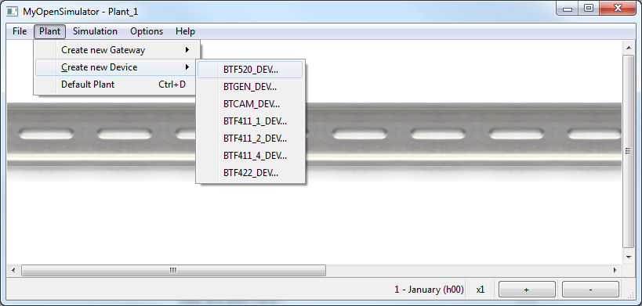
Fig. 28 F520 creation pannel
- Right click to enter the configuration menu. For F520 can be configured. You can set device address, this address id divided in 2 part, the first is a constant ( 5 ), the second is ranging between 1 and 255. You can chose where to save F520 resources file using Browser button on second line. Energy max Value indicate the max energy value in an hour, it is express in Watt per hour.

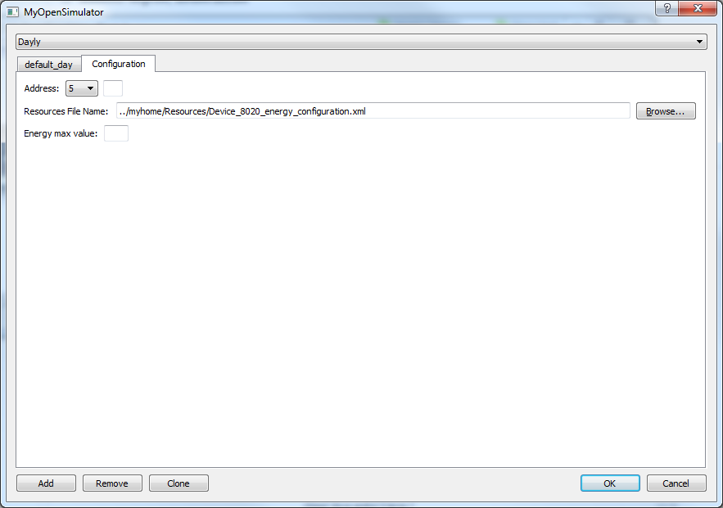
Fig. 29 F520 configuration panel

- In the configuration menu you can simulate the consumption made ​​on a specific day of the year, split over 24 hours, or the consumptions in a specific month of the year, split over 31 days. In the months with less than 31, the user will be put to zero the values ​​of the excess days. In this case, the VDK however always returns zero as the value for the non-existent days.
For example, you can click on “Add”, into daily tab view, to add the 1st January, figure n. 30, the user can’t create 2 times the same day, the error “Daily is already save” will be show. The user can be clone the selected day by clicking on “Clone” button, also in this case duplicate day can’t be allowed. The user can remove specific day by clicking on “Remove” button, “default_day” and “Configuration” tab can’t be remove and error message “Can’n remove default TAB” will be show.
The second example show how to create a specific month, figure n. 32, to create a new simulation month the user must be select “Monthly” on combo box menu.
The user can, in the same way, simulate days and months of the previous year, show in figure n.34.

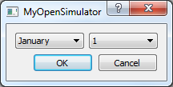

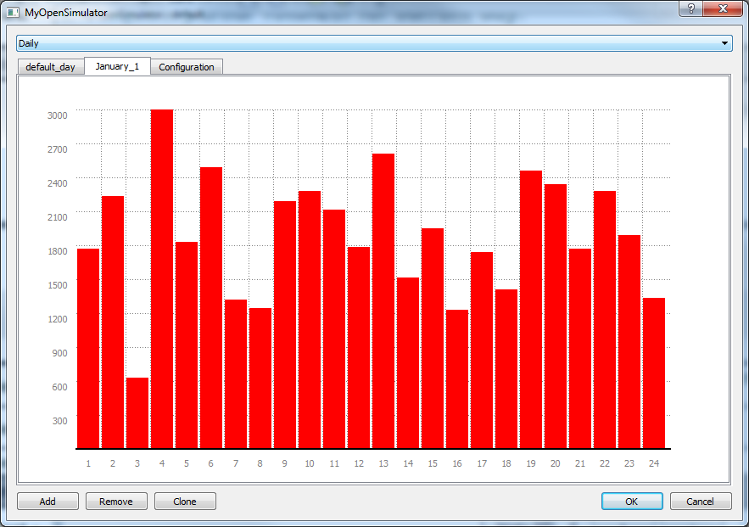
Fig. 30 daily configuration, in this case is rappresent the configuration of 1st january
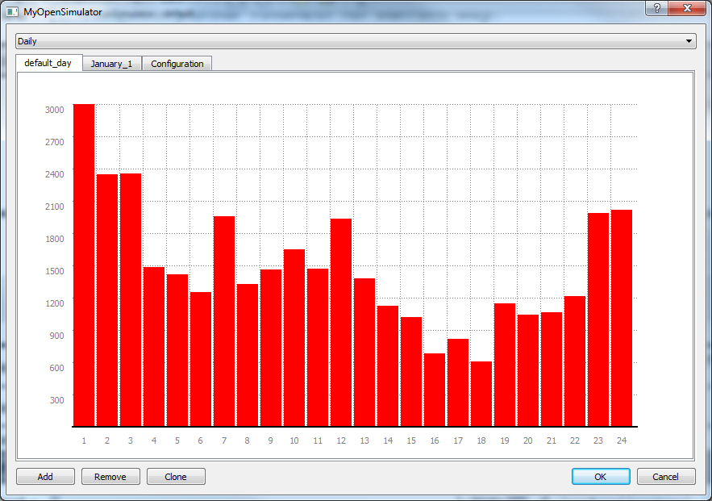
Fig. 31 Daily Configuration, in this case is rappresent the defualt day configuration
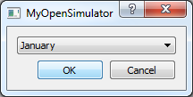

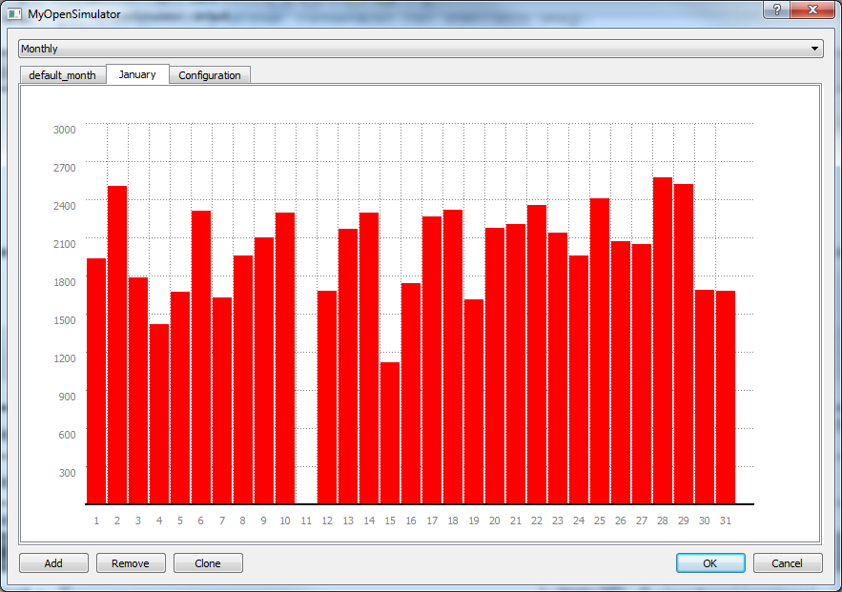
Fig. 32 Monthly configuration, in this case is rappresent the configuartion of january
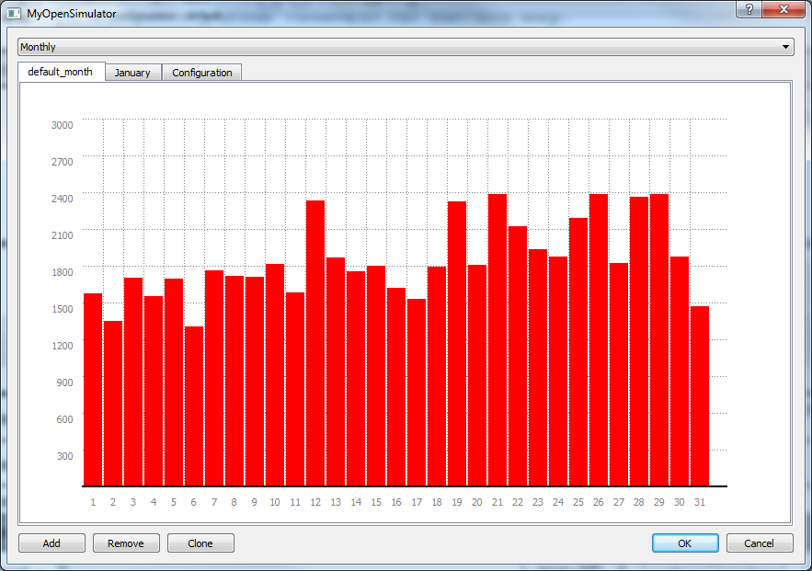
Fig. 33 Daily Configuration, in this case is rappresent the defualt day configuration

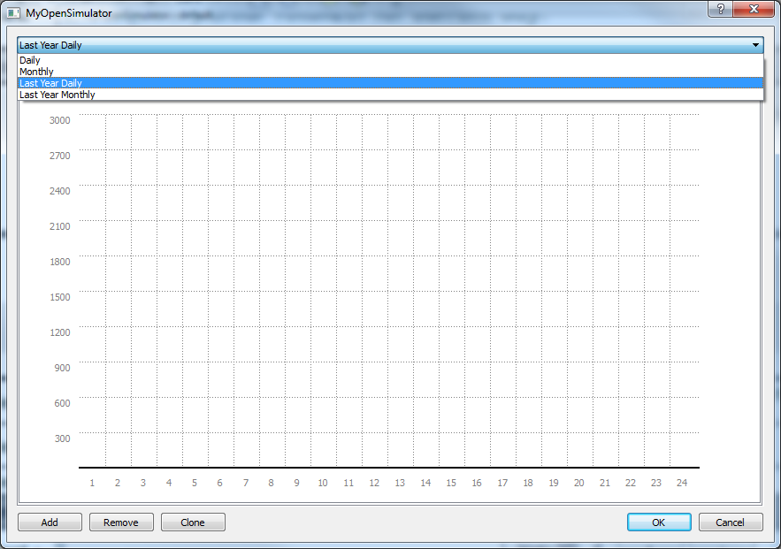
Fig. 34 You can set the value assumed in the past year
- From the Simulation menu -> Energy simulation it is possible to start, stop or pause the simulation of energy. When energy simulation is stared, the system begins to load the values ​​from the 1st January, if the day / month is specified, then the simulator loads the values ​​of the specific graphic, but if the day / month is not specified, the simulator loads the values ​​from the graph of day / month of default. .
When the simulation is stopped, the date is reset and when the simulation is restart date start from 1st January.
When the simulation is paused, the date is not reset and when the simulation is restart date start from the last value.
The user can speed up or slow down the simulation using the + and - buttons in the lower right.

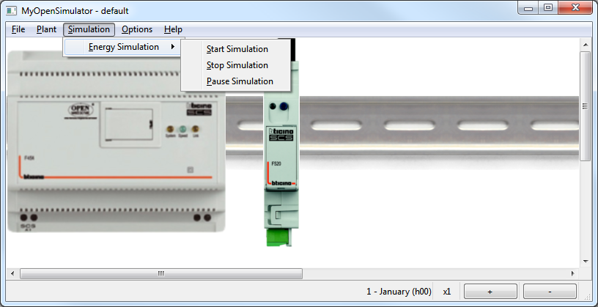
Fig. 35 Simulation control panel

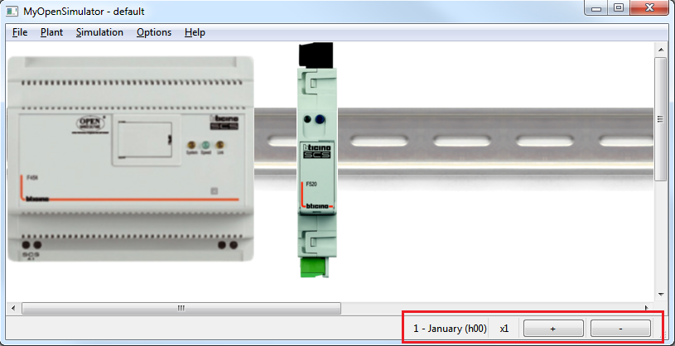
Fig. 36 Simulation control manager

- The following table shows management type, as described in “Open Web Net - WHO = 18 - Energy Management Functions” document. You can find to the following link http://www.myopen-legrandgroup.com/resources/own_protocol/m/own_documents/36029.aspx

*18*57#<M>#<D>*<where>## | <M> month  <D> day  <Where> 5N with N = 1 - 255
*18*58#<M>*<where>## | <M> month  <Where> 5N with N = 1 - 255
*18*59#<M>*<where>## | <M> month  <Where> 5N with N = 1 - 255
*18*510#<M>*<where>## | <M> month  <Where> 5N with N = 1 - 255
*#18*<Where>*#1200#<Type>*<Time>## | <Time>: Indicates after how many minutes  it sends the consumption if it changes.  Values from 1 to 255  <Type>: 1 = active power  <Where> 5N with N = 1 - 255
*#18*<where>*#1200#<Type>*0## | <Type>: 1 = active power  <Where> 5N with N = 1 - 255
*#18*<Where>*511#<M>#<D>## | <M> month  <D> day  <Where> 5N with N = 1 - 255
*#18*<Where>*113## | <Where> 5N with N = 1 - 255
*#18*<where>*51## | <Where> 5N with N = 1 - 255
*#18*<where>*52#<Y>#<M>## | <Y> Year in yy format  <M> Month  <Where> 5N with N = 1 - 255
*#18*<where>*53## | <Where> 5N with N = 1 - 255
*#18*<where>*54## | <Where> 5N with N = 1 - 255

15 License
By using and/or copying this document, you (the licensee) agree that you have read, understood, and will comply with the following terms and conditions:
Permission to copy, and distribute the contents of this document, in any medium for any purpose and without fee or royalty is hereby granted, provided that you include the following on ALL copies of the document, or portions thereof, that you use:
A link or URL to the www.myopen-legrandgroup.com.
The copyright notice of the original author, or if it doesn't exist, a notice (hypertext is preferred, but a textual representation is permitted) of the form: "Copyright © [date-of-document] www.myopen-legrandgroup.com. All Rights Reserved".
When space permits, inclusion of the full text of this NOTICE should be provided. We request that authorship attribution be provided in any software, documents, or other items or products that you create pursuant to the implementation of the contents of this document, or any portion thereof.
Any contributions to the document (i.e. translation, modifications, improvements, etc) has to be submitted to and accepted by the My Open staff (using the forum of the community or sending an email via the www.myopen-legrandgroup.com dedicated section) . Once the improvement has been accepted the new release will be published in the My Open Community web site.
.
Disclaimers
THIS DOCUMENT IS PROVIDED "AS IS," AND COPYRIGHT HOLDERS MAKE NO REPRESENTATIONS OR WARRANTIES, EXPRESS OR IMPLIED, INCLUDING, BUT NOT LIMITED TO, WARRANTIES OF MERCHANTABILITY, FITNESS FOR A PARTICULAR PURPOSE, NON-INFRINGEMENT, OR TITLE; THAT THE CONTENTS OF THE DOCUMENT ARE SUITABLE FOR ANY PURPOSE; NOR THAT THE IMPLEMENTATION OF SUCH CONTENTS WILL NOT INFRINGE ANY THIRD PARTY PATENTS, COPYRIGHTS, TRADEMARKS OR OTHER RIGHTS.
COPYRIGHT HOLDERS WILL NOT BE LIABLE FOR ANY DIRECT, INDIRECT, SPECIAL OR CONSEQUENTIAL DAMAGES ARISING OUT OF ANY USE OF THE DOCUMENT OR THE PERFORMANCE OR IMPLEMENTATION OF THE CONTENTS THEREOF.
The name and trademarks of copyright holders may NOT be used in advertising or publicity pertaining to this document or its contents without specific, written prior permission. Title to copyright in this document will at all times remain with copyright holders.

