SE 491I  
Web-Based Collaboration Forum Use Case

Taghreed Bagies

February 10, 2012

|  |  |
| --- | --- |
| ***UC: 001*** | |
| ***Use Case Name*:** | Create new thread |
| ***Type:*** | Primary |
| ***Description:*** | Create a new post to share ideas |
| ***Actors:*** | Instructor, Students, Customers |
| ***Trigger*:** | N/A |
| ***Goals:*** | To share ideas among students, instructor, and customer |
| ***Preconditions*:** | 1. The user is logged on the system |
| ***Incoming information*:** | User’s information |
| ***Results*:** | The entered data is saved |
| ***Postconditions*:** | A new post is in the system |

***Primary Event Flow***

1. This use case begins when a user selects ‘create a thread’ from ‘Forum’ page.
2. The system displays a form with blank entries and buttons.
3. The user fills out the form.
4. The system gets user’s information from session or cookie.
5. The system saves the entered data and user’s information into a record.
6. This use case ends when the system displays ‘Done’ for the user.

|  |  |
| --- | --- |
| ***UC: 002*** | |
| ***Use Case Name*:** | Reply to thread |
| ***Type:*** | Primary |
| ***Description:*** | Reply to an existing thread in order to share information and knowledge |
| ***Actors:*** | Instructor, students, customer |
| ***Trigger*:** | N/A |
| ***Goals:*** | User would like to answer or give some information about a posted idea |
| ***Preconditions*:** | 1. The user is logged on the system |
| ***Incoming information*:** | User’s information |
| ***Results*:** | The new post is saved |
| ***Postconditions*:** | The post is in the system |

***Primary Event Flow***

1. This use case begins when the user selects ‘reply’ from ‘Forum’ page.
2. The system displays a form with blank entries and buttons.
3. The user fills the form.
4. The system gets user’s information from session or cookie
5. The system saved the new entered data and user’s information into a record
6. This use case ends when the system displays ‘Done’.

|  |  |
| --- | --- |
| ***UC: 003*** | |
| ***Use Case Name*:** | List threads |
| ***Type:*** | Primary |
| ***Description:*** | Displays all posted threads by subject |
| ***Actors:*** | Visitor, Artifact Tracking Subsystem, Memberships and Member Services |
| ***Trigger*:** | N/A |
| ***Goals:*** | To know another exhibit location |
| ***Preconditions*:** | The visitor has a tour plan, interest profile, or previous exhibit. The system knows type of visitor |
| ***Incoming information*:** | Memberships and Member Services |
| ***Results*:** | Map for the direction of an exhibit’s location |
| ***Postconditions*:** | The visitor arrives at a new location |

***Primary Event Flow***

1. This use case begins when a visitor selects ‘next stop’ option on the screen.
2. The system requests from Artifact Tracking Subsystem information about interesting exhibit
3. The Artifact Tracking Subsystem provides the system the information
4. The system displays a map to direct the visitor to the interesting exhibit location
5. This use case ends when the visitor selects ‘arrived’.

|  |  |
| --- | --- |
| ***UC: 004*** | |
| ***Use Case Name*:** | Track visitor usage |
| ***Type:*** | Primary |
| ***Description:*** | Track each feature of the exhibit information program used by the visitor. |
| ***Actors:*** | Memberships and Member Services, Artifact Tracking Subsystem |
| ***Trigger*:** | The visitor moves from one place to another |
| ***Goals:*** | To know the interesting exhibits for the visitor |
| ***Preconditions*:** | The visitor has selected ‘exit’ from ‘show exhibit information’  The system knows the visitor’s information  The system knows the visited exhibit |
| ***Incoming information*:** | Memberships and Member Services, Artifact Tracking Subsystem |
| ***Results*:** | N/A |
| ***Postconditions*:** | the visitor interest profile is updated |

***Primary Event Flow***

1. This use case begins when a visitor selects ‘exit’ option from ‘show exhibit information’.
2. The system provides information to Memberships and Member Services to update the visitor interest profile
3. This use case ends when the visitor interest profile is updated.

|  |  |
| --- | --- |
| ***UC: 005*** | |
| ***Use Case Name*:** | Browse list of exhibits |
| ***Type:*** | Primary |
| ***Description:*** | Display a list of exhibits for a visitor |
| ***Actors:*** | Visitor, Artifact Tracking Subsystem, Memberships and Member Services |
| ***Trigger*:** | N/A |
| ***Goals:*** | Visitor wishes to know what the other exhibits |
| ***Preconditions*:** | 1. The system knows the visitor interest profile 2. The visitor has selected ‘exhibits’ option. |
| ***Incoming information*:** | Memberships and Member Services |
| ***Results*:** | List of names for exhibits is shown |
| ***Postconditions*:** | The information are not changed |

***Primary Event Flow***

1. This use case begins when a visitor selects ‘browse list’ option from ‘exhibits’ menu.
2. The system uses the visitor interest profile to determine the interesting exhibit
3. The system requests from the Artifact Tracking Subsystem a list of exhibits similar to the interesting exhibit
4. Artifact Tracking Subsystem provides the system a list of exhibits similar to the interesting exhibit
5. The system displays the list of exhibits for the visitor.
6. This use case ends when the visitor selects ‘exit’ from the displayed screen.

|  |  |
| --- | --- |
| ***UC: 006*** | |
| ***Use Case Name*:** | Add a tour plan |
| ***Type:*** | Primary |
| ***Description:*** | Custom a tour for visitor based on their interesting exhibits |
| ***Actors:*** | Visitor, Artifact Tracking Subsystem, Memberships and Member Services |
| ***Trigger*:** | N/A |
| ***Goals:*** | Visitor wished to view exhibits of special interest |
| ***Preconditions*:** | The system knows the visitor interest profile |
| ***Incoming information*:** | Memberships and Member Services |
| ***Results*:** | Map of direction guiding the visitor |
| ***Postconditions*:** | The tour plan is in the system |

***Primary Event Flow***

1. This use case begins when the visitor selects ‘Add a tour’ option from ‘main’ menu.
2. The system requests from Artifact Tracking Subsystem list of interesting exhibits
3. The visitor selects from the list some exhibits.
4. This use case ends when the visitor selects ‘save’ from the screen.

***Ranking Use Cases***

|  |  |  |
| --- | --- | --- |
| ***Rank*** | ***Use Case*** | ***Justification*** |
| High | Show exhibit information | Scored on most increased ranking criteria |
| Configure exhibit information program | Scored on most increased ranking criteria |
| Medium | Suggest another location | Need a technology (RFID) |
| Add a tour plan | increases benefits (less tour guide) |
| Browse list of exhibits | increases benefits (satisfied visitor) |
| Track visitor usage | Affects management the museum |

***Use Case diagram***

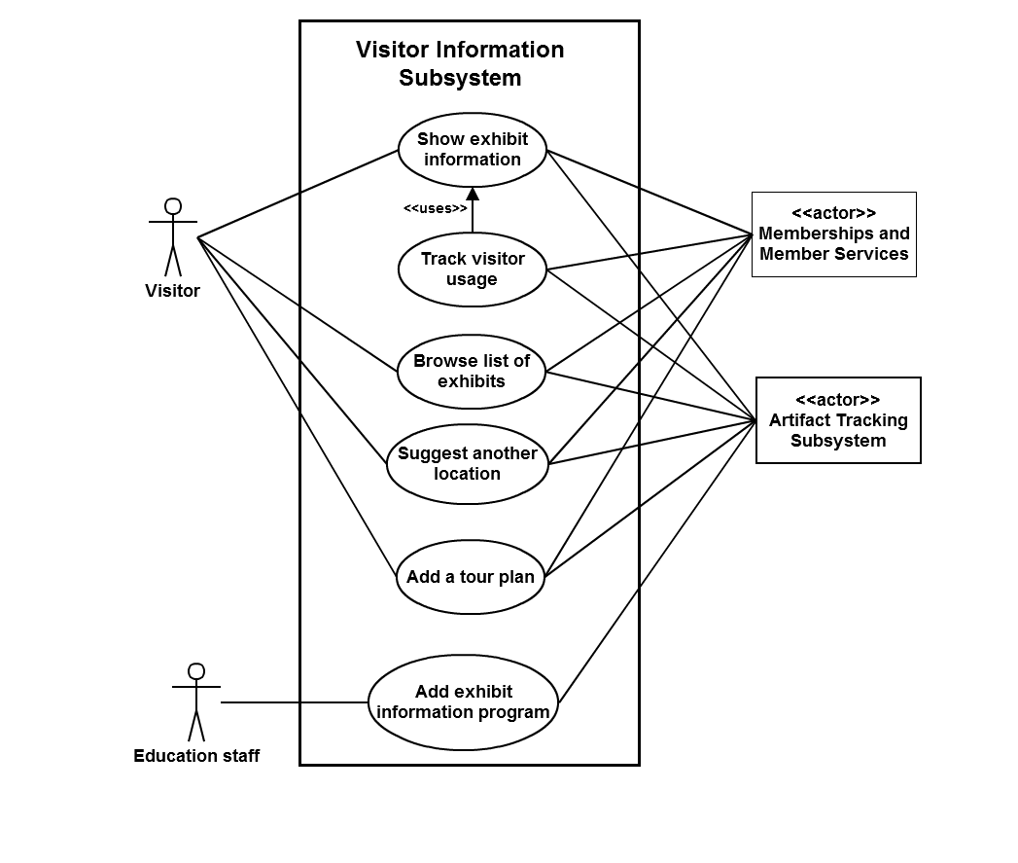

|  |  |
| --- | --- |
| **UC:** 001 | |
| **Use Case Name:** Show exhibit information | |
| **Type:** Primary | |
| **Description:** Display information about an exhibit or artifact whose name is entered by the visitor. | |
| **Actors:** primary: visitor, supporting: Artifact Tracking Subsystem, off-stage: Memberships and Member Services | |
| **Trigger:** The visitor visits a place for a pacific exhibit or artifact | |
| **Purpose or Goal:** the visitor wishes to know the information about exhibit or artifact | |
| **Cross References:** Functional Requirement | |
| **Prioritization:** it is highly required. It has technology risks because of displaying format, and might need some application for represents information such as pictures | |
| **Priority:** High | |
| **Risk:** High | |
| **Preconditions:** The museum visitor knows the name of the artifact or exhibit  The museum visitor has selected ‘exhibits’ option. | |
| **Incoming information:** Artifact Tracking Subsystem | |
| **Results:** Information about the exhibit and artifact is presented on the screen | |
| **Postconditions:** The museum visitor knows the information about the artifact | |
| **Invariants:** the information about the exhibit and artifacts are not changed | |
| **Typical Course of Events** | |
| **Actor Actions:** | **System Response:** |
| 1) This Use case starts when the visitor selects ‘show exhibit information’ from ‘exhibits’ menu on Virtual Tour Guide. |  |
|  | 2) The system displays a blank entry form for the exhibit’s name. |
| 3) The visitor enters the exhibit’s name. |  |
| 4) The visitor selects ‘Continue’ to end name entry. |  |
|  | 5) The system requests the visitor to confirm that the name of exhibit is written properly. |
| 6) The visitor confirms the name of exhibit is written properly. |  |
|  | 7) The system requests from Artifact Tracking Subsystem information about the exhibit’s whose name has been entered by the visitor. |
| 8) The Artifact Tracking Subsystem provides the system with information of the exhibit in the museum that has name similar to that entered by the visitor. |  |
|  | 9) The system displays the information of the exhibit. |
| 10) This use case ends when the visitors selects ‘exit’ from the displayed information. |  |
| **Alternate Course of Events** | |
|  | 7a) Invalid exhibit’s name (not found in the system): |
|  | 1. The system informs the visitor that the exhibit’s name is wrong |
|  | 1. Repeat steps 2-7 |
|  |  |
| **Special requirements:** some applications such as a movie player are used to present the information | |
| **Open issues:** What are details of Artifact Tracking Subsystem?  What are the keys on Virtual Tour Guide? | |

***Sequence Diagram***

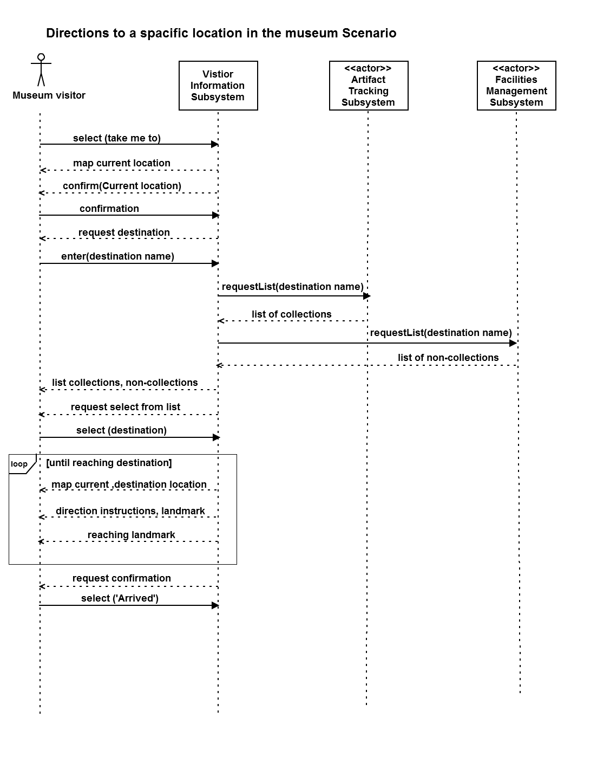

# **Glossary**

*Exhibit information program*: Presentation of information about a particular exhibit, its artifacts, and its context within the Museum. The exhibit information program will be further tailored to the interests of the individual visitor.

*System configurator*: VIS staff responsible for configuring exhibit information and programs. *Aka* content author,

*Virtual Tour Guide*: a hand held device to present VIS programs and information to the visitor

*Member*: paid, regular visitor. Member of the Museum at any of the membership levels.

*Non-member*: One-time or infrequent visitor to Museum.

*Scholar*: learned visitor performing research. Needs detailed information on artifacts.

*Docent*: a tour guide or speaker. Leads tours and provides detailed information on exhibits.

*Artifact*: part of the collection

*Exhibit*: a group of artifacts that are organized around a common theme.

*RFID*: a technology that allows radio interrogation of passive devices from a distance.

*System*: Visitor Information System

*Main menu:* has the essential options in the system.

*Menu:* has different links for a particular request.

*Current location:* the visitor stands on it

*Destination location:* the indented location to move forward it

*Next stop:* the next location that the visitor can move to it

*Displayed screen:* the active screen that the visitor works on it

*Displayed information:* the information that is presented on the screen and the visitor reads it

*Interesting exhibit:* the exhibit that the visitor would like to know about. It is the visitor interest profile, tour plan, or previous exhibit.

*The visitor interest profile:* has all interesting exhibit for the visitor

*List of names for exhibits:* links for exhibits’ names

*Type of visitor:* includes member, non-member and scholar

*Visitor’s information*: such as interest profile, name, type of visitor

*Visited exhibit:* when the visitor selects ‘show exhibit information’, the exhibit is considered as being visited