**Article**

An article is a word that follows a noun, giving some basic information about that noun, such as whether it is plural or singular, or whether it is a general or specific object. The articles in English are: a, an, some and the.

The articles are the words that go with nouns. In English, the definite articles, the, and the indefinite articles, a and an, are used.

**Definite articles**

These articles in English are 'the' and we can use them with singular or plural nouns. So we use 'the' when:

We have already identified the noun we are referring to in a previous sentence.

When there is only one of these things (e.g. 'the station' - there is only one in the town).

For certain expressions, especially related to physical things like 'the weather', 'the sea', 'the environment'.

Always use the articles before:

Names of rivers, seas and oceans such as; the Atlantic Ocean, the Black Sea, and the Missouri River.

Deserts, gulfs, forests or peninsulas such as; the Amazon, the Sahara Desert, and the Gulf of Mexico.

Jobs such as; an engineer, a doctor, or a lawyer.

An article is not used:

Before a proper name such as; Queen Elizabeth, Steve Jobs, or John Smith.

The names of most countries such as; Italy, Brazil, or Saudi Arabia.

Sports such as; basketball, football, or soccer.

Languages such as; English, Spanish, or Portuguese.

Academic subjects such as; Mathematics, English, or Literature.

Cumple en inglés la función de el, la, los y las, lo que implica que acompaña sustantivos femeninos, masculinos y neutros, sin hacer diferencia si están en singular o plural. Por ejemplo:

• The boy is in the park.

El niño está en el parque.

• The boys are in the park.

Los niños están en el parque.

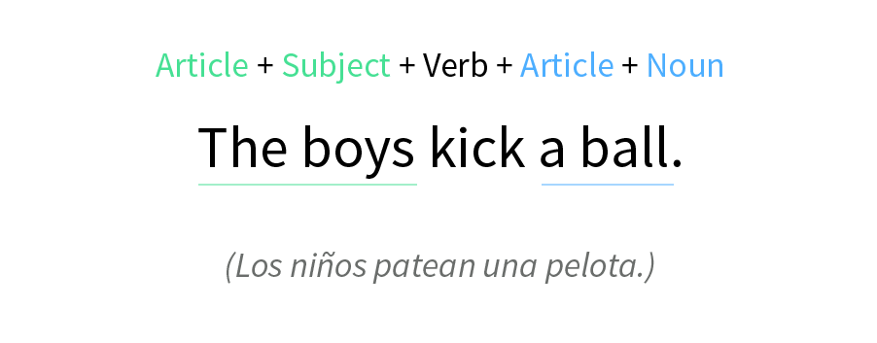Se le llama artículo definido porque al acompañar un sustantivo nos habla específicamente de uno o unos en particular. Es decir, puede haber muchos niños, pero al agregar the, nos indica uno o unos en especial, que probablemente ya conocemos, por lo cual los podemos diferenciar del resto.

These are some examples:

You can't go to the post office now. It is closed.

Can you turn on the television?

The shopping bags are still in the car. I'll get them.

Where's the bottle opener?

The pupils are waiting for class to start.

The washing machine is broken. We have to buy another one.

The presentation is ready for your review, Mrs. Harper.

What is the weather like in your country?