# Performance Testing roles in Software Testing, Approach, Use Case, and Automated Testing

|  |  |
| --- | --- |
|  | Huynh  Computer Sciences Dept  Purdue University Fort Wayne  Fort Wayne, USA  [huyntl02@pfw.edu](mailto:huyntl02@pfw.edu) |

***Abstract*—An Introduction to Performance Testing. An approach to performance testing is discussed. A case study using Locust IO to perform performance testing on a blog website is presented (***Abstract***)**

***Keywords—Software performance testing, performance testing, software testing, locust IO, automated testing (****keywords****)***

# I. INTRODUCTION

## A. Performance Testing Definition

Performance testing is a testing technique, performed to determine the responsiveness and stability of a software system under the various workload. Performance testing metrics are scalability, reliability, resource usage. There are four primary types of performance testing: Load Testing, Stress Testing, Soak Testing, and Spike Testing. Performance testing is non-functional testing [3].

## B. System Performance Degradation

According to [1], system performance degradation or problems handling required system throughput is an extremely significant issue for many large industrial projects. Although the software system has undergone extensive functionality testing, it was never tested to assess its expected performance [1].

During an architecture review at AT&T, a group of engineers has found that “performance issues account for one of the three major fault categories. Performance problems identified might include such things as the lack of performance estimates, the failure to have proposed plans for data collection or the lack of a performance budget”. They also claimed that insufficient planning for performance issues is the major issue when deploying software to the field [1].

Major issues are issues that will impact user satisfaction.

## C. Uneven Distribution of Resource Usage

Pareto-type distribution is also known as a very uneven distribution of resource usage. The main reason for system performance degradation is claimed distribution of project-affecting issues (Pareto-type distribution). According to [1], it was found that 70 percent of the most severe class of problems resided in the weakest 30 percent of the project.

# II. PREVIOUS WORK

According to [1], The author doesn’t find any adequate performance testing knowledge on the Internet. He found out that “there is neither an existing body of research literature nor an extensive collection of practical or experiential information available to help testers faced with the prospect of doing software performance testing”.

# III. PERFORMANCE TESTING TOOLS

## A. Locust IO

Locust is an easy-to-use, scriptable and scalable performance testing tool. Instead of being constrained by a UI or domain-specific language, Locust is infinitely expandable and very developer-friendly due to its codebase tools. Locust IO is required Python programming knowledge, and it is easy to use and develop test cases.

* **Write user test scenarios in Python code:** If the tester wants the users to loop, perform some conditional behavior or do some calculations. Locust runs every user inside its greenlet (a lightweight process/coroutine) which enables the tester to write your tests like normal Python code (instead of using callbacks or other methods). The tester can use any Python IDE, and version control tester’s test script as regular code (as opposed to some other tools that use XML or binary formats).
* **Distributed & Scalable - supports hundreds of thousands of users:** Locust makes it easy to run load tests distributed over multiple machines. It is event-based which makes it possible for a single process to handle many thousands of concurrent users.
* **Locust Features:** Running in Docker, distributed load generation, running test in a debugger, running Locust distributed with Terraform/AWS, running Locus automation, retrieved test statistics in CSV format, testing non-HTTP systems, testing request base SDKs, increase performance with a faster HTTP client, event hooks, logging, using locust as a library.

## C. Expertus

Retrieved from [4], Expertus is designed to automate large-scale distributed experiment studies in IaaS clouds to address three challenges:

* **Experiment challenges:** Performance testing for enterprise applications consists of multiple closely related scenarios by varying a few configurable (preferably one) parameters at a time.
* **Application challenges:** In distributed software testing the applications should start efficiently and in the provably correct order by simultaneously enforcing serialization constraints and leveraging the distributed system’s inherent parallelism.
* **Cloud challenges:** Selecting the most appropriate cloud from many cloud offerings is a non-trivial task. Also, migrating an application between two clouds is a complex, time-consuming, and error-prone task. Finally, communication, coordination, synchronization, monitoring, and complete management challenges; lastly, the dynamic nature of the cloud introduces extra complexity.

# IV. USE CASE: TESTING WEBSITE (BLOG) USING LOCUST IO

In this experiment, I will also perform performance tests (automated tests) on working websites that were designed by Dr. Angela Yu, and implemented by myself.

## A. Requirement Analyst

The application name is Blog-Template, and it was designed using Flask Framework, and Jinja Template (Python). It’s also using PostgreSQL for the database. The database schema is used primarily to store blog content and user information. This website is fully functional and extendable. Code review was conducted by Truc Huynh. Technologies that are implemented in the application: Flask framework, Jinja template, Object-Oriented Programming, SQL Alchemy, Password Hashing (werkzeug. security), Bootstrap, CK Editor (user input), HTML, CSS, JavaScript…

Blog-Template was originally designed by Dr. Angela Yu and implemented by Truc Huynh. Application is a blog template that allows registered users to edit or comment on a post. Only the admin can create, edit or delete posts. The application was hosted at heroku.com, and the hyperlink is “<https://template-blog.herokuapp.com/>”.

|  |
| --- |
| from flask import Flask, render_template, redirect, url_for, flash, abort  from flask_bootstrap import Bootstrap  from flask_ckeditor import CKEditor  from datetime import date  from functools import wraps  from werkzeug.security import generate_password_hash, check_password_hash  from flask_sqlalchemy import SQLAlchemy  from sqlalchemy.orm import relationship  from flask_login import UserMixin, login_user, LoginManager, login_required, current_user, logout_user  from forms import LoginForm, RegisterForm, CreatePostForm, CommentForm  from flask_gravatar import Gravatar  import os  app = Flask(__name__) app.config['SECRET_KEY'] = os.environ.get("SECRET_KEY") ckeditor = CKEditor(app) Bootstrap(app) gravatar = Gravatar(app, size=100, rating='g', default='retro', force_default=False, force_lower=False, use_ssl=False, base_url=None)  ##CONNECT TO DB app.config['SQLALCHEMY_DATABASE_URI'] = os.environ.get("DATABASE_URL", "sqlite:///blog.db") app.config['SQLALCHEMY_TRACK_MODIFICATIONS'] = False db = SQLAlchemy(app) login_manager = LoginManager() login_manager.init_app(app)  @login_manager.user_loader def load_user(user_id):  return User.query.get(int(user_id))  Fig 1. Python Package of Blog-Template |

The Blog-Template was designed as a template on GitHub by Truc Huynh (“<https://github.com/jackyhuynh/blog-template>”). Anyone can use the blog for any purpose. The first user will be automatically set as the admin

## B. Structure of Backend

**main.py** is the python script containing all components required to run the application (Blog Template). The “main.py” consists of all required packages and the route for the front-end. The front-end was built with HTML, CSS, and Bootstrap, and stored in the templates folder (about.html, contact.html, footer.html, header.html, index.html, login.html, make-post.html, post.html, register.html).

The static folder contains all the .css files, images, javascript. The package (folders containing main.py and all the necessary files) is then pushed through GitHub and deployed to Heroku from GitHub. Therefore, every time I make a change, the application will automatically change. I also schedule automatic testings (mostly functional testing and GUI testing) for the app every time I make a change (just to make sure nothing will break when I make a new commit). PyCharm IDE was used to develop this code, but the user can use any IDE to navigate the code.

## B. Test Plan Design

After analyzing Blog-Template Source Code and requirements, I design my test plan. My plan is simple to increase the number of users over time and stop at 3 million users. I will only perform 3 tasks on the websites: login, visit the contact page and visit post number 1. Even though, Locust IO allows me with much more tests such as creating tasks, editing, or deleting them; creating new users; importing new documentation into user posts… However, I just want to keep my tasks simple for this use case.

I will run an automated test starting at 1000 users at a spawn of 1.00 seconds then I will increase by 1000 for each test case. There are 2 scripts that I need to design: the performance test script and the schedule test script.

|  |
| --- |
| @app.route('/') def get_all_posts():  posts = BlogPost.query.all()  return render_template("index.html", all_posts=posts, current_user=current_user)  @app.route('/register', methods=["GET", "POST"]) def register():  form = RegisterForm()  # ... Code to Register ...  @app.route('/login', methods=["GET", "POST"]) def login():  form = LoginForm()  # ... Code to log in...  @app.route('/logout') def logout():  logout_user()  # ... Code to Logout ...   @app.route("/post/<int:post_id>", methods=["GET", "POST"]) def show_post(post_id):  form = CommentForm()  # ... Code to show post ...  @app.route("/about") def about():  return render_template("about.html", current_user=current_user)  @app.route("/contact") def contact():  return render_template("contact.html", current_user=current_user)  @app.route("/new-post", methods=["GET", "POST"]) @admin_only def add_new_post():  form = CreatePostForm()  # ... Code to add new post ...  @app.route("/edit-post/<int:post_id>", methods=["GET", "POST"]) @admin_only def edit_post(post_id):  post = BlogPost.query.get(post_id)  # ... Code to edit the post ...  @app.route("/delete/<int:post_id>") @admin_only def delete_post(post_id):  post_to_delete = BlogPost.query.get(post_id)  # ... Code to delete the post ...  if __name__ == "__main__":  app.run(debug=True)  Fig 2. Python route structure of Blog-Template |

## C. Test Suite Implementation

**Plan:** Run the test script (or use another script to schedule the test script). The schedule script should be able to increase the number of users after each successful test. The process is described below.

**Test Script:** Set the wait time for each user from 1 to 300 seconds so that each user will be able to navigate and read 1 post or do some comments. Task number 1 is to navigate to the contact page (and stay there for 40 seconds). After 50 seconds navigate to post 1. PyCharm IDE is used to run the code. This is the content of the test script (locust_test.py)

**Execute:** Run this script within the Terminal of PyCharm IDE: “locust -f locust_test.py”. Then go to “<http://localhost:8089/>” for monitoring.

**Automation Testing:** For automation testing without the WEB UI, run this script instead: “locust -f locust_test.py -u 1000 -r 100 --run-time 1h30m --stop-timeout 99.” To schedule a full test suite, we need to write another Python script that increments the users as our test plan and simply schedules it. Depend on the application report on peak time (e.g. 2 million people operate at the same time). The tester can simply set the user to that peak, and schedule the performance test when they have a change in the system (or just for regular maintainable).

Call this: “python3 schedule-script.py”. Schedule script (schedule-script.py) can be used to scan and detect code changes, then run a performance test if needed.

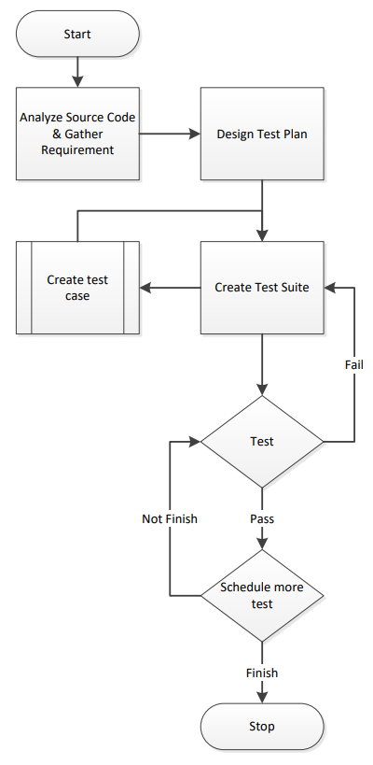

Fig 3. Tets Suite Design Process

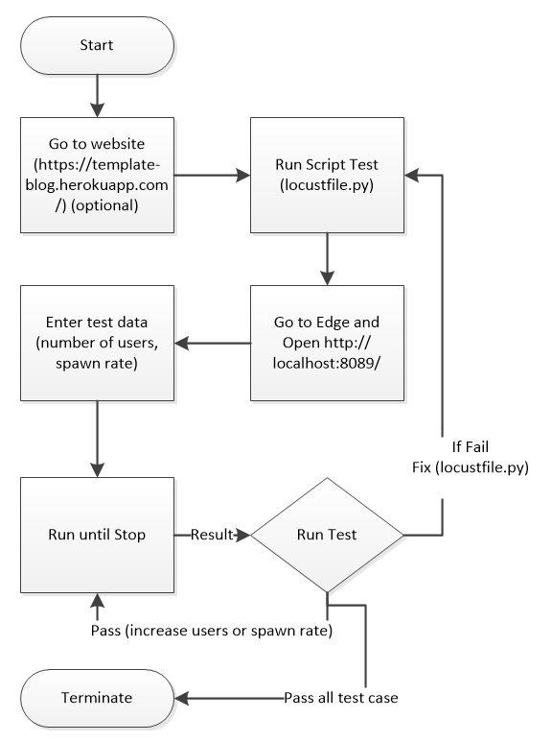

Fig 5. Tets Suite Implementation Process

from locust import HttpUser, task, between  
  
  
class TestCases(HttpUser):  
 host = "https://template-blog.herokuapp.com/"  
 # Set the wait time for each user from 1 to 300 seconds  
 # So that each user will be able to navigate and read 1 post or do some comment  
 wait_time = between(1, 300)  
   
 # When a user in login the user  
 def on_start(self):  
 self.client.post("/login", json={"Email": "jackyhuynh87@gmail.com", "Password":"1234"})  
  
 # task number 1 is to navigate to the contact page (and stay there for 40 seconds)  
 @task(10)  
 def visit_contact(self):  
 self.client.get("/contact")  
  
 # after 50 seconds navigate to post 1  
 @task(50)  
 def visit_post_1(self):  
 self. client.get("/post/1")

Fig 4. Locust Performance Test Script for Blog Template (locust_test.py)

## C. Result

**Plan:** Run the test script (or use another script to schedule the test script). The schedule script should be able to increase the number of users after each successful test. The process is described below Result for the first test case 1000 users at 1.00 spawn rate. The result return with a 0% fails rate. Testers can download the PDF, CVS version for

data analysis. Web UI can also be used for monitoring with real-time monitoring and interactive chart.

In my latest test, Template-Blog was able to handle 20,000 users at a 0.5 spawn rate.

**Test Result** This is printed within my IDE (Py Charm).

# V. ADVANTAGES AND DISADVANTAGES OF LOCUST

## A. Advantages:

Verifies the speed, accuracy, and stability of the software match expectation. Assists the system by authenticating the responsiveness and managing the scalability and reliability of software features. It is free and open source.

## B. Disadvantages:

Locust can be a costly mistake if done haphazardly, leading to inaccurate results and conclusions. Need Python programming knowledge to perform the test (must be very familiar with Python to design complicated test cases).

REFERENCES

1. E. J. Weyuker and F. I. Vokolos, “Experience with performance testing of software systems: issues, an approach, and case study,” in IEEE Transactions on Software Engineering, vol. 26, no. 12, pp. 1147-1156, Dec. 2000, DOI: 10.1109/32.888628. *(references)*
2. Kumar. K., “Write your first performance/load test in Python.”, Retrieved from <https://medium.com/@kundan3034/write-your-first-performance-load-test-in-python-e8e2132ef775>.
3. Tutorial Points (n.d.), “Performance Testing”, Retrieved from <https://www.tutorialspoint.com/software_testing_dictionary/performance_testing.htm>.
4. D. Jayasinghe et al., “Expertus: A Generator Approach to Automate Performance Testing in IaaS Clouds,” 2012 IEEE Fifth International Conference on Cloud Computing, 2012, pp. 115-122, DOI: 10.1109/CLOUD.2012.98.K.
5. Bystron. C., Heyman. J., Hamren J., Heyman. H. and Holmberg. L., Locust, Retrieved from <https://github.com/locustio/locust>.
6. Y. Yorozu, M. Hirano, K. Oka, and Y. Tagawa, “Electron spectroscopy studies on magneto-optical media and plastic substrate interface,” IEEE Transl. J. Magn. Japan, vol. 2, pp. 740–741, August 1987 [Digests 9th Annual Conf. Magnetics Japan, p. 301, 1982].

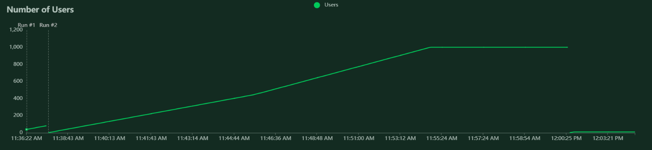

Fig 7. Number of User Chart. This is the WEB UI chart (1000 users at 1.00 spawn rate)

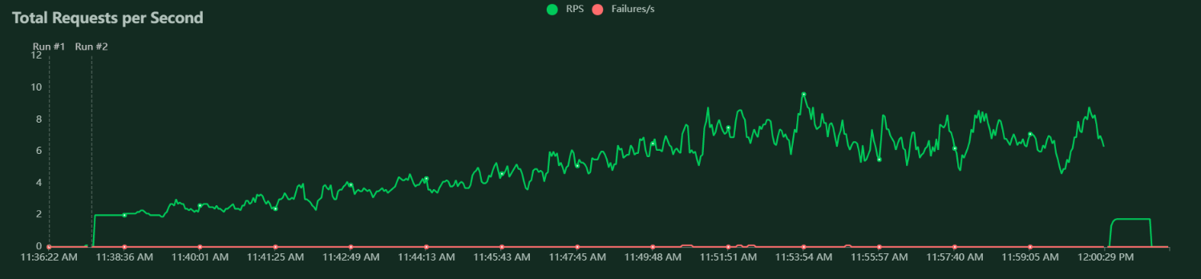

Fig 9. Total Request per second. This is the WEB UI chart (1000 users at 1.00 spawn rate)

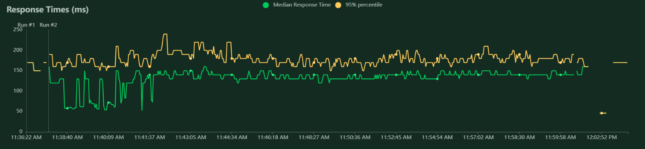

Fig 8. Number of Response Time. This is the WEB UI chart (1000 users at 1.00 spawn rate)

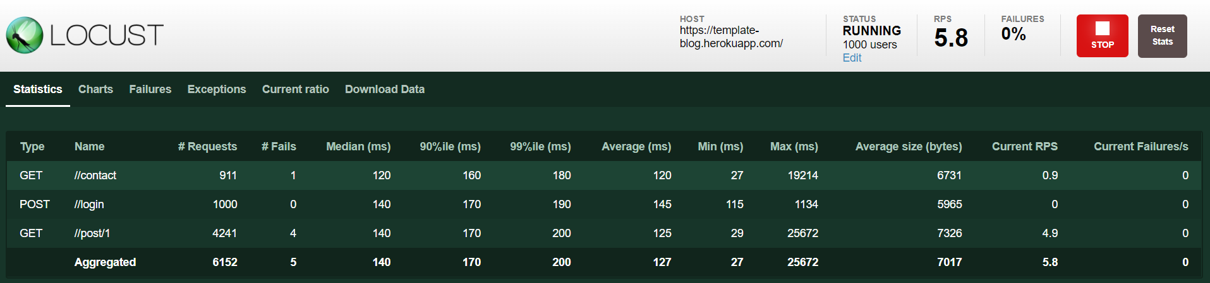

Fig 7. Locus Web UI

2022-03-10T17:00:41Z  
[2022-03-10 12:00:41,483] DESKTOP-J4K30PB/INFO/locust.main: Shutting down (exit code 1)  
 Name # reqs # fails | Avg Min Max Median | req/s failures/s  
----------------------------------------------------------------------------------------------------------------------------------------------------------------  
 GET //contact 1095 1(0.09%) | 120 27 19214 130 | 0.81 0.00  
 POST //login 1000 0(0.00%) | 144 114 1134 140 | 0.74 0.00  
 GET //post/1 5162 4(0.08%) | 125 28 25672 140 | 3.83 0.00  
----------------------------------------------------------------------------------------------------------------------------------------------------------------  
----------------------------------------------------------------------------------------------------------------------------------------------------------------  
 2 GET //post/1: ConnectionResetError(10054, 'An existing connection was forcibly closed by the remote host', None, 10054, None)  
 2 GET //post/1: RemoteDisconnected('Remote end closed connection without response')  
 1 GET //contact: ConnectionResetError(10054, 'An existing connection was forcibly closed by the remote host', None, 10054, None)  
----------------------------------------------------------------------------------------------------------------------------------------------------------------  
 Name # reqs # fails | Avg Min Max Median | req/s failures/s  
----------------------------------------------------------------------------------------------------------------------------------------------------------------  
 GET //contact 1 0(0.00%) | 42 42 42 42 | 0.01 0.00  
 POST //login 10 0(0.00%) | 162 137 181 160 | 0.05 0.00  
 GET //post/1 18 0(0.00%) | 106 40 194 66 | 0.09 0.00  
----------------------------------------------------------------------------------------------------------------------------------------------------------------  
 Aggregated 29 0(0.00%) | 123 40 194 150 | 0.15 0.00  
  
Response time percentiles (approximated)  
 Type Name 50% 66% 75% 80% 90% 95% 98% 99% 99.9% 99.99% 100% # reqs  
--------|--------------------------------------------------------------------------------|---------|------|------|------|------|------|------|------|------|------|------|------|  
 GET //contact 42 42 42 42 42 42 42 42 42 42 42 1  
 POST //login 170 170 170 170 180 180 180 180 180 180 180 10  
 GET //post/1 69 170 170 170 180 190 190 190 190 190 190 18  
--------|--------------------------------------------------------------------------------|---------|------|------|------|------|------|------|------|------|------|------|------|  
 None Aggregated 150 170 170 170 180 180 190 190 190 190 190 29

Fig 6. Test Result is printed within Py Charm IDE