# COAT Functional Design

1. COAT Functional Design 1

1.1. Modules: 2

1.2. Page Template 2

1.1.1. Home 2

1.1.2. Login 3

1.1.3. Left Bar (For sub module) 3

1.1.4. Grid (Search) 4

1.1.5. Edit (Validate) 4

1.3. Site Levels 5

1.4. Validate Work Flow 6

1.5. Input and Output Data Structure 7

1.1.1. Input Data Structure 7

1.1.2. Output Data Structure 8

1.6. Modules and Functions 10

1.6.1. Module: User 10

1.6.2. Module: ORP Deal Approval 13

1.6.3. Module: Data Management 22

1.6.4. Module: Other Managements 28

1.6.5. Module: Admin 29

## Modules:

|  |  |
| --- | --- |
| **Name** | **Description** |
| User | User Login/ Reset Password |
| ORP Deal Approval | Manage Deal Record Approval Work Flow |
| Data Management | Search, Import and Export Deal Data, Account Name List … |
| Other Management | Contract files and repayment show |
| Admin | Change site settings and manage account |

## Page Template

### Home

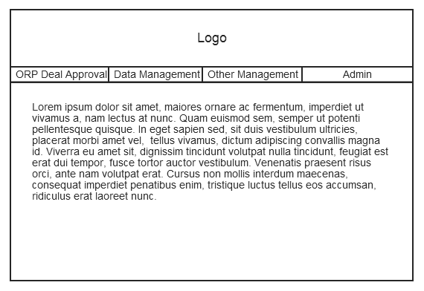

### Login

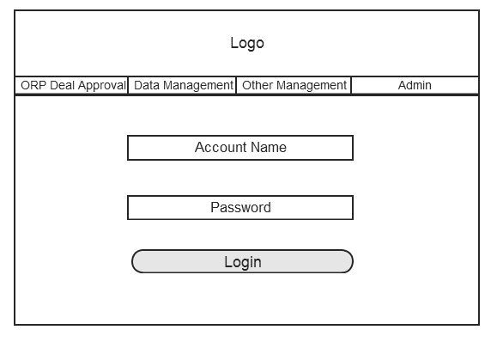

### Left Bar (For sub module)

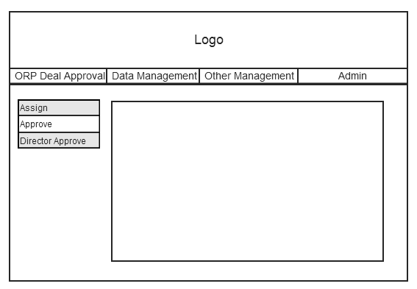

### Grid (Search)

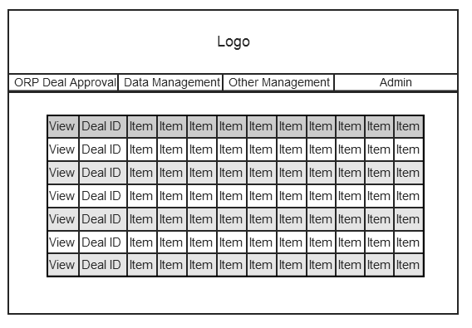

### Edit (Validate)

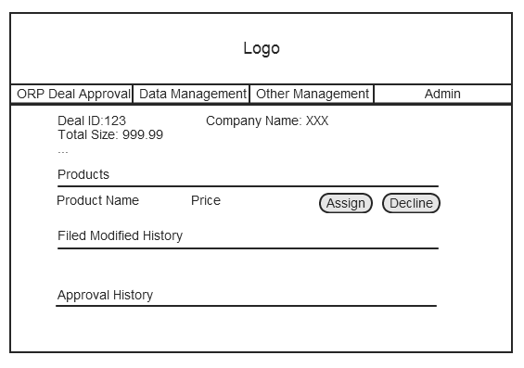

## Site Levels

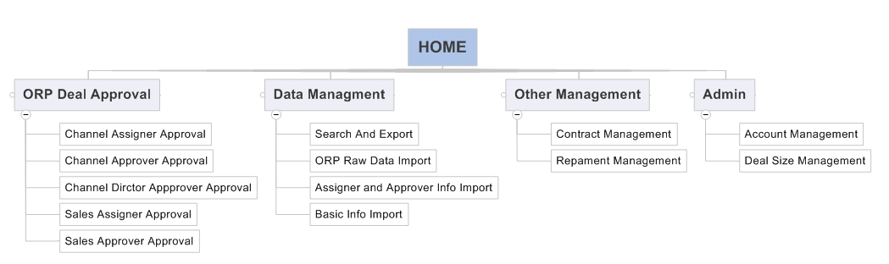

## Validate Work Flow



## Input and Output Data Structure

### Input Data Structure

|  |  |  |
| --- | --- | --- |
| **Field Name** | **Type** | **Memo** |
| PAM |  |  |
| COMM |  |  |
| TAM |  |  |
| Created Date |  |  |
| Deal ID |  |  |
| Opportunity Name |  |  |
| Registration Status |  |  |
| End User Company |  |  |
| End User Company (English) |  |  |
| End User Company Street |  |  |
| End User Company City |  |  |
| End User Company State/Province |  |  |
| Industry |  |  |
| Product Name |  |  |
| Registration Status |  |  |
| Quantity/Term |  |  |
| Total Price Currency |  |  |
| Total Price |  |  |
| Total Price (converted) Currency |  |  |
| Total Price (converted) |  |  |
| Partner Account |  |  |
| Opportunity Owner |  |  |
| Partner Qualification |  |  |
| Distinct |  |  |
| Opp Reg Promotion |  |  |
| Opp Reg Promotion Order ID |  |  |

### Output Data Structure

|  |  |  |
| --- | --- | --- |
| **Filed Name** | **Type** | **Memo** |
| Deal ID |  |  |
| End User Company |  |  |
| End User Company (EN) |  |  |
| Country |  |  |
| Province |  |  |
| Industry -1 (Raw Data) |  |  |
| Industry-2 (Assign by Sammy/Emily) |  |  |
| Province (Assigned by Sammy/Emily) |  |  |
| Opportunity Project Name |  |  |
| Partner Name |  |  |
| Partner Type |  |  |
| Opportunity Owner (Partner Contact) |  |  |
| Contact Information |  |  |
| Product Name |  |  |
| Total Price (USD) |  |  |
| Solution ORP Deal Size |  |  |
| ORP Type |  |  |
| Sales Operation / ISO Admin |  |  |
| Emily & Sammy/Winnie Action Date |  |  |
| Insides Sales / Channel Manager |  |  |
| CAM/ISO Action Date |  |  |
| Channel Director |  |  |
| Channel Director Action Date |  |  |
| Deal Validation Result |  |  |
| Contract Received |  |  |
| Rebate Payment Approval |  |  |

## Modules and Functions

### Module: User

#### Function: User Login

|  |  |  |  |
| --- | --- | --- | --- |
| **Is Background** | No | **Background Type** | NA |
| **UI Type** | Page | **Relative URL** | \User\Login |
| **Description** | | | |
| User should login to the website to do work. User should provide “User Name” and “Password”.  If user login for the first time, user should use the password sent by COAT mail.  After first login, user should reset their password before other process. | | | |

#### Function: User Log off

|  |  |  |  |
| --- | --- | --- | --- |
| **Is Background** | No | **Background Type** | NA |
| **UI Type** | Widget | **Relative URL** | \User\Logoff |
| **Description** | | | |
| User should logoff COAT after their work.  If a user is logoff, all data on the web page b will be forbidden to put to server.  User can login again to put that data to server. | | | |

#### Function: Show Login Info

|  |  |  |  |
| --- | --- | --- | --- |
| **Is Background** | No | **Background Type** | NA |
| **UI Type** | Widget | **Relative URL** | NA |
| **Description** | | | |
| Show user login name and date time on every page | | | |

#### Function: User reset password

|  |  |  |  |
| --- | --- | --- | --- |
| **Is Background** | NO | **Background Type** | NA |
| **UI Type** | Page | **Relative URL** | \User\ResetPwd |
| **Description** | | | |
| User can reset their password after login.  User should provide their current password.  User should type their new password twice. | | | |

#### Function: User find password back

|  |  |  |  |
| --- | --- | --- | --- |
| **Is Background** | NO | **Background Type** | NA |
| **UI Type** | Page | **Relative URL** | \User\ForgetPwd |
| **Description** | | | |
| This just a notification page.  When user see this page, a mail include new password is sent by COAT. | | | |

#### Function: Password reset on the first load

|  |  |  |  |
| --- | --- | --- | --- |
| **Is Background** | NO | **Background Type** | NA |
| **UI Type** | Page | **Relative URL** | \User\FstLogin |
| **Description** | | | |
| This page will be show when user login, after user’s password reset by COAT.  This page will be hiding after user login successfully. | | | |

#### Function: View User Basic Info

|  |  |  |  |
| --- | --- | --- | --- |
| **Is Background** | NO | **Background Type** | NA |
| **UI Type** | Page | **Relative URL** | \User\View |
| **Description** | | | |
| This page will show “User Name” “User Email” and “Role Info”  If user role is “Inside Sales” should show “Industry” “Location” | | | |

#### Function: Change User Basic Info

|  |  |  |  |
| --- | --- | --- | --- |
| **Is Background** | NO | **Background Type** | NA |
| **UI Type** | Page | **Relative URL** | \User\Edit |
| **Description** | | | |
| Use can change their “User Name” “User Email” on this page | | | |

### Module: ORP Deal Approval

#### Sub Module: COAT System Auto Approval

##### Function: Assign to Next

|  |  |  |  |
| --- | --- | --- | --- |
| **Is Background** | Yes | **Background Type** | Synchronize |
| **UI Type** | NA | **Relative URL** | NA |
| **Description** | | | |
| If deal size (sum Total Price) is <= 15K and the ORP Type of all productions it include is SMB/Data Protection with BE/ Enterprise Security/Encryption, deal will be assigned to Sales Assigner.  Other deal will be assigned to Channel Assigner | | | |

##### Function: Send notification by mail

|  |  |  |  |
| --- | --- | --- | --- |
| **Is Background** | YES | **Background Type** | Synchronize |
| **UI Type** | NA | **Relative URL** | NA |
| **Description** | | | |
| Send a notification via email. | | | |

#### Sub Module: Channel Assigner Approval

##### Function: List pending approval records

|  |  |  |  |
| --- | --- | --- | --- |
| **Is Background** | NO | **Background Type** | NA |
| **UI Type** | Page | **Relative URL** | \SO\List |
| **Description** | | | |
| List all pending approval records on the page.  Each page show 20 records | | | |

##### Function: Approve and decline records

|  |  |  |  |
| --- | --- | --- | --- |
| **Is Background** | NO | **Background Type** | NO |
| **UI Type** | Page | **Relative URL** | \SO\Edit |
| **Description** | | | |
| Approve: Should make a selection on “China Region, and make a selection on Channel Approver (Channel Manager).  Decline: Record marked as Complete Decline. Must add a comment | | | |

##### Function: Assign to Next

|  |  |  |  |
| --- | --- | --- | --- |
| **Is Background** | YES | **Background Type** | Synchronize |
| **UI Type** | NA | **Relative URL** | NA |
| **Description** | | | |
| This process will be triggered by approve action.  Move to Selected Channel Approver | | | |

##### Function: Send notification by mail

|  |  |  |  |
| --- | --- | --- | --- |
| **Is Background** | YES | **Background Type** | Synchronize |
| **UI Type** | NA | **Relative URL** | NA |
| **Description** | | | |
| Send a notification via email.  TO: Channel Approver | | | |

#### Sub Module: Sales Assigner Approval

##### Function: List pending approval records

|  |  |  |  |
| --- | --- | --- | --- |
| **Is Background** | NO | **Background Type** | NA |
| **UI Type** | Page | **Relative URL** | \ISOA\List |
| **Description** | | | |
| List all pending approval records on the page.  Each page show 20 records | | | |

##### Function: Approve and decline records

|  |  |  |  |
| --- | --- | --- | --- |
| **Is Background** | NO | **Background Type** | NA |
| **UI Type** | Page | **Relative URL** | \ISOA\Edit |
| **Description** | | | |
| Approve: Should make a selection on “China Region, and make a selection on Sales Approver (Inside Sales).  Decline: Record marked as Complete Decline. Must add a comment | | | |

##### Function: Assign to Next

|  |  |  |  |
| --- | --- | --- | --- |
| **Is Background** | YES | **Background Type** | Synchronize |
| **UI Type** | NA | **Relative URL** | NA |
| **Description** | | | |
| This process will be triggered by approve action.  Move to Sales Approver | | | |

##### Function: Send notification by mail

|  |  |  |  |
| --- | --- | --- | --- |
| **Is Background** | YES | **Background Type** | Synchronize |
| **UI Type** | NA | **Relative URL** | NA |
| **Description** | | | |
| Send a notification via email.  TO: Sales Approver | | | |

#### Sub Module: Channel Approver Approval

##### Function: List pending approval records

|  |  |  |  |
| --- | --- | --- | --- |
| **Is Background** | NO | **Background Type** | NA |
| **UI Type** | Page | **Relative URL** | \CM\List |
| **Description** | | | |
| List all pending approval records on the page.  Each page show 20 records | | | |

##### Function: Approve, decline and assigned wrong records

|  |  |  |  |
| --- | --- | --- | --- |
| **Is Background** | NO | **Background Type** | NA |
| **UI Type** | Page | **Relative URL** | \CM\Edit |
| **Description** | | | |
| Approve: Should make a selection on “Account Sales” and make a selection on “Industry”. If Deal size >=40K, must add a comment  Decline: Record marked as Complete Decline. Must add a comment  Assigned Wrong: Back to last step | | | |

##### Function: Assign to Next

|  |  |  |  |
| --- | --- | --- | --- |
| **Is Background** | YES | **Background Type** | Synchronize |
| **UI Type** | NA | **Relative URL** | NA |
| **Description** | | | |
| If deal size is >=40K should assign to Channel Director Approver and deal size set to “Escalate to Channel Director”.  Else move Record marked as Complete Approved | | | |

##### Function: Send notification by mail

|  |  |  |  |
| --- | --- | --- | --- |
| **Is Background** | YES | **Background Type** | Synchronize |
| **UI Type** | NA | **Relative URL** | NA |
| **Description** | | | |
| Send a notification via email.  TO: Named Account Sales  CC: Sales Leader  If ORP Size > 40K, mail content need the remark: need **Channel Director** to Approve  TO: Channel Director  CC: Sales Leader, Named Account Sales | | | |

#### Sub Module: Sales Approver Approval

##### Function: List pending approval records

|  |  |  |  |
| --- | --- | --- | --- |
| **Is Background** | NO | **Background Type** | NA |
| **UI Type** | Page | **Relative URL** | \ISA\List |
| **Description** | | | |
| List all pending approval records on the page.  Each page show 20 records | | | |

##### Function: Approve, decline and assigned wrong records

|  |  |  |  |
| --- | --- | --- | --- |
| **Is Background** | NO | **Background Type** | NA |
| **UI Type** | Page | **Relative URL** | \ISA\Edit |
| **Description** | | | |
| Approve: Should make a selection on “Volume Sales” and make a selection on “Industry”.  Decline: Record marked as Complete Decline. Must add a comment  Assigned Wrong: Back to last step | | | |

##### Function: Send notification by mail

|  |  |  |  |
| --- | --- | --- | --- |
| **Is Background** | YES | **Background Type** | Synchronize |
| **UI Type** | NA | **Relative URL** | NA |
| **Description** | | | |
| Send a notification via email.  TO: Volume Sales  CC: Sales Leader | | | |

#### Sub Module: Channel Director Approver Approval

##### Function: List pending approval records

|  |  |  |  |
| --- | --- | --- | --- |
| **Is Background** | NO | **Background Type** | NA |
| **UI Type** | Page | **Relative URL** | \CD\List |
| **Description** | | | |
| List all pending approval records on the page.  Each page show 20 records | | | |

##### Function: Approve, decline and assigned wrong records

|  |  |  |  |
| --- | --- | --- | --- |
| **Is Background** |  | **Background Type** |  |
| **UI Type** |  | **Relative URL** |  |
| **Description** | | | |
| Approve: Record marked as Complete Approved  Decline: Record marked as Complete Decline  Assigned Wrong: Back to last step | | | |

##### Function: Send notification by mail

|  |  |  |  |
| --- | --- | --- | --- |
| **Is Background** | YES | **Background Type** | Synchronize |
| **UI Type** | NA | **Relative URL** | NA |
| **Description** | | | |
| Send a notification via email.  TO: Account Sales  CC: Sales Leader, Channel Approver | | | |

### Module: Data Management

#### Function: Search Records

|  |  |  |  |
| --- | --- | --- | --- |
| **Is Background** | NO | **Background Type** | NA |
| **UI Type** | Page | **Relative URL** | \DMGR\List |
| **Description** | | | |
| Output Data format see “Export data structure”  **Filters**:  **ORP Type**  Solution Specialization ORP  Distribution Specialization ORP  SMB Specialization ORP  All Specialization ORP  **China Region**  China North  China East  China South  China West  **COAT Status**  All  New  On Progress  Completed, Approved  Completed, Declined  Approve  Reject. (Reject means Item 5 showing "Completed, Declined" base the judgment that either Item 2 or 3 with "Reject" or "Not Accept" comments.)  **SFDC Status**  All  Pending Pending Jo Validation  No Status  Approved  Limited Approved  Rejected  Lost  Closed  Expired  Resubmit Pending Jo Validation  Pending Administrative Review  **Deal ID**  **Customer Name**  **Period** | | | |

#### Function: Upload SFDC Excel File to COAT System

|  |  |  |  |
| --- | --- | --- | --- |
| **Is Background** | NO | **Background Type** | NA |
| **UI Type** | Page | **Relative URL** | \DMGR\Upload |
| **Description** | | | |
| Upload Excel file to server and backup | | | |

#### Function: Convert SFDC Data to COAT Data

|  |  |  |  |
| --- | --- | --- | --- |
| **Is Background** | YES | **Background Type** | Synchronize |
| **UI Type** | NA | **Relative URL** | NA |
| **Description** | | | |
| Read Excel File’s Data and import data to DB  1. Deal Identifier: “Deal ID” & “Product Name”  2. Validate: “ORP Type by specialization”, “Deal Size” & “Promotion” are must.  3. Duplicate Deal: Judged by “Customer Name” & “Product Name”  4. Duplicate Deal Actions:  COAT System should only warn Channel Assigner there are duplicated deals. No other action should be taken.  5. Same Deal Actions:  COAT System should update old deal and record which filed is modified.  6. Deal Size: Deal size is a >40K, >15K, <=15K, calculated by programming code | | | |

#### Function: Export Records from COAT by searching

|  |  |  |  |
| --- | --- | --- | --- |
| **Is Background** | NO | **Background Type** | NA |
| **UI Type** | Widget | **Relative URL** | \DMGR\Export |
| **Description** | | | |
| Output Data format see “Export data structure”  The data in excel file is same as search page. | | | |

#### Function: Upload ORP Eligible Product & Specialization Matrix Excel File to COAT System

|  |  |  |  |
| --- | --- | --- | --- |
| **Is Background** | NO | **Background Type** | NA |
| **UI Type** | Page | **Relative URL** | \DMGR\Upload |
| **Description** | | | |
| Upload Excel file to server and backup | | | |

#### Function: Upload Name Account Sales List Excel File to COAT System

|  |  |  |  |
| --- | --- | --- | --- |
| **Is Background** | NO | **Background Type** | NA |
| **UI Type** | Page | **Relative URL** | \DMGR\Upload |
| **Description** | | | |
| Upload Excel file to server and backup | | | |

#### Function: Upload Volume Sales List Name & Email Excel File to COAT System

|  |  |  |  |
| --- | --- | --- | --- |
| **Is Background** | NO | **Background Type** | NA |
| **UI Type** | Page | **Relative URL** | \DMGR\Upload |
| **Description** | | | |
| Upload Excel file to server and backup | | | |

#### Function: Upload Inside Sales Name & Email Excel File to COAT System

|  |  |  |  |
| --- | --- | --- | --- |
| **Is Background** | NO | **Background Type** | NA |
| **UI Type** | Page | **Relative URL** | \DMGR\Upload |
| **Description** | | | |
| Upload Excel file to server and backup | | | |

#### Function: Upload Enterprise Channel Manager Name& Email Excel File to COAT System

|  |  |  |  |
| --- | --- | --- | --- |
| **Is Background** | NO | **Background Type** | NA |
| **UI Type** | Page | **Relative URL** | \DMGR\Upload |
| **Description** | | | |
| Upload Excel file to server and backup | | | |

#### Function: Upload Standard Industry List Excel File to COAT System

|  |  |  |  |
| --- | --- | --- | --- |
| **Is Background** | NO | **Background Type** | NA |
| **UI Type** | Page | **Relative URL** | \DMGR\Upload |
| **Description** | | | |
| Upload Excel file to server and backup | | | |

#### Function: Upload China Region List Excel File to COAT System

|  |  |  |  |
| --- | --- | --- | --- |
| **Is Background** | NO | **Background Type** | NA |
| **UI Type** | Page | **Relative URL** | \DMGR\Upload |
| **Description** | | | |
| Upload Excel file to server and backup | | | |

### Module: Other Management

#### Function: Upload contract to COAT server

|  |  |  |  |
| --- | --- | --- | --- |
| **Is Background** | NO | **Background Type** | Synchronize |
| **UI Type** | Page | **Relative URL** | \Contract\Upload |
| **Description** | | | |
| Upload Contract to Server  1. Channel Approver (Channel Manager) and Sales Approver (Inside Sales) upload contracts to COAT.  2. Contracts can be relative to a deal at any time.  3. Approver can update contracts, but old contracts should be saved in COAT | | | |

#### Function: Attach contract to deal record

|  |  |  |  |
| --- | --- | --- | --- |
| **Is Background** | No | **Background Type** | NA |
| **UI Type** | Page | **Relative URL** | \Contract\Attach |
| **Description** | | | |
| Attach contract info to Deal | | | |

#### Function: Show repayment status of deal record

|  |  |  |  |
| --- | --- | --- | --- |
| **Is Background** | NO | **Background Type** | NA |
| **UI Type** | Page | **Relative URL** | \Repay\List |
| **Description** | | | |
| show the rebate payment approval status of the opportunities data according to the another raw data, if the another raw data have the data in database, so this status is “paid”, otherwise, “no paid” | | | |

### Module: Admin

#### Sub Module: Account Management

##### Function: List all Account

|  |  |  |  |
| --- | --- | --- | --- |
| **Is Background** | NO | **Background Type** | NA |
| **UI Type** | Page | **Relative URL** | \Account\List |
| **Description** | | | |
| List all Active Account | | | |

##### Function: Add an Account

|  |  |  |  |
| --- | --- | --- | --- |
| **Is Background** | NO | **Background Type** | NA |
| **UI Type** | Widget | **Relative URL** | \Account\Add |
| **Description** | | | |
| Add a new Account | | | |

##### Function: Delete an Account

|  |  |  |  |
| --- | --- | --- | --- |
| **Is Background** | NO | **Background Type** | NA |
| **UI Type** | Widget | **Relative URL** | \Account\Delete |
| **Description** | | | |
| Inactive an account | | | |

##### Function: Change Account Role

|  |  |  |  |
| --- | --- | --- | --- |
| **Is Background** | NO | **Background Type** | NA |
| **UI Type** | Widget | **Relative URL** | \Account\Role |
| **Description** | | | |
| Change Account Role | | | |

##### Function: Send password by mail

|  |  |  |  |
| --- | --- | --- | --- |
| **Is Background** | YES | **Background Type** | Synchronize |
| **UI Type** | NA | **Relative URL** | NA |
| **Description** | | | |
| System will send user password by email for new account and find password back.  The email address is based on account info | | | |

#### Sub Module: Deal Size Management

##### Function: Deal Size Management

|  |  |  |  |
| --- | --- | --- | --- |
| **Is Background** | NO | **Background Type** | NA |
| **UI Type** | Page | **Relative URL** | \Question\View |
| **Description** | | | |
| Admin can change the Deal size rule. | | | |