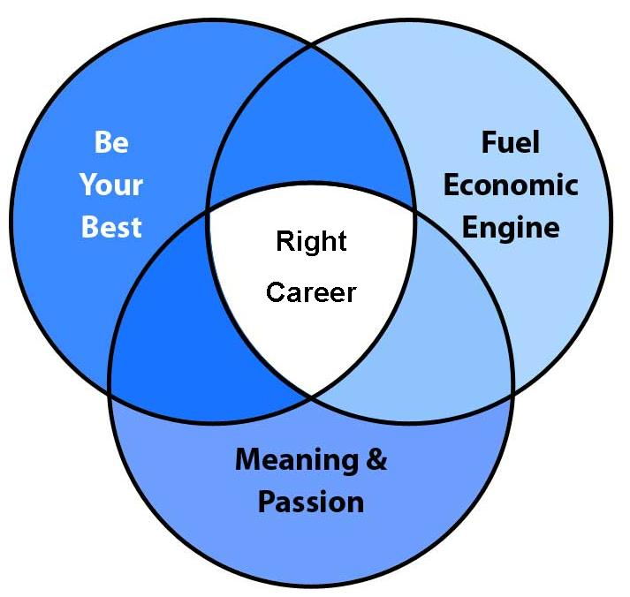
Begin at the End Exercise

Personality Exercise

Interests

Autobiography Exercise

Accomplishments Exercise

Strengths Exercise

Skills Exercise

Stories Exercise

Drivers Exercise

Measure Your Life Exercise

Economic Engine Exercise

