Week 1 Report: Data Acquisition, Cleaning, and Exploratory Data Analysis

Project: Titanic Dataset Analysis
Prepared by: Dayalan G N

1. Objective
This project demonstrates the complete data preparation workflow for a data science project using the Titanic dataset. The tasks include data acquisition, cleaning, preprocessing, exploratory data analysis (EDA), visualization, and reporting.

2. Dataset
Dataset: Titanic passenger dataset (891 rows, 12 columns).
The dataset contains passenger information such as age, sex, passenger class, fare, survival status, and embarkation port.

3. Libraries Used
Python 3.11
Pandas
Matplotlib
Seaborn
Jupyter Notebook (VS Code)
These libraries were used for data manipulation, visualization, and exploratory data analysis.

4. Data Acquisition
The Titanic dataset was downloaded from a publicly available GitHub repository in CSV format. The dataset contains information about 891 passengers, including demographic details, ticket information, and survival status. It was imported into Python using the Pandas library for further analysis.

5. Data Cleaning
The following preprocessing steps were performed:
• Loaded the CSV dataset using Pandas.
• Inspected the dataset using df.info(), df.describe(), and df.isnull().sum().
• Filled missing values in Age using the median value.
• Filled missing values in Embarked using the mode.
• Removed the Cabin column because it contained a large number of missing values.
• Verified that no missing values remained.
• Checked for duplicate records and confirmed the dataset was clean.
• Saved the cleaned dataset as cleaned_titanic.csv.

6. Exploratory Data Analysis
The following visualizations were created:
1. Passenger Survival Count
2. Survival by Gender
3. Age Distribution
4. Age Distribution by Passenger Class (Box Plot)
5. Correlation Heatmap
6. Age vs Fare Scatter Plot

  - Visualization Results:
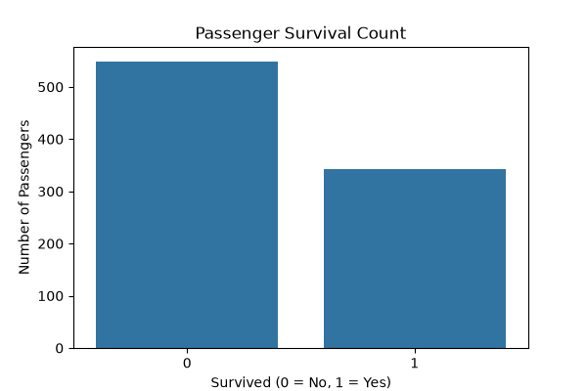

Figure 1: Passenger Survival Count
This chart compares the number of passengers who survived and those who did not. It shows that the number of non-survivors is higher than the number of survivors.

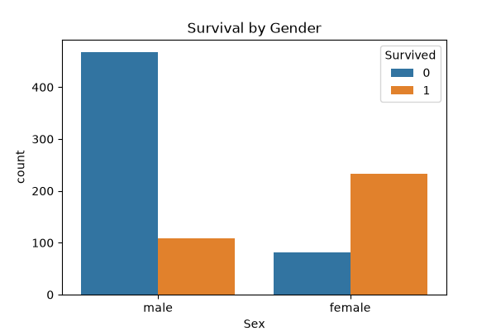
Figure 1: Passenger Survival Count

Figure 2: Survival by Gender
Female passengers had a noticeably higher survival rate than male passengers, suggesting that gender played a significant role during evacuation.

Figure 2: Survival by Gender
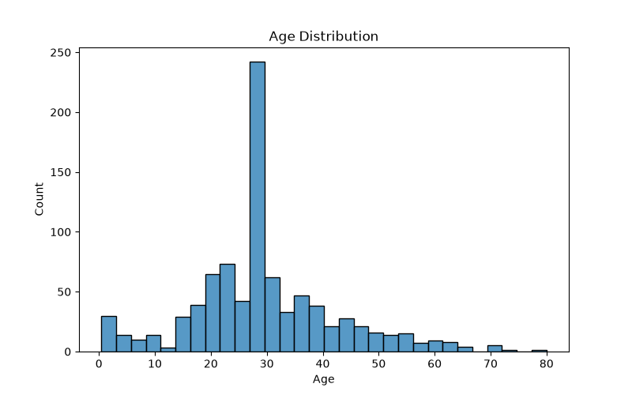
Figure 3: Age Distribution
Most passengers were between 20 and 40 years old, with fewer elderly passengers and children.

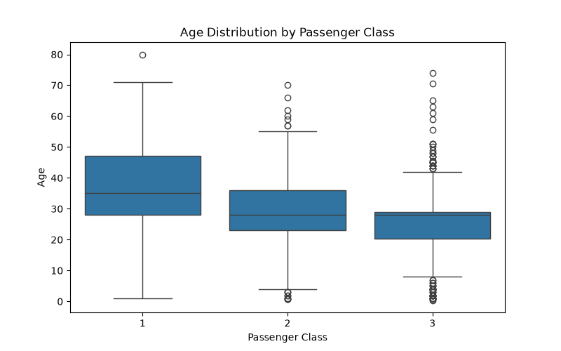
Figure 3: Age Distribution

Figure 4: Age Distribution by Passenger Class
First-class passengers tended to be older on average, while third-class passengers included more younger travelers.

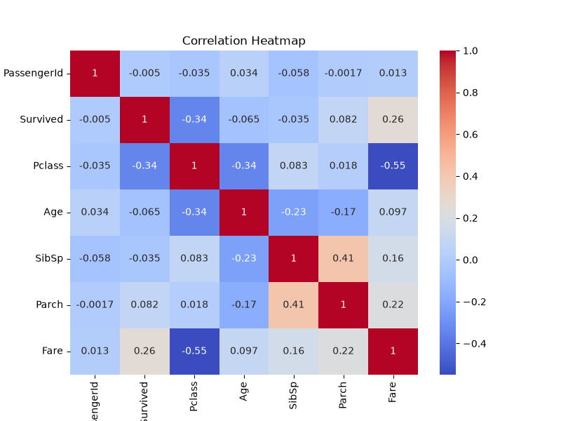
Figure 4: Age Distribution by Passenger Class

Figure 5: Correlation Heatmap
The heatmap shows relationships between numerical variables. Most correlations are weak to moderate, indicating that multiple factors influenced survival.

Figure 5: Correlation Heatmap
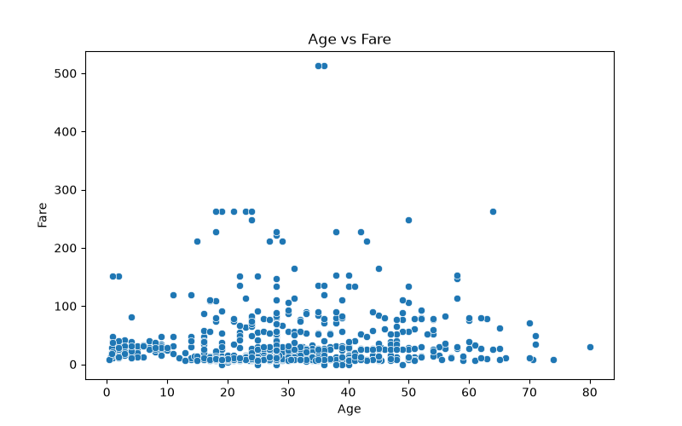

Figure 6: Age vs Fare
There is no strong linear relationship between age and fare, though some passengers paid significantly higher fares.

Figure 6: Age vs Fare

6. Key Findings
• Most passengers did not survive.
• Female passengers had a higher survival rate than male passengers.
• Most passengers were young adults.
• Passenger class influenced age distribution.
• Fare varied significantly among passengers.
• Correlation analysis showed relationships among several numerical variables.

7. Conclusion
This project successfully completed the required stages of data acquisition, cleaning, preprocessing, and exploratory analysis. The cleaned dataset and visualizations provide useful insights into passenger characteristics and survival patterns. The workflow demonstrates fundamental Python data analysis skills using Pandas, Matplotlib, and Seaborn.

