**Mfrs: Shredder machines | Dewatering machines | Conveyors | Wire strippers | Reverse Vending Machines**

**Orbit Machines**

**No:47, Maruthamalaigounder layout,**

**R.K.Puram, Ganapathy**

**Coimbatore TN India. Pin: 641006**

**sales.orbitmachines@gmail.com**

**orbittextoolengineers@gmail.com  
Mob: 9500506615 | 9500506615**

**www.orbitmachines.in**

**TIN: 33822104104 | GSTIN: 33BSVPB7613LIZE**

**Sales Quotation**

**Date: Nov 30, 2021**

**Quotation No: 624-A/QTN/OM/2021-2022/2**

no:

|  |  |
| --- | --- |
| **TO:**  **MR. John,**  **John JohnJohnJohnJohnJohnJohn**    **0123456987**  **john@gmail.com** | **Ref Person: Mr. John**  **Contact no: 0123456987** |

**Thank you for your inquiry dated:**

**We are pleased to quote you the following:**

**We are pleased to quote you the following:**

|  |
| --- |
|  |
| |  |  |  |  | | --- | --- | --- | --- | | **S.No.** | **Image** | **Description** | **UnitPrice+GST** | | 01 |  | **Product448163264128**  **Product4**   * **dsfzxcsndfd** * **sdfsdfsdf** * **sdfdsf** * **sdfsdf** * **sddfds** * **dsf** * **sdf** * **sdfsdfdsf** | 500.00 GST 18% 90.00 | | 02 |  | **Product337153163127**  Product3Product3Product3P  roduct3Product3Product3Product3Product3 | 255.00 GST 18% 45.90 | | 03 |  | **Product226143062126**  **Product2**    Product2Product2Product211111111111111111  Product2Product2Product211111111111111111  Product2Product2Product211111111111111111Product2Product2Product211111111111111111 | 1000.00 GST 18% 180.00 | | 04 |  | **Product448163264128**  **Product4**   * **dsfzxcsndfd** * **sdfsdfsdf** * **sdfdsf** * **sdfsdf** * **sddfds** * **dsf** * **sdf** * **sdfsdfdsf** | 500.00 GST 18% 90.00 | | 05 |  | **Product337153163127**  Product3Product3Product3P  roduct3Product3Product3Product3Product3 | 255.00 GST 18% 45.90 | | 06 |  | **Product226143062126**  **Product2**    Product2Product2Product211111111111111111  Product2Product2Product211111111111111111  Product2Product2Product211111111111111111Product2Product2Product211111111111111111 | 1000.00 GST 18% 180.00 | | 07 |  | **Product448163264128**  **Product4**   * **dsfzxcsndfd** * **sdfsdfsdf** * **sdfdsf** * **sdfsdf** * **sddfds** * **dsf** * **sdf** * **sdfsdfdsf** | 500.00 GST 18% 90.00 | | 08 |  | **Product337153163127**  Product3Product3Product3P  roduct3Product3Product3Product3Product3 | 255.00 GST 18% 45.90 | | 09 |  | **Product226143062126**  **Product2**    Product2Product2Product211111111111111111  Product2Product2Product211111111111111111  Product2Product2Product211111111111111111Product2Product2Product211111111111111111 | 1000.00 GST 18% 180.00 | | **Sub Total Inclusive GST 18%** |  |  | **12030.00** | | **Total** |  |  | **12030** | |
|  |
| |  |  |  | | --- | --- | --- | | **S. NO** | **PRODUCT NAME** | **UNIT PRICE + GST** | | 01 | Product448163264128 | 500.00 | | 02 | Product337153163127 | 255.00 | | 03 | Product226143062126 | 1000.00 | | 04 | Product448163264128 | 500.00 | | 05 | Product337153163127 | 255.00 | | 06 | Product226143062126 | 1000.00 | | 07 | Product448163264128 | 500.00 | | 08 | Product337153163127 | 255.00 | | 09 | Product226143062126 | 1000.00 | | **Inclusive GST 18%** |  |  | | **TOTAL** |  | **12030** | |

Orbit Machines– Industrial & Recycling Machines Manufacturer

**Orbit** stands out in terms of experience and expertise when it comes to crushing, shredding, and dewatering equipment. We are able to offer complete crushing, shredding, conveying, wire stripping, and dewatering systems.

**We will be happy to supply any further information you may need and trust that you call on us to fill your order, which will receive our prompt and careful attention.**

**Terms & Conditions**

**Tax : GST 18%**

**PACKING & FORWAD : Ex-works, Coimbatore**

**PAYMENT : 50% Advance, Balance Against material dispatch**

**VALIDITY OFFER : 15 Days**

**DELIVERY : material will be dispatched within 30 to**

**35 working days from advance payment**

**WARRANTY : 1 year machine warranty from the invoice date.**

**INSTLATION &**

**COMMISSIONING : Travelling and accommodation will be at your scope**

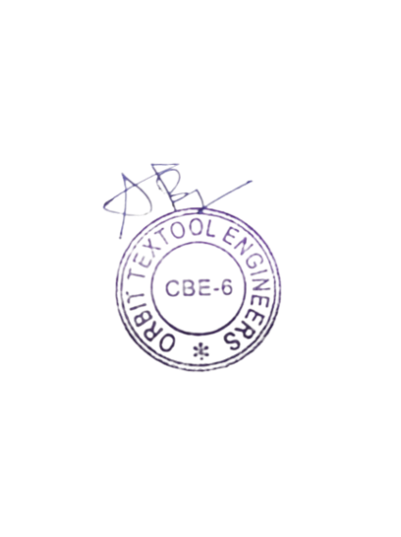

**Authorized Signature**