React Js
To start with react we need to have the node js installed in our system.
Steps to install the react JS :
- Install node js to get the node package manager (npm)
- To install the react app we use the command
Npm create vite@latest
- Will ask for the name and select the framework (react)
- Select the javascript
- Will show the below commands and run them
cd "First app"
npm install : will install the required apps
npm run dev : will run the server
- When the installation is completed then we will have the following contents.
  - Node_modules : will contain the required libraries/ packages in it.
  - Public : Will contain the public aspects like common fonts, images, e.t.c which will not be included in the bundled.
  - Src : Will contain the original/ main code inside it. In this src folder we will create the pages.
    - Assests : Are the sub parts of the src folder and will contain all the images or files that are related to the code.
    - .jsx files : javascript XML files. We write the code in .jsx files in react framework.
    - Css files : We will have 2 CSS files app and index. Index is the main css file we work on
  - Index.html : It is the main html file where we use as the base for the react web page
  - Package.json : Will contain the meta data for our projects, dependencies.
React mostly works on components. A component is nothing but a jsx file we are having inside src.

React concepts :
- Component : are the block of code which can be reused. Components are buttons, pages, inputs, e.t.c
  - It returns the jsx and not the html unlike js code.
  - JSX are not html elements hence we write everything in camel case.
    - Ex : class will be written as className
  - HTML is a static content where we can make it dynamic with the help of jsx.
- Curly Braces : To use the js values we use the curly braces { values }
- Fragments : We can’t return multiple statements at a time hence we wrap the entire html code inside another <></> to wrap and make is as a single component. It is called as Fragment
- Prop : Prop is used to pass a value to the child from parent
  - Syntax :
Parent side :
<Button text = {“Hello”} />
Child Side :
Function Button(){
Return(
<>
<h1> {prop.text} </h1>
</>
);
}
- Key prop : It is a built in prop which is used by the react to identify the component. It is a either a string or a value.
- Rendering : The process of displaying something in the browser is called as rendering.
  - React will do that by default
  - Though sometimes it will fall under infinite loop. So inorder to prevent this we have to understand it
  - React uses the VirtualDOM (VDOM)
  - React Rendering Steps :
    - If the DOM changes then it will updated the VDOM
    - React uses the diffin to compare the updated VDOM with the previous VDOM.
    - Once the change is found then it will uses the reconciliation and will change the DOM.
- Event Listeners : User interactions on the webpage.
  - We are having the below event listeners in react.
    - Click
    - Mouseover
    - Onchange
    - OnSubmit
  - We use the function to call when we trigger any event.
- State : To manage Data we need to use the state. Here it is not suggestable to use the normal javascript variables hence we use the state methods/ features.
  - useState() : takes a argument and returns a array which contains stateVariable and function.
  - useReducer()
- controlledComponents : Uses states and make it more predictable behavior.
  - Steps :
    - User will enter a value and setValue to the state
    - State will get updated
    - Input reads from state

Component : Is a block of code which is having the html code inside it.
NOTE : We can create new components by saving the file with the .jsx extension.
Whenever we are using the components and it will return the plain old javascript object/ javascript object.
Steps to create components :
- Create a file and save it with the .jsx extension.
- Now create a function inside it. Name the function with the filename.
- Add a return statement inside the function and write the html code inside it.
Syntax :
Return (
Html code;
);
Example :
function header(){
return(
<>
<p>
<h1>This is the first app</h1>
</p>
<p>
<ul>
<li>Home</li>
<li>Options</li>
<li>Services</li>
</ul>
</p>
</>
);
}

export default header;

- Then export the function as default.
- Then import this function into the app.jsx
Syntax :
Import functionName from ‘./filename.jsx’;
Example :
import Header from './header.jsx';
- To use this component we need to add a return into the app.jsx if it is the first time or else just write the component inside the return statement.
Syntax :
Function app(){
Return(
<componentName> </componentName>
);
}
Example :
import Header from './header.jsx';
function App() {
return(
<>
<Header></Header>
</>
);
}

export default App

NOTE : We can write the component in a single tag for both open and close.
Syntax :
<component/>
Example :
<Header/>
- But when we are returning more than one line of html code then we need to use the a blank open and close statements inorder to make them as one. Those are called as fragments.
Syntax :
Function functionName(){
Return(
<>
components
</>
);
}
Example :
import Header from './header.jsx';
import Footer from './Footer.jsx';
import Sample from './Sample.jsx';
function App() {
return(
<>
<Header/>
<Sample/>
<Footer/>
</>
);
}
export default App

- We can use the javascript code when ever we are using the javascript code we can use the curly braces { }.
NOTE : We can reuse the components in react as per our choice. The display of the webpage is completely based upon the order of our components.

Output :
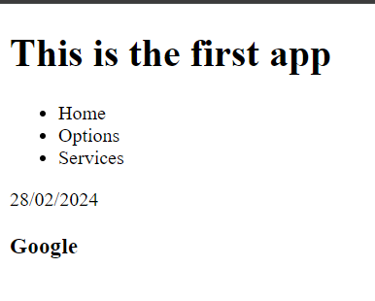
In react we use the className for the class attribute in html code.
NOTE : className is a case sensitive.
NOTE : When you are using images always place them in assets folder.
NOTE : Always give the first letter as capital for the components.
Adding image to the page :
- Import the image from the assets then use a name to it.
Example :
import profilePicture from './assets/images/image.jpeg';

function Card(){
return(
<>
<div className="container">
<img src={profilePicture} alt="" className="image" />
</div>
</>
);
}

export default Card;

Using css to the jsx :
We can use the css in react js like
- External :
We use the index.css to style when you want to apply globally. The more component the more we will have a issue with the naming convention
- Modules :
Here we will create a new dedicated style sheet for the button. We will place the component and the modules inside same folder and will be imported to utilize it.
Example :
import profilePicture from '../assets/images/image.jpeg';
import styles from './card.module.css';

function Card(){
return(
<>
<div className={styles.container}>
<img src={profilePicture} alt="" className= {styles.image}/>
</div>
</>
);
}

export default Card;

NOTE : We need to name the css file/ module file including the module after and before the filename.
Syntax :
Filename.module.css
NOTE : Issue with the modules are they are isolated with in a folder hence we can’t directly apply the global selectors, so that if we want to use them we need to import them manually.
- Inline : To use the inline we will take a javascript object and will store all the values init then will implement inside the style tag.
Example :
import profilePicture from '../assets/images/image.jpeg';

function Card(){

const styles = {
width : "100px",
display : "inline-block"
};

const Image = {
width : "100%"
};

return(
<>
<div style={styles}>
<img src={profilePicture} alt="" style={Image}/>
</div>
</>
);
}

export default Card;

Displaying javascript value :
In react we can display the values with the help of the curly braces ‘ { }’ and we have to place the variable in between it.
Syntax :
Function FunctionName( ){
Let/ Const variableName = value;

Return (
<>
{variableName}
</>
);
}
Example :
function Body(){
const firstName = 'John';
const lastName = 'Doe';
return(
<>
<div className="container">
<h1>Welcome {lastName} {firstName}</h1>
</div>
</>
);
}

Props :
Props are read-only properties that can be used/ shared between components. Here the parent component will send a data to the child component through key pair values and we have to receive it at the child side. This is just like functions.

Syntax to create prop:
Function childComponent( parameter/props ){
Return(
<div>{props.key}</div>
);
}
Example :
function Card(props) {
return(
<div>
<p>{props.name}</p>
</div>
);
}
export default Card;

Syntax to pass the values to the props :

Import child from ‘childComponentPath’;
Function parentComponent(){
Return(
<>
<child key = ‘value’ /> //For string
<child key = {30} /> //For number
<child key = {true} /> //for Boolean
</>
);
}
Example :
import Hello from './card/card.jsx';
function App() {

return (
<>
<Hello name = "Mike"/>
<Hello name = "John"/>
<Hello name = "Mary"/>
</>
)
}
export default App

NOTE : We can’t change the key name when we are calling the values.
NOTE : We can even use the conditional statements

Destructuring the props :
Prop is a normal object which is used to pass the data between the pages. As prop is an object we can use the object destructing method to work with the values inside the prop.
Syntax :
Function functionName( {variable1, variable2} ){
//body
}
Example :
function Card({img, number, name, address}){
//body of the component
}

TIP : We can even use the props inside or in between the code.
Syntax :
Function functionName( prop ){
Return(
<>
<img src = { `../directory/{prop.key}` }>
</>
);
}
Key Prop Types :
A method that ensures that the passed value is of correct datatype. It is mainly use for the debugging purpose as it will throw and warning in the console.
To set the prop Type then we follow the below syntax.
childComponentName.propType = {
key : propType.dataType
}
Example :
import propTypes from 'prop-types';
function Check(prop){
return(
<>
<p>{prop.name}</p>
</>
);
}
Check.propTypes = {
name : propTypes.string
}
export default Check;

ParentComponent :
import Check from './check.jsx';
function App() {
return (
<>
<Check name = {30} />
</>
)
}
export default App

Output :
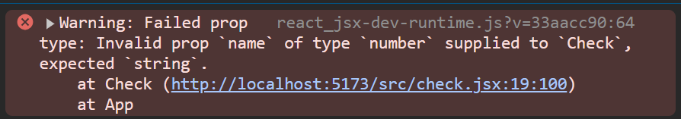
NOTE : We have to import the prop-Types from the node modules.
NOTE : If we are not passing any values then we have use the default props.
Syntax :
Component.defaultProps = {
Key : value,…..
}
Example :
Check.defaultProps = {
name : 'default'
}

Array Rendering :
Array Rendering is used to consider them as a single set of element or a single string.
Syntax :
Function functionName( ){
Const arrayName = [ value1, value2,.., value n ]
Return(
<>
{arrayName}
</>
);
}
Example :
function App() {
const array = [
<h4>This is the first tag</h4>,
<h4>This is the secound tag</h4>,
<h4>This is the third tag</h4>,
<h4>This is the fourth tag</h4>,
<h4>This is the fifth tag</h4>
];
return (
<>
{array}
</>
)
}

Output :
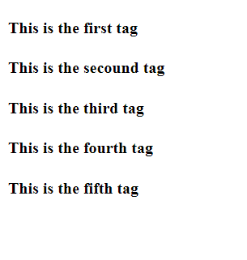
We can use the array Methods to do the rendering, Rendering with the help of the map method.
Example :

function App() {

const contact = [
{
img : "https://imgs.search.brave.com/BpVJrmuLlIKwG15rZuWPMC6r6jDwXbtuXNAMJAo05iE/rs:fit:860:0:0/g:ce/aHR0cHM6Ly9pbWcu/ZnJlZXBpay5jb20v/ZnJlZS1waG90by9n/cmFuZHBhLWdyYW5k/c29uLWxvb2tpbmct/ZWFjaC1vdGhlcl8y/My0yMTQ4Mjk0OTIy/LmpwZz9zaXplPTYy/NiZleHQ9anBn",
name: "Grandpa",
number : "899483932",
address : "Hitech City, Hyderabad"
},
{
img : "https://parade.com/.image/t_share/MTkwNTgxMDYyMTg3Mjk2NjM2/grandma-names-we-love-jpg.jpg",
name : "Grand Maa",
number : "899483342",
address : "Hitech City, Hyderabad"
}
]

const contactList = contact.map((value) => {
console.log(value.img);
return <Contact
img = {value.img}
name = {value.name}
number = {value.number}
address = {value.address}
/>;
});

console.log(contactList);
return (
<>
<div className='mainContainer'>
{contactList}
</div>
</>
)
}

Conditional Rendering :
Rendering the component based on the condition. Here we can use the conditional statements like ternary/ if/ if-else, e.t.c.
Syntax :
Function componentName(){
If(codition){
Return htmlCode
}
Else{
Return htmlCode
}
}
Example :
import propTypes from 'prop-types';

function Home(para){
if(para.condition){
return(
<>
<div className={para.class}>
<h1>Conditional Statement</h1>
<p>Hello</p>
</div>
</>
);
}
else{
return(
<>
<div className={para.class}>
<h1>Conditional Statement</h1>
<p>Hello</p>
</div>
</>
);
}
}

Home.propTypes = {
name : propTypes.string,
class : propTypes.string,
condition : propTypes.bool
}

Home.defaultProps = {
name : 'World',
class : 'contact',
condition : false
}
export default Home;

App.jsx :
import Home from './HomePage.jsx';
function App() {
return (
<>
<Home name ="Guest" class="success" condition ={true}/>
<Home></Home>
</>
);
}
export default App

Output :
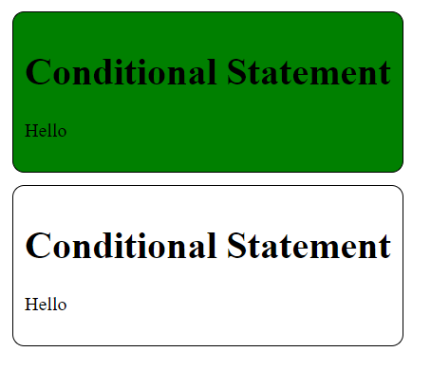
Click Events :
Will trigger when the user interacts with any button and will pass a callback to the on click event handler.
Sytax :
Function eventFunction(){
Block of code for it
}
<button onclick = {eventFunction}> ButtonName </button>
Example :

function Render(){

const imageDisplay = () =>{
console.log("WOrking")
};
return(
<button onClick={imageDisplay}>Click Me</button>
);
}
export default Render;

For passing parameters we have to use the functionName( parameters)
Syntax :
Function functionName(parameter){
Block of code
}
<button onclick ={( ) => functionName(arg)}> ButtonName </button>
Example :

function Render(){

const imageDisplay = (name) =>{
console.log("WOrking",name)
};
return(
<button onClick={() => imageDisplay("Robert")}>Click Me</button>
);
}
export default Render;

NOTE : As we have to pass the callback and we don’t have it call it. Hence we use anonymous function and will call the Click Event Function in it.

Event Listeners :
- Mouse Events
  - onClick : Will trigger when we click on a button.
  - onDoubleClick : Will trigger when we double click a button.
  - onMouseDown : Triggered when a mouse button is pressed.
  - onMouseUp : Triggered when a mouse button is released.
  - onMouseEnter : Triggered when the mouse pointer enters an element.
  - onMouseLeave : Triggered when the mouse pointer leaves an element.
  - onMouseMove : Triggered when the mouse pointer is moved over an element.
  - onMouseOver : Triggered when the mouse pointer is moved onto an element or its child elements.
- Keyboard Events :
  - onKeyDown: Triggered when a key is pressed down.
  - onKeyPress: Triggered when a key is pressed (deprecated in React, use onKeyDown instead).
  - onKeyUp: Triggered when a key is released.
- Form Events :
  - onChange: Triggered when the value of an input, select, or textarea element changes.
  - onInput: Triggered when the value of an input element is being changed.
  - onSubmit: Triggered when a form is submitted.
  - onFocus: Triggered when an element gains focus.
  - onBlur: Triggered when an element loses focus.
  - onReset: Triggered when a form is reset.

NOTE : There are many other events which was not mentioned here. Please if needed then please refer to the documentation of react or use external source as reference.

Event Object :
Every event will invoke the event object. Here in order to use the event object then we pass this to the method everytime when we click on it.
Syntax :
Function functionName(eventParameter){
Console.log(eventParameter);
}
Return(
<button onClick = { (event) => functionName(e) } > </button>
);
Example ;

function Render(){

const imageDisplay = (name) =>{
console.log(name)

};
return(
<button onClick={(e) => imageDisplay(e)}>Click Me</button>
);
}
export default Render;

To change the text content inside the button we use the eventObj.target.textContent.
Syntax :
eventObj.target.textContent = “text”;
Example :

function Render(){

const imageDisplay = (name) =>{
console.log(name);
name.target.textContent = "Clicked";
};
return(
<button onClick={(e) => imageDisplay(e)}>Click Me</button>
);
}
export default Render;

useState Hook :
In react we have to render the component each time we are changing a value, but it is not possible here as it will not able to render the values directly into the page like JavaScript. So to render the page each time whenever it changes the value we have to use the use state hook.
It is a built in Hook in react we have to import it from react library.
Syntax :
Import {useState} from ‘react’;
Example :

Also We have to declare variable as in array format which as shown below.
Syntax :
Type [ variableName, setVariableName] = useState( init value );
Example :

Syntax to change the variable value :
setVariableName( new value );
Example :

Using Arrays in React :
In react we use arrays to store and return list of values at a time. We use Array methods of JavaScript in-order to return the values inside array. When we are rendering more than one item we will have performance issues and rendering issues like rendering the items without an order, e.t.c. In order to avoid it we have to use the “key” attribute.

Key attribute :
keys are special attributes used to uniquely identify elements in a list. They help React efficiently update and render elements by identifying which items have changed, been added, or been removed.
Syntax :
Const arrayName = [item1, item2,..,item-n]

arrayName.map(
( item ) => {
<p key = {uniqueValue}>
{item.keyPair}
</p>
}
);

