CIS11 Lab 4: Programming Instructions in LC-3
In this lab we will program LC-3 instructions for arithmetic functions, based on required conditions (branching). We will utilize operation and condition instructions: AND, NOT, ADD, LD, LDI, LDR, LEA, ST, STI, STR, BR(znp), and JMP.
Complete the following exercises, provide screen captures and answer questions in each exercise.
Submission: Upload document that contains screen captures and answers in Canvas.

Arithmetic Functions
- In this exercise we will create a program that contains the following criteria:
- X and Y are found at locations x3120 and x3121, respectively.
X | x3120
Y | x3121

- Compute the difference X −Y and place it at location x3122.
- Place the absolute values |X| and |Y| at locations x3123 and x3124, respectively.
- Determine which of |X| and |Y| is larger. Place 1 at location x3125 if |X| is, a 2 if |Y| is, or a 0 if they are equal.
X - Y | x3122
|X| | x3123
|Y| | x3124
Z | X3125

- Z is defined as:
Z = $\left\{\begin{aligned}1 if \left|X\right|-\left|Y\right|>0 \\ 2 if \left|X\right|-\left|Y\right|<0 \\ 3 if \left|X\right|-\left|Y\right|=0\end{aligned}\right.$
Many branch instructions are conditional which means that the branch is taken only if a certain condition is satisfied. For example the instruction BRz TARGET means the following: if the result of a previous instruction was zero, the next instruction to be executed is the one with label TARGET. If the result was not zero, the instruction that follows BRz TARGET is executed and execution continues as normal. The exact condition for a branch instructions depends on three Condition Bits: N (negative), Z (zero), and P (positive). The value (0 or 1) of each condition bit is determined by the nature of the result that was placed in a destination register of an earlier instruction.
For example, we note that at the execution of the instruction BRz LABEL N is 0, and therefore the branch is not taken:
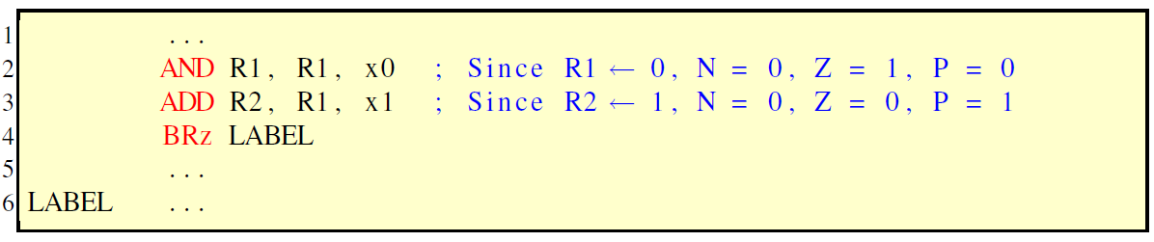

BR | branch unconditionally | BRnz | branch if result was negative or zero
BRz | branch if result was zero | BRnp | branch if result was negative or positive
BRn | branch if result was negative | BRzp | branch if result was zero or positive
BRp | branch is result was positive | BRnzp | branch unconditionally

One way to implement absolute value is seen below:
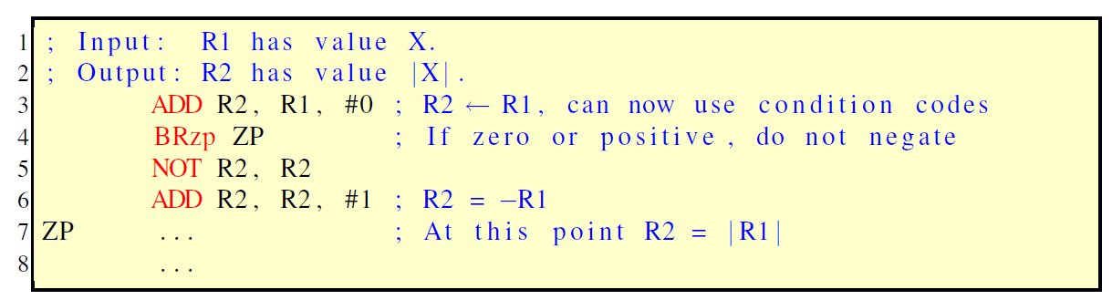
In LC-3 Editor, input the below program. Then, Assemble, Load and Run the program. The program should include comments for value, label and condition (see the first two sections of code)
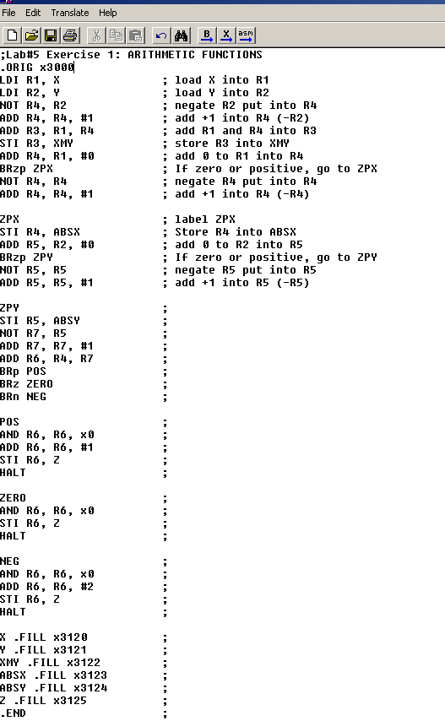
- Provide screen captures showing
- The code in Editor
- The program successfully assembled in Editor
- The program ran in Simulator – with X, Y and Labels location.
- In Simulator, use the Step Over button to go through the program and answer the following questions:
- Identify the registers that were loaded at the beginning of the program. Double-click each line and specify location and value of each register.
- Continue to Step Over the program and identify the TRAP vector in the program.
- In Simulator, use the Jump To drop-down arrow and select x3000 to view the program code.
- Review the labels of the program and identify each label’s location, value and Register.
- Use the Toggle Breakpoint button (red dots with arrows) and place a breakpoint on Label Z, then click the Run Program button (green arrow).
- What is the value of Label Z in PC?
- In this step, we will test the program by setting value for X and Y. Reload the program in Simulator. DO NOT RUN the program until the values are set. Click Set Value button (Purple 1011) or Click Simulate, then select Set Value. Choose Drop-down menu of Location and choose R1, set value to x1, then click Apply. Repeat this step to set the value for R2 to x2.
- Do you see the set values in the Simulator? Provide screen captures.
Click Run Program button or Click Execute, then Run.
- What is the value of R5?
- Retest the program for the following value of (X,Y) to determine the value of Z.
- (x5, x4)
- (x-4, x-5)
- (x6, x5)
- (x5, x7)

Arithmetic Comparison program
- Use Exercise 1 as reference, create a program in LC-3 that contains the following criteria:
- P is found at location x3200
- Q is found at location x3201
- RES is found at location x3202
- If P – Q > 0, add 2 to RES.
- If P – Q < 0, subtract 1 from RES
- If P - Q = 0, add 1 to RES
- Labels must be found in subsequent locations, from x3200.
- Provide screen captures of code, loaded program and successfully ran program.
- Identify the location and values of P, Q and R.
- Assume that P = 4, Q = 5 and R = 3. Test the program and provide result screen capture.
- Determine final result of R, if its initial value is 5.
P = 7, Q = 10
P = 10, Q = -4
P = -5, Q = -5

- Write a program in LC-3 to solve for:
- D + C > 10
- C ≥ 10
- Illustrate the use branching.
Provide screen capture of Code, Simulator with test input for C is #11 and D is #3.

