NIM : A11.2023.15194

NAMA : RESTU ARDIANSYAH

KELOMPOK : A11.4303

**UTS BASIS DATA**

1. **CREATE**
2. **INSERT TABLE**

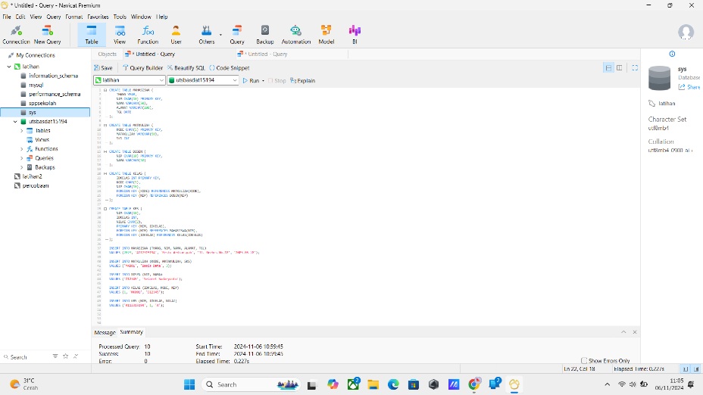

1. Inner join

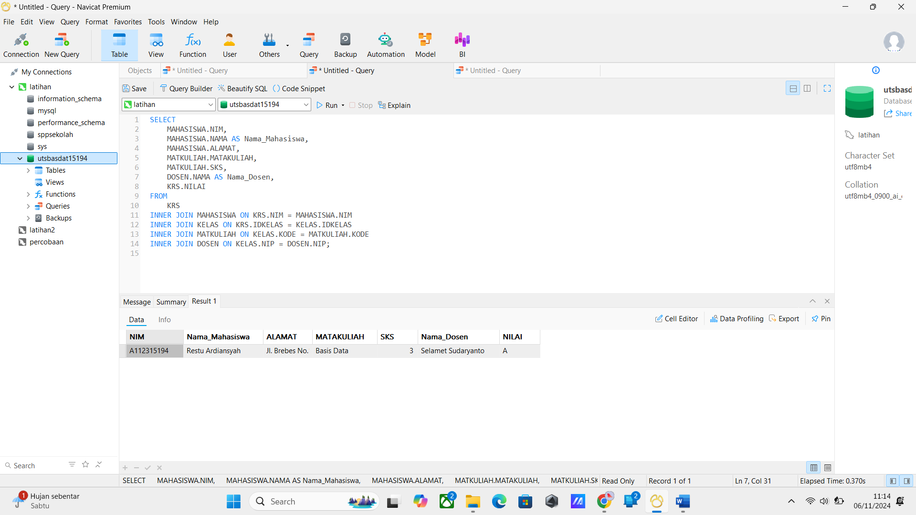

1. **Left join**

