Sprint 1 - Endurance Design Document

October 27, 2019

By: Aaila Arif, Dominick Del Bene, Zaccery Tarver

Table of Contents

1. Executive Summary 3

1.1 Project Overview 3

1.2 Purpose and Scope of this Specification 3

2. Product/Service Description 3

2.1 Product Context 3

2.2 User Characteristics 3

2.3 Assumptions 3

2.4 Constraints 3

2.5 Dependencies 4

3. Requirements 4

3.1 Functional Requirements 5

3.2 Security 5

3.2.1 Protection 5

3.2.2 Authorization and Authentication 6

3.3 Portability 6

4. Requirements Confirmation/Stakeholder sign-off 6

5. System Design 6

5.1 Algorithm 6

5.2 System Flow 6

5.3 Software 6

5.4 Hardware 6

5.5 Test Plan 7

5.6 Task List/Gantt Chart 7

5.7 Staffing Plan 7

# Executive Summary

## Project Overview

* *This project has been created to program a Sphero robot to travel along a blue-tape rectangle track. It has been created to test the capabilities of the Sphero robot and applications and the ability to meet the specified requirements. The intended audience of this project is Professor Eckert and our fellow classmates.*

## Purpose and Scope of this Specification

*In scope*

* *Traveling along blue-tape rectangle track*
* *Changing LED colors*
* *Programming robot to “speak” certain phrases*
* *Programming directional changes as well as delays*

*Out of Scope*

* *Courses other than blue-tape rectangle*
* *Actions not specified by requirements*

# Product/Service Description

## Product Context

*This product is one of three parts of the Robotics Triathlon. This product is self-contained and independent of the other parts of the Triathlon, as all that is needed is the Sphero Edu application and robot.*

## User Characteristics

* *Team members- Students, two years of coding experience, beginner knowledge of Sphero programming*

## Assumptions

* *The classroom (HH-208) is available for students when necessary for testing*
* *Team members have non-conflicting schedules and can meet up*
* *The Sphero robot is provided by Professor Eckert*
* *Sphero robot is functional as well as the application used for programming*

## Constraints

* *Team members are only able to meet up at specific times*
* *Parts of the tape on the course are missing*
* *Tiles on the ground of the classroom are uneven*
* *HH-208 is not always available*

## Dependencies

* *Testing must occur in HH-208*
* *Requirements table and algorithm must be completed before coding can begin*
* *Sphero robot must be placed on blue tape rectangle and complete the course*
* *Sphero Edu application must be used to program robot*

# Requirements

## Functional Requirements

| Req# | Requirement | Comments | Priority | Date Rvwd | SME Reviewed / Approved |
| --- | --- | --- | --- | --- | --- |
| ENDUR_01 | The robot will start on the upper left corner of the blue rectangle. The robot’s light will be set to green and say ‘Ready. Set. Go!’ The robot will travel forward to a rectangle corner and stop. It will rotate 90° to repeat this motion. Repeat until it reaches its original start location. The robot will change to a red light and speak ‘I’m done, and I need water.’ | No other requirements will be started until this requirement is completed. | 1 | 10/26/22 | Aaila Arif |
| ENDUR_02 | Setting a delay for 2 seconds will allow the robot to come to a complete stop. | This requirement improves the processing of the robot and prevents any sliding. | 2 | 10/26/22 | Aaila Arif |
| ENDUR_03 | Before the robot rotates 90°, a yellow light will signal a shift in direction. | This requirement is added on and is not required. | 3 | 10/26/22 | Aaila Arif |

## Security

### Protection

* Windows Laptops
* Monmouth Accounts
* Sphero Accounts
* GitHub Accounts

### Authorization and Authentication

* All accounts have some sort of authentication that verifies who someone is.
* GitHub has authorization to decide what files the user has access to.

## Portability

* Sphero is easily portable among the team members. If a member wants to use the robot, they can connect their phone or computer to Sphero. Then they can control the robot via a program on their device.
* To share a Sphero program, hit the share icon on the top right and send it to a member.

# Requirements Confirmation/Stakeholder sign-off

|  |  |  |
| --- | --- | --- |
| Meeting Date | Attendees (name and role) | Comments |
| 10/26/22 | **Aaila Arif** (Software Designer, Overseer, Documenter, Marketer), **Dominick Del Bene** (Documenter, Software Designer, Robot Tester, Videographer), and **Zaccery Tarver** (Project Manager, Software Designer, Robot Test Case Designer, Robot Tester) | Confirmed all requirements |

System Design

## Algorithm

1. Instantiate a Boolean variable canEnd, giving it the initial value **false**.
2. Set LED light to green
3. Robot speaks “Ready, set, go!”
4. Delay robot
5. Process these events only twice:
   1. Robot travels to the next checkpoint on a long side of the rectangle
   2. Stop robot once it reaches the checkpoint
   3. Set main LED to yellow
   4. Delay robot
   5. Turn robot 90 degrees right
   6. Set main LED to green
   7. Robot travels to the next checkpoint on a short side of the rectangle
   8. Stop robot once it reaches the checkpoint
   9. Set main LED to yellow
   10. Delay robot
   11. Turn robot 90 degrees right
   12. Check if canEnd is set to true. If it is true, only process steps 5.13 and 5.14 of the remaining steps of this current iteration of step 5. If it is false, only process steps 5.15, 5.16, and 5.17 of the remaining steps of this current iteration in step 5.
   13. Set the main LED to red
   14. Robot speaks “I’m done, and I need water”
   15. Delay robot
   16. Set the main LED to green
   17. Set canEnd to **true**.
6. End program

## System Flow

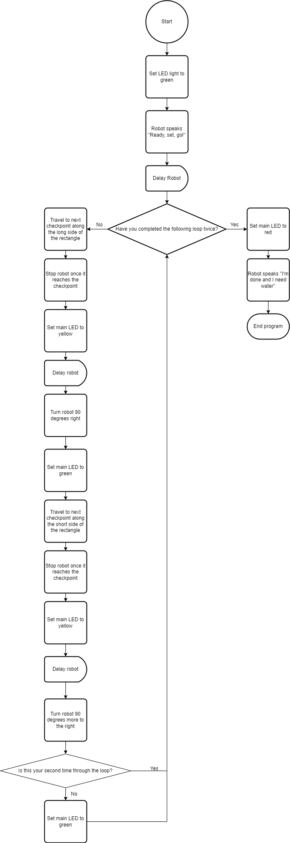

## Software

* Sphero Block Code
* Sphero Edu

## Hardware

* Sphero Robot
* Laptops and phone to run the program.

## Test Plan

| **Reason for Test Case** | **Test Date** | **Expected Output** | **Observed Output** | **Staff Name** | **Pass/Fail** |
| --- | --- | --- | --- | --- | --- |
| Testing green LED | 10/26 | Sphero turns green | Sphero turned green | Aaila | Pass |
| Testing first checkpoint | 10/26 | Sphero stays on tape and stops at checkpoint | Sphero didn’t stay on tape | Dominick | Fail |
| Testing first checkpoint | 10/26 | Sphero stays on tape and stops at checkpoint | Sphero stayed on tape and stopped at checkpoint | Dominick | Pass |
| Testing turning angle | 10/26 | Sphero flashes yellow and turns 90 degrees | Sphero flashed yellow but didn’t turn the correct angle | Dominick | Fail |
| Testing turning angle | 10/26 | Sphero flashes yellow and turns 90 degrees | Sphero flashed yellow and turned 90 degrees | Dominick | Pass |
| Testing second checkpoint | 10/26 | Sphero stays on tape and stops at second checkpoint | Sphero stayed on tape and stopped at second checkpoint | Aaila | Pass |
| Testing turning angle | 10/26 | Sphero flashes yellow and turns 180 degrees | Sphero flashed yellow and turned 180 degrees | Dominick | Pass |
| Testing for correct, looped movement. | 10/26 | Sphero travels the long and short side of the rectangle, does it again for the other two sides, and terminates the program upon reaching the endpoint. | Robot does not stop after the endpoint and continues to move in a rectangle | Zaccery | Fail |
| Testing for correct, looped movement. | 10/26 | Sphero travels the long and short side of the rectangle, does it again for the other two sides, and terminates the program upon reaching the endpoint. | Robot does not stop after the endpoint and continues to move in a rectangle | Zaccery | Fail |
| Testing for correct, looped movement. | 10/26 | The robot should stop and not enter the loop again. | The robot does not enter the loop. It works properly. This test was performed in my dorm, so I need to test it in a full-scale environment. | Zaccery | Pass |
| Testing for correct, looped movement in a full-scale environment. | 10/28 | Sphero does the same movement pattern it did when it was in my dorm but moves farther distances to accommodate for the size of the actual path. | The robot moves very accurately, nearly staying on the path. Roll time needs to be adjusted. | Zaccery | Fail |
| Testing for precision in its movement. | 10/28 | The robot stops at corners and does not continue to move beyond that. The robot should always be aligned with the blue-tape path. | Sphero sometimes does not move perfectly, perpendicularly. This is strange, because it always changes its initial heading of 0 by 90. Sphero may be moving too fast, which makes it wobble and lose course. | Zaccery | Fail |
| Testing for stable, controlled movement. | 11/2 | Robot stays on the blue line as much as possible, stops at corners of blue tape. The robot should be fully functional. | After several identical tests, the robot still leans off course. Achieving the right heading is nearly impossible due to the functionality of the app seemingly preventing that. This current robot also seems to consistently lean left instead of straight, so it may need to be replaced. | Zaccery | Fail |
| Testing for the most accurate movement possible within the constraints of the testing environment and app. Robot replaced? | 11/3 | Robot should not be leaning left as it travels, it should travel straight when told. Inconsistencies in motion should be almost gone. | The robot leans left still, but this is not as big as an issue as it was thought to be. The movement is accurate enough, and it is successful! | Zaccery | Pass |

## Task List/Gantt Chart

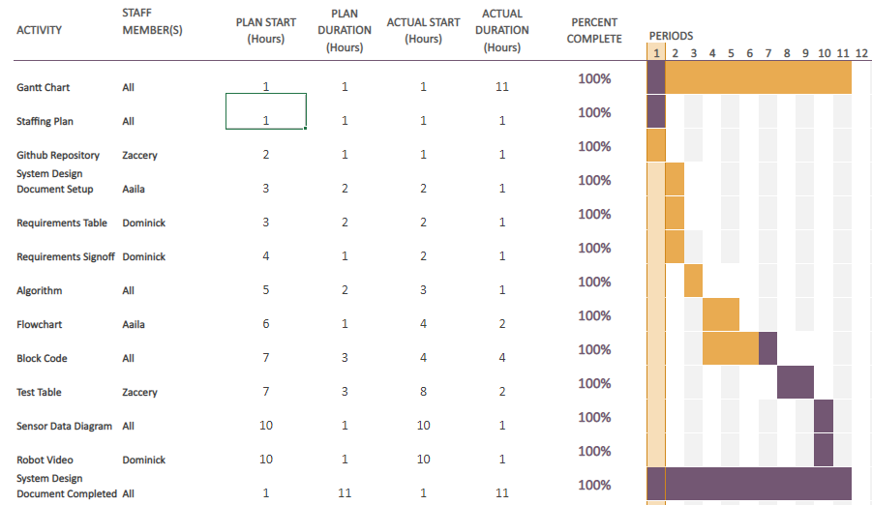

## Staffing Plan

| Name | Role | Responsibility | Reports To |
| --- | --- | --- | --- |
| Aaila Arif | Software Designer, Overseer, Documenter, Marketer | -Design software for robot to complete all specified requirements  -Oversee completion of documents as well as ensure all requirements are fulfilled  -Document as well as create flowchart for algorithm  -Market the product by filling out descriptions as well as characteristics | Team members |
| Dominick Del Bene | Documenter, Software Designer, Robot Tester, Videographer | -Design software for robot to complete all specified requirements  - Run software for Robot to test as well as document test cases  - Record robot during testing as well as completion  -Protect program/robot from malicious access/misuse | Aaila (overseer) |
| Zaccery Tarver | Project Manager, Software Designer,  Robot Test Case Designer, Robot Tester | -Design software for robot to complete all specified requirements  -Ensure team members stay on task as well as complete requirements in a timely manner  -Run software for robot to test  -Manage Github repository  -Develop Robot test cases | Aaila (overseer) |

## Block Code

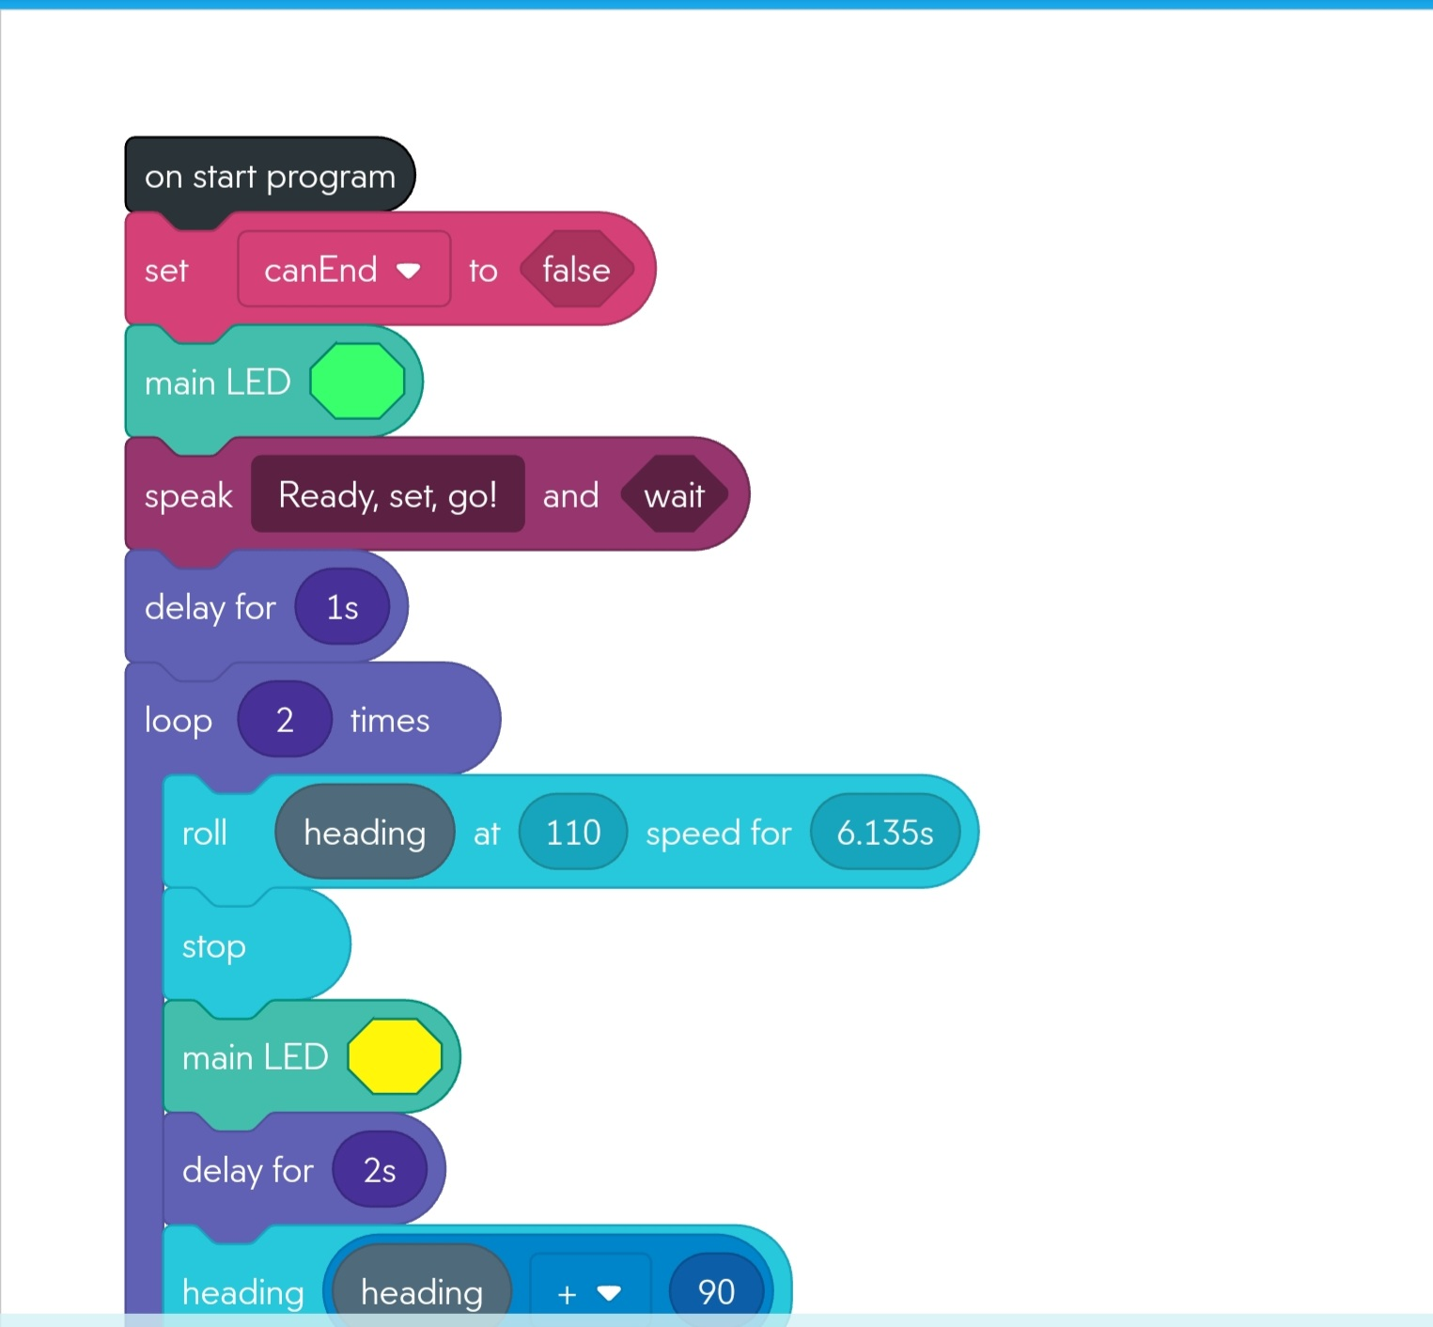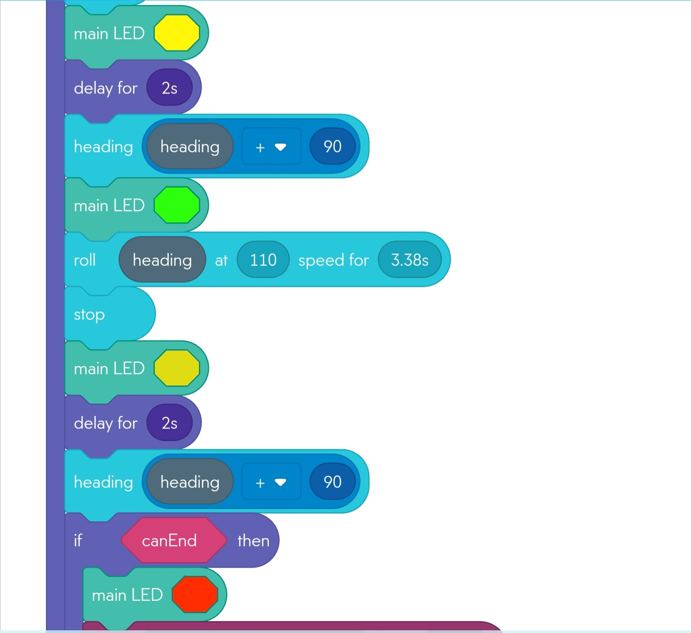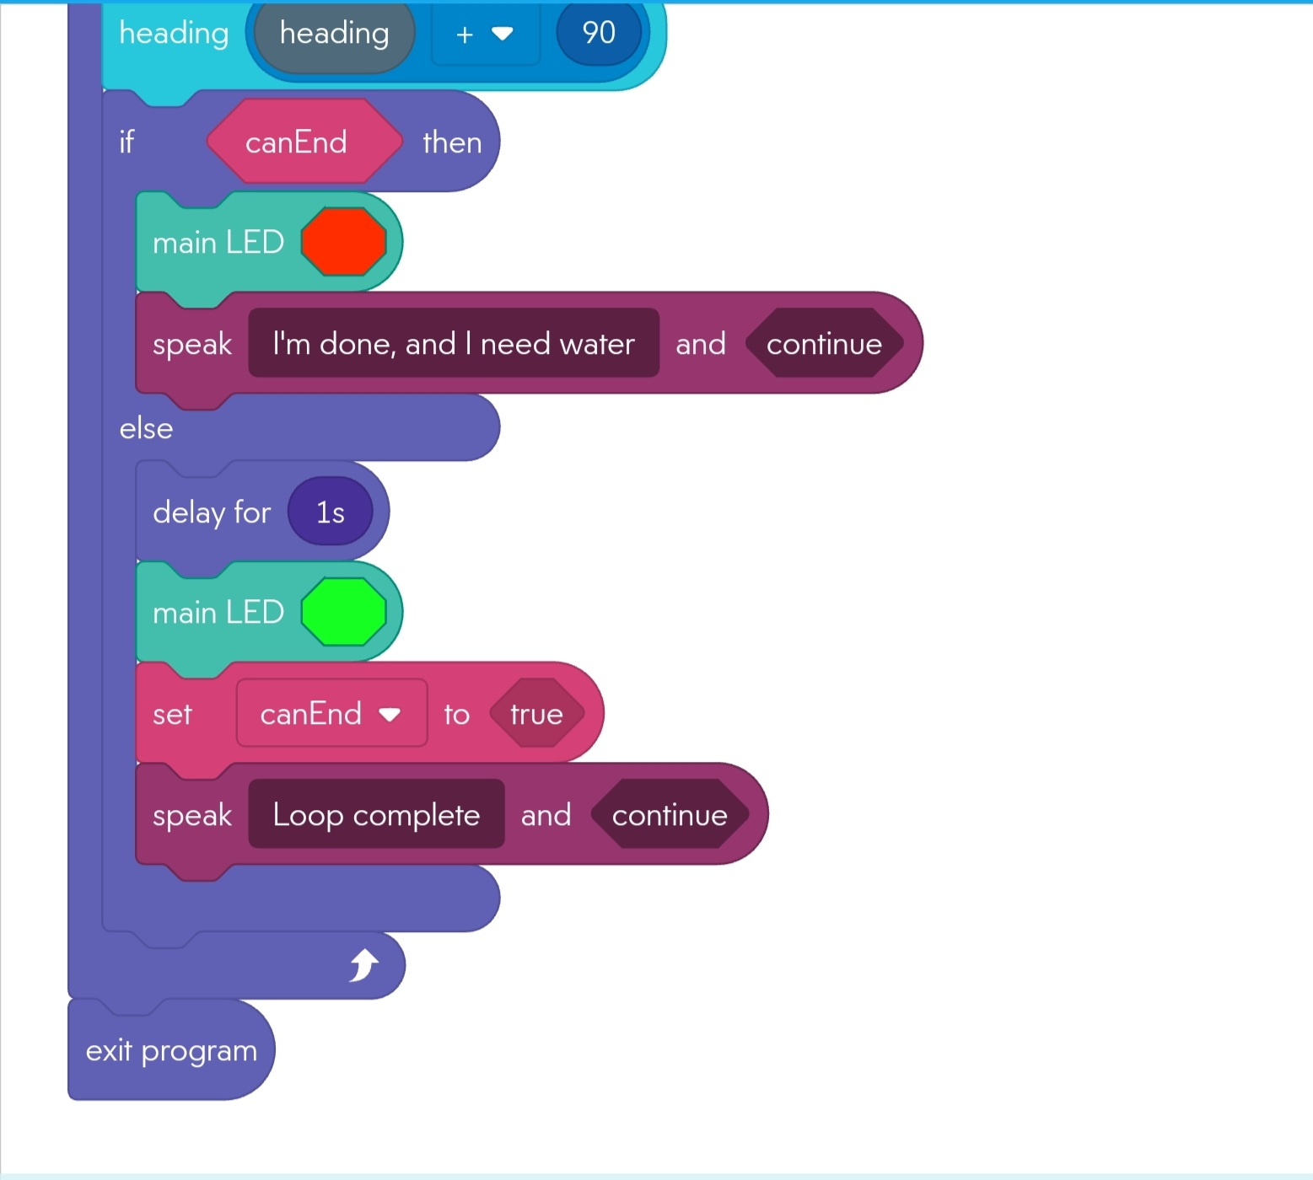

## Sensor Data Diagram

